Grade 3
Understanding Fractions as Parts of a Whole
Family Letter

Dear ____________

We will soon be starting a new math unit focused on Understanding Fractions as Parts of a Whole. The purpose of this letter is to give you some background information about our new unit.

Focuses of the Unit:
During this unit, students will:
- Explore the meaning of fractions and develop an understanding that fractions are numbers.
- Represent fractions using drawings, number lines, and symbols (such as ¼)
- Use their knowledge of fractions to solve word problems.
- Compare two fractions by reasoning about their size.

Strategies and Concepts That Students Will Learn
- Partition a whole or number line into equal parts to represent a fraction with denominators of 2, 3, 4, 6 and 8 using area models and number lines.
- Explain that the denominator (bottom number) is the number of equal parts that would make a whole.
- Explain that the numerator (top number) is the number of parts we have.
- Area Model:
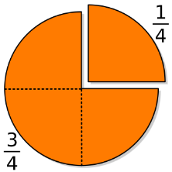
“I partitioned the circle into fourths, so each part is ¼. If I take one-fourth (1/4) away, I’m left with three one-fourths, which is three-fourths (3/4).”

- Number line:
“I partitioned the number line into fourths, so each part is ¼. If I take 1 hop of the 4 total hops I will be at ¼.”

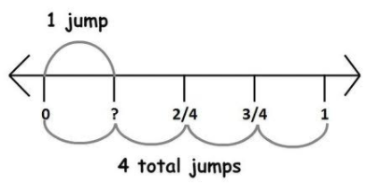

- Represent equivalent fractions with area models and number lines by

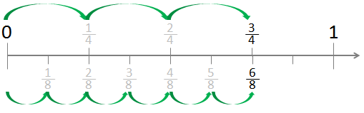
We’ve shown that ¾ and 6/8 are equivalent using a number line.

- Explaining that a fraction with the same numerator and denominator equals one whole. ( 4/4 = 1)

- Compare two fractions by reasoning about their size and use >, < and = symbols.

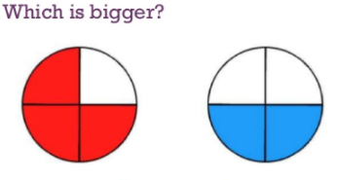
3/4 > 2/4

Ideas for home support:

Fractions in our world: Look for fractions in your everyday life to help your child make sense of fractions. Talk to your student about where you see and use fractions in your life (at home, at the grocery store, on your job, etc.). Look around the house and locate items that have or use fractional amounts. Challenge your student to find fractions in their world. Discuss opportunities such as:
- If we want to share a pan of brownies with the four people in our family, how can we share them equally? How much does each person get? What if you have a friend over? How does that change each person’s share?
- The tea pitcher holds 2 gallons, but right now it is one-half full. How much tea do we need to make to fill up our pitcher for dinner?
- If we cut a whole pizza into 8 equal slices and our family ate 4 slices, what fraction of the pizza did we eat? How can we describe that fraction two ways? (1/2 or 4/8)

Parts of a Whole: At school, third graders will be exploring ways to combine fractions to make a whole. (For example ½ + ½ = 1). Cooking provides a great experience for practicing and putting these ideas to use. If a recipe calls for 1 cup of sugar, give your student the ½ cup measuring cup and ask how we can measure that amount with that measuring cup. What other cups could you use to make that same amount (1/4 cup, 1/8 cup, 1/3 cup, etc.). Then have them check their guesses by pouring those into a one-cup measuring cup to see if it fills the cup.

Thank you for serving as partners in your child’s success as a mathematician!

Grade 3 Math Team

