Grade 3: Cluster 9
Time
Family Letter

Dear ____________

During the week of <date> we will be starting a new math unit focused on telling time. The purpose of this letter is to give you some background information about our new unit.

Focus of the Unit
This unit will focus on telling time to the nearest minute and solving problems involving addition and subtraction within the same hour. Time is a topic that is covered throughout the year as a part of classroom routines. This unit will be an opportunity for students to apply their understanding by solving problems.

Building off Past Mathematics
In grade 2 students learned how to tell and write time from analog and digital clocks to the nearest five minutes, using a.m. and p.m. Third graders take this a step farther by telling time to the nearest minute, then applying that knowledge to solve problems, such as problems involving party schedules, bedtime routines, or minutes per day spent reading.

This unit comes at the end of the year so that students can apply their understanding of addition and subtraction to the context of time.

Strategies that students will learn
Depending on a student’s understanding of addition and subtraction strategies, problems with elapsed time may be solved in various ways.

Students needing a visual strategy could use clock models or number lines to solve. The number line is a strategy used in the addition and subtraction unit, so students are familiar with using it to solve problems. Students could also use their addition and subtraction strategies based on place value, such as breaking numbers apart.

Example problem:
Kenan’s bus comes at 7:55am. If it takes him 14 minutes to shower, 8 minutes to get dressed, and 21 minutes to eat breakfast, what time will he need to wake up?

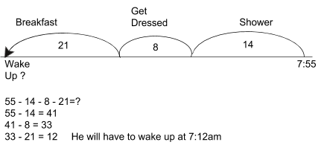
Ideas for home support

You can help your child practice telling time by asking them questions about everyday activities:
- Look at the clock. What time is it?
- We will be leaving for school in 35 minutes. What time will it be then?
- If dinner is at 6:00, and the recipe calls for 50 minutes of cooking time, what time will it need to go in the oven?
- Your friend calls and says to meet her at the park in 25 minutes. What time will you meet her? How long does it take you to get there? What time will you need to leave?

Thank you for serving as partners in your child’s success as a mathematician!

Grade 3 Math Team

