Bikes and Trikes
NC.3.OA.2 and NC.3.OA.3
Domain | Operations and Algebraic Thinking
Cluster | Represent and solve problems involving multiplication and division.
Standard(s) | NC.3.OA.2 For whole-number quotients of whole numbers with a one-digit divisor and a one-digit quotient:  - Interpret the divisor and quotient in a division equation as representing the number of equal groups and the number of objects in each group.  - Illustrate and explain strategies including arrays, repeated addition or subtraction, and decomposing a factor.  NC.3.OA.3 Represent, interpret, and solve one-step problems involving multiplication and division.  - Solve multiplication word problems with factors up to and including 10. Represent the problem using arrays, pictures, and/or equations with a symbol for the unknown number to represent the problem.  - Solve division word problems with a divisor and quotient up to and including 10. Represent the problem using arrays, pictures, repeated subtraction and/or equations with a symbol for the unknown number to represent the problem.
Materials | - Student work paper  - Manipulatives  - Counters  - Square tiles  - Base ten blocks
Task | “Today, you are going to be thinking about how many bike and tricycles are in a bike shop.”  Hand out the task. Have a student read the task out loud. Give students 2-3 minutes to turn and talk about what is going on in the problem (not talk about how to solve it).  There are 42 wheels in a bicycle shop. The bicycle shop sells bikes and tricycles. How many of each might the shop have? (The shop has at least one of each.)  “You may use what you need to solve this problem, be sure to explain your thinking.”

Rubric (Use to make decisions about your next instructional moves with students.)
Level I  Not Yet | Level II  Progressing | Level III  Meets Standard
- Does not have any correct solutions.  - Does not understand how to connect strategy to context of the problem.  - Cannot explain how they solved the problem. | - Has come up with 2 correct solutions but cannot explain their thinking.  - OR has at least 1 correct solution and their explanation matches their thinking. | - Has come up with 2 correct solutions to the problem.  - Explains their work and it matches the work that they have used to find the solution.

Standards for Mathematical Practice
1. Make sense and persevere in solving problems.
2. Reasons abstractly and quantitatively.
3. Construct viable arguments and critiques the reasoning of others.
4. Models with mathematics.
5. Uses appropriate tools strategically.
6. Attends to precision.
7. Looks for and makes use of structure.
8. Looks for and expresses regularity in repeated reasoning.

There are 42 wheels in a bicycle shop. The bicycle shop sells bikes and tricycles. How many of each might the shop have? (The shop has at least one of each.)

What could be another solution?

Explain how you solved this.
______________________________________________________________________________________________________________________________________________________________________________________________________________________________________________________________________________________________________________________________________________________________________________________________________________________________

Scoring Examples

Not Yet: This student received a Level 1 because answers are not correct and explanation does not connect to the problem. While the strategy is neat and organized, it does not show understanding of the mathematical concepts that the task demands. The student does show an understanding of the concept that bikes have two wheels and tricycles have three wheels, but misunderstanding is shown when connecting that concept to what the task is asking.
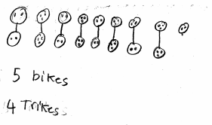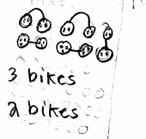
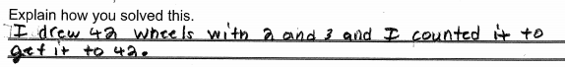
Progressing: This work sample demonstrated different strategies, but student did not come up with different solutions. This student received a Level II (Progressing) because he/she was unable to come up with 2 different solutions. The thinking was modeled in two different ways, however, the explanation does not match the work.
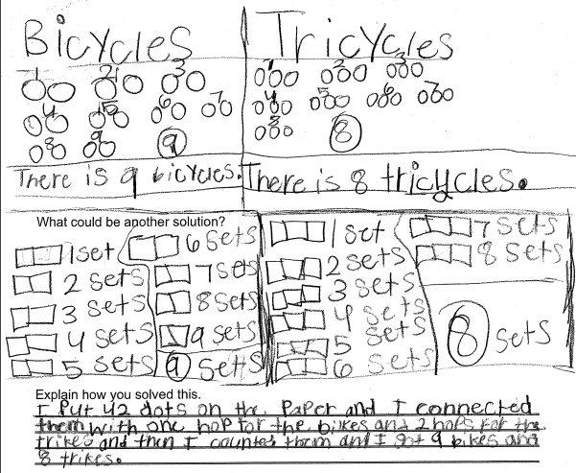
Meets Expectations: This work sample demonstrated different strategies that the student used to find solutions. (Please note: that student was working with 32 wheels, not 42 wheels). The work was clear and the explanation matched the work This student received a Level III (Meets Expectations) because he/she modeled two correct solutions, used a strategy that was successful in helping find the solution and wrote a clear explanation supporting the work.

