Ladybugs
NC.3.OA.3 - Task 1
Domain | Operations and Algebraic Thinking
Cluster | Represent and solve problems involving multiplication and division.
Standard(s) | NC.3.OA.3 Represent, interpret, and solve one-step problems involving multiplication and division.  - Solve multiplication word problems with factors up to and including 10. Represent the problem using arrays, pictures, and/or equations with a symbol for the unknown number to represent the problem.  - Solve division word problems with a divisor and quotient up to and including 10. Represent the problem using arrays, pictures, repeated subtraction and/or equations with a symbol for the unknown number to represent the problem.
Materials | Paper, pencils, counters, optional Whiteboards and dry-erase markers
Task | Ladybugs have 6 legs. You see a group of ladybugs on the ground. If you see 48 legs, how many ladybugs are there? How many eyes would you see? If ladybugs have 4 wings, how many wings would you see? Draw a picture for each part of the task and explain how you found your answers.

Rubric
Level I  Not Yet | - Level II  - Progressing | Level III  Meets Expectations
- Even with help from a teacher or peer, struggles make sense of or use a strategy for exploring this task. | - Finds the correct answer, but there is an incorrect model or explanation.  OR  - Work is logically shown, but there is a calculation or mathematical error | - Accurately finds the answers (8 ladybugs, 16 eyes, 32 wings). AND  - An appropriate picture or explanation for each part of the task.

Standards for Mathematical Practice
1. Makes sense and perseveres in solving problems.
2. Reasons abstractly and quantitatively.
3. Constructs viable arguments and critiques the reasoning of others.
4. Models with mathematics.
5. Uses appropriate tools strategically.
6. Attends to precision.
7. Looks for and makes use of structure.
8. Looks for and expresses regularity in repeated reasoning.

Ladybugs

Draw a picture for each part of the task and explain how you found your answers.

Ladybugs have 6 legs. You see a group of ladybugs on the ground.

If you see 48 legs, how many ladybugs are there?

How many eyes would you see?

If ladybugs have 4 wings, how many wings would you see?

Scoring Examples
Not Yet: This student he has a calculation error in all parts of the problem. He added the total number of legs (48) to the number of legs on a ladybug (6), making his answer 54. In question 2 he added the number of ladybug legs (6) to the total from the first part (54) for a total of 60. In question 3, he add the number of wings (4) to the previous total (60) for a total of 64.
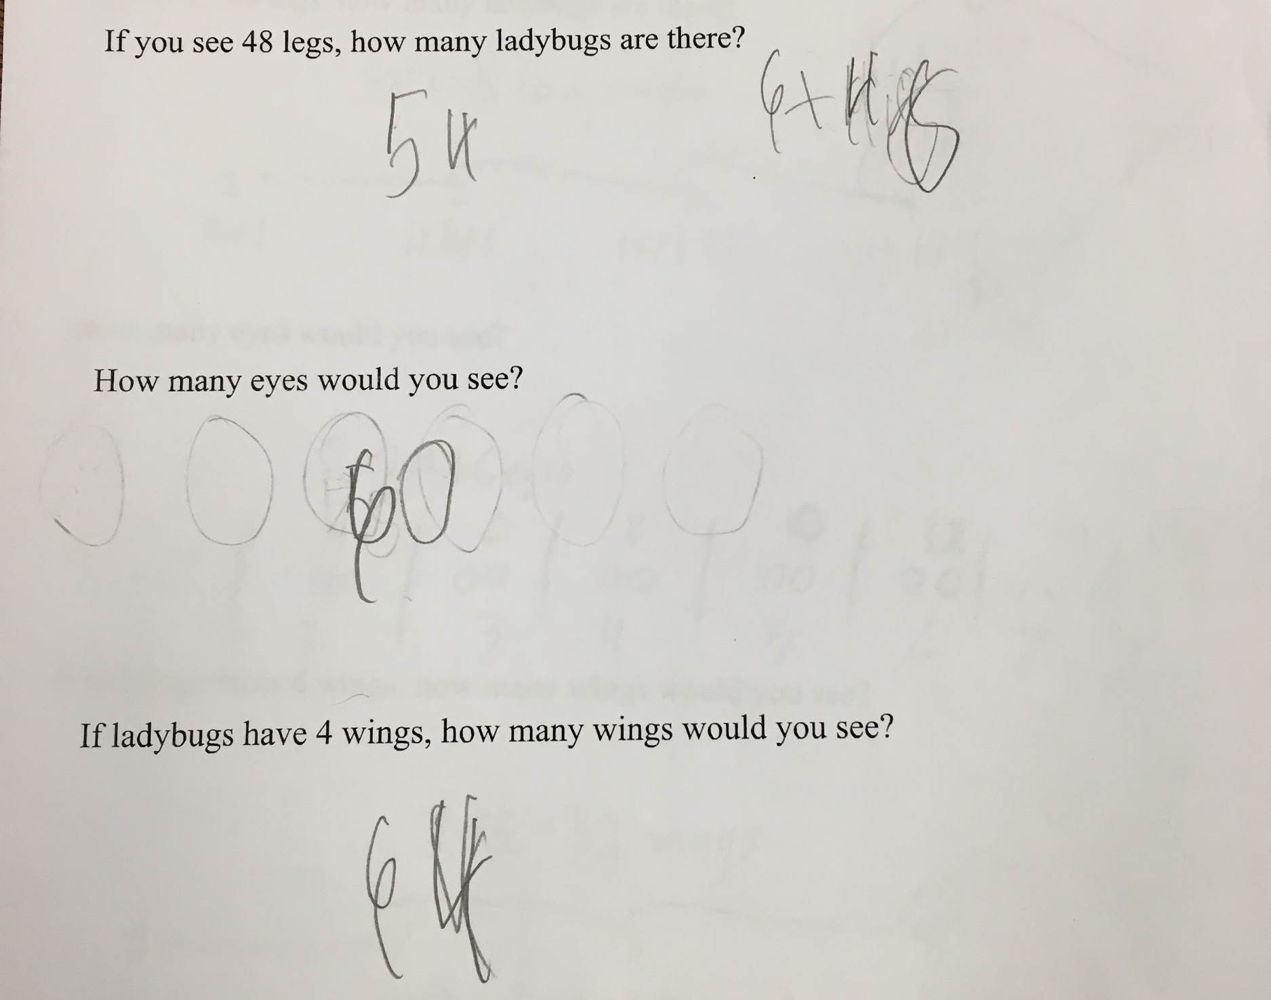

Progressing: This student realized that 2 ladybugs have 12 legs, so he added twelve four times to get 48, but when he decontextualized the numbers (pulled them out of context), he lost track of those 12s representing 2 ladybugs, and he did not answer the question of how many ladybugs are there. He answered question 2 correctly, but did not answer question 3. His drawing could lead to a correct answer, but his answer was 8, which is the number of ladybugs instead of 32 wings. This student had a lot of the mathematical understanding, but needs more work with contextualizing (keeping the context of the numbers in mind).

Question 1:
Question 2:
Question 3:

Meets Expectations: This student accurately found the answer to all parts of the task. He also provided appropriate pictures and even wrote equations (which is not required) for each part of the task.

