Party Planning
NC.3.OA.3
Domain | Operations and Algebraic Thinking
Cluster | Represent and solve problems involving multiplication and division
Standard(s) | NC.3.OA.3 Represent, interpret, and solve one-step problems involving multiplication and division.  - Solve multiplication word problems with factors up to and including 10. Represent the problem using arrays, pictures, and/or equations with a symbol for the unknown number to represent the problem.  - Solve division word problems with a divisor and quotient up to and including 10. Represent the problem using arrays, pictures, repeated subtraction and/or equations with a symbol for the unknown number to represent the problem.
Materials | Activity sheet, pencils, paper, manipulatives if needed
Task | Part A: The Smith family is hosting a dinner party. They set up 6 tables, and each table has 8 seats. How many guests could there be?  - Draw a picture representation of the table setup.  - Write an equation to represent the problem.  - Explain your strategy in words.  Part B: Each guest needs a salad fork and a dinner fork. How many forks will the Smith family dinner party need altogether?  - Write an equation to represent the problem.  - Explain your strategy in words.  Part C: The Jones family is having a dinner party next week. They will have 56 guests. They are also using the tables that have 8 seats. How many tables will they need?  - Draw a picture representation of the table setup.  - Write an equation to represent the problem.  - Explain your strategy in words.  Part D: Each guest at the Jones party will also need a salad fork and a dinner fork. How many forks will the Jones family dinner party need altogether?  - Write an equation to represent the problem.  - Explain your strategy in words.

Rubric (Use to make decisions about your next instructional moves with students.)
Level I  Not Yet | Level II  Progressing | Level III  Meets Expectation
- Student is unable to solve for products or unknown factors.  - Student does not demonstrate complete and appropriate strategy or strategies.  - Student is unable to explain each strategy using equations, words, and pictures where appropriate. | - Student inconsistently solves for products or unknown factors or requires teacher assistance to solve accurately.  - Student demonstrates partial or inconsistent understanding of appropriate strategy or strategies.  - Student inconsistently explains each strategy using equations, words, and pictures where appropriate. | - Student accurately solves for products or unknown factors.  - Student demonstrates complete and appropriate strategy or strategies.  - Student explains each strategy using equations, words, and pictures where appropriate.

Standards for Mathematical Practice
1. Makes sense and perseveres in solving problems.
2. Reasons abstractly and quantitatively.
3. Constructs viable arguments and critiques the reasoning of others.
4. Models with mathematics.
5. Uses appropriate tools strategically.
6. Attends to precision.
7. Looks for and makes use of structure.
8. Looks for and expresses regularity in repeated reasoning.

Party Planning Tasks

Part A: The Smith family is hosting a dinner party. They set up 6 tables, and each table has 8 seats. How many guests could there be?
- Draw a picture representation of the table setup.
- Write an equation to represent the problem.
- Explain your strategy in words.

Part B: Each guest needs a salad fork and a dinner fork. How many forks will the Smith family dinner party need altogether?
- Write an equation to represent the problem.
- Explain your strategy in words.

Part C: The Jones family is having a dinner party next week. They will have 56 guests. They are also using the tables that have 8 seats. How many tables will they need?
- Draw a picture representation of the table setup.
- Write an equation to represent the problem.
- Explain your strategy in words.

Part D: Each guest at the Jones party will also need a salad fork and a dinner fork. How many forks will the Jones family dinner party need altogether?
- Write an equation to represent the problem.
- Explain your strategy in words.

Represent your solution with an equation. | Explain your strategy using words, pictures, or computations.
A. | A.
B. | B.
C. | C.
D. | D.

Scoring Examples

Not Yet: This student received a Level 1 because on part A, (s)he started the equation correctly but did not draw a matching picture and did not have the correct product. On part B, the equation and product does not match the problem, and there is no picture. On part C, the student did not provide an equation, and the picture does not match the scenario. On part D, (s)he did not provide a picture or correct equation and product. This shows that this student did not meet the standards for this task and did not show evidence of understanding multiplication and division.
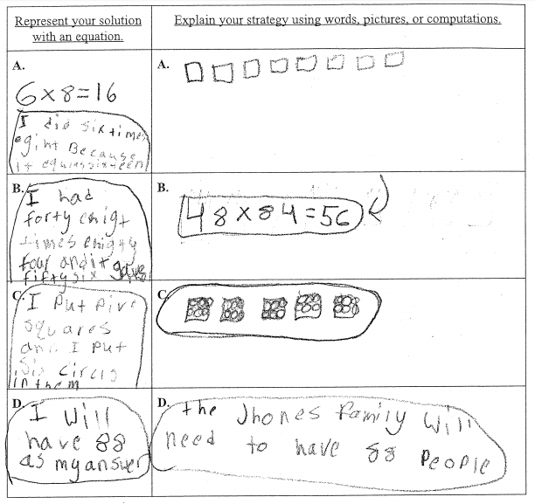
Progressing: This student received a level II because (s)he accurately solved parts A and C using acceptable equations (repeated addition and multiplication, respectively) and showing work using a picture, but did not describe strategies using sentences. Also, for parts B and D, which were extensions of A and C, the student did not solve for the correct solution even though (s)he showed work using pictures and equations. For Part B in particular, the work shown does not support the inaccurate solution of 82.

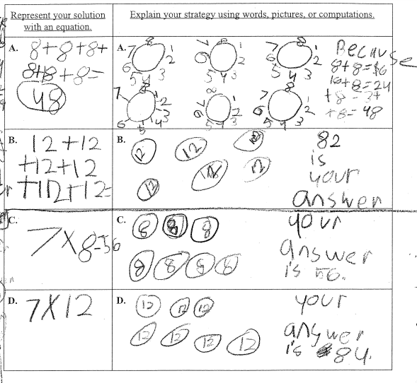

Meets Expectations: This student earned a Level III because for each part, an appropriate picture, equation, and sentence is shown. In part A, (s)he showed that 6 times 8 equals 48 using an array. In part B, s(he) showed understanding of the problem by writing a multiplication equation and then using repeated addition to solve and find the correct product. In part C, (s)he showed a connection between the multiplication and division equation and drew an accurate picture to represent it. In part D, (s)he again showed the connection between multiplication and repeated addition to solve and find the correct number of forks needed.
