Cluster 4 Images:
Identifying, Describing, Classifying and Composing Shapes
Topic | Build Shapes and Distinguish Attributes
Description | Students use their understanding of defining attributes to identify, name, build, and draw triangles, rectangles, squares, hexagons, and circles. Student also build cubes, cones, spheres, and cylinders.  Students learn that defining attributes are always present features that classify an object such as number of sides, lengths of sides, and number of angles. Students also learn that non-defining attributes are features that may be present, but do not help to identify the name of a shape (e.g., color, size, orientation, etc.).  Students should be exposed to shapes in a variety of sizes and positions and they should be encouraged to notice shapes in their everyday world.
Image | 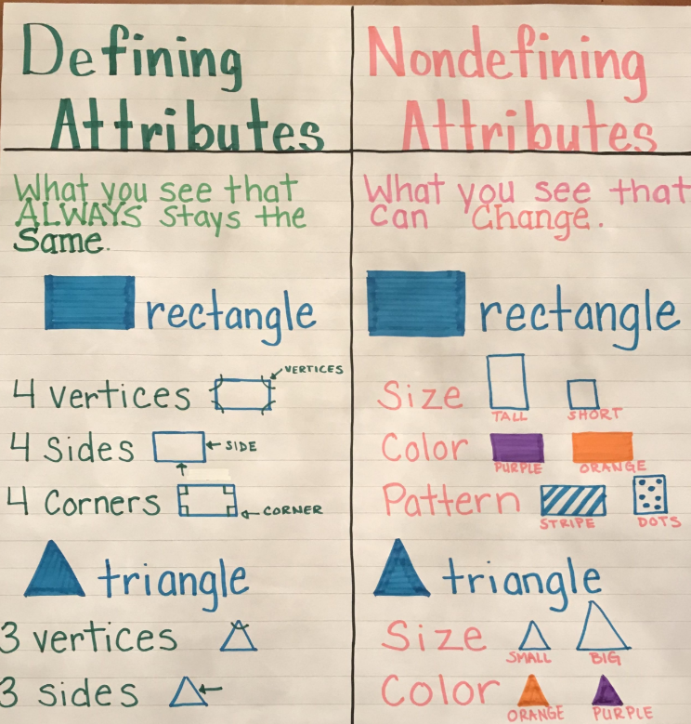  https://i.pinimg.com/originals/36/f3/da/36f3daa287f4bc0061bc35c053c71735.jpg

Topic | Create Composite Shapes
Description | This activity could be used when students combine rectangles, squares, trapezoids, triangles, and half-circles to create and describe new composite shapes that have been created. Students should engage in experiences with a variety of models such as tangrams, attribute blocks, and pattern blocks (pattern blocks shown below).  Students should also combine cubes, rectangular prisms, cones, spheres, and cylinders to create new composite shapes and name the components of the new shape.
Image | 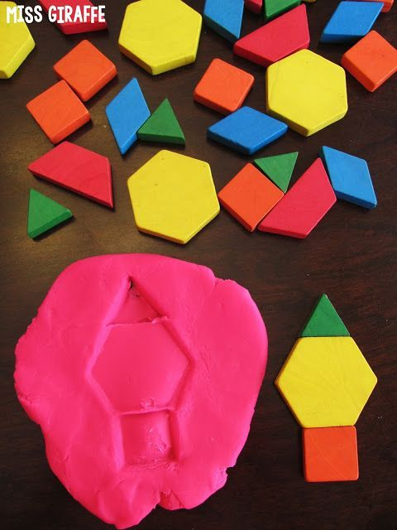  https://www.bloglovin.com/blogs/miss-giraffes-class-12558829/composing-shapes-in-1st-grade-4845417116

