Next Steps Document- Kindergarten, Cluster 4
The intended purpose of this document is to provide teachers with a tool to determine student understanding and suggest instructional moves that may help guide a student forward in their learning of a concept or standard. This guide is not an exhaustive list of strategies.
Kindergarten: Cluster 4
Identifying, Describing, Classifying, and Composing Shapes
NC.K.CC.3 Write numbers from 0 to 20. Represent a number of objects with a written numeral 0-20, with 0 representing a count of no objects.

NC.K.CC.5 Count to answer “How many?” in the following situations:
● Given a number from 1-20, count out that many objects.
● Given up to 20 objects, name the next successive number when an object is added, recognizing the quantity is one more/greater.
● Given 20 objects arranged in a line, a rectangular array, and a circle, identify how many.
● Given 10 objects in a scattered arrangement, identify how many.

NC.K.CC.6 Identify whether the number of objects, within 10, in one group is greater than, less than, or equal to the number of objects in another group, by using matching and counting strategies.

NC.K.G.1 Describe objects in the environment using names of shapes, and describe the relative positions of objects using positional terms.

NC.K.G.2 Correctly names squares, circles, triangles, rectangles, hexagons, cubes, cones, cylinders, and spheres regardless of their orientations or overall size.

NC.K.G.3 Identify squares, circles, triangles, rectangles, hexagons, cubes, cones, cylinders, and spheres as two dimensional or three-dimensional.

NC.K.G.4 Analyze and compare two- and three-dimensional shapes, in different sizes and orientations, using informal language to describe their similarities, differences, attributes and other properties.

NC.K.G.5 Model shapes in the world by building shapes from components and drawing shapes.

NC.K.G.6 Compose larger shapes from simple shapes.

NC.K.MD.1 Describe measurable attributes of objects; and describe several different measurable attributes of a single object.

NC.K.MD.3 Classify objects into given categories; count the numbers of objects in each category and sort the categories by count.

Not Yet | Students that are consistently scoring “Not Yet” could have a variety of errors. These errors may include not being able to count 10 objects in a line, array, or circle (K.CC standards). Students at this level may not yet be able to correctly name two shapes form the various shapes expected by the end of the year. Further, students may not be able to tell whether objects are flat (2D) or solid (3D).
Next Steps:
For students who are not yet able to count a set of 10 objects in a line, circle, or array (K.CC.5, foundation for K.MD.3):
- Provide opportunities for students to count sets of objects within 5. Remind them to move counters one at a time as they count. Work with students to ensure that they are demonstrating tagging and one-to-one correspondence.
- Provide opportunities for students to count objects by placing counters/cubes on a number path or 10s chart (hundreds board with only numbers 1 to 10. Number paths and 10s charts are good resources since they include each written numeral which helps students to keep track of the number of objects they have.
- Play games that involve students pulling number cards (numbers and pictures) from a stack of cards and counting out that set with objects with the use of a number path or 10s chart. Discuss with students that when we count a set of objects the last number that we say is the total number of objects in that set. “When I counted the group I had 1, 2, 3, and 4. Since the last number I said was 4 that means that I have 4 counters.”
- Instructional and Assessment Task: Counting Objects and Writing Numerals

For students who are not yet able to identify at least two of the shapes listed in K.G.2:
- Provide opportunities for students to work in small groups or individually with the teacher on distinguishing between circles and non-circles. Circles are the only shape in Kindergarten that does not have straight sides. Discuss with students real-life examples of circles (e.g., wheels, tires, top and bottom of most cups).
- Provide opportunities for students to work in small groups or individually with the teacher on counting the sides of shapes. Any shape with exactly three straight sides is a triangle. Shapes with exactly four sides could be a variety of shapes, including but not limited to a rectangle and a square.

For students who are not yet able to identify if shapes are flat (2D) or solid (3D) (K.G.3):
- Provide opportunities for students to touch and hold objects and describe if they are flat (no thickness or depth) or solid (3D shapes and figures). Be careful with shapes such as pattern blocks that have thickness and may look 3D to students. Shapes on paper or card stock are best so students see those shapes as flat (2D) shapes.

For students who are not yet able to orally start to describe shapes, positions, or measurable attributes (K.G.1, K.G.2, K.G.4, K.MD.1)
- Provide opportunities for students to explore shapes in small groups or individually with the teacher. Provide a sentence starter or choices to support students. Examples: “Is the triangle above or below the square?” “The cube is ________ than the piece of paper.”
- Provide opportunities for students to identify shapes in a variety of orientations. For example, students should recognize that a triangle is still a triangle when it is rotated or placed “upside down”.

For students who are not yet able to sort objects by an attribute (K.MD.3):
- Provide opportunities for students to sort two different colors of counters by color and then count the number in each group. This can also be done with three different colors of counters.
- Discuss with students that the purpose of the counting is to answer the question, “How many have this attribute? OR “How many are <color, size, shape, etc.>?’

Progressing | Students who are “Progressing” are able to count a group of 10 objects in a line, array, or circle and use their counting skills to explore sorting and counting quantities after they sorted. In this cluster, students at the “Progressing” level are working towards demonstrating consistent evidence of their understanding of the Geometry and Measurement and Data concepts.
Next Steps:

For students who are progressing towards counting a set of 20 objects in a line, circle, or array or 10 counters in a scatter (K.CC.5, foundation for K.MD.3):
- Provide opportunities for students to count sets of objects within 10. Remind them to move counters one at a time as they count. Work with students to ensure that they are demonstrating tagging and one-to-one correspondence consistently.
- Provide opportunities for students to count objects by placing counters/cubes on a number path or 20s chart (hundreds board with only numbers 1 to 20. Number paths and 10s charts are good resources since they include each written numeral which helps students to keep track of the number of objects they have.
- Play games that involve students pulling number cards (numbers and pictures) from a stack of cards and counting out that set with objects with the use of a number path or 10s chart. Discuss with students that when we count a set of objects the last number that we say is the total number of objects in that set. “When I counted the group I had 1, 2, 3, and 4. Since the last number I said was 4 that means that I have 4 counters.”

For students who are progressing on standards related to comparing numbers (K.CC.6:
- Provide experiences for comparing two quantities using counters. Students can compare numbers by lining up counters where each set has a match. For example, if comparing four black cubes and three white cubes students may line them up and determine there are more more black cubes since there is one extra after matching them up.

- Build and compare: Students draw a number card and build that quantity with counters/cubes. Students draw a 2nd number card and also build that quantity. Students determine which quantity is larger and explain how they know.
- Find one larger, find one smaller: Students draw a number card and build that quantity with counters/cubes. Students then write a number that is smaller than that number and also write a number that is larger than that number.

For students who can identify if shapes are flat (2D) or solid (3D), but are progressing at identifying specific shapes (K.G.2) and describing shapes (K.G.4):
- Provide opportunities for students to explore shapes and discuss attributes and characteristics of shapes that they recognize (K.G.2). Remind students that color is never an attribute for a shape, and in a lot of cases size is not an attribute either.
- Provide a sentence starter or choices to help students. Examples: “Is the triangle to the left or right of the square?” “The block is ______ than the piece of paper.”
- Tools4NCTeachers Center Ideas

For students who are progressing at describing shapes, their relative positions and/or the measurable attributes of objects (K.G.4, K.MD.1):
- Provide opportunities for students to explore and hold objects. Have students describe shapes, positions and attributes. Provide a sentence starter or choices to help students. Examples: “Is the triangle to the left or right of the square?” “The block is ______ than the piece of paper.”

Meets Expectation | Students that are consistently scoring “Meets Expectation” in this cluster have met all standards with proficiency.
Next Steps:
For students who have demonstrated proficiency with concepts in this Cluster:
- Provide opportunities for students to work on other standards, specifically K.OA.1, K.OA.2, K.OA.4.

Primary Number Cards (Adapted from Investigations, TERC)

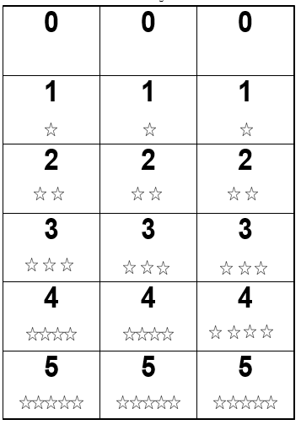

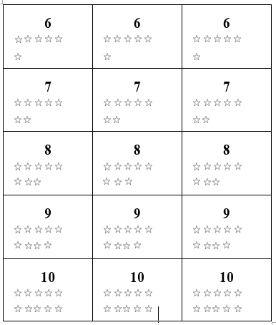

Number Path to 10 (Tens Chart)

1 | 2 | 3 | 4 | 5 | 6 | 7 | 8 | 9 | 10

Number Line

0 |  | 1 |  | 2 |  | 3 |  | 4 |  | 5 |  | 6 |  | 7 |  | 8 |  | 9 |  | 10

