Partner Quick Flash
This lesson should occur after students have experiences with perceptual subitizing*.
In this lesson, students use conceptual subitizing** as a flexible and efficient method for finding “how many”.

*Perceptual subitizing: instantly recognizing “how many” in a set
**Conceptual subitizing: efficiently finding “how many” by recognizing and combining subgroups within a set.

NC Mathematics Standards:
Understand addition and subtraction.
NC.K.OA.6: Recognize and combine groups with totals up to 5 (conceptual subitizing).

Standards for Mathematical Practice:
2. Reason abstractly and quantitatively.
8. Look for and make use of structure.

Student Outcomes:
- I can use subitizing to help find “how many”.
- I can be flexible and efficient when finding “how many”.

Math Language:
- Count  - How many?  - Set  - Numerals: 1, 2, 3, 4, 5 | Students should be exposed to, but not held accountable for using:  - Subitize  - Flexible  - Efficient

Materials:
- Mouse and Cheese Maze
- Quick Flash Cards – Set 1 or Set 2

Advance Preparation:
- Make one copy of the Mouse and Cheese Maze.
- Copy and cut out Quick Flash Cards (Set 1, Set 2, or both) – one set per pair of students.

Launch:
- Introduce two components of fluency - flexibility and efficiency. (2-3 minutes)
  - Display the Mouse and Cheese Maze. Discuss: What are some ways the mouse could get to the cheese? When we know many ways to do something, it means we are flexible. We are efficient when we choose the way that takes the least amount of steps. What is the most efficient way for the mouse to get to the cheese?
  - Say: Mathematicians are flexible when they think about different ways to solve a problem. They are efficient when they choose the way that takes the least number of steps. Today, let’s work to be flexible and efficient.
- Do a whole-group quick flash (3-5 minutes)
  - Display a Quick Flash Card under the document camera for 3-4 seconds.
  - Say: Put your thumb to your chest when you know how many dots are on the card.
  - Ask: How many dots are on this card? How did you find “how many”? Are there different ways to find the amount?
  - Share one or more strategies students may not have mentioned.

Examples of strategies:
“I counted 1, 2, 3, 4.”
“I saw/subitized 2 and 2. I know that makes 4.”
“I saw/subitized 2. Then, I counted 3, 4.”
“I saw/subitized 3. One more makes 4.”
“I saw 1 dot on top. Then, I said, 2, 3, 4.”
“It looked like 4 on a die/dice, but one dot fell down.”

  - Say: Wow, we were flexible because we knew many ways to find the quantity of dots. Hopefully, you noticed that some ways are easier than others. Choosing the way that takes the least number of steps, means you are efficient.
  - Say: Today, we will play a game with dots cards. As you find the amount of dots on each card, you will notice there are many ways to find “how many”. Use the way that takes the least number of steps.
- Explain directions for “Partner Quick Flash”. (2-3 minutes)
  - Partners place a set of Quick Flash Cards face down between them.
  - Partner A picks a card, and secretly finds the quantity of dots.
  - Partner A shows the card to Partner B for 3-4 seconds.
  - Partner B says the quantity, and explains how he/she found it.
  - If Partner B is correct, he/she keeps the card.
  - Partners switch roles and repeat until teacher gives signal.

Explore:
- Allow about 5 minutes for partners to complete the quick flash.
  - Observe strategies used. Ask questions to elicit thinking and encourage use of efficient strategies. For example:

Strategy used… | Questions to ask…
Count all dots individually.  1, 2, 3, 4 | - Is there an easier way to find “how many” without counting every dot?  - What parts do you see?
Count dots individually,  then notice parts.  1, 2, 3, 4…That’s 4! I see 2 and 2. | - Rather than count every dot, how could use the parts you saw to find “how many”?
Instantly see (subitize) a subgroup within the set, and count on.  2…3, 4 | - You subitized part and counted on. Is this an efficient way to find “how many”? Explain.  - Are there other ways to use subitizing to help you find “how many”?
Instantly see (subitize) subgroups and know a corresponding fact.  2 and 2 makes 4 | - How could you teach a friend to use this strategy?  - Is this an efficient way to find “how many”? Explain.

  - Select students who will their strategies during the “Discuss” phase of the lesson and the sequence in which they will share (i.e., least to most sophisticated). In order to directly compare strategies, focus the sharing around two pre-determined Quick Flash Cards.
  - Note: Let selected students know they will be sharing. Prior to sharing, they may circle/draw on their card as a reminder of how the found “how many”.

Discuss:
- Bring class together for a discussion about strategies used during the game. (10 minutes)
  - Show a Quick Flash Card.
    - Have pre-selected students share strategies for finding the quantity.
    - Ask the class: How were the strategies the same? How were they different?
    - Say: Think to yourself… Later, we will play this game again. If you see this card, which strategy would you like to use? For you, which is the most efficient? (Do not say responses aloud, as this may cause students who shared their strategies to feel as though they are being evaluated.)
  - Show another Quick Flash Card.
    - Have pre-selected students share strategies for finding the quantity.
    - Ask: Were the strategies for this card exactly the same as the ones used for the last card? What was different?
  - The goal of this lesson is to use conceptual subitizing (efficiently finding “how many” by recognizing and combining subgroups within a set). Highlight strategies that related to conceptual subitizing.

Examples of Conceptual Subitizing:
“I subitized 2 and 2. I know that makes 4.”
“I saw 3. One more makes 4.”
“I subitized 2. Then, I counted 3, 4.”

  - Explain: Mathematicians are flexible when they know many ways to solve problems. They are efficient when they choose the easiest way, which takes the least number of steps. Whenever you are trying to find “how many”, you can be efficient by subitizing parts of the set rather than counting each dot individually.
Evaluation of Student Understanding:
Informal Evaluation:
At the end of the lesson, have students re-play the partner quick image game. Observe to see if students count dots individually, subitize one part and count on, or subitize multiple parts and know the matching addition fact.

Meeting the Needs of the Range of Learners:
- This lesson comes with two sets of cards: dots arranged on five frames, and dots arranged on blank cards. The structure of the five frames provide additional support for students. Strategically select which cards to use based on students’ varying needs.

Extensions:
- Repeat this game to provide additional opportunities with conceptual subitizing.
- Make whole-group quick flashes part of your daily math routine. Encourage students to share their strategies, highlighting those that focus on conceptual subitizing.

Possible Misconceptions/Suggestions:
Possible Misconception | Suggestion
Students may want to say they are subitizing when they are actually counting items individually. | Be aware of the strategies students are using, and help articulate them. Nudge students toward subitizing one or more subgroups in order to find the total amount.

Special Notes:
- Perceptual subitizing means to instantly see “how many”. Conceptual subitizing means to find “how many” by recognizing and combining subgroups within a set. For example:
  - Subitize part and count on from there.
  - Subitize multiple parts and know a corresponding addition or multiplication fact.
  - Subitize multiple parts and use skip counting.
- Because conceptual subitizing requires the application of perceptual subitizing, students must have many experiences with perceptual subitizing prior to this lesson.
- Fluency means to be flexible, efficient, and accurate. When students learn a variety of strategies and when to apply them, they are flexible. Once students are flexible, they become efficient by selecting the strategy that requires the least amount of effort. Flexibility and efficiency will lead to accuracy.

Mouse and Cheese Maze

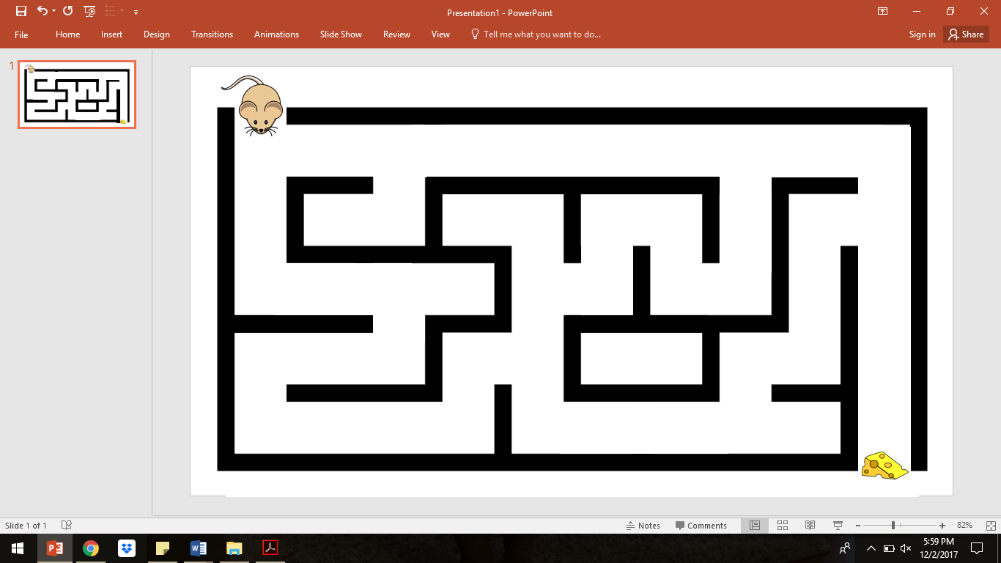

Quick Flash Cards – Set 1
Quick Flash Cards – Set 2

