Stuck in the Sink!
In this lesson, students will represent and solve an addition problem
using a variety of representations and strategies.

NC Mathematics Standard:
Understand addition and subtraction.
NC.K.OA.1 Represent addition and subtraction, within 10:
- Use a variety of representations such as objects, fingers, mental images, drawings, sounds, acting out situations, verbal explanations, or expressions.
- Demonstrate understanding of addition and subtraction by making connections among representations.

Supporting Standard
NC.K.CC.5 Count to answer “How many?” in the following situations:
- Given a number from 1-20, count out that many objects.
- Given up to 20 objects, name the next successive number when an object is added, recognizing the quantity is one more/greater.
- Given 20 objects arranged in a line, a rectangular array, and a circle, identify how many.
- Given 10 objects in a scattered arrangement, identify how many.

Standards for Mathematical Practice:
- Make sense of problems and persevere in solving them
- Construct viable arguments and critique the reasoning of others.
- Model with mathematics.

Student Outcomes:
- I can use objects and drawings to represent problems.
- I can add to solve problems in my world.

Math Language:
- add, join, count, total

Materials:
- projection equipment (document camera or laptop and projector)
- Stuck in the Sink! Pictures #1-3
- Stuck in the Sink! Answer Picture #4

Advance Preparation:
- Print Stuck in the Sink! pictures to display via document camera, or plan to display pictures using laptop and projector. It’s important that pictures are shown one at a time.
- Ensure that all students have access to manipulatives, paper, and crayons.

Launch:
- Ask: Have you ever been caught doing something you weren’t supposed to be doing? How did you feel?
- Give students opportunities to notice and wonder.
  - Display picture #1. Have partners discuss what they notice and what they wonder. Partners may use the sentence starters, “I notice _____. I wonder _____.”
  - Display picture #2. Have partners discuss what they notice and what they wonder.
  - Display picture #3. Have partners discuss what they notice and what they wonder.
- Introduce today’s task.
  - OPTION A: If students wondered about the number of doll legs in the sink, allow this to guide today’s task. For example: Josh wants to know how many doll legs are stuck in the sink. Let’s go back to our seats, use our manipulatives or paper/crayons to find the answer to Josh’s question.
  - OPTION B: If no students wondered about the number of doll legs in the sink, say: This is Reagan. She got some of her baby dolls’ legs stuck in the sink. How many doll legs are stuck in the sink?

Explore:
- Allow 1-2 minutes for students to grapple with today’s task alone. After two minutes, students may work with partners. While students work, observe strategies used. Ask questions to help students get started, check their thinking, or challenge them to use advanced strategies.

Observation | Questions to Ask
Student does not know how to start the task. | What was Reagan doing in the pictures?  How many dolls did she put in the sink?  How can we use our math tools to show each doll’s legs?
Student represents the task, but doesn’t know how to find total. | What are we trying to find out?  How did you show the doll legs with your math tools?  How can we use counting to find the total number of legs?
Student confuses the number of legs with the number of dolls | How many legs do you think this first doll has (pointing)?  How can we show the first doll’s legs using our math tools?  How could we show the legs for the other dolls?  How many legs are on two dolls?
Student builds sets of two, then counts all items individually. | How many legs are in this first set? You already know that’s two. How can you count on to find the total amount?
Student quickly and successfully solves task. | Is there another way to represent your thinking?  How many legs would there be if 4 dolls were stuck? 5 dolls?  What patterns do you notice?

- As students work, select a few to share their solution strategies during the “Discuss” section of the lesson. Determine a sequence in which students will share (e.g., justifications progress from least to most sophisticated).
Discuss:
- Bring students together to share solution strategies. Remind students of the task.
- Have pre-selected students share.
  - As students share, draw attention to representations used (e.g., actions, objects, drawings, numbers, words) and methods for finding the total quantity of doll legs.

Examples of Problem Solving Methods
Counting All | 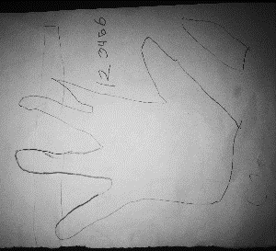  I made two, two, and two on my fingers.  That’s 1, 2, 3, 4, 5, 6 legs!
Counting On | I used squares to show the dolls’ legs.  2…3, 4, 5, 6. Six legs.
Using Known Facts | Each doll has two legs. Two and two is four.  4…5, 6. There are 6 legs.  (Student used a known fact to get 4, then added on.)
Skip Counting | I did it on my fingers. 2…4…6. That’s 6 legs.  Then, I also saw that 5 fingers plus one more is six.  (Student started with skip counting, then noticed a related math fact.)

  - Ask questions to elicit student thinking, drawing attention to their strategies.
  - Encourage students to repeat strategies they heard classmates share. This promotes active listening, and encourages students to attend to other’s strategies.

- Display picture #4 to reveal correct answer. Have class count all the legs to verify answer.
- Close lesson. Say: As we solved today’s task, we built/drew sets of two and joined them together to find the total. We learned that we can solve tasks like this in a variety of ways. We can build each set and count all. We can count on from one of the sets, and we can also use our math facts to help us find the total. These are strategies we can use today and every day to solve problems.

Evaluation of Student Understanding:
Informal Evaluation:
- Students will use objects, pictures, numbers or words to represent the problem.
- Students will join sets to find the total amount. Strategies used may include counting all, counting on, skip counting by twos, and using known facts.

Meeting the Needs of the Range of Learners:
Interventions:
- Start with a simpler problem: have student find the total amount in two sets of doll legs.
- In small groups, encourage students act out problem situations or represent with objects.
Extensions:
- Challenge students with related problems. What if Reagan had 5 dolls stuck in the sink?
- Avoid giving math tasks in which a complete picture is provided, which allows students to simply count all items in the picture. Provide additional problems in which students must represent the situation or create a mental image prior to solving.
- Encourage students to use advanced strategies rather than relying on counting all.

Special Notes:
- Presenting math tasks in the form of pictures reduces the students’ cognitive load. This allows them to focus on the math without being overwhelmed by the text. This is an important instructional method for kindergarten, as students are not yet proficient readers.

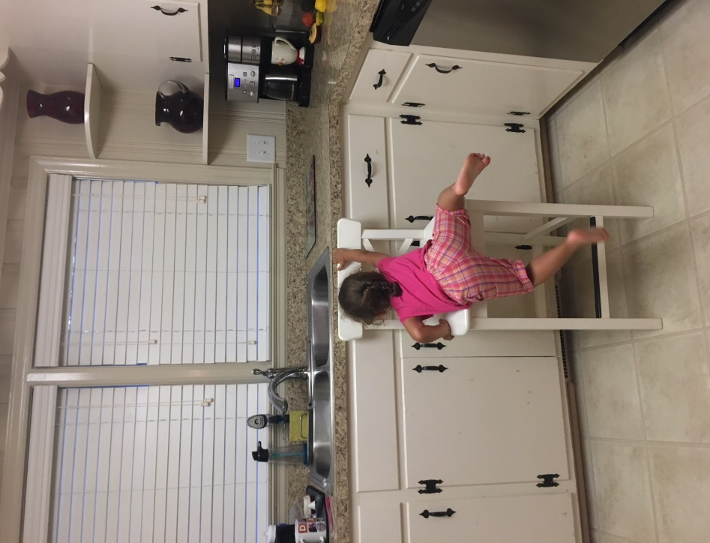
Stuck in the Sink! Pictures
1
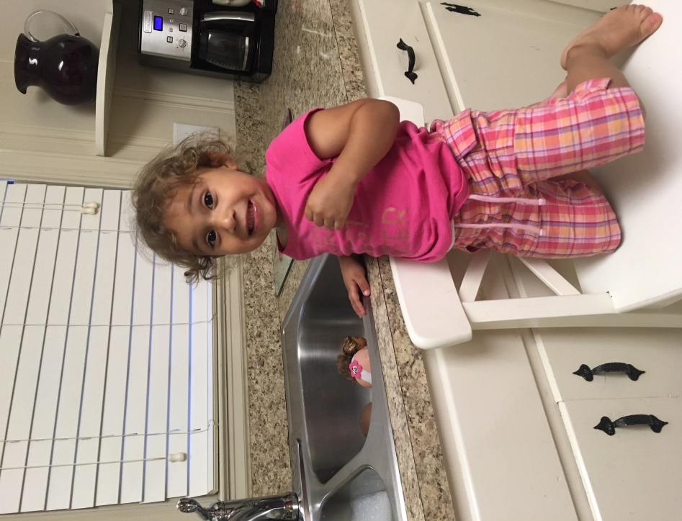
2

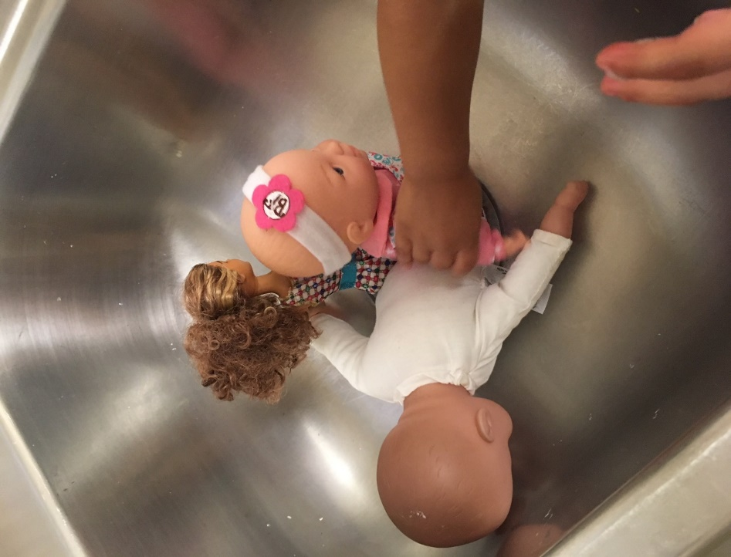
3

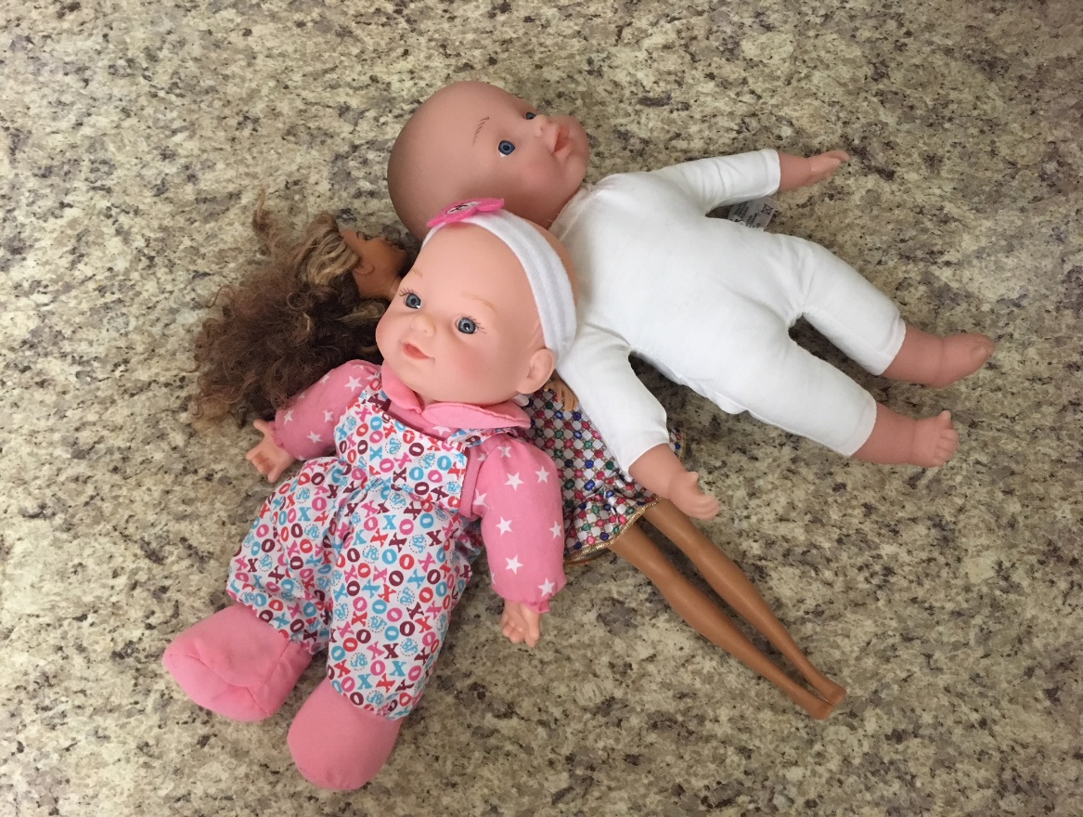
Stuck in the Sink! Answer Picture
4

