Comparing Lollipops
This lesson focuses on comparing sets and numerals using terms greater than, less than, and equal to. The main goal is for students to generate their own sets to compare to a given set.

NC Mathematics Standards:
Compare Numbers
NC.K.CC.6 Identify whether the number of objects, within 10, in one group is greater than,
less than, or equal to the number of objects in another group, by using matching and counting
strategies.

NC.K.CC.7 Compare two numbers, within 10, presented as written numerals.

Standards for Mathematical Practice:
1. Make sense of problems and persevere in solving them
2. Reason abstractly and quantitatively.
3. Construct viable arguments and critique the reasoning of others.
7. Look for and make use of structure

Student Outcomes:
- I can compare the quantity in one set (within 10) to the quantity in another set using greater than, less than, or equal to.
- I can compare two numerals (within 10) using greater than, less than, or equal to.
- I can create my own set to compare to a given set.

Math Language:

- Greater than
- Less than
- Equal to / same amount as
- Compare

Materials:
- Lollipops Picture (p. 5)
- Question #1 (p. 5)
- Question #2 (p. 5)
- Student math journals for recording thinking
- Familiar manipulatives (e.g. cubes, bears, chips), at least 10 per student

Advance Preparation:
- Print or be prepared to project the “Comparing Lollipops” Task.
- Have manipulatives available for easy distribution.

Launch: (Prior to this lesson, students have had opportunities to compare two sets of objects. The goal of this lesson is to generate their own sets to compare to the given set.)
- Launch Part I:
- Ask: Do you like lollipops? What is your favorite flavor?
- Students share with a partner. Allow a few students to share with the class.
- Display Lollipop Picture.
- Ask: What do you notice? What do you wonder? Allow a few students to share.
NOTE: Ensure students noticed the amount of lollipops shown in each set.
- Display the first question (Q1): Ashley has 4 lollipops and Amber has 6 lollipops. Which person has the greater amount of lollipops?
- Give students time to think through this question; carpet buddies will do a quick “solve and share”. As students work, teacher observes and decides which students will share.
- Discuss solutions.
- Launch Part II:
- Say: Now that we know who has more, let’s solve the next question.
- Display the second question (Q2): How many could Sam have if he has less than Amber?
- Allow for think time. Ask: What is this problem asking? Share with your carpet buddy.
- Draw students’ attention to available tools at the table (e.g., manipulatives, journals, paper, pencils). Send students to their seats to independently grapple with the task using self-selected tools.

Explore:
- Allow 7-10 minutes for students to explore various solutions to the task. This exploration time is useful for observing and collecting formative data on students’ current level of understanding. If students are productively grappling, walk around asking questions to elicit thinking (see chart). If the class shows unproductive frustration, pull students back together. Redirect the entire class by asking questions to elicit thinking.

Observation | Questions to Ask
Student does not know  where to begin. | Refocus student on the task:  - What do you know?  - What is the question asking?
Student confuses greater  than/less than. | - What do you think greater means?  - Say: Think back to Question 1. Who had a greater amount of lollipops? What did greater mean? So if greater means more, what do you think less means?
Student builds sets with objects and directly compares them.  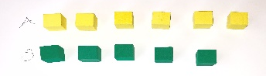 | - How do you know your set is less?  - Are there any other solutions that are also correct?  - Would you still be able to solve this problem if there weren’t any objects in front of you?
Student writes numerals and compares the numerals.  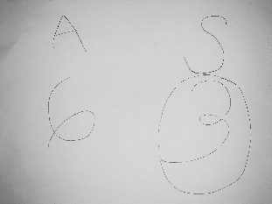 | - How do you know your solution is correct?  - How can you prove this?  - How many other solutions can you find?
Students quickly and correctly find a/all correct response(s). | Provide extension questions:  - Can you explain to me how you found your answer?  - How many lollipops could Sam have if he had more than Amber? Are there other possible answers?  - Now that you have compared the numbers, how many would you have if you put together Amber and Ashley’s lollipops?

- As students work, select a few to share their solutions during the “Discuss” section of the lesson. Determine sequence in which students will share (e.g., justifications for knowing one solution from least to most sophisticated).

Discuss:
- Bring students together on the carpet. Students should bring their written work.
  - Call students’ attention to the Lollipop Picture.
  - Say: _________, will you remind us of the question we are answering?
- Have pre-selected students to share their combinations.
  - As each student shares, direct attention to the set that they have created.
  - Ask Sharing Student: How many is in the set that you created?
  - Ask a Classmate: Do you agree with the amount in the set that ______ created? How did you count the set? (This can tie in conceptual subitizing)
  - Highlight vocabulary: As you solved, you found how many Sam could have if he has less than Amber. What does less than mean?
  - Ask: What strategy did you use to find a number less than 6? (Sample strategies: matching objects from each set, drawings pictures, comparing numerals, etc.)
  - Be sure to call on a student who wrote and compared numerals as this is the most difficult for students because it is a new skill.
- Say: Through today’s task we found there is more than one correct response. When finding the numbers that are less than 6 we have to find numbers that are smaller in value. As we shared our strategies we found all possible numbers that are less than 6. I’m very proud of your perseverance today as you worked together to find all the solutions.

Evaluation of Student Understanding:
Informal Evaluation:
- How many correct responses were students able to find on their own?
- What strategies are students using to find numbers less than 6?
  - Direct modeling with objects
  - Direct modeling with drawings
  - Counting strategies (mental math while keeping track on fingers)
  - Matching, one-to-one, with objects
  - Comparing written numerals

Meeting the Needs of the Range of Learners:
Interventions:
- Pair struggling students up to collaborate on solving the problem.
- Intensive students provide only one correct solution to the problem and explain their thinking.

Extensions:
- Challenge students to find more than one solution and explain their thinking.
- Encourage students to solve the problem in another way.
- Ask students to compare the lollipops by color (Example: How many more red lollipops does Ashley have than Amber has blue lollipops?)

Lollipops Picture
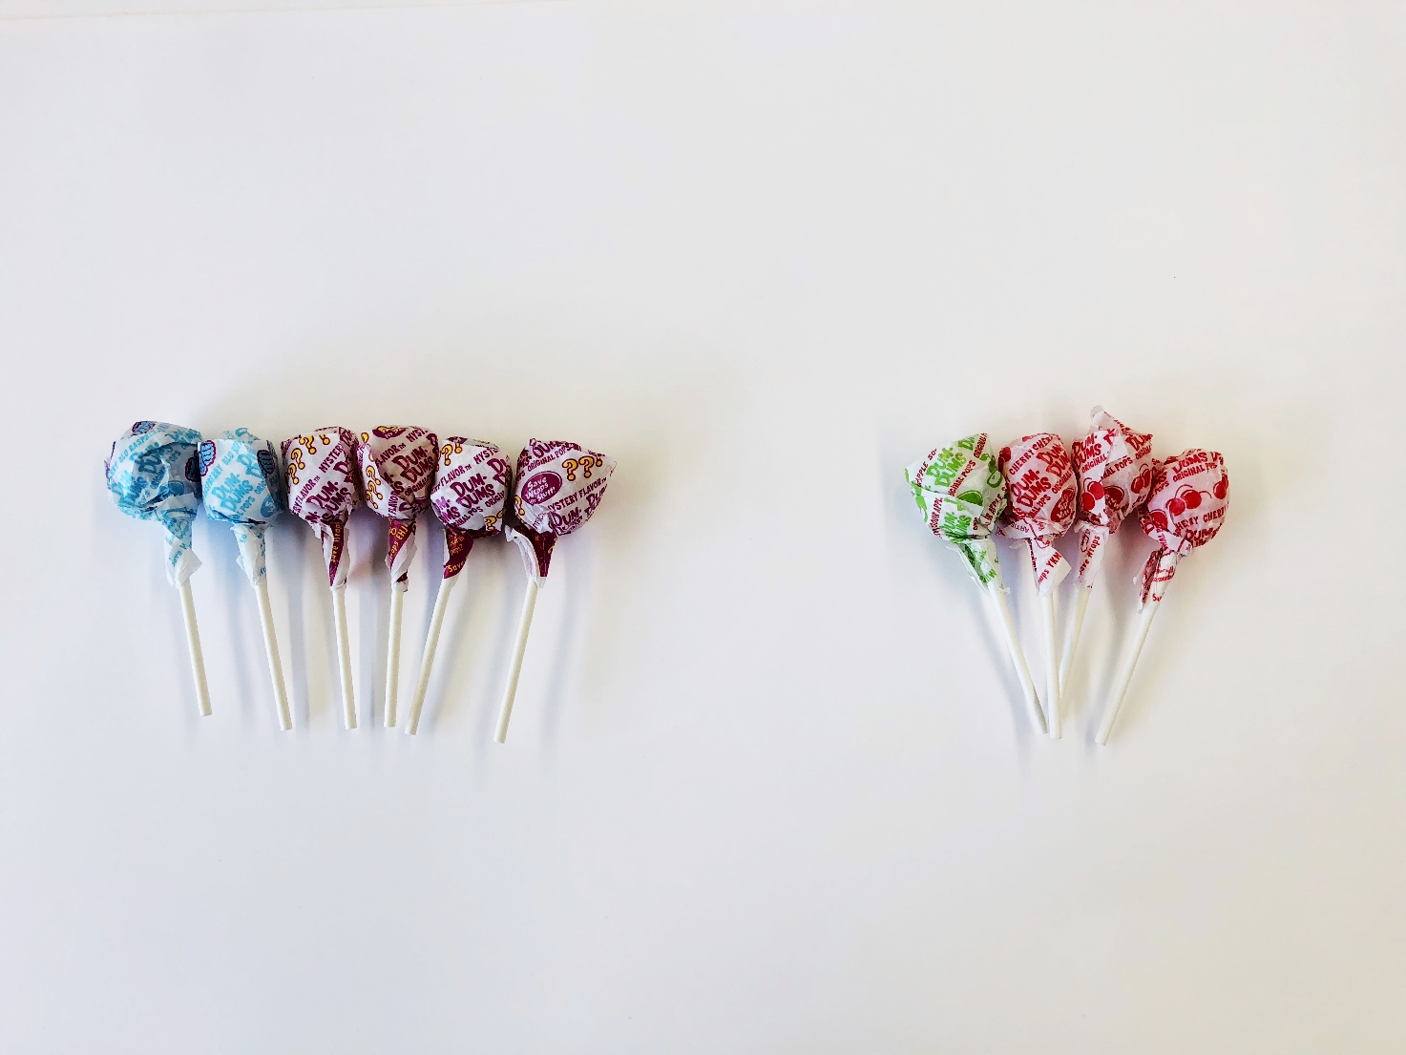

Q1: Ashley has 4 lollipops. Amber has
6 lollipops. Which person has the greater amount of lollipops?

Q2: How many lollipops could Sam
have if he has less than Amber?

