Birds on the Tree
In this lesson, students solve word problems involving addition.

NC Mathematics Standard(s):
Understand addition and subtraction.
NC.K.OA.1 Represent addition and subtraction, within 10:
• Use a variety of representations such as objects, fingers, mental images, drawings, sounds, acting out situations, verbal explanations, or expressions.
• Demonstrate understanding of addition and subtraction by making connections among representations.

NC.K.OA.2 Solve addition and subtraction word problems, within 10, using objects or drawings to represent the problem, when solving:
- Add to/Take From-Result Unknown
- Put Together/ Take Apart (Total Unknown and Two Addends Unknown)

Additional Supporting Standard(s)
NC.K.OA.5 Demonstrate fluency with addition and subtraction within 5.

Count to tell the number of objects.
NC.K.CC.5 Count to answer “How many?” in the following situations:
- Given a number from 1–20, count out that many objects.
- Given up to 20 objects, name the next successive number when an object is added, recognizing the quantity is one more/greater.
- Given 20 objects arranged in a line, a rectangular array, and a circle, identify how many.
- Given 10 objects in a scattered arrangement, identify how many

Standards for Mathematical Practice:
- Make Sense and Persevering while Solving Problems
- Reason Abstractly and Quantitatively
5. Use Appropriate Tools Strategically
8. Look for and Express Regularity in Repeated Reasoning

Student Outcomes:
- I can use strategies to show my work for a word problem.
- I can solve a word problem.

Math Language:
What words or phrases do I expect students to talk about during this lesson?
join, more, fewer

Materials:
- Whole class: number cards, counters, ten frame
- Station 1: number cards (0-5), counters, ten frame
- Station 2: number cards (0-9), counters or cubes
- Station 3: pom-poms, hoops
- Station 4: cubes
- Station 5: paper plate with a line drawn down the center, counters

Advance Preparation:
- Gather Materials

- Launch:
Cats on the Grass (5-7 minutes)
As a whole class, pull a number card (0-5) and use it in as your start number in your problem. Tell the following story to the class.
There were --- cats on the grass. 1 more cat came. How many cats are there now?

Show a Ten Frame to the students and say:
Let’s use a Ten Frame to help us.

The teacher should say:
cats were sitting on the grass. Who can put counters on the five frame to show the cats?

So, some more cats came. Do we know how many cats came?
Who can show that with counters?
How can we find out how many cats we have now?

Ask students to share their strategies.
As students give their strategies, it is acceptable to allow many students to share their strategies, even if they are the same.

After asking students to share strategies, ask students to share their solution. Again, it is acceptable for many students to share their solution.
The teacher might say: How many cats walked there? Does anyone have a different solution?

Regardless of the solution, the teacher should not lead students to think whether their solution is correct or incorrect.
The teacher then asks students: How can we solve this problem?
Possible responses:
I counted the counters.
I knew that __ and 1 is .
I started at ___ and counted one more in my head to get .

The teacher finishes the problem by placing -- counters of a different color on the Five Frame.
How can we use counters to help us solve this problem?

- Explore and Discuss:
Adding with the Five Frame (10-12 minutes)
Give each student a Five Frame and counters.
Pull a number card and use that number as the start number in your problem. Tell the story:
There are -- dogs in the park. 1 more dog ran there. How many dogs are there now?
Students will use the counters and Five Frame to solve the problem.

The teacher will ask students to share their solution and strategies. Possible responses:
I knew that -- and 1 is .
I started at -- and counted one more in my head to get --- .

Continue this with 2-3 more examples. The teacher should keep asking students questions to check for understanding.

- Additional Activities

Centers Activities (30-35 minutes)
Students will spend the remainder of the lesson in independent work stations practicing concepts related to joining and number sense. The teacher’s role is to scaffold and extend students’ learning by interacting with students at each of the stations.
These stations are intended to focus on combinations of 3, 4, and 5 only. Each day a student should only be working on combinations of either 3, 4, or 5. This is determined by the teacher or the student.
Here is an overview of the five stations: Station 1: One or Two More Animals
Students will select a number card (0-5) and use that number as the start number in their story problem. Students make that number using counters. From the start number, students will determine how many there will be if there will be one more animal came. Students can also find “two more” if they need enrichment. No recording is needed at this station. Students continue to select different number cards.

Station 2: Make the set
Students pull a number card (0-9) and use counters to make a set that matches the number. For an extension, students can see if they can figure out what 1 more is mentally.

Station 3: Pom-pom Toss
Students will toss pom-poms at a hoop on the floor. Students will count how many landed inside the hoop and how many landed outside the hoop. Students record their solutions on the sheet.

Station 4: Snap It
Students make a tower of cubes and place it behind their back. While their tower is behind their back, they snap it and bring one part of the tower in front so they can see it. Students determine how many cubes are still behind their back. They check their solution and record their results.

Station 5: Walk the line
Students will spill beans or counters onto a paper plate that has a line drawn down the center. Students will count the number of counters on the left and on the right and record their results.

Evaluation of Student Understanding
Informal Evaluation:
At Stations 1 and 2:
Do students accurately place the correct number of counters out? Are students able to join two sets and correctly identify the total?

At Station 3:
What strategies are students using to determine one more?
Do they count on mentally? Do they add a counter and count all of the counters?

At Stations 4-5:
Can students accurately determine the various parts and the whole while working?
What strategies are students using to determine the various parts? (e.g., counting all, counting on, fluently identifying parts)

Formal Evaluation/Exit Ticket:
If you would like a formal evaluation you may pose the following task to students:
There are 4 rabbits in the grass. One more rabbit arrives. How many cats are there now? Use manipulatives to show your work.

Meeting the Needs of the Range of Learners
Intervention: If students are struggling, have students only work with the numbers 3 or 4 in work stations. If students are struggling with the whole class activity, only use the numbers 1, 2, and 3 as your start number until students demonstrate an understanding of the process of finding 1 more.

Extension: The teacher may increase the number of objects at each station.
For the whole class activity, these tasks can be done by using number cards (0-9) and a ten frame. The focus is still adding a counter and finding what number is 1 more than the start number.

Possible Misconceptions/Suggestions:
Possible Misconceptions | Suggestions
Students may struggle with counting objects. | Provide students with a number line that they can place objects on to help them determine how many objects there are.
Students may struggle independently with the center activities. | Consider teaching the center activities as a whole class or in small groups and giving students the opportunity to complete a few rounds before doing them independently or with partners.

Picture Cards 0-5
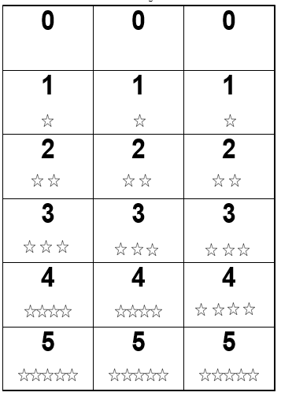

Ten Frame

Ten Frame

10

Primary Number Cards Page 1 of 2
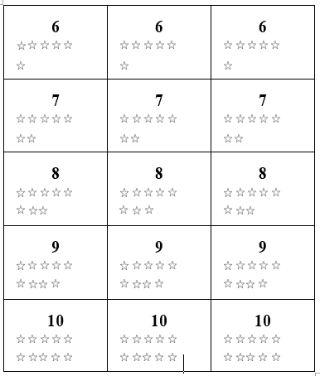

Snap It!
I started with cubes.

Cubes I see | Cubes hidden

Walk the Line I started with __ beans.

Beans on the left | Beans on the right

Pom Pom Toss I threw pom poms.

Pom Poms Inside | Pom Poms Outside

