Ducks on the Pond
In this lesson, students will use manipulatives to solve addition problems within 10 that involve putting together two groups of objects.

NC Mathematics Standard(s):
Understand addition and subtraction.
NC.K.OA.1 Represent addition and subtraction, within 10:
- Use a variety of representations such as objects, fingers, mental images, drawings, sounds, acting out situations, verbal explanations, or expressions.
- Demonstrate understanding of addition and subtraction by making connections among representations.

NC.K.OA.2 Solve addition and subtraction word problems, within 10, using objects or drawings to represent the problem, when solving:
- Add to/Take From-Result Unknown
- Put Together/ Take Apart (Total Unknown and Two Addends Unknown)

Additional Supporting Standard(s)
NC.K.OA.5 Demonstrate fluency with addition and subtraction within 5.

Count to tell the number of objects.
NC.K.CC.5 Count to answer “How many?” in the following situations:
- Given a number from 1–20, count out that many objects.
- Given up to 20 objects, name the next successive number when an object is added, recognizing the quantity is one more/greater.
- Given 20 objects arranged in a line, a rectangular array, and a circle, identify how many.
- Given 10 objects in a scattered arrangement, identify how many

Standards for Mathematical Practice:
- Make Sense and Persevering while Solving Problems
- Reason Abstractly and Quantitatively
- Use Appropriate Tools Strategically
- Look for and Express Regularity in Repeated Reasoning

Student Outcomes:
- I can join two groups of objects.
- I can find the total quantity after joining two groups of objects.
- I can explain their process of joining two groups of objects to find the quantity.

Math Language:
What words or phrases do I expect students to talk about during this lesson?
- Count, join, put together
Materials:
- Whole class: work mat, counters, large story cards
- Station 1: number cards, counters, ten frame
- Station 2: small picture cards, number cubes (1-3), tree work mat, counters Station 3: picture cards, counters, work mat
- Station 4: cubes
- Station 5: paper plate with a line drawn down the center, counters
- Recording sheets for Stations 3, 4, and 5

Advance Preparation:
- Gather materials

Launch:
- Ducks on the Pond (3-5 minutes)
  - During whole group time, show Picture Card K to the entire class and model the activity.
  - The teacher asks students, “What do you see on the card?”
Possible responses: I see ducks. I see water.
- The teacher says: Let’s see if I can come up with a story problem for this picture for you to solve. There are 2 dark ducks and 1 white duck. How many ducks are on the water?
  - As students give their solutions, it is acceptable to allow many students to share their solution, even if they all say “3.”
  - The teacher may ask: How many ducks are in the water? Does anyone have a different solution?
  - Regardless of the solution, the teacher should not lead students to think whether their solution is correct or incorrect.
- The teacher then asks students: How can we find out how many ducks are in the water?
Possible responses:
  - We can count the number of ducks.
  - I know that 1 more than 2 is 3.
  - I know that 2 and 1 is 3.
  - I counted them all: 1, 2, 3.

Explore and Discuss:
- Ducks on the Pond (10-12 minutes)
  - Give each student a work mat and counters. Show Picture Card L to the entire class.
  - Have students recreate the picture using counters.
  - The teacher will make up a story to go with the picture card, using the same problem structure, such as:
    - There are 3 ducks on the water and 1 duck on the shore.
    - How many ducks are there in all?
  - The teacher then asks students: How can we find out how many ducks are on the water?
Possible responses:
    - We can count the number of ducks. I know that 1 more than 4 is 5.
    - I know that 1 and 4 is 5.
    - I counted all of them: 1, 2, 3, 4, 5
  - The teacher will repeat this process with Picture Card M. This time, the students will create a story to go with the picture cards. Consider giving students the sentence starter that you can display on the whiteboard or document camera- “There are ___ ducks on the shore. There are ___ ducks on the water. How many total ducks are there?”

Additional Activities (if needed)
- Center Activities (30-35 minutes)
Students will spend the remainder of the lesson in independent work stations practicing concepts related to joining and number sense. The teacher’s role is to scaffold and extend students’ learning by interacting with students at the stations.

These stations are intended to focus on combinations of 3, 4, and 5 only. Each day a student should only be working on combinations of either 3, 4, or 5. This is determined by the teacher or the student.

Here is an overview of the five stations:
  - Station 1: One or Two More Animals: Students will select a number card (0-5) and use that number as the start number in their story problem. Students make that number using counters. From the start number, students will determine how many there will be if there will be one more animal came. Students can also find “two more” if they need enrichment. No recording is needed at this station. Students continue to select different number cards.
  - Station 2: Adding to a Picture: Students will select a Picture Card and make the picture with counters. Students will roll a number cube marked 1, 2, and 3. Students will add that many counters to their picture. Students will determine how many total counters they have. No recording is needed at this station. Students continue to select different story cards.
  - Station 3: Ducks on a Pond: Students will select a Picture Card and create an Addition story about the ducks in the picture. Students will ask a question and count the ducks to solve the problem. No recording is needed at this station. Students continue to select different story cards.
  - Station 4: Snap It: Students make a tower of cubes and place it behind their back. While their tower is behind their back, they snap it and bring one part of the tower in front so they can see it. Students determine how many cubes are behind their back and record their results.
  - Station 5: Walk the line: Students will spill beans or counters onto a paper plate that has a line drawn down the center. Students will count the number of counters on the left and on the right and record their results.

Evaluation of Student Understanding
- Informal Evaluation: Ask students to explain how they set up and solve problems.

- Formal Evaluation/Exit Ticket: A formal evaluation of students’ performance can be done during the Follow-up Activities if desired. On the water there are 3 green ducks and 2 brown ducks. How many ducks are there?

Meeting the Needs of the Range of Learners
Intervention: For struggling students, only work with combinations to 3 and 4.
Extension: The number of objects at each station can be increased to provide more rigor.

Possible Misconceptions/Suggestions:
Possible Misconceptions | Suggestions
Students may struggle with counting objects. | Provide students with a number line that they can place objects on to help them determine how many objects there are.
Students may struggle independently with the center activities. | Consider teaching the center activities as a whole class or in small groups and giving students the opportunity to complete a few rounds before doing them independently or with partners.

Special Notes:
- Center activities can be repeated after this lesson. Feel free to substitute other activities related to number sense as well to reinforce previously taught concepts.

Picture Card K
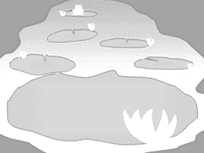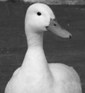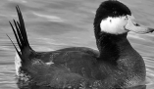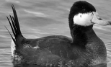

Picture Card L
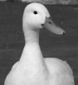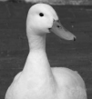

Picture Card M
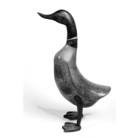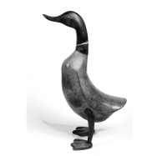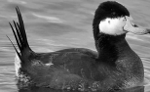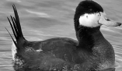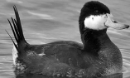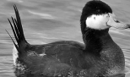

Picture Card N
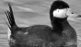
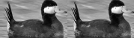
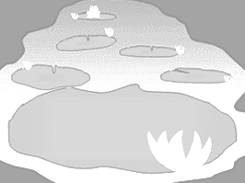

Picture Card O | Picture Card P
Picture Card Q | Picture Card R

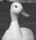
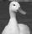
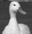
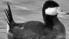

Picture Card | Picture Card T
Picture Card U | Picture Card V

Snap It!
I started with cubes.

Cubes I see | Cubes hidden

Walk the Line I started with __ beans.

Beans on the left | Beans on the right

