This rubric may be used with any of the succeeding tasks.
The teacher should select a task based on number range, as determined by pacing.

NC.K.OA.3
Decomposing Numbers
Domain | Operations and Algebraic Thinking
Cluster | Understand addition as putting together and adding to, and understand subtraction as taking apart and taking from.
Standard(s) | NC.K.OA.3 Decompose numbers less than or equal to 10 into pairs in more than one way using objects or drawings, and record each decomposition by a drawing or expression.
Materials | Manipulatives, pencil, SF  (Teacher selects a Student Form/task based on number range.)
Directions | - Provide materials to student(s). Read the problem aloud to student(s).  - Say: Show as many ways as you can. Show your thinking with objects, pictures or numbers.  - Prompt if needed: Can you show another way?

Continuum of Understanding

Not Yet Proficient | - Provides 0 possible pairs, even with prompting  - Unable to show a strategy for solving.
Progressing | - Provides only 1 possible pair, even with prompting.  - Provides 1 or more possible pairs that are incorrect.  - A correct pair is provided, but has difficulty explaining the strategy used to solve
Meets Expectations | - Correctly shows, states, or draws two or more combinations.  - Uses pictures, numbers, or words to explain the strategy used to find the parts.

Standards for Mathematical Practice
1. Makes sense and perseveres in solving problems.
2. Reasons abstractly and quantitatively.
3. Constructs viable arguments and critiques the reasoning of others.
4. Models with mathematics.
5. Uses appropriate tools strategically.
6. Attends to precision.
7. Looks for and makes use of structure.
8. Looks for and expresses regularity in repeated reasoning.

Scoring Examples

Problem: There were 10 animals on the farm. Some of the animals were horses and some of the animals were chickens. How many horses and chickens are on the farm?

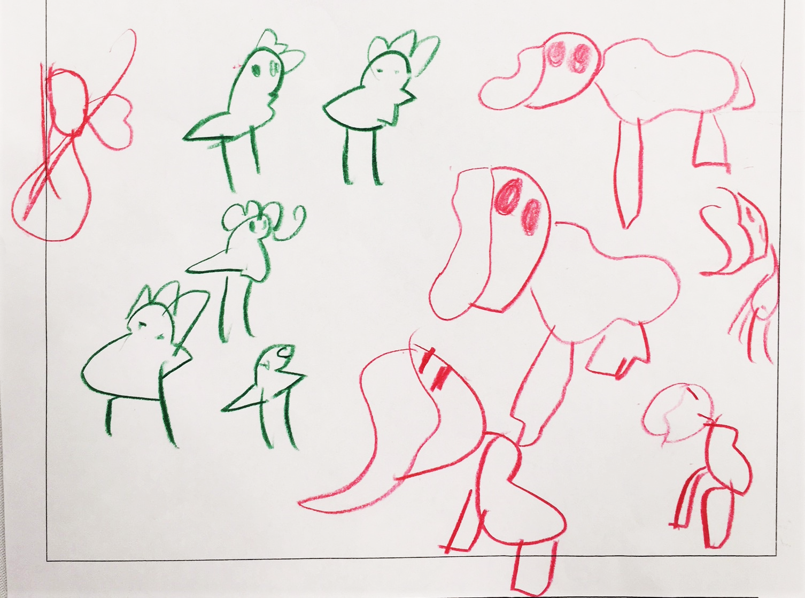
Not Yet Proficient: Student created a set of horses and a set of chickens. He was unable to make the sets total ten, even with prompting.

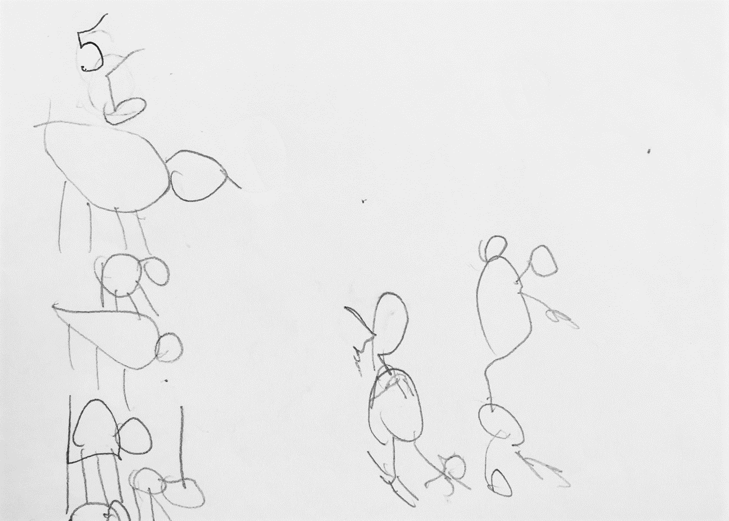
Progressing: The student was able to represent the problem using one combination of horses and chickens. Student said she knew that five and five makes ten. However, she was unable to recognize other combinations of ten.

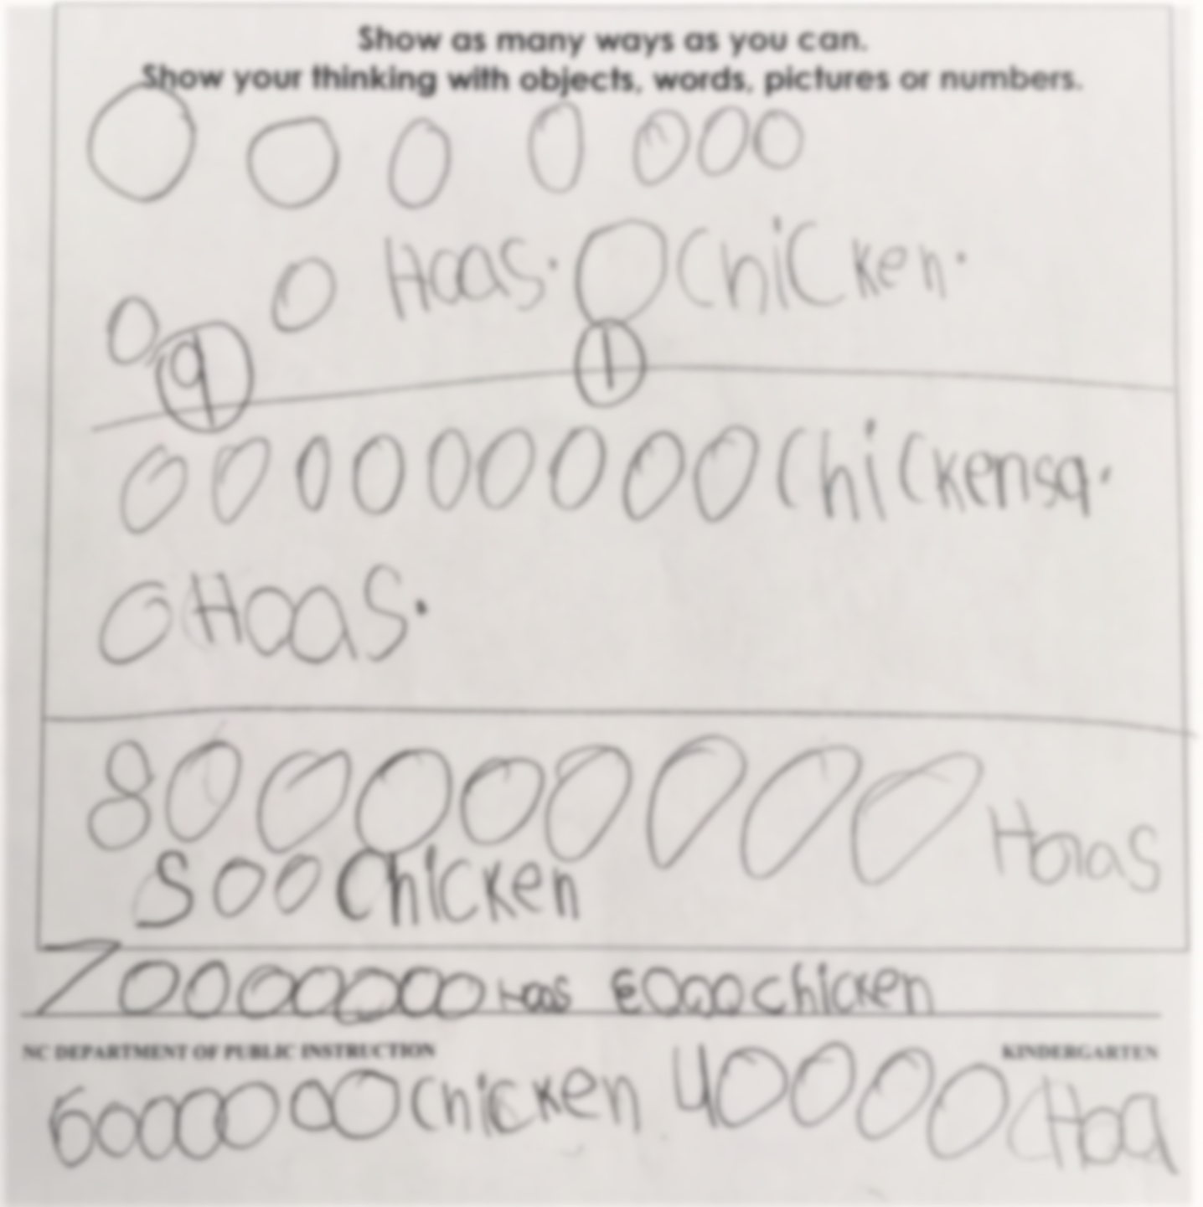
Meets Expectation: The student strategically found multiple combinations to correctly solve the problem. He used pictures to solve, and labeled with numbers. Upon questioning, student stated, “I started with 9 horses and 1 chicken. Then, I made 1 horse and 9 chickens. Then, I made 8 horses and 2 chickens, 7 horses and 3 chickens, and 6 chickens and 4 horses.”

There were 3 pieces of fruit in the basket. Some were bananas and some were oranges. How many bananas and oranges are in the basket?
Show as many ways as you can.
Show your thinking with objects, words, pictures or numbers.

There were 4 leaves on the ground. Some of the leaves were red and some of the leaves were yellow. How many red and yellow leaves are on the ground?

Show as many ways as you can.
Show your thinking with objects, words, pictures or numbers.

There are 5 cats in the yard. Some of the cats are orange and some of the cats are black. How many orange and black cats are in the yard?

Show as many ways as you can.
Show your thinking with objects, words, pictures or numbers.

There were 6 cars in the parking lot. Some of the cars were blue and some of the cars were white. How many blue and white cars are in the parking lot?

Show as many ways as you can.
Show your thinking with objects, words, pictures or numbers.

A snowman has 7 buttons. Some of the buttons are black and some of the buttons are red. How many black and red buttons does the snowman have?
Show as many ways as you can.
Show your thinking with objects, words, pictures or numbers.

There are 8 grapes in the bowl. Some of the grapes are green and some of the grapes are purple. How many green and purple grapes are in the bowl?

Show as many ways as you can.
Show your thinking with objects, words, pictures or numbers.

There are 9 candies in the bowl. Some of the candies are yellow and some of the candies are green. How many yellow and green candies are in the bowl?

Show as many ways as you can.
Show your thinking with objects, words, pictures or numbers.

There were 10 animals on the farm. Some of the animals were horses and some of the animals were chickens. How many horses and chickens are on the farm?

Show as many ways as you can.
Show your thinking with objects, words, pictures or numbers.

There were 10 children at the park. Some were boys and some were girls. How many girls and boys are at the park?

Show as many ways as you can.
Show your thinking with objects, words, pictures or numbers.

