The intended purpose of this document is to provide teachers with a tool to determine student understanding and suggest instructional moves that may help guide a student forward in their learning of a concept or standard. This guide is not an exhaustive list of strategies.
Third Grade: Cluster 1
Operations and Algebraic Thinking
Equal Groups
NC.3.OA.1 For products of whole numbers with two factors up to and including 10:
- Interpret the factors as representing the number of equal groups and the number of objects in each group.
- Illustrate and explain strategies including arrays, repeated addition, decomposing a factor, and applying the commutative and associative properties
NC.3OA.3 Represent, interpret, and solve one-step problems involving multiplication and division.
- Solve multiplication word problems with factors up to and including 10. Represent the problem using arrays, pictures, and/or equations with a symbol for the unknown number to represent the problem.
- Solve division word problems with a divisor and quotient up to and including 10. Represent the problem using arrays, pictures, repeated subtraction and/or equations with a symbol for the unknown number to represent the problem.
Not Yet  Not Yet  (continued)  Not Yet  (continued) | Students that are consistently scoring “Not Yet” on equal groups and foundations of multiplication/division tasks could have a variety of errors. These errors may include confusion about the number of equal groups or the size of equal groups. Students may also demonstrate struggle solving tasks using repeated addition, or may struggle identifying differences between operations, including multiplication and division.
Next Steps:
For students having trouble with understanding of equal groups:
- Support students use of vocabulary by allowing students to communicate about strategies and representations. Words to focus on include but are not limited to: equal, groups, repeated addition, products, factors, illustrations, arrays, decompose divisor, quotient. An anchor chart and sentence starters have potential to support students’ work with the key vocabulary terms.
- Pose tasks in context that provide opportunities to model and represent multiplication in various ways. Use smaller numbers at first to make modeling with manipulatives more possible.
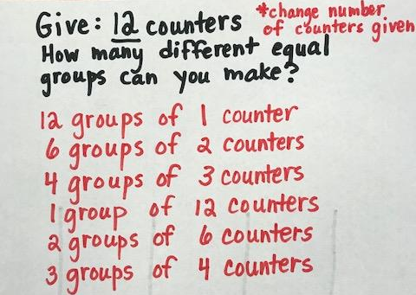
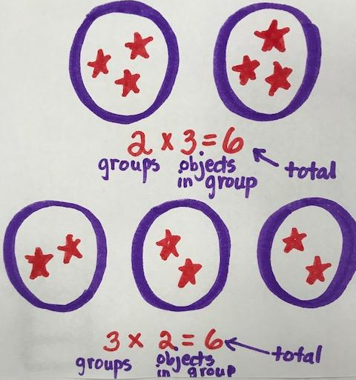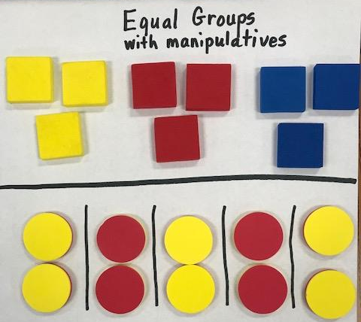
- Pose tasks that involve skip counting by 2, 5, 10, which students have worked with in previous grades. Connect skip counting to multiplication during discussions.
- Pose tasks that allow students to explore various ways to make equal groups for a set number of objects (see picture to the right).
- Ask students to find, draw, and discuss examples of equal groups in the environment (fingers on a hands, wheels on a bike, cans of soda).
- Read aloud the book, Each Orange Had Eight Slices by Paul Giganti Jr. Stop at each situation and have students model the equal groups. This is a great way for students to conceptually understand equal groups.
- Groups of Things Lesson

For students having trouble interpreting factors as representing the number of equal groups and number of objects in each group. :
- Provide opportunities and supports for students to use vocabulary (factor, product, equal groups) while exploring tasks that involve skip counting, repeated addition, or models of multiplication.
- Support conversations about connections between a picture of equal groups or arrays with repeated addition.

XX
XX
XX
XX
2 + 2 + 2 + 2

- Provide opportunities for students to represent equal groups in multiple ways including with numbers, words, drawing pictures and using objects. Have students share their thinking and how the different ways are related.
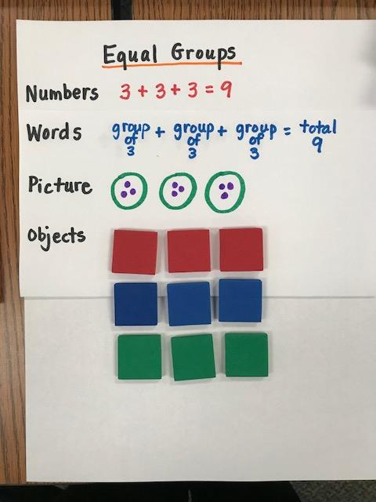
- Card Activity: Students will be given a deck of cards (with numbers 1-6) or dice. Students turn over the first card or roll. This first card represents the number of groups. The student draws that many groups. Student turns over another card or rolls again. Student draws that many triangles in the group. Student then creates a repeated addition sentence and a multiplication sentence for the picture.
For students having difficulty with arrays:
- Provide opportunities for students to represent tasks by building arrays with manipulatives or graph paper. Discuss with students the connections between arrays and the related multiplication equations.
- Have students look for real life examples of arrays (egg carton, panes on a window, pack of soda)
- Provide opportunities to draw and/or make arrays and relate it to a multiplication problem using precise vocabulary. When creating these arrays with students emphasize rows of and columns of so that they understand how the picture is different.
- Activity: Give each pair of students two different colored dice, counters, paper, and pencils. Have one student roll the die to show how many rows and then other student rolls the die for how many objects in each row. Students then build the corresponding array with counters and records the multiplication equation on paper.
- Seeing Arrays Lesson

For students having trouble with understanding the commutative and associative property:
- Provide opportunities for students to develop a sense of the commutative property by having them build models with manipulatives representing both addition and multiplication problems. Commutative 4+3=7 and 3+4=7 (same answer) 4x3=12 and 3x4=12 (same answer). Multiplication and addition operate in the commutative property similarly. You can change the order of the addends and you get the same answer (sum). In multiplication you can change the order of the factors and you get the same answer (product).
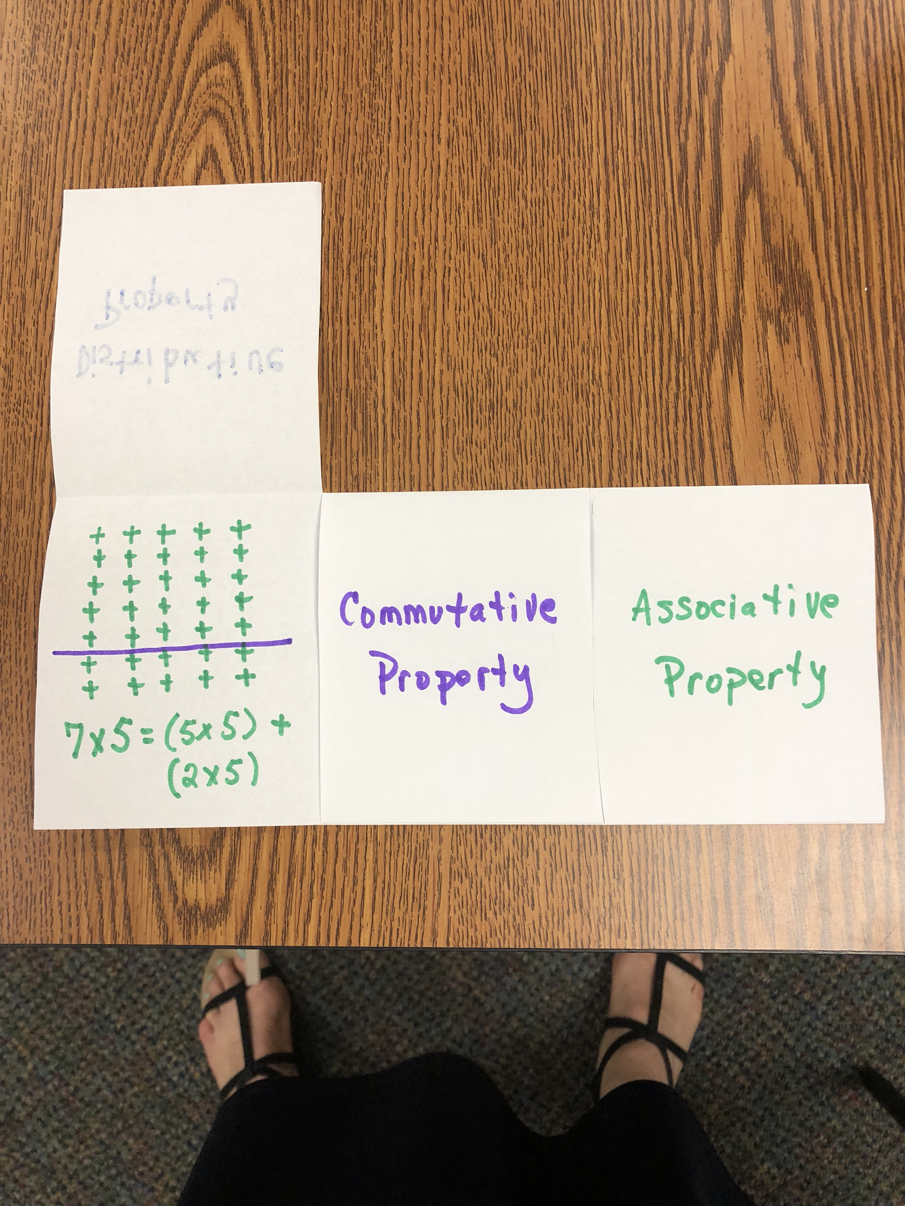
- Provide opportunities for students to develop a sense of the associative property by having them build models with manipulatives representing both addition and multiplication problems. Examples: (4+3)+2=9 and 4+(3+2)=9 and (2x3)x2=12 and 2x(3x2)=12. You can regroup numbers in both addition problems and multiplication problems and get the same answer. Discuss that this is another way that addition and multiplication are related.
- Have students make connections between properties and models. Example pictured to the right is a flip book. Students create a folded book to show what they know about each of the properties and then can use it later as a reference as the properties are revisited with different fact sets.

For students having difficulty with equal group word problems:
- Encourage students to read the problem and retell it in their own words. Have students talk about, “What the problem is asking?” “What do we need to find out?” “How can we represent this problem with a picture?”
- Encourage students to use manipulatives to represent the problem by making an array, picture and/or equation with a symbol for the unknown number to represent the problem.

Progressing | Students that are consistently scoring “Progressing” may still have confusion interpreting the factors as representing the number of equal groups and the number of objects in each group. They may not understand the vocabulary that represents the illustrations and equations. Students may struggle with the meaning of the commutative and associative properties. They may have trouble choosing a strategy to help them solve a one-step word problem. Also, students may not be able to decide whether to use multiplication or division to solve the problem.
Next Steps:
For students still struggling with an understanding of equal groups:
- Provide tasks where students need to draw or make equal groups with manipulatives. Use the vocabulary crucial for understanding the standard. Engage students in creating their own visual definition for equal groups, repeated addition, products, factors, illustrations, arrays, decompose, divisor, and quotient.
- Use hands-on manipulatives with a variety of different numbers and have students write along with their picture or illustration. ____ groups of _____ equals _______. Be sure to link the equation to the model or picture.
- Pose tasks with real-life examples of equal groups in class (e.g., ways desks are arranged, partner work) and in the world (5 pieces of gum in a pack, 6 sodas in a drink pack, 12 eggs in a cartoon, etc.).
- Give non-examples of equal groups and have students explain why they are not equal groups. Students should be able to explain that multiplication and division rely on having groups that have equal sizes or the same number of objects in each group.

For students still struggling with interpreting factors representing the number of equal groups and the number of objects in each group:
- Provide opportunities for students to focus on vocabulary and how a multiplication task relates to a model, picture, and an equation
- Encourage students to represent tasks with manipulatives and/or pictures as well as equations that include repeated addition or multiplication.

For students still struggling with the concept of arrays:
- Provide opportunities for students to represent tasks by building arrays with manipulatives or graph paper. Discuss with students the connections between arrays and the related multiplication equations.
- Provide opportunities to draw and/or make arrays and relate it to a multiplication problem using precise vocabulary. When creating these arrays with students emphasize rows of and columns of so that they understand how the picture is different.
- Activity: Give each pair of students two different colored dice, counters, paper, and pencils. Have one student roll the die to show how many rows and then other student rolls the die for how many objects in each row. Students then build the corresponding array with counters and records the multiplication equation on paper.
- Seeing Arrays Lesson

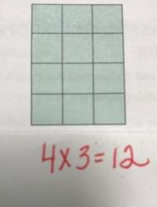
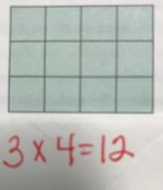
For students still struggling with an understanding of commutative and associative properties:
- Pose number talks that provide opportunities for students to reason through ways to use the commutative and associative properties to multiply.
- Activity for commutative property: Distribute grid paper to students. Students draw an array, cut it out, and record both multiplication equations on the back (rows x columns = total AND columns x rows = total). After cards are made students can look at the arrays and think of the two equations that match the array.
- Activity for associative property: Pose tasks with three factors and have students explore different ways to find the product.
Examples:
6 x 2 x 5 =
5 x 5 x 2 =
3 x 6 x 10 =
2 x 7 x 2 =

For students having difficulty with equal group word problems:
- Encourage students to read the problem and retell it in their own words. Have students talk about, “What the problem is asking?”, “What do we need to find out?”, and “How can we represent this problem with a picture?”
- Encourage students to use manipulatives to represent the problem by making an array, picture and/or equation with a symbol for the unknown number to represent the problem.
- Provide opportunities for students to write word problems for a given equation. Example: Write a story problem that matches 5 x 4 = __.

Meets Expectation | Students that are consistently scoring “Meets Expectation” have a good understanding of equal groups. They have a strong understanding of how addition and multiplication are related. They understand the vocabulary used with equations and illustrations. They can explain the differences in the commutative and associative properties in both addition and multiplication. They can represent, interpret, and solve one-step multiplication and division word problems. They are beginning to be fluent with multiplication without having to draw a picture or use manipulatives.
Next Steps:
- Ask students to select an array picture card and write:
* an equal group story problem that matches the image
OR
* an equal group division problem that matches the image
If students can successfully write a story problem that represents equal grouping situations and consistently solve equal group problems using the strategies listed in 3.OA.1 and 3.OA.3, they have a good understanding of the standards in cluster one.

Array Picture

