Equal Group
(early in year)
or
Multiplication & Division
(later in year)
Family Math Night
Family Math Night

- Overview
  - Summary
  - Target Audience
  - Focus Area

- Preparation Packet
  - Preparation Checklist
  - Advertisement Flier or Letter

- Event Packet
  - Sign-In Sheet
  - Agenda and Materials Checklist
  - NC.3.OA.1 Center-Double Up!
  - NC.3.OA.2 Center-Murphy to Manteo
  - NC.3.OA.1 Center-Tic-Tac-Toe Array
  - NC.3.OA.3 Center-Find the Unknown Number
  - NC.3.OA.1 Center- No Leftovers Wanted
  - NC.3.OA.1, OA.7 Sakes Alive, Go For Fives!!!!!
  - NC.3.OA.2, OA.7 Center- Race to Resort
  - NC.3.OA.1, OA.7 Center- Whose Winning Products
  - NC.3.OA.1 & 2, OA. 7 & 8 Center-Out of this World Operations
  - NC.3.OA.1, OA.7 Center-Charlotte Speedway Race
  - NC.3.NBT.3 Center- Money Wheel
  - NC.3.NBT.3 Center- Race to 300
  - Parent Evaluation
Overview

Summary: Family Math Night is an opportunity for families to collaborate with their students using 3rd grade math objectives to solve real world problems. Families interact with the child’s teacher and other school staff, as well as receive resources to use at home with their student. This family night focuses on Multiplication and Division- content in Cluster 1 and Cluster 4. Prior to beginning, teachers may wish to print the parent letters from www.Tools4NCTeachers.com.

Target Audience: Third Grade Families

Focus:
Cluster 1
NC.3.OA.1 For products of whole numbers with two factors up to and including 10:
- Interpret the factors as representing the number of equal groups and the number of objects in each group.
- Illustrate and explain strategies including arrays, repeated addition, decomposing a factor, and applying the commutative and associative properties.

NC.3.OA.3 Represent, interpret, and solve one-step problems involving multiplication and division.
- Solve multiplication word problems with factors up to and including 10. Represent the problem using arrays, pictures, and/or equations with a symbol for the unknown number to represent the problem.
- Solve division word problems with a divisor and quotient up to and including 10. Represent the problem using arrays, pictures, repeated subtraction and/or equations with a symbol for the unknown number to represent the problem.

NC.3.OA.2 For whole-number quotients of whole numbers with a one-digit divisor and a one-digit quotient:
- Interpret the divisor and quotient in a division equation as representing the number of equal groups and the number of objects in each group.
- Illustrate and explain strategies including arrays, repeated addition or subtraction, and decomposing a factor.

NC.3.OA.9: Interpret patterns of multiplication on a hundreds board and/or multiplication table.

Cluster 4
NC.3.NBT.3 Use concrete and pictorial models, based on place value and the properties of operations, to find the product of a one-digit whole number by a multiple of 10 in the range 10–90.

NC.3.OA.1 For products of whole numbers with two factors up to and including 10:
● Interpret the factors as representing the number of equal groups and the number of objects in each group.
● Illustrate and explain strategies including arrays, repeated addition, decomposing a factor, and applying the commutative and associative properties.

NC.3.OA.2 For whole-number quotients of whole numbers with a one-digit divisor and a one-digit quotient:
● Interpret the divisor and quotient in a division equation as representing the number of equal groups and the number of objects in each group.
● Illustrate and explain strategies including arrays, repeated addition or subtraction, and decomposing a factor.

NC.3.OA.3 Represent, interpret, and solve one-step problems involving multiplication and division.
● Solve multiplication word problems with factors up to and including 10. Represent the problem using arrays, pictures, and/or equations with a symbol for the unknown number to represent the problem.
● Solve division word problems with a divisor and quotient up to and including 10. Represent the problem using arrays, pictures, repeated subtraction and/or equations with a symbol for the unknown number to represent the problem.

NC.3.OA.6 Solve an unknown-factor problem, by using division strategies and/or changing it to a multiplication problem.

NC.3.OA.7 Demonstrate fluency with multiplication and division with factors, quotients and divisors up to and including 10.
● Know from memory all products with factors up to and including 10.
● Illustrate and explain using the relationship between multiplication and division.
● Determine the unknown whole number in a multiplication or division equation relating three whole numbers.

NC.3.OA.8 Solve two-step word problems using addition, subtraction, and multiplication, representing problems using equations with a symbol for the unknown number.

NC.3.OA.9 Interpret patterns of multiplication on a hundreds board and/or multiplication table.

Preparation Checklist
- Print cluster family letters from www.Tools4NCTeachers.com.
- Send out invitations or flyers a few weeks prior to the event to families.
- Advertise on email, phone messages, or the marquee at school.
- Prepare and print a sign-in sheet.
- Print the directions for each center and gather necessary materials.
- Print and send a reminder before the day before the event.
- Write list of the equal groups centers on the board as well as where in the classroom each center is located.
- Consider displaying recent student work on current cluster for families to see.
- For each game, print the game and game cards on card stock and cut out game cards prior to use.

Join Us for Family Math Night
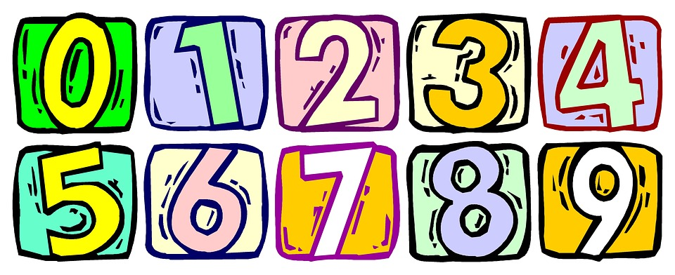

When: (Insert Date & Time Here)
Where: (Address Here)
Learn third grade math strategies while having a great time with your student. There will be special fun activities for you to learn with your child. We look forward to seeing you at this exciting educational event!

Join us for Family Math Night

When: (Insert Date & Time Here)
Where: (Address Here)

Learn third grade math strategies while having a great time with your student. There will be special fun activities for you to learn with your child. We look forward to seeing you at this exciting educational event!
Family Math Night Sign-In
Date:________________
Family Member(s) | Student Name

Family Math Night Agenda

As students and families drop in, hand out the parent letters and provide explanations for the centers listed on the board.

During the event, students will participate in the centers with their families in order to foster equal groups understanding of multiplication or to practice the concepts of multiplication and division. Teachers will choose from the following center activities as they prepare for the event, depending on where they are with their instruction of multiplication and division concepts. Some of these are certainly for later in the year while others can be used early in the third grade year. Suggested centers and materials are listed below:
- NC.3.OA.1 Center- Double Up!
Materials: Game board, spinner (paper clip, pencil), 8 different colored game markers – Note: The factors in this game go beyond the expectation for third grade. This can still be used for enrichment, and it may be beneficial to have manipulatives available for students to use with this game.
- NC.3.OA.2 Center- Murphy to Manteo
Materials: gameboard, a die, game marker
- NC.3.OA.1 Center- Tic-Tac-Toe Array
Materials: game board, piles of centimeter cubes (at least 20), 5 different color game makers, spinner (your choice)
- NC.3.OA.3, OA.6 Center- Find the Unknown Number
Materials: a recording sheet for each player, unknown number game cards
- NC.3.OA.1 Center- No Leftovers Wanted
Materials: game board, a die, spinner (pencil and paperclip), 21 color tiles, cubes, or counters
- NC.3.OA.1, OA.7 Sakes Alive, Go For Fives!!
Materials: Game board, pair of dice, 20 game markers (different colors for each player)
- NC.3.OA.2, OA.7 Center- Race to Resort
Materials: A die, game board, game markers (different color for each player)
- NC.3.OA.1, OA.7 Center- Whose Winning Products
Materials: game board for each player, spinner (pencil, paper clip), 25 game markers for each player
- NC.3.OA.1, OA.2, OA.7, OA.8 Center-Out of this World Operations
Materials: Operation card per player, set of game cards
- NC.3.OA.1, OA.7 Center-Charlotte Speedway Race
Materials: game board, spinner (paper clip, pencil), game markers
- NC.3.NBT.3 Center- Money Wheel
Materials: spinners (pencil, paper clip), paper money (optional)
- NC.3.NBT.3 Center- Race to 300
Materials: a die, recording sheet

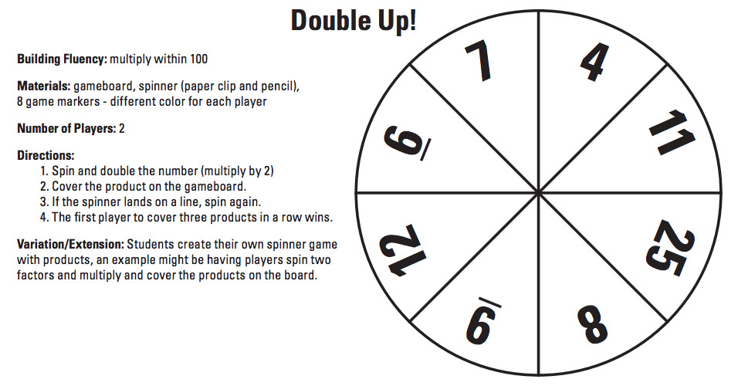
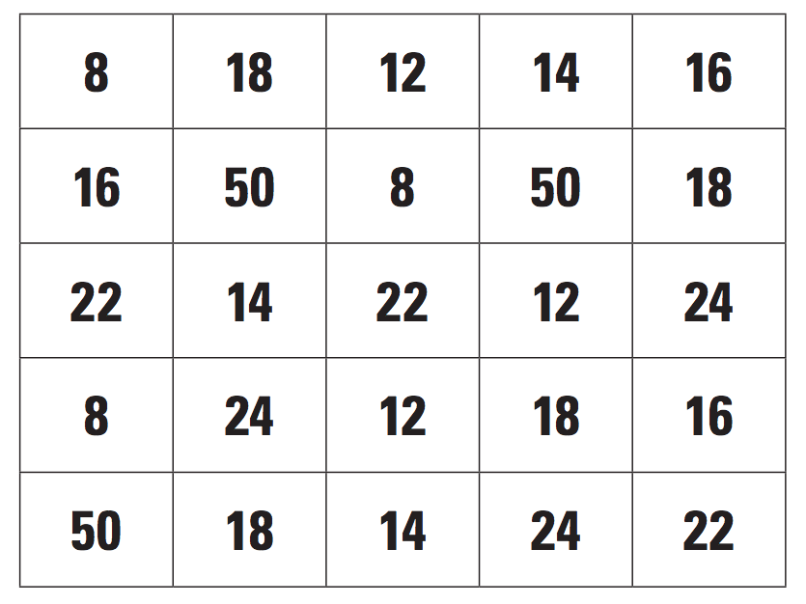

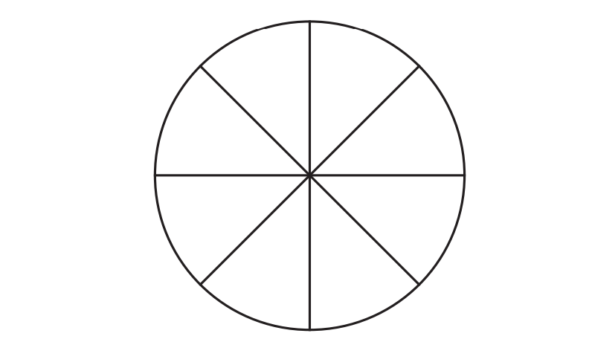

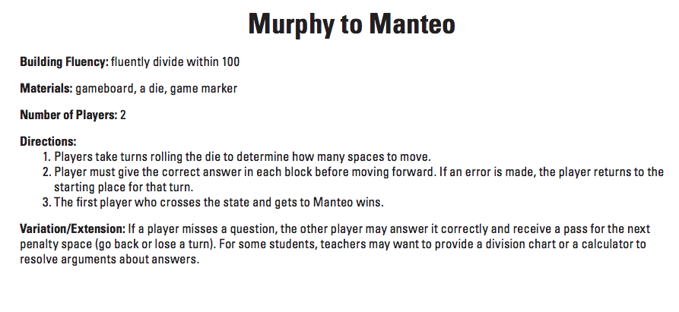
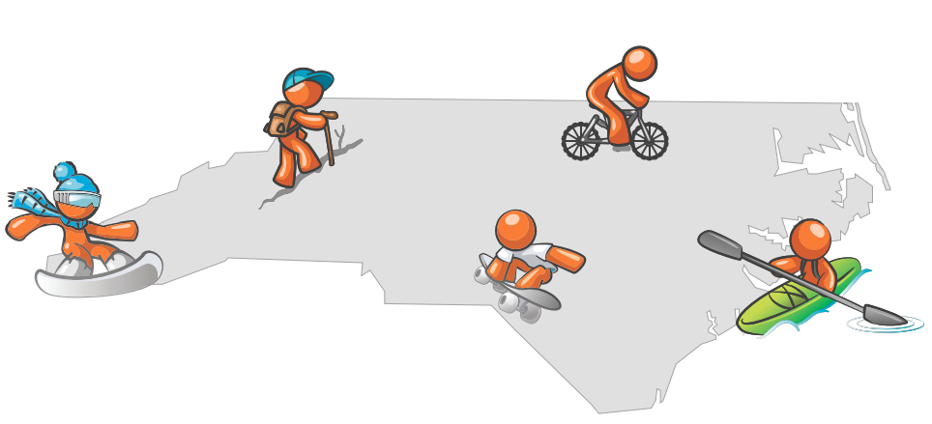

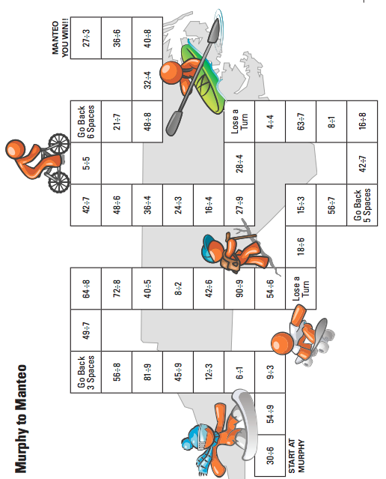

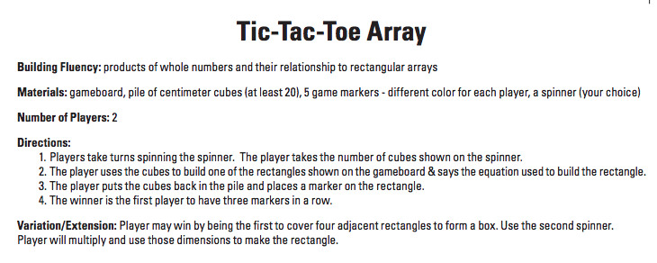
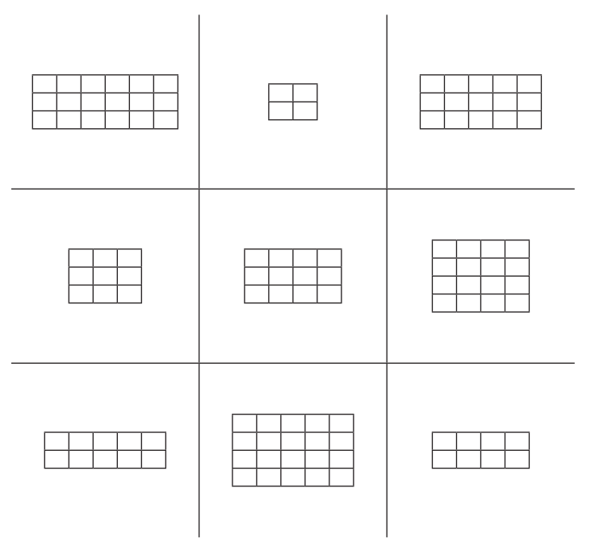
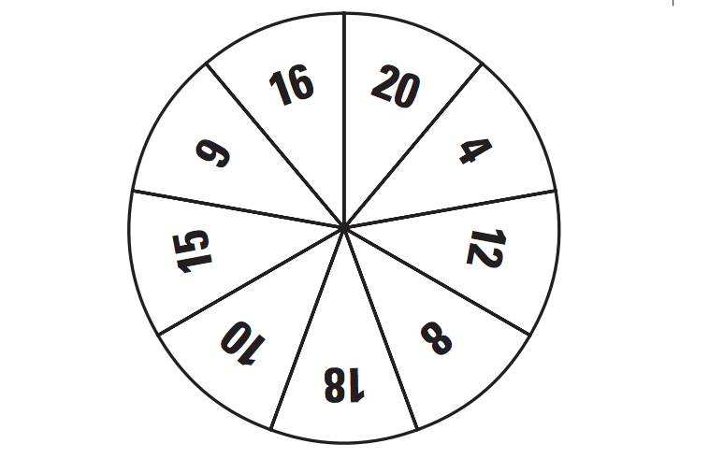
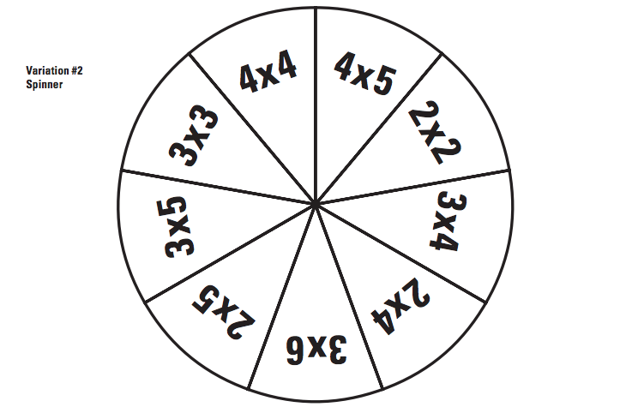
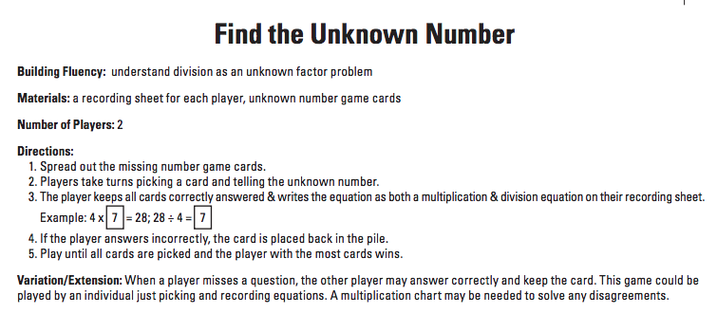

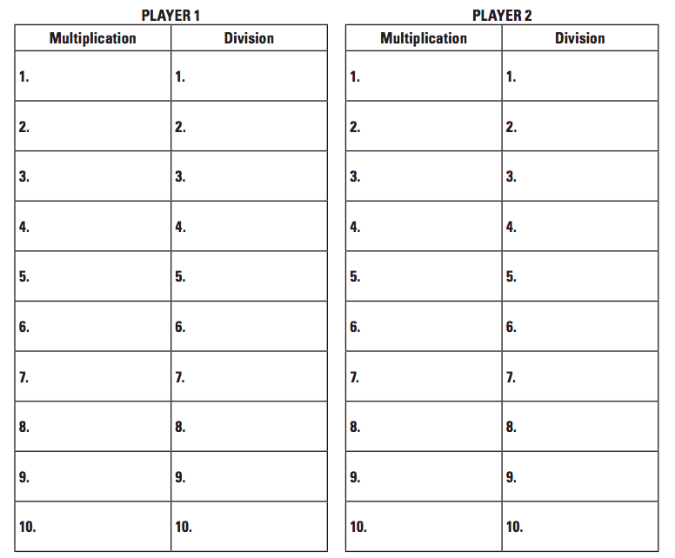
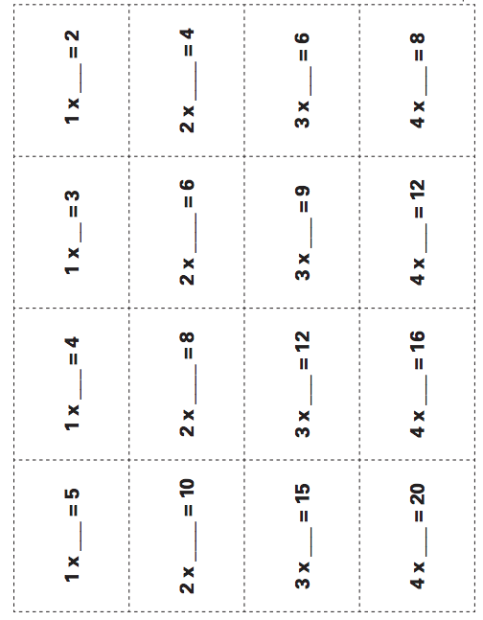
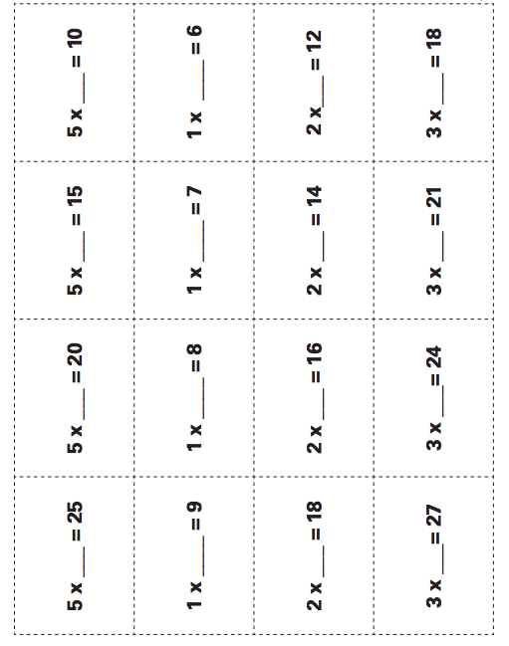

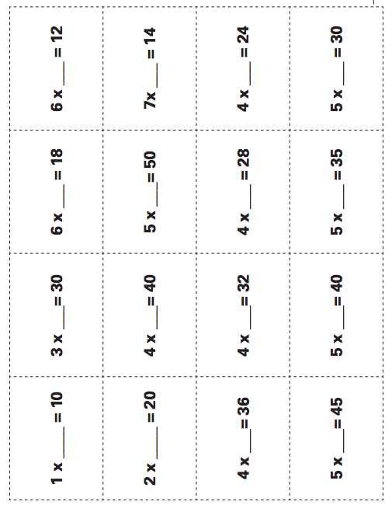
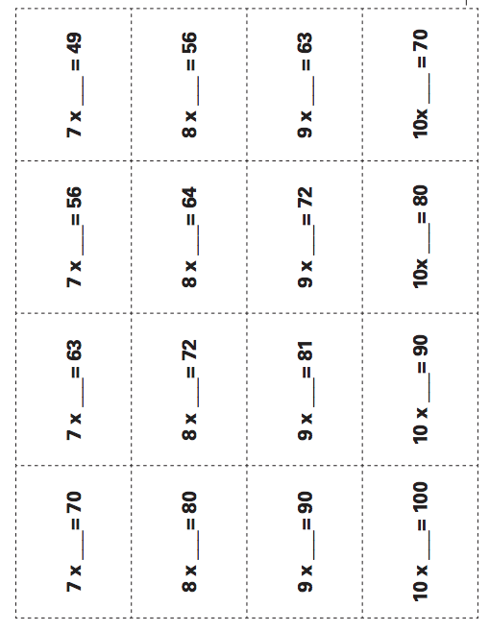

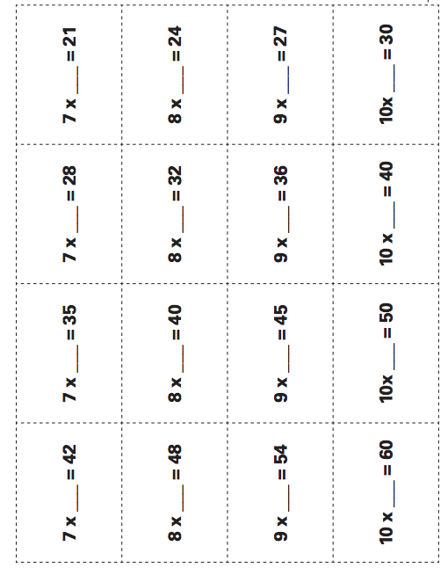

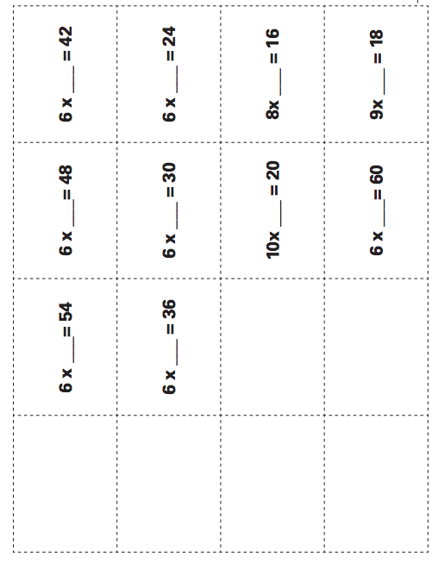
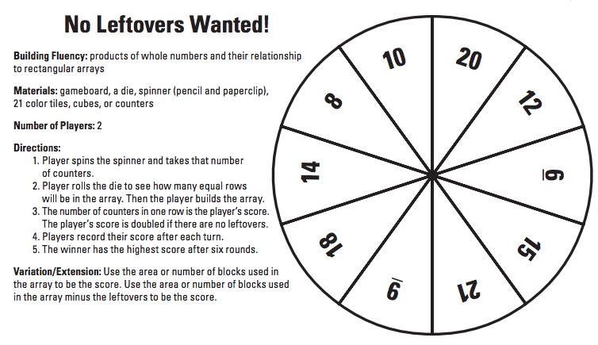

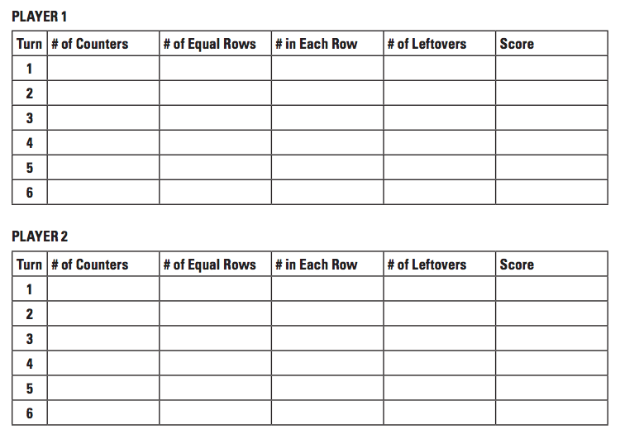

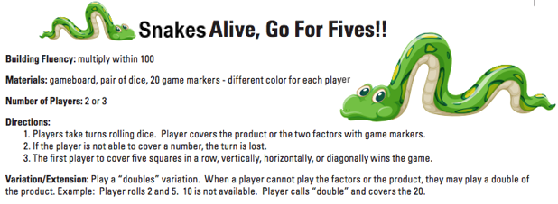
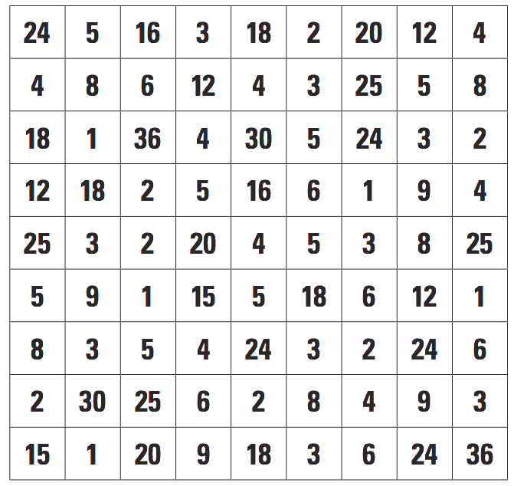
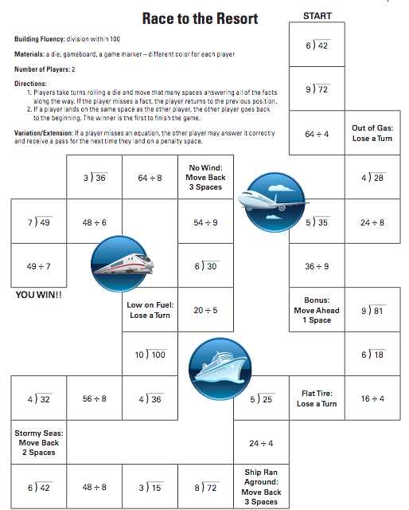

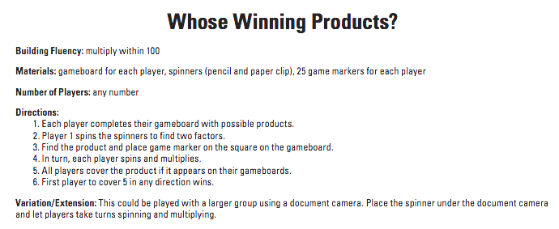
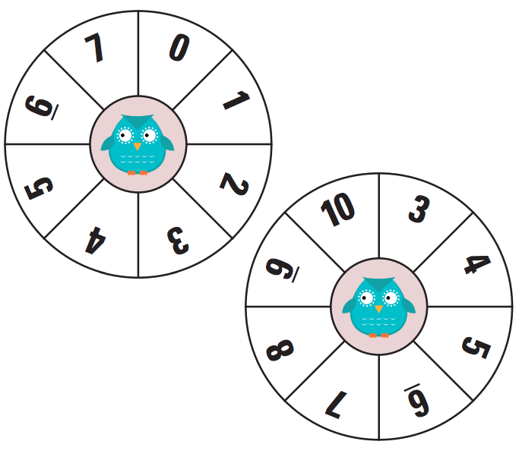

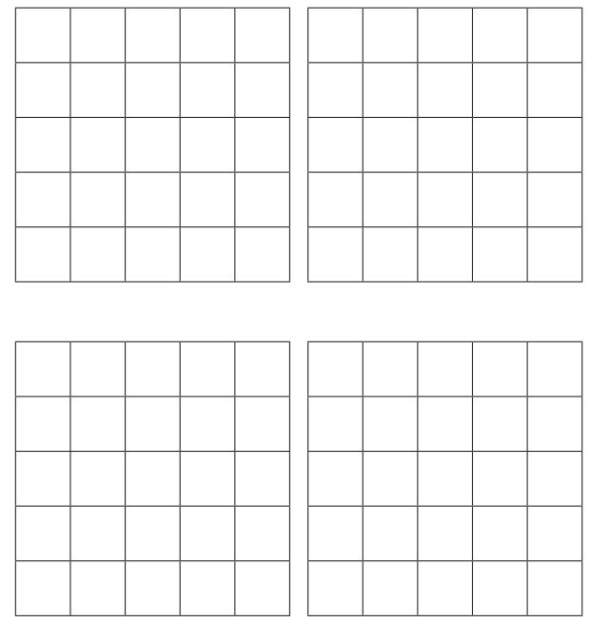
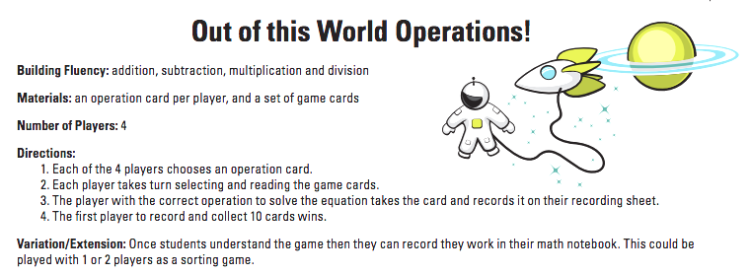
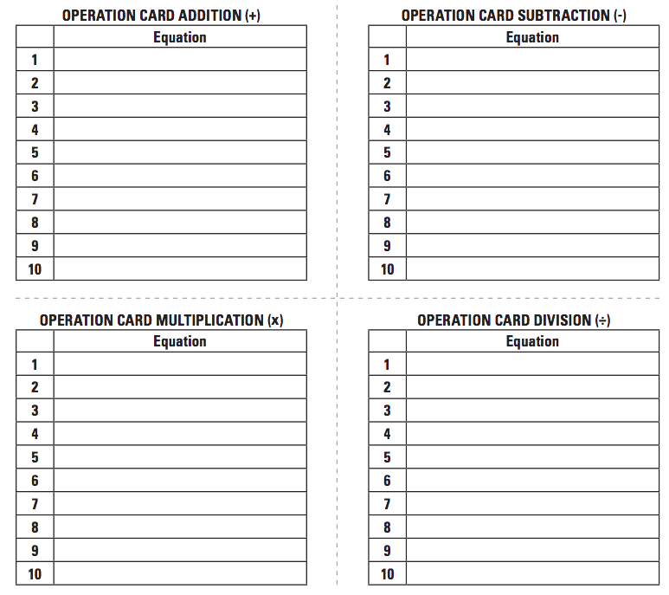

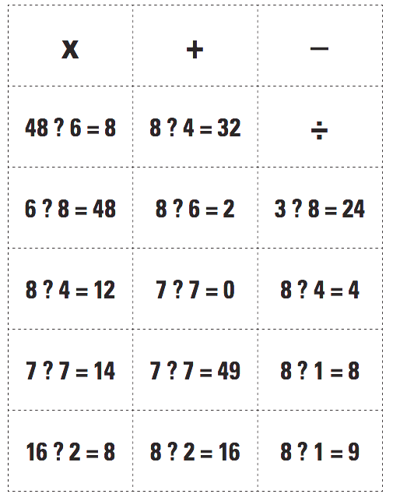

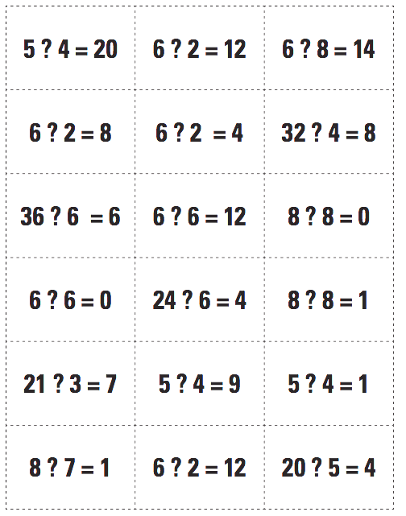

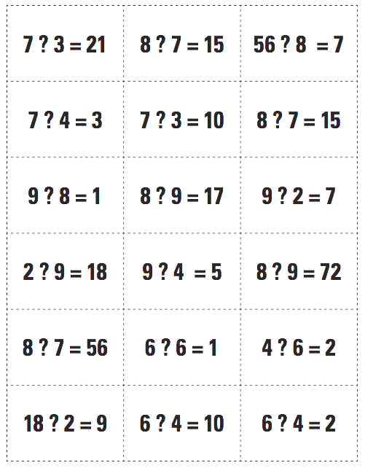

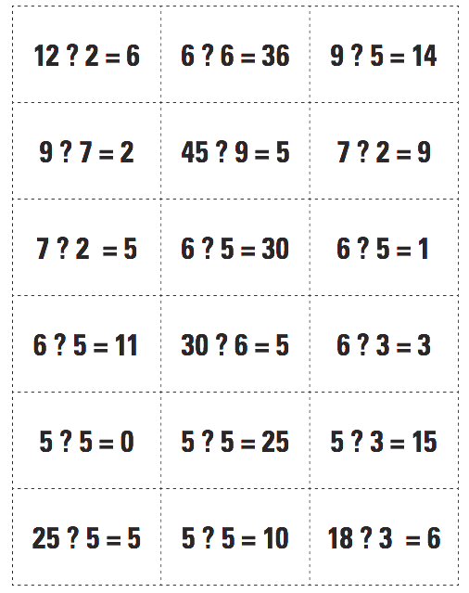

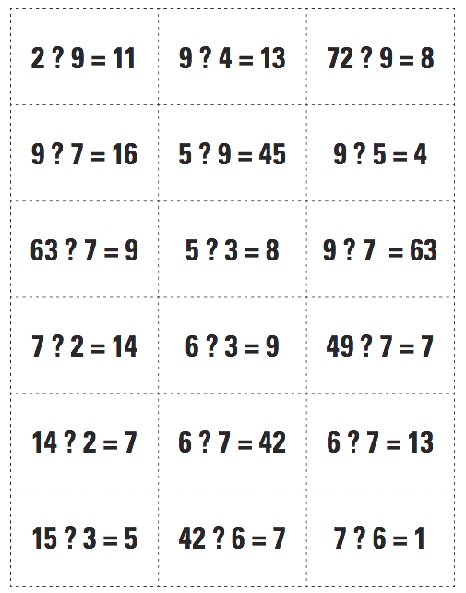

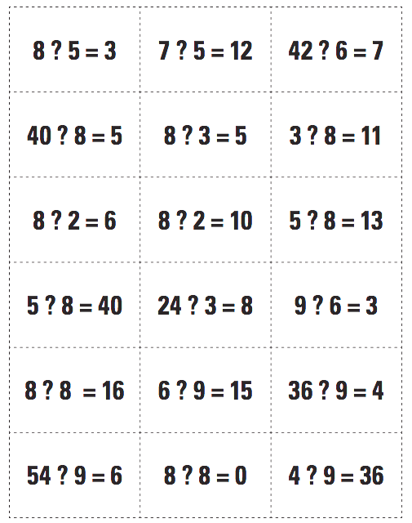

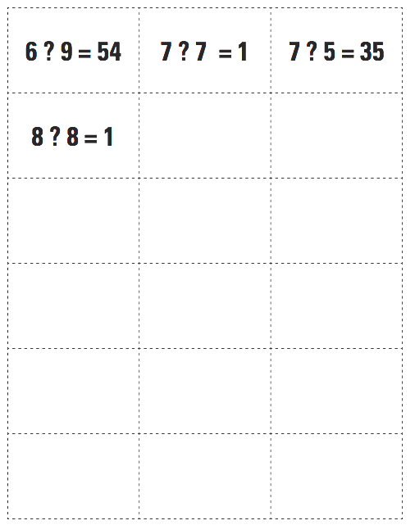

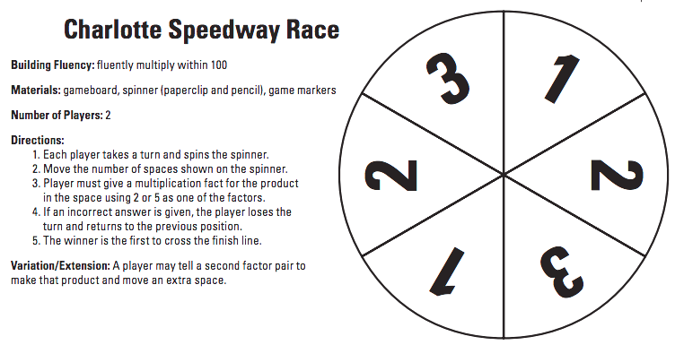
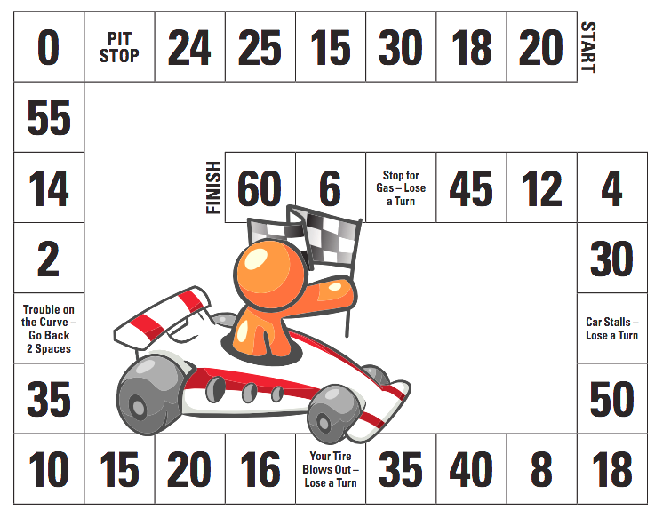

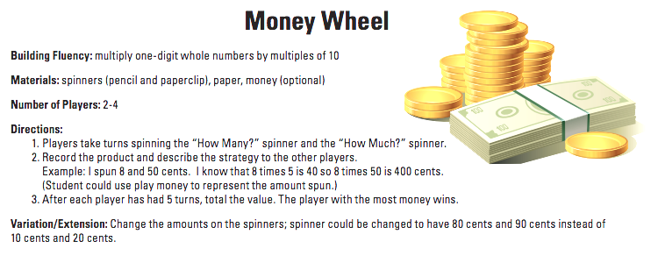
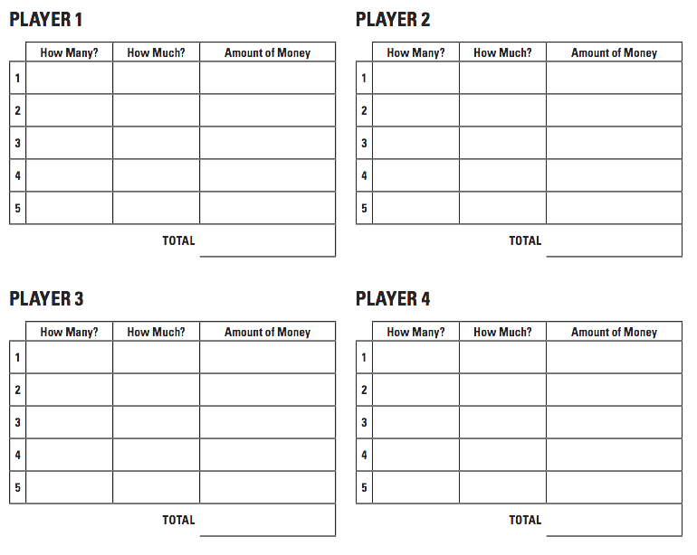
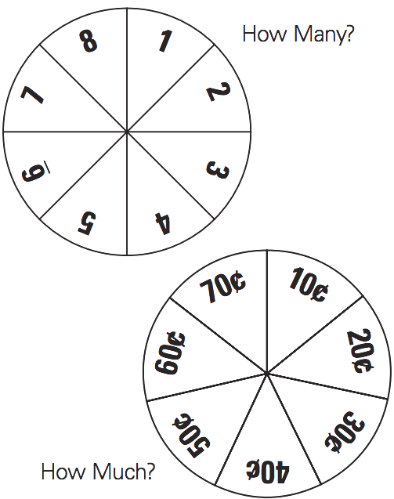

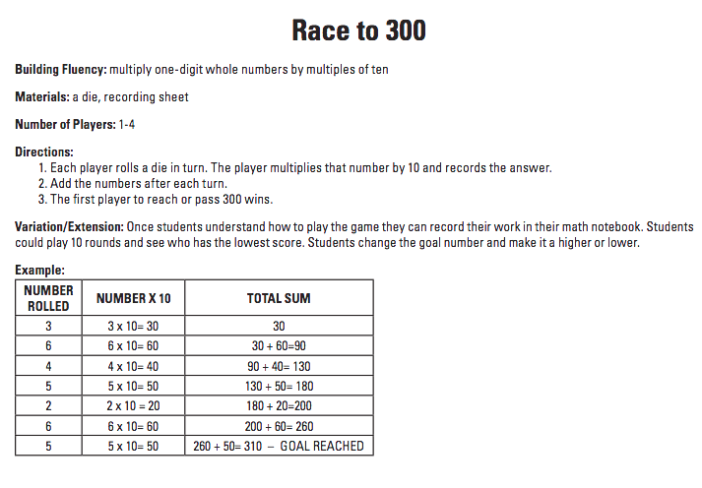
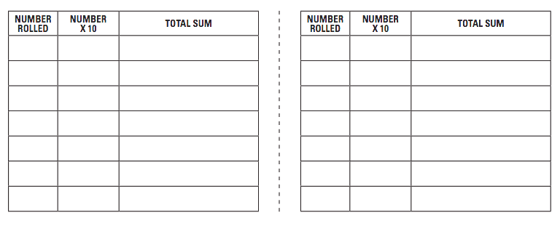

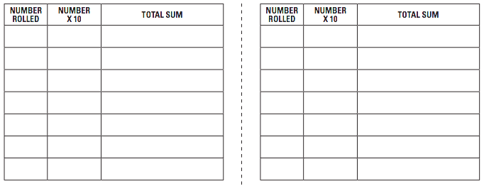

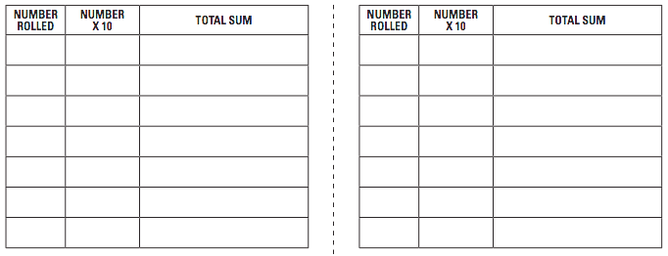

Thank you for attending our Family Math Night!
We value your feedback.

- What was your favorite part of Family Math Night?

- What would you change about our Family Math Night?

- What did you learn from Family Math Night?

- Additional Comments:

Thank you for attending our Family Math Night!
We value your feedback.

- What was your favorite part of Family Math Night?

- What would you change about our Family Math Night?

- What did you learn from Family Math Night?

- Additional Comments:

