Third Grade Cluster 1 CFA Assessment
Teacher Guide
This assessment assesses students’ ability to:
- Recognize contexts that involve multiplication and division
- Connect multiplication and division situations to multiplication expressions and equations
- Given a multiplication or division equation, write a story that matches the equation
- Use multiplication and division within 100 to solve word problems in situations involving equal groups, arrays, and measurement quantities
- Solve problems in which you need to find the number of things in a group
- Solve problems in which you need to find the number of groups
- Use drawings and number lines to represent multiplication and division situations
- Use the commutative property
- Use arrays to show the commutative property

NCSCOS 2017 Standards:
This assessment addresses each of the following NCSCOS 2017 standards:

Standard | Questions
NC.3.OA.1 | 8, 9, 13, 14
NC.3.OA.2 | 5, 11, 15
NC.3.OA.3 | 1, 2, 6

Data Driven Instruction:
This assessment is one data point and should be used with data gathered from multiple sources to make an informed decision about each student’s misconceptions and mastery.

3rd Grade Cluster 1 CFA – Scoring Guide

Question | Standard | Answer
1 | NC.3.OA.3 | C
2 | NC.3.OA.3 | B
3 | NC.3.OA.2 | A
4 | NC.3.OA.3 | D
5 | NC.3.OA.1 | B
6 | NC.3.OA.1 | D
7 | NC.3.OA.2 | C
8 | NC.3.OA.1 | Rubric
9 | NC.3.OA.1 | Rubric
10 | NC.3.OA.2 | Rubric

Question 8 (2 points):
Student receives 1 point for each of the following bullets:
- Student states that product of 6 x 3 and 3 x 6 is 18.
- Student creates a representation that shows that 6 x 3 = 3 x 6 (ie number line with both 3 x 6 and 6 x 3 represented, two congruent arrays, equal groups sorted into groups with one of each color-then resorted by color)

Question 9 (4 points):
Student receives 1 point for each of the following bullets:
- Student uses the number line to show 6 jumps of 7 inches.
- Student states that the length of the chalk line is 42 inches.
- Student records the addition equation: 7 + 7 + 7 + 7 + 7 + 7 = 42
- Student records the multiplication equation: 6 x 7 = 42 (*Note that if a student records 7 x 6 = 42, it may be counted correct, but teachers should continue to discuss this with students because it does not match the situation exactly since there are 6 groups of 7 inch bricks, rather than 7 groups of 6 inch bricks).

Question 10 (3 points):
Student receives 1 point for each of the following bullets:
- Student writes a story in which 56 items or units are separated into 8 equal groups OR Student writes a story in which 56 items or units are separated into groups of 8.
- Student represents their story problem with a drawing that shows how items are being separated.
- Student states that the quotient is 7.

Student Name: ________________________ Date: _________

3rd Grade Cluster 1 Assessment
Directions:

Solve each problem and show your work.
_________________________________________________________________________
1. Lucas and Ima are playing a card game. They place cards face down in equal rows.

- They made 9 rows.
- They put 7 cards in each row.

How many cards did Lucas and Ima place in rows?

A 16 B 56
C 63 D 72

2. Ms. Chang wants to rearrange the desks into rows.

- There are 24 desks in the classroom.
- She wants 6 rows of desks.

How many desks will Ms. Chang put in each row?

A 3 B 4
C 18 D 30

3. Which of the following could be represented with a division expression?
A Kai practiced soccer for a total of 8 hours this week. He practiced the same amount of time on 4 different days. How long did Kai practice each day?
B Jaleel practiced football for 9 hours this week. That was 3 hours more than he practiced last week. How many hours did Jaleel practice last week?
C Carlita practiced basketball for 5 days in a row. Each day she practiced for 2 hours. How many hours did Carlita practice?
D Ming Li practiced gymnastics on 3 days this week. She practiced 4 hours on Monday, 2 hours on Tuesday, and 3 hours on Thursday. How many hours did Ming Li practice?

4. Ming Li has 8 packs of gum. Each pack has 8 pieces of gum. How many pieces of gum does Ming Li have?
A 16 B 48
C 56 D 64

5. Which equation shows why the two arrays have the same number of squares?
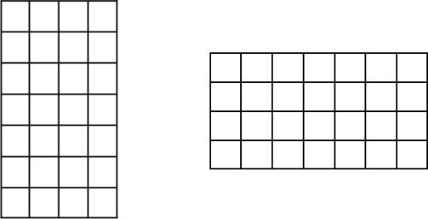
A 4 + 4 + 4 + 4 = 7 + 7 + 7 + 7 + 7 + 7 + 7
B 7 x 4 = 4 x 7
C 7 + 4 = 4 + 7
D 7 x 1 = 1 x 4

6. Which problem could be solved using the expression 10 x 5?
A Liana has 10 candy bars. She wants to share them equally between herself and four friends. How much of a candy bar should each friend get?
B Liana had 10 stickers. She gave 5 of them to her younger sister. How many stickers does Liana have now?
C Liana had $10. She earned $5 for washing her neighbor’s car. How much money does Liana have now?
D Liana drew 10 pentagons on her paper. A pentagon has 5 sides. How many total sides do Liana’s pentagons have?

7. DeAndre has 72 pieces of gum. He has 8 flavors. If he has an equal number of pieces for each flavor, which equation could he use to find how many pieces of gum he has for each flavor?

A 72 + 8 = 80 B 72 x 8 = 576
C 72 ÷ 8 = 9 D 72 - 8 = 64

Student Name: ___________________
Open Response Questions:

Questions 9 - 10 are open response questions. You will need to use pictures, numbers, or words to answer these questions.

8. Kaneka said that the product of 3 x 6 is the same as the product of 6 x 3. Do you agree or disagree?

Use a representation to show your thinking:

9. A group of children were having relays races for fun. They wanted to build a line on drive way using chalk to use for their races. Jose found some brick that were 7 inches long. He laid 6 bricks end-to-end with no gaps or overlaps. Use jumps on the number line to show the bricks and the length of the chalk line.

How long is the chalk line? _____ inches

Write an addition equation and a multiplication equation to represent your work on the number line:
Addition equation: ______________________________________

Multiplication equation: __________________________________

10. Write a math story to match 56 ÷ 8.

Draw a picture to represent your division story.

What is the quotient of 56 ÷ 8?

Additional MD3 Items:

1. The bar graph shows how many different kinds of pets are available at a pet store.

How many fewer dogs and cats are available than fish and birds?
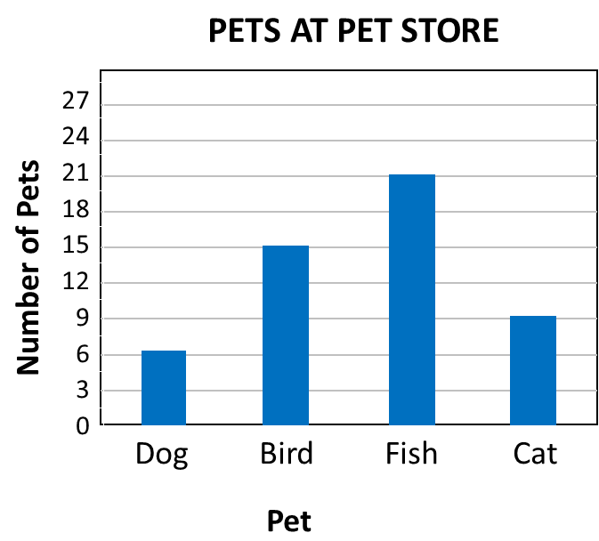
A 6 B 9

C 21 D 51

2. The principal at Panthers Elementary School made a graph to show the absences in January for each grade level.
How many more fourth grade students were absent than third grade students?
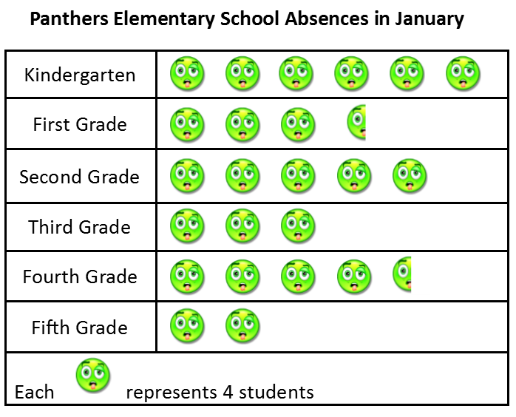
A 2
B 6
C 18
D 30

23. A third grade class tracked the weather over a 4-month period. They created a bar graph to show the results.

How many sunny days were there over the 4-month period?

A 24
B 78
C 80
D 82

