NC.3.MD.3
Flexible Classroom Seating
Domain | Measurement and Data
Cluster | Represent and Interpret Data
Standard(s) | NC.3.MD.3 Represent and interpret scaled picture and bar graphs:  - Collect data by asking a question that yields data in up to four categories.  - Make a representation of data and interpret data in a frequency table, scaled picture graph, and/or scaled bar graph with axes provided.  - Solve one and two-step “how many more” and “how many less” problems using information from these graphs.  Supporting Standards:  NC.3.NBT.2 Add and subtract whole numbers up to and including 1,000.  NC.3.OA.3 Represent, interpret and solve one-step problems involving multiplication.  NC.3.OA.8 Solve two-step word problems using addition, subtraction, and multiplication, representing problems using equations with a symbol for the unknown number.
Materials | Flexible Seating Recording Sheets, paper, pencils
Task | Part 1:  Distribute Flexible Seating Choices chart to students.  .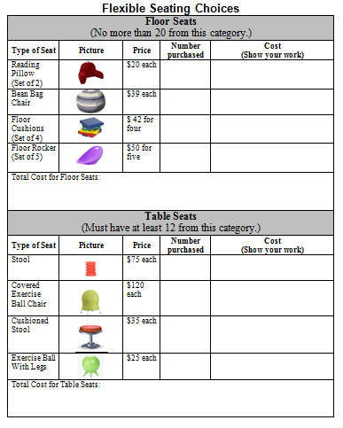  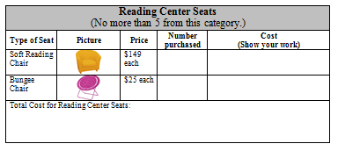  Read directions: “Your teacher was just awarded $1000 to spend on flexible seating for your classroom! Work with a partner to help her decide how to spend the money on flexible seating for your classroom, which has 20 students. Think about which seats will be most popular and how many seats you need. You may choose up to 20 floor seats, at least 12 table seats, and there is only room for 5 seats in the Reading Center.  You are asked to:  - Write down the different seats and how many of each you would choose. Find the total for each category: Floor Seats, Seats for Tables, and Reading Center Seats).  - What was the total cost of all your choices?  - Did you have any money left over? If so, how much?”  Give students time to complete part 1.  Part 2: (May be completed directly after or in another class period)  Say: “Use your work from Part 1 to:  - Create a bar graph to represent how you would spend the money. Notice the scale on vertical axis. What is it? (100). Include labels on your graph.  - After you complete your graph, you will compare your choices with a partner and complete the second chart. How much more or less did you spend on each category than your partner? How much more or less total did you spend than your partner?”  A possible extension is to ask students if it is possible to spend exactly $1,000 and ask them to explain.  Part 3:  Students use their graphs created in Part 2 to compare their choices with a partner’s choices. To encourage use of the bar graph, collect the work from Part 1 before completing Part 3.  Say:  - Use the chart for Part 3 and compare your choices with a partner.  - How much more or less did you choose to spend on each category than your partner? Show your work.  - How much more or less did you choose to spend in total than your partner? Show your work.

Rubric for Part 1: This rubric allows teachers to make instructional decisions for students.
Level I  Not Yet | Level II  Progressing | Level III  Meets Expectation
- Student’s response is incorrect, incomplete, or student is off task.  - The task is attempted and some mathematical effort is made. There may be fragments of accomplishment but not complete success. Further teaching is required. | - The task is accomplished, but there is lack of evidence of understanding or evidence of not understanding. Further teaching is required.  Student does 1-4 of the following:  - Student selects a list of seats valued at or near $1,000.  - Student identifies the cost of items for each category and total cost of items on his/her table.  - Student identifies amount of money left over.  - Student correctly draws and labels bar graph. | - Student works to full accomplishment with minimal feedback from teacher. Errors are minor. Teacher is confident that understanding is adequate to accomplish the objective with minimal assistance.  - Student selects a list of seats valued at or near $1,000.  - Student identifies the total cost of item on his/her chart.  - Student identifies amount of money left over.  - Problem solving strategies are clearly articulated.

Rubric for Part 2: This rubric allows teachers to make instructional decisions for students.
Level I  Not Yet | Level II  Progressing | Level III  Meets Expectation
- Student is unable to graph data on the graph.  - Student does not identify total number of seats for each category on graph.  - Student incorrectly labels bar graph scale. | - Student organizes data on graph with few errors  - Student compares choices to partner’s choices with few errors. | - Student works to full accomplishment with minimal feedback from teacher. Errors are minor. Teacher is confident that understanding is adequate to accomplish the objective with minimal assistance.  - Student correctly organizes data on graph and correctly compares choices to partner’s.

Rubric for Part 3: This rubric allows teachers to make instructional decisions for students.
Level I  Not Yet | Level II  Progressing | Level III  Meets Expectation
- Student’s response is incorrect, incomplete, or student is off task.  - The task is attempted and some mathematical effort is made. There may be fragments of accomplishment but not complete success. Further teaching is required. | - The task is accomplished, but there is lack of evidence of understanding or evidence of not understanding. Further teaching is required.  Student does 1-4 of the following:  - Student compares his/her choices to a partner's, indicating the differences between the amounts but makes a few errors.  - Student indicates who spent more in each category, but makes a few errors.  - Student correctly indicates how much more or less he/she spent in total than his/her partner, but may make computational errors for exact amount.  - Student left cells in the chart blank.  - Problem solving strategies are clearly articulated. | - Student works to full accomplishment with minimal feedback from teacher. Errors are minor. Teacher is confident that understanding is adequate to accomplish the objective with minimal assistance.  - Student compares his/her choices to a partner's, indicating the correct differences.  - Student correctly indicates who spent more in each category.  - Student correctly indicates how much more or less he/she spent in total than his/her partner.  - Problem solving strategies are clearly articulated.

Standards for Mathematical Practice
Bold the standards below that are a focus for your lesson.
1. Makes sense and perseveres in solving problems.
2. Reasons abstractly and quantitatively.
3. Constructs viable arguments and critiques the reasoning of others.
4. Models with mathematics.
5. Uses appropriate tools strategically.
6. Attends to precision.
7. Looks for and makes use of structure.
8. Looks for and expresses regularity in repeated reasoning.

Flexible Classroom Seating

Your teacher was just awarded $1,000 to spend on flexible seating for your classroom! She asked all 20 of her students in the class to help her decide how to spend the money. Think about which seats will be most popular and how many seats you need. You may choose up to 20 floor seats, at least 12 table seats, and there is only room for 5 seats in the Reading Center.

Part 1:

Use the Seat Choices Charts (2 pages) to:

- Write down the different seats and how many of each you would choose. Find the total for each category: Floor Seats, Seats for Tables, and Reading Center Seats.

- Find the total cost of all your choices. Did you have any money left over? If so, how much?

Part 2:

- Create a bar graph to represent how you would spend the money by category. Scale the vertical axis by $100. Label your graph.

Part 3:

- Use the chart for Part 3 to compare your choices with a partner on the chart.
- How much more or less did you choose to spend on each category than your partner? Show your work.
- How much more or less did you choose to spend in total than your partner? Show your work below.
- On the back of the paper: Find the total cost of all your choices. Did you have any money left over? If so, how much?

Flexible Classroom Seating: Part 1 Seat Choices (2 pages)

Your teacher was just awarded $1,000 to spend on flexible seating for your classroom! She asked all 20 of her students in the class to help her decide how to spend the money. Think about which seats will be most popular and how many seats you need. You may choose up to 20 floor seats, at least 12 table seats, and there is only room for 5 seats in the Reading Center. Use the Classroom Seat Choices Charts (2 pages) to:

- Write down the different seats and how many of each you would choose. Find the total for each category: Floor Seats, Seats for Tables, and Reading Center Seats. Use another sheet of paper (or the back of this one) if you need more work space.

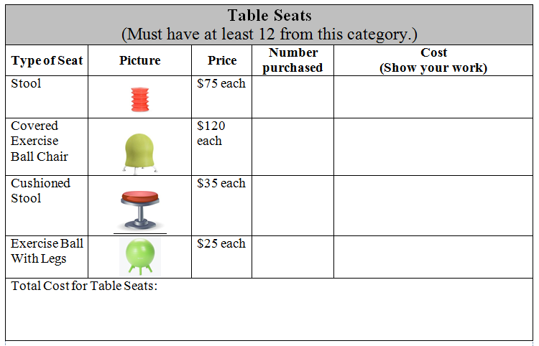
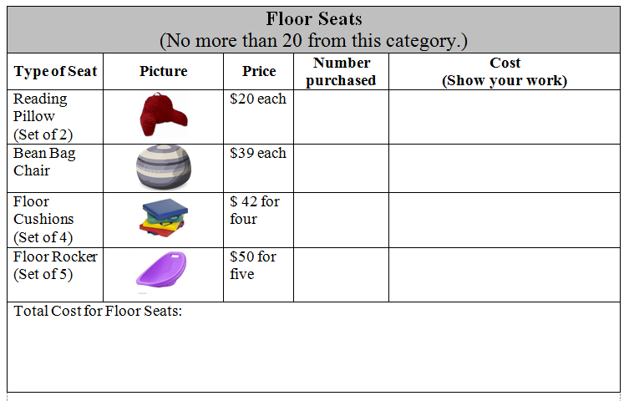
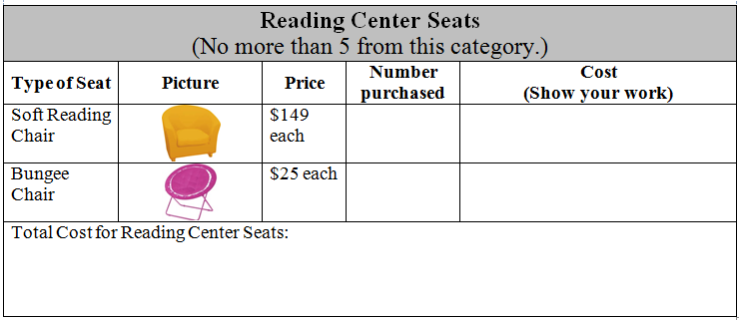

On the back of the paper: Find the total cost of all your choices. Did you have any money left over? If so, how much?
Flexible Classroom Seating: Part 2
0

Create a bar graph to represent how you would spend the money by category. Scale the vertical axis by $100. Label your graph.

Graph Title: _________________________________

1000
900
800
700
600
500
400
300
200
100
0
___________  (Category 1) |  | ___________  (Category 2) |  | ___________  (Category 3)

Flexible Classroom Seating: Part 3

- Use your bar graph from Part 2 to compare your choices with a partner on the chart.
- How much more or less did you choose to spend on each category than your partner? Show your work.
- How much more or less did you choose to spend in total than your partner? Show your work below.

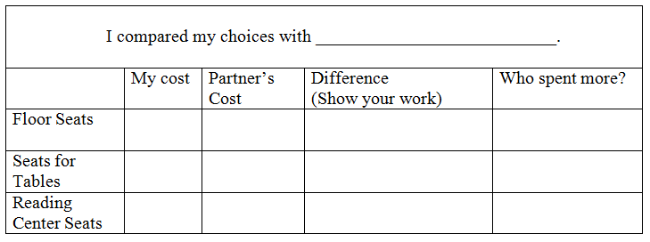

How much more or less did you choose to spend in total than your partner?

_______________________________________________________________________

Show your work below.

Answer Key

Part 1: (Answers will vary; this is an example)
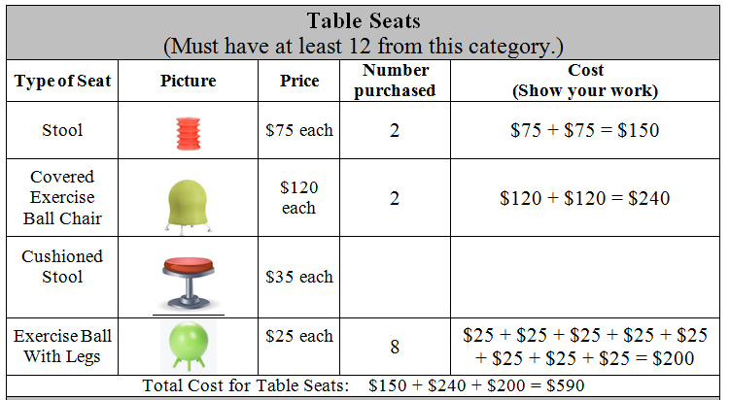

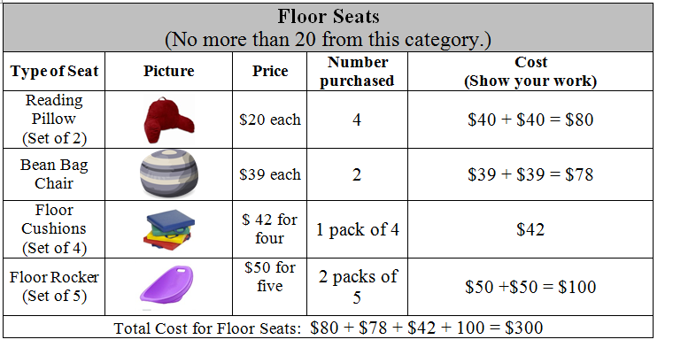
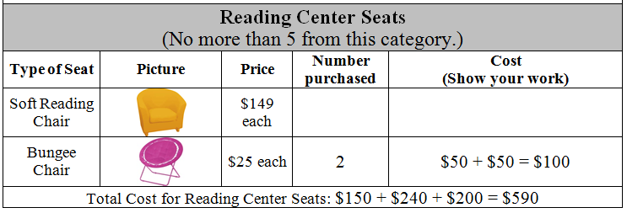

Part 2: This bar graph shows the totals.

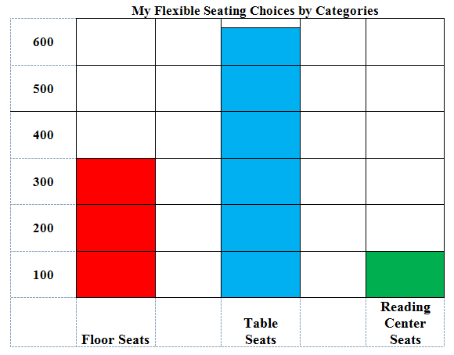

The total from all the purchases would be $300 + $590 + $100 = $990. So these purchases would total $990 and $10 would be left over ($1000-990 = $10).

Part 3: Answers will vary.

Teacher Considerations:
In this task students are asked to decide how to spend $1,000 on flexible seating for their classroom. Students make choices not to exceed the budget, construct a bar graph to represent data, and are asked to compare their choices with other students' choices. In third grade students are asked to fluently add and subtract within 1,000, which is why the total budget is $1,000. This task provides students with an opportunity to decide which operations they will use to approach the task. They may choose to use addition, subtraction, and multiplication, and they might also use division.

It is possible that students will choose to purchase a number of one of the items where the total is greater than $100. While students are not expected to be fluent in multiplication above 100, they should be able to use addition or their multiplication strategies to find such products. This task could also be used early in the school year, and students could totally use addition, rather than multiplication, to solve. The focus of this task is 3.MD.3, so students should not be penalized for solving Part 1 using addition instead of multiplication.

To encourage students to use bar graphs for part 3, teachers may choose to collect the charts from Part 1 before beginning Part 3. Otherwise, the task is more of an OA task than an MD task. Bar graphs make it easy for students to compare their choices. If all students in the class include all categories on their graphs (whether they allotted any spending to them or not), list the categories in the same order that they are listed in the data table, and use the same colors for each category on a final draft, the teacher can put all of the final graphs up for display and the class can see whether there is a general consensus for how to spend the $1000 or not.

The task asks students to represent their total purchases with an equation, and the task allows for multiple entry points. For example, if a student chooses 15 reading pillows, 3 sets of rocker chairs and 2 packs of Floor Cushions, he may represent his solutions with these equations after he has learned how to multiply multiples of ten (4 x $20 = $80 ; 3 × $50 = $150; and 2 × $50 = $100) and then add those totals together to get the total ($80 + $150 + $100 = $330).

Earlier in the year, or if students struggle with multiplication, students may choose to represent solution with these addition equations ($20 + $20 + $20 + $20 = $80; $50 + $50 + $50 = $150; $50 + $50 = $100) and add those totals together ($80 + $150 + $100 = $330).

Thoughts from a NC teacher who implemented this task in her classroom: “We loved this task. We did it two days. Part 1 took an hour. We did parts 2 and 3 on the next day. Some students wanted to spend all their money on one category, and I had to reference the limitations written on the task (must use each category, up to 20 floor seats, at least 12 table seats, and only 5 seats in the Reading Center). Also, we used extra paper for students to show their work for determining the costs of each type of seat and had them write the answer in the chart. There was not enough space for students to use their preferred strategies on the chart. My students were into figuring out how much money they had left over. A challenge for enrichment would be to ask students how close to $1000 they could spend. Some students were fine with having $50 left over, others wanted to go back to the chart and see what else they could buy.”

This task was adapted from an Illustrative Mathematics Task (www.IllustrativeMathematics.org) titled “Classroom Supplies.”

Student Work Examples
This is an instructional task. The following student work showcases examples teachers may see in class. These may help anticipate responses from students before using the task to plan ahead to push students’ thinking to the next level.

Part 1: Student A used repeated addition to figure out the cost (75+75+75), but student B used multiplication (2 x 75). Student A held numbers in his head, and was flexible with adding multiples of 10 and 5. Student B used place value to add to find the total cost.
Student A
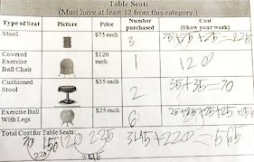

Student B
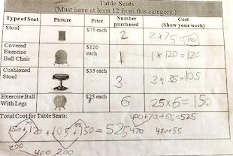

Part 2 Graphs: Some students had difficulty with the scale and knowing how to indicate a number such as 349 on the graph with the scale of 100.

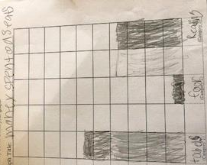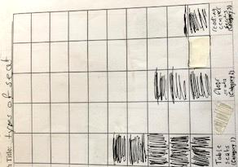

Part 3: These partners used number lines to find the differences in each category. Note how they decomposed the numbers differently to add up to find the differences between their seating categories. (When finding the difference of table seats, student A just added 90, student B added 50 and then 40 to get to 490).

