The intended purpose of this document is to provide teachers with a tool to determine student understanding and suggest instructional moves that may help guide a student forward in their learning of a concept or standard. This guide is not an exhaustive list of strategies.
Third Grade: Cluster 2
Measurement and Data
Using Data to Solve Problems
NC.3.MD.3 Represent and interpret scaled picture and bar graphs:
- Collect data by asking a question that yields data in up to four categories.
- Make a representation of data and interpret data in a frequency table, scaled picture graph, and /or scaled bar graph with axes provided.
- Solve one and two-step “how many more” and “how many less” problems using information from these graphs.
Not Yet | Students that are consistently scoring “Not Yet” on graphing tasks could have a variety of errors. Students are unable to interpret bar graphs with scales or pictographs with keys. Students consistently struggle to answer questions about graphs they are shown.
Next Steps:
For students having trouble reading and interpreting scaled graphs and pictographs:
- Give students data and have them create graphs using manipulatives, such as cubes.
- Provide opportunities for students to read and interpret bar graphs and pictographs with single unit scales (scales that count by ones).
- Incorporate graphs into daily mathematics routines.

For students having trouble reading the key for the pictograph:
- Provide students with graphs and have conversations about the graph.
Examples: Tell me about the key. What does the key mean in this graph? How much does one _____ represent?
- Begin with picture graphs that have a value of one per picture (Grade 2). As students are more successful with the equivalence of one, move to a picture with the equivalence of 2.

For students having trouble reading a pictograph when there is a half picture represented:
- Begin with a picture graph that has a picture equivalent to 2. Consider using two cubes in a group so that students see that one group is worth two. Then have the students take one cube out. Have them explore how this would be represented by the _____ (whatever picture is on the pictograph).
- Provide data in a table and have students make a pictograph that has a value of two for each object. Discuss with students about how they would show a value of 1 on their graph.

For students having trouble answering questions about graphs:
- Have students retell the questions in their own words to help them make sense of the questions. Continue work from Second Grade where students asked questions about how many more, how many less, how many in all, how many altogether.
- For comparison questions, have students demonstrate how they determined how many more/how many fewer. Examples:
  - How many more does _____ have than _______?
  - How many less (fewer) does ____ have than ______?
  - How many do ______ plus ______ have if they put them together?
- Ask students to write down or talk about 2-3 things they notice from a graph.

Progressing | Students that are consistently scoring “Progressing” have a strategy to use for graphing questions; however, they have not mastered this strategy for bar graphs with keys or may also still struggle with answering more difficult multi-step problems about the graph.
Next Steps:
For students who need more practice creating graphs:
- Students can create their own survey questions, graphs and create a key to go with it. They can then write questions that could be answered from their graph.

For students having trouble identifying category totals for bar graphs and pictographs:
- Pose tasks where students find values on a graph based on the scale or key. Use both vertical and horizontal scales.
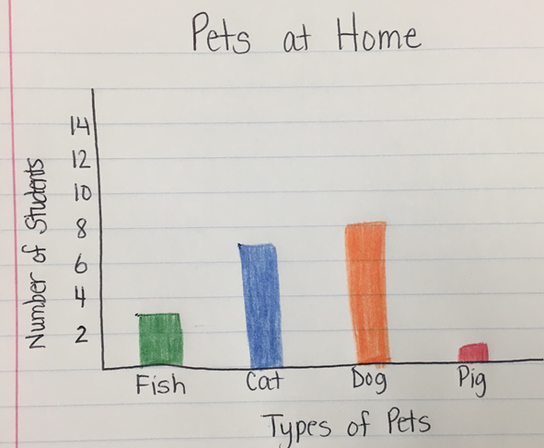
- Provide tasks where students must read a scaled bar graph where a bar is halfway between two values. Start with a scale of 2 or 10 at first.
- Provide students with data and have them make scaled bar graphs and pictographs.
As you can see in the graph, fish, cat, and pig all are between the scale lines. Therefore, the students will need to see that the fish is 3, the cat is 7 and the pig is 1.

For students with errors answering questions about the graph:
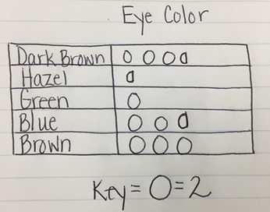
- Encourage students to solve questions using multiple strategies and discuss how the strategies are alike.
Dark Brown, Hazel, and Blue all have half circles. This means that dark brown has 7, hazel has 1 and blue has 5.

- Ask students to examine their answers to check for reasonableness.
- For two-step questions provide support by having students identify the number of parts in the question, the answers to each part, and examine their answer to make sure that it makes sense.
- Display a graph and have students describe what they notice. Have students pose questions that could be answered based on the data in the graph. See the Launch in this lesson.
- Football graphs task which incorporates addition and subtraction through 999, multi-step questions, and reading data on a graph.

Meets Expectation | Students that are consistently scoring “Meets Expectation” on data understand how to read and interpret bar graphs and pictographs. These students understand and can answer questions related to specific graphs.
Next Steps:
- Give students pictographs and bar graphs and have students interpret them and answer 1 and 2 step questions about the data in the graph.
- Students can create their own survey questions, graphs and create a key to go with it. They can also write questions that could be answered from their graph.
- Allow students to make predictions about what they think their results may look like and compare that to their results. This allows them to further analyze their work so they may be able to think of more questions that could help explain their results.

