Building Mathematical Mindsets: Day 2 for Grade 4
Lesson Overview:
Standards for Mathematical Practice:
4. Model with mathematics.
7. Look for and make use of structure.
8. Look for and express regularity in repeated reasoning.

Mathematical Mindset Goal:
- Math is about creativity and sense making.
- Math is about making connections and communicating.
- Math is about creating ways to solve that others can see, discuss, and critique.
- Math is about looking for patterns around us and representing our ideas.

Materials:
- poster of Standards for Mathematical Practice
- student copies of Design Your Half
- square tiles
- blank paper/graph paper
- coloring materials such as crayons, colored pencils, markers
- math journals

Video:
- Solving the Math Problem: https://www.youcubed.org/resources/solving-math-problem/ (2:56)
- Fibonacci: https://www.youtube.com/watch?v=P0tLbl5LrJ8 (3:43)
- Dance of Venus and Earth around the Sun: https://youtu.be/tTYGLoVb5xA (0:27)
Before: 15 minutes
1. Introduction
Yesterday, we talked about the difference between having a fixed mindset and a growth mindset. What do you remember about the difference between the two mindsets? We are going to watch a video clip that helps us remember some of the important things we discussed yesterday. As you watch, I also want you to ask yourselves what math is all about. After the clip, we will talk about what mathematics really is.
Video Clip: https://www.youcubed.org/resources/solving-math-problem/
After the video clip, ask: What did you learn about what math really is when you watched this video clip?

Video Summary:
Math is about creativity and sense making. Math is about making connections and communicating.
Math is about creating ways to solve that others can see, discuss, and critique. Math is about looking for patterns around us and representing our ideas. We can use tools like snap cubes or square tiles, pictures, or other visual representations to show our thinking. We can use colors, labels, and numbers to communicate what we notice.

2. Mathematical Practices
When we represent the mathematics we see around us with symbols and numbers, we are modeling the real-world with mathematics (MP4). That is another habit of good mathematicians that we can find our Standards for Mathematical Practice poster.
During: 25 minutes
3. Math Activity
Today we are going to use mathematical creativity as we think about ways to represent one half. Ask students to consider the following questions:
- How do you know when something is split in half?
- What does it mean to have half of something?

Show images from YouCubed Halving Handout shown below (https://bhi61nm2cr3mkdgk1dtaov18-wpengine.netdna-ssl.com/wp-content/uploads/2017/07/3-5-WIM-3-Halving.pdf):
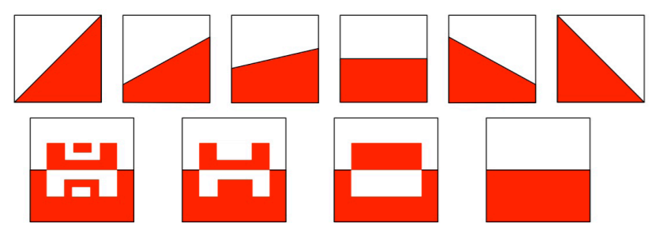
Say: Each of these images is split in half. How can you check that each is correct? How could you convince someone that each is split in half? What does it mean to split a square in half? What needs to be true in order for it to be half?

Today, you are going to use mathematical creativity to split another square in half. You will make your own design that splits your square in half. You can choose your tools. You may use square tiles, graph paper or blank paper squares to design your halves. You can choose your color or use two colors to show halves (SMP5). Once your design is planned, you can use the blank square or the partitioned square for your design on the handout.
Allow students time to design half of square.
After: 20 minutes
4. Discussion
Ask students to share some of the things that they noticed as they worked. Ask students how they know that half of their square is one color? Ask how they could prove it (i.e. possible, cutting half out and laying it over the top of the other half or counting the squares or triangles if the lined version was used). Highlight that students thought about half in many different ways, but many times there is more than one right way to find a solution. Highlight that sometimes there are interesting patterns or structures that we don’t notice at first, but as we work and think about mathematics we notice those patterns and structures. Today, many of you used a pattern or structure to help design half (i.e. You may have noticed that for every square you colored, another had to be blank or the other color). You may have also noticed that since there are 64 squares (or 256 triangles) that 32 squares would be half (or 128 triangles).

Tell students that when they notice patterns or structures that they are showing another good practice of mathematicians (MP7) and when they make statements about what they notice and think is true in math that they are showing yet another practice of good mathematicians (MP8). Refer to the poster or display of the Mathematical Practices.

Following the lesson, you can post the squares in the classroom or create a bulletin board to remind students that math is creative and that we can use structures and patterns to help us think about mathematics. (You can create a quilt design by backing the squares with black paper and spacing the squares into equal rows and columns).

5. Reflection
Say: In a few minutes, I am going to give you a chance to reflect on what you have found interesting in today’s math class. We want to remember that math is not about getting answers to a bunch of questions, but is about noticing patterns, relationships, and connections as we solve problems.

The following two video clips are short videos that highlight mathematics in nature. You may use one or both videos. The first one is based on a famous pattern called the Fibonacci Sequence. In the Fibonacci Sequence, each number is added to the previous number to find the next number in the sequence: 1, 1, 2, 3, 5, 8, 13, 21… The interesting thing about this number pattern is how often these numbers occur in nature. Built with squares these numbers form a spiral. Some of the number work in this video will be harder for younger students to follow.
Fibonacci: https://www.youtube.com/watch?v=P0tLbl5LrJ8
Dance of Venus and Earth around the Sun: https://youtu.be/tTYGLoVb5xA (0:27)

Allow students 5-10 minutes to reflect on and write about something interesting that they thought about in math class today.

*Ideas, tasks, and some videos for this series of lessons were developed from the following the Week of Inspiration and Tasks tabs at https://www.youcubed.org/ and Jo Boaler’s book Mathematical Mindsets: Unleashing Students’ Potential Through Creative Math, Inspiring Messages, and Innovative Teaching. However, these lessons and videos are in a different order, contain additional detail, have an explicit connection to Standards for Mathematical Practice, and contain a few outside sources. YouCubed (https://www.youcubed.org/) is a free site, but you will have to register to access some of the materials. Additional information regarding today’s tasks can be found here: https://bhi61nm2cr3mkdgk1dtaov18-wpengine.netdna-ssl.com/wp-content/uploads/2017/07/3-5-WIM-3-Halving.pdf.

Design Your Half
