Weekend Fun
Students organize a set of data about their favorite weekend activities and create a representation to display the data. This lesson allows the teacher to assess students’ prior understandings of graphical representations and introduce mathematical practice #4 – Model with mathematics.

NC Mathematics Standards:
Measurement and Data
NC.4.MD.4 Represent and interpret data using whole numbers.
- Collect data by asking a question that yields numerical data.
- Make a representation of data and interpret data in a frequency table, scaled bar graph, and/or line plot.
- Determine whether a survey question will yield categorical or numerical data.

Review Standards
NC.3.MD.3 Represent and interpret scaled picture and bar graphs:
- Collect data by asking a question that yields data in up to four categories.
- Make a representation of data and interpret data in a frequency table, scaled picture graph, and/or scaled bar graph with axes provided.
- Solve one and two-step “how many more” and “how many less” problems using information from these graphs.

Standards for Mathematical Practice:
- Make sense of problems and persevere in solving them.
3. Construct viable arguments and critique the reasoning of others.
4. Model with mathematics.
6. Attend to precision.

Student Outcomes:
- I can develop classifications to organize categorical data.
- I can represent categorical data in different ways.

Math Language:
- data
- categories, categorical data
- representation, graph
- collect, organize, display or represent

Materials:
- sticky notes or index cards
- data sorting cards (previously created)
- large poster paper
- markers/colored pencils/crayons
- rulers, yard/meter sticks
- Optional: anchor chart, poster of Math Practice #4 (http://www.debbiewaggoner.com/math-practice-standards.html)

Advance Preparation:
- Decide how to group students (groups of 3 – 4 students)
- Before the lesson, ask each student to respond to the question “What is something you like to do on the weekend?” This can be done on sticky notes or index cards. Each student should place one response on each piece of paper. Type up the responses, copy, and cut apart so each group will have one set of data for the lesson.
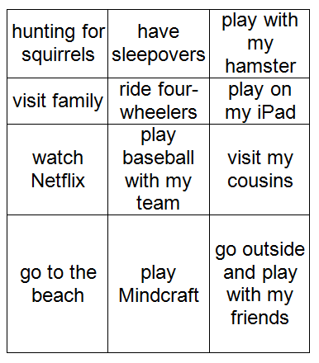
Example:
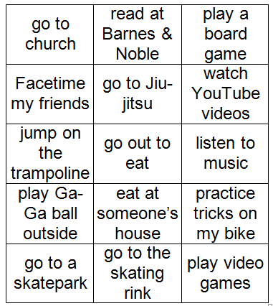

Launch:
- Introduction of Task (5 – 10 minutes)
Point out that today’s lesson will focus on data. Remind students what data means and provide a few examples. Say: Data are pieces of information. You can collect data in a variety of ways. Allow students to describe examples of data and ways it can be collected. Some possible ways data can be collected include observations, surveys and questionnaires, experiments, interviews, polls, simulations, examining past records, or searches of the internet, library, or other resources. Refer back to the data that students collected yesterday (something you like to do on the weekend). Have students describe how the data was collected (survey). Point out that after mathematicians collect data, they organize it, and display or represent the data they collected.

Instruct students to work in groups to sort and classify the data by putting it into groups or categories so it is easier to understand. After they sort the data into categories, they will make a representation to show how they organized the data. If time allows, have students write several sentences on index cards or sticky notes about their observations or what they notice about the data.

Explore:
- Creating Data Representations (30 – 45 minutes)
Give students time to work within their groups to sort, organize, and represent the data. As students work, observe students to see how they are organizing the data and selecting categories. Possible sorts: inside or outside, alone or with friends, with friends or with family, sports or technology, at home or not.

Provide students with materials (large poster paper, markers/colored pencils/crayons, rulers, yard/meter sticks) to create a representation to display the data. Possible representations: tables, bar graphs, picture graphs, drawings. If students have additional time to work, encourage them to record observations about their data and data displays.

As students work, observe:
- How are students sorting and organizing the data? How are they grouping activities together?
- Do students sort the data in multiple ways? How do students decide on their final sort or groupings?
- How do students determine the names of the categories?
- How do students model and represent the categorical data? What types of representations are they using?
- How are the representations and displays alike? How are the representations different?
- What understandings and misunderstandings do students have about data representations?
- What observations do students make about the data and their representations?

Carefully select representations and students to present to the class. Select aspects of the graphs that you would like to highlight during the discussion (types of representations, groupings, organization, misunderstandings).

Discuss:
- Discussion of Representations (15 - 20 minutes)
Bring the group back together and have the selected groups share their sorts and representations. Allow students time to share their work with the class and discuss the representations they created. Use questions to highlight various aspects of the displays.
Possible points to address:
- Discuss various ways students sorted or categorized the data.
- Discuss and compare the various representations.
- Discuss how students organized their data displays to make them easier to read and understand (title, labels, numbers, etc.).
- Discuss student observations about the data.
  - What does the data show about our class?
  - Does anything stand out about the data?
  - Did anything surprise you?

Close the lesson by reviewing the learning targets: I can develop classifications to organize categorical data and I can represent categorical data in different ways. Have students summarize the different ways they organized and represented the categorical data in today’s lesson.

Use the final discussion to make connections to Mathematical Practice #4 – Model with mathematics. Introduce the practice to students (display on the board, add to anchor chart, or present as a poster http://www.debbiewaggoner.com/math-practice-standards.html). Discuss what it means to model with mathematics and the various models used in this lesson to display data. In this lesson, students experimented with representing categorical data in multiple ways including numbers, words, pictures, charts, lists, or graphs. Students had opportunities to connect the different representations, explain the connections, and evaluate which representations were useful.

Evaluation of Student Understanding
Informal Evaluation:
- Observe students and ask questions as they are organizing and displaying data. Look for students who may need more support as they are creating the various representations.
Formal Evaluation/Exit Ticket:
- Display the various representations around the classroom. Have students walk around the classroom to view the representations and write down at least two observations on sticky notes or index cards.
- Give each student a sticky note or index card and have them respond to following question, “What does the data show about our class?”

Meeting the Needs of the Range of Learners:
Interventions:
- For students who struggle with organizing the data into categories, provide a sorting mat with a limited number of spaces or groups. Another option is to reduce the amount of data that the student is sorting. Remove some of the cards from the group of responses.
- For students who struggle creating a representation, provide blank paper or graph paper to help them plan and organize their display before creating on a large poster.
- For students who struggle creating a graph with a scale, have them use 1 box on the graph paper for each number on the scale but only have them label parts of the scale in groups of two, five, ten, etc.
Extensions:
- Have students sort the data into different categories and create a new display to represent the data. Encourage students to use a new representation or use a different scale.

Special Notes:
- This lesson may take longer than one math block and could be extended over two days. On the second day, you may need to provide additional time for students to finish their representations and finish conducting the final discussion.

Examples of Data Representations:
Organized by Outside and Inside Activities (Categories: Outside, Inside, Outside and Inside)
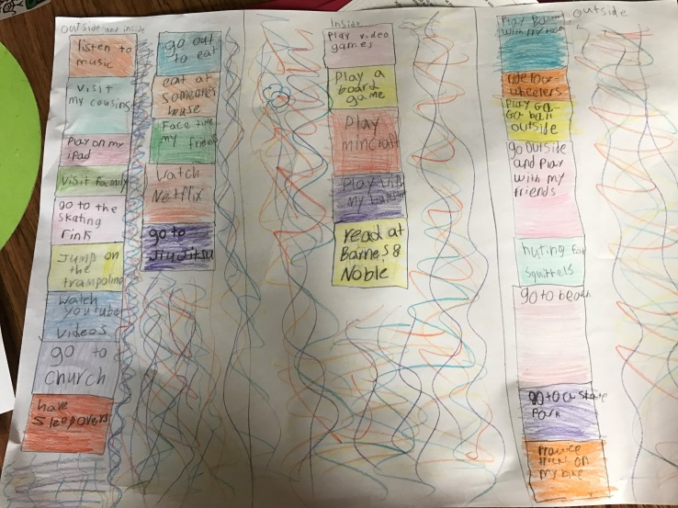

Organized by Outside and Inside Activities (Categories: Outside, Inside, Both)
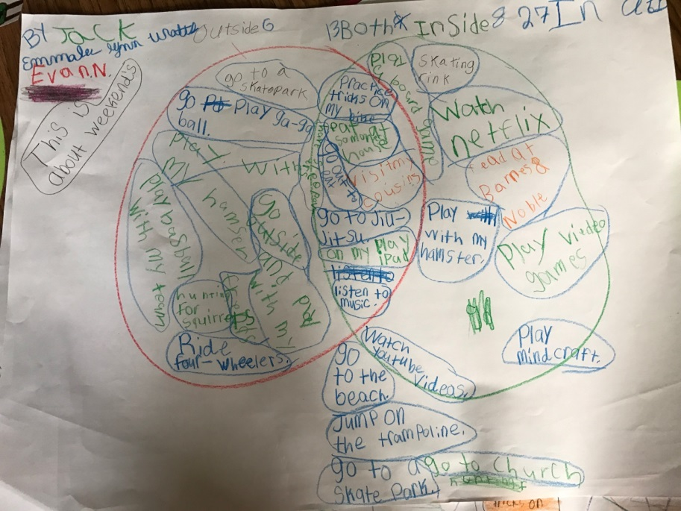

Organized by Location and Type of Activities (Categories: Outside, Indoors, Electronics, Somewhere Else)
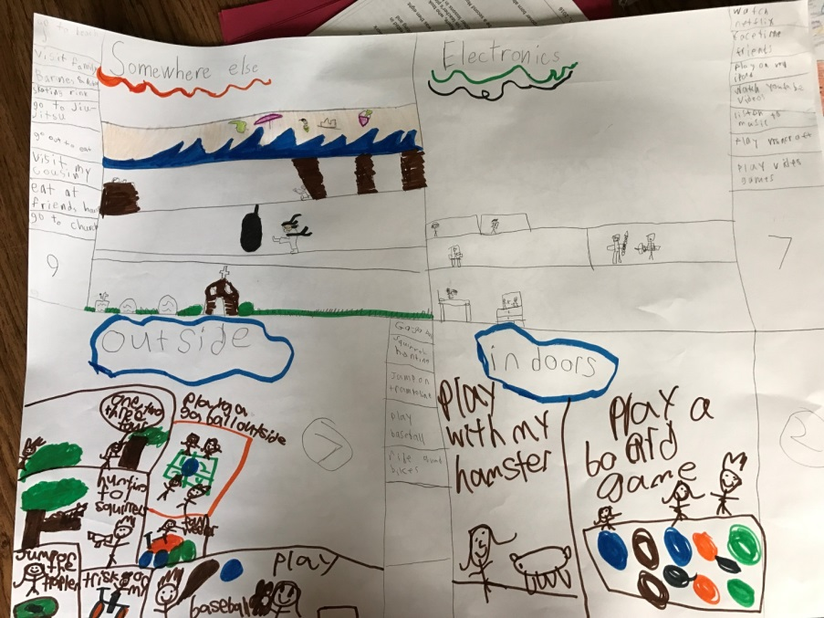

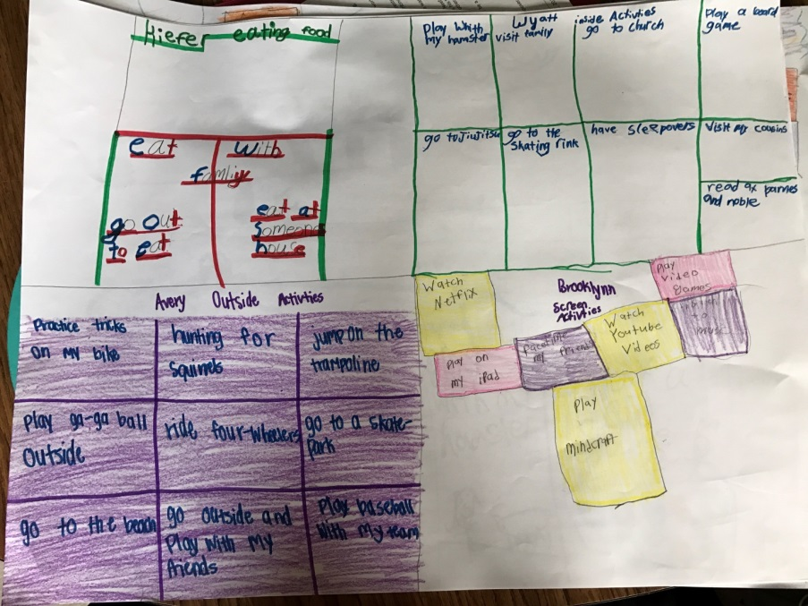
Organized by Types of Activities (Categories: Eating Food, Inside Activities, Outside Activities, Screen Activities)

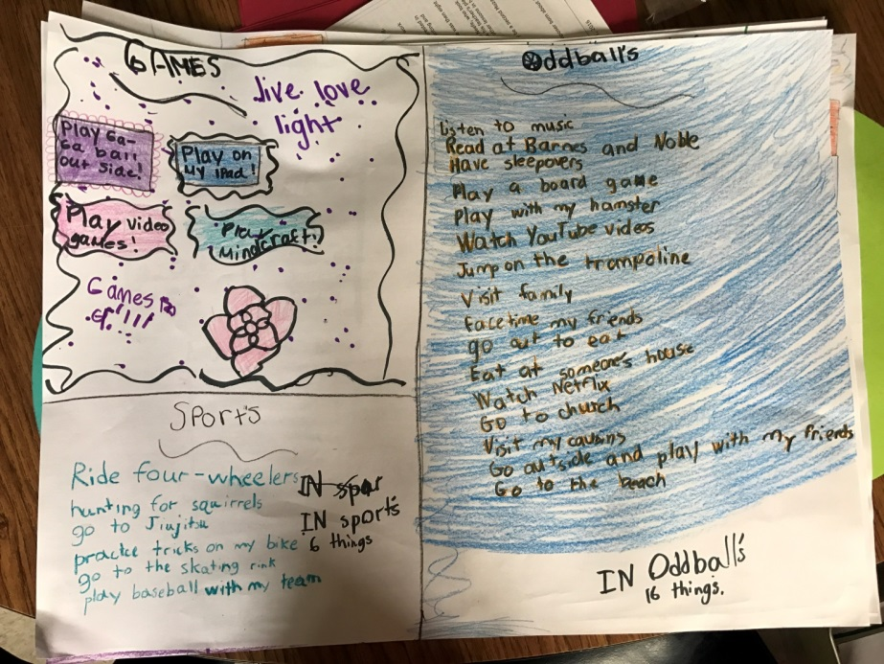
Organized by Types of Activities (Categories: Games, Sports, Oddballs)

