NC.4.MD.4
Getting to Know You
Domain | Measurement and Data
Cluster | Represent and interpret data.
Standard(s) | NC.4.MD.4 Represent and interpret data using whole numbers.  - Collect data by asking a question that yields numerical data.  - Make a representation of data and interpret data in a frequency table, scaled bar graph, and/or line plot.  - Determine whether a survey question will yield categorical or numerical data.
Materials | activity sheet, question strips, pencils, metric measuring tapes or rulers
Task | Students will be collecting data to represent, analyze, and interpret.  - Prior to the lesson, copy and cut apart question strips. Put strips in a bag or container.  - Students may work individually, with partners, or in small groups for this task. Be sure to have enough question strips so each student or group has one question.  - Allow each student or small group to randomly select a strip.  - The students should record the question on top of the handout.  - Allow students to interview all of their classmates, asking the questions from the strip.  - The students should use the collection portion of their handout to record the responses.  - Once all data have been collected, students will create a line plot on the handout to represent the data.  - Finally, students should answer the question “What does this data tell you about the students in our classroom?”  Things to consider:  - During the data collection phase, it is important to allow students to organize their data in whatever way that makes the most sense to them. Some possible examples of ways they may organize data include, but are not limited to: tables, tally marks, random numbers on the page, or lists of names with numbers beside the names. This will prove to be a good source for discussion later.  - In addition, when children are creating their line plots, pay attention to whether the child is including ticks on the number line to indicate all numbers in the range. Are the numbers appropriately spaced apart?

Rubric
Level I  Not Yet | Level II  Progressing | Level III  Meets Expectation
Student work exhibits 0-1 of the following characteristics:  - Correct number of data points on the line plot  - The X’s are drawn approximately at the same size  - Consistent value of the X’s in the line plot  - Appropriately spaced numbers on the line plot  - Analyzed data is correct | Student work exhibits 2-3 of the following characteristics:  - Correct number of data points on the line plot  - The X’s are drawn approximately at the same size  - Consistent value of the X’s in the line plot  - Appropriately spaced numbers on the line plot  - Analyzed data is correct | Student work exhibit 4-5 of the following characteristics:  - Correct number of data points on the line plot  - The X’s are drawn approximately at the same size  - Consistent value of the X’s in the line plot  - Appropriately spaced numbers on the line plot  - Analyzed data is correct
Standards for Mathematical Practice
1. Makes sense and perseveres in solving problems.
2. Reasons abstractly and quantitatively.
3. Constructs viable arguments and critiques the reasoning of others.
4. Models with mathematics.
5. Uses appropriate tools strategically.
6. Attends to precision.
7. Looks for and makes use of structure.
8. Looks for and expresses regularity in repeated reasoning.

Getting to Know You
Survey Question Slips
Duplicate and cut apart as necessary so that you have enough for each student to have a strip.
It is acceptable for more than one student to ask the same question.

How many kinds of pets do you have?
How many siblings do you have?
What is the length of your shoe?
How many teeth have you lost?
How many bones have you broken?
How many letters are in your first name?
How many sports do you play?
How many days a week do you stay up past 9:00pm?
How many siblings attend the same school as you?
How many years have you gone to this school?

Getting to Know You

My question is: _________________________________________________
Organize the data you collect in this space.

Represent your data in a line plot.

What does this data tell us about the students in our classroom?

Scoring Examples
Not Yet: Data was collected, but the student was unable to organize the data, use the data to create a line plot, or analyze the data.
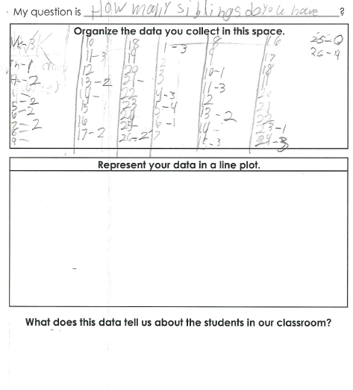

Progressing: The student represented each piece of data on the line plot, with appropriately spaced numbers. The student also analyzed the data correctly. However, this student did not arrange the data in numerical order and the Xs are different sizes for some data points.
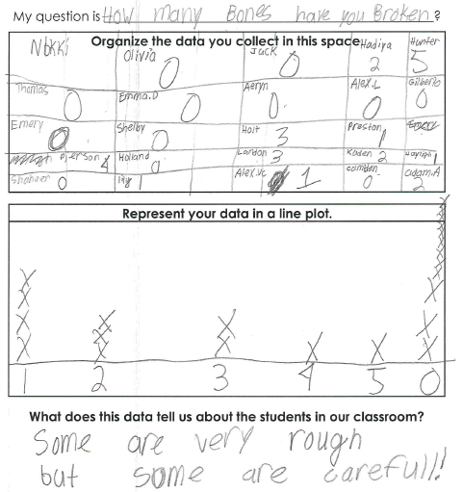

Meets Expectation: The student was able use the data collected to put the correct number of data points on the number line with appropriately spaced Xs. The student made each X represent one student. The student could interpret the data correctly.
