NC.4.MD.4
How High Did it Bounce?
Domain | Measurement and Data
Cluster | Represent and interpret data.
Standard(s) | NC.4.MD.4 Represent and interpret data using whole numbers.  - Collect data by asking a question that yields numerical data.  - Make a representation of data and interpret data in a frequency table, scaled bar graph, and/or line plot.  - Determine whether a survey question will yield categorical or numerical data.
Materials | paper, pencil, activity sheet
Task | How High Did it Bounce?  A class bounced a ball 18 times and recorded the data in a table.  Make a line plot to display the data.  Height in Meters  3 5 1 6 5 6  6 5 4 4 2 6  5 1 5 6 4 5  - How many balls bounced 3 meters or higher? (15)  - How many balls bounced fewer than 3 meters? (3)  - Based on the data, if we bounced the ball another time, what is the height likely to be? Why? (5 or 6 because in the 18 times we have bounced the ball, it has bounced to 5-6 meters more often than any other distance.)

Rubric
Level I  Not Yet | Level II  Progressing | Level III  Meets Expectation
Student work exhibits 0-1 of the following characteristics:  - Correct number of data points on the line plot  - The X’s are drawn approximately at the same size  - Consistent value of the X’s in the line plot  - Appropriately spaced numbers on the line plot  - Analyzed data is correct | Student work exhibits 2-3 of the following characteristics:  - Correct number of data points on the line plot  - The X’s are drawn approximately at the same size  - Consistent value of the X’s in the line plot  - Appropriately spaced numbers on the line plot  - Analyzed data is correct | Student work exhibits 4-5 of the following characteristics:  - Correct number of data points on the line plot  - The X’s are drawn approximately at the same size  - Consistent value of the X’s in the line plot  - Appropriately spaced numbers on the line plot  - Analyzed data is correct

Standards for Mathematical Practice
1. Makes sense and perseveres in solving problems.
2. Reasons abstractly and quantitatively.
3. Constructs viable arguments and critiques the reasoning of others.
4. Models with mathematics.
5. Uses appropriate tools strategically.
6. Attends to precision.
7. Looks for and makes use of structure.
8. Looks for and expresses regularity in repeated reasoning.

How High Did it Bounce?

A class bounced a ball 18 times and recorded the data in a table.
Make a line plot to display the data.

Height in Meters
3 | 5 | 1 | 6 | 5 | 6
6 | 5 | 4 | 4 | 2 | 6
5 | 1 | 5 | 6 | 4 | 5

0 1 2 3 4 5 6 7

A) How many balls bounced 3 meters or higher?

B) How many balls bounced fewer than 3 meters?

C) Based on the data, if we bounced the ball another time, what is the height likely to be? Why?

Scoring Examples

Not Yet: The data are incorrectly plotted. The Xs are not consistent or the same size. Calculations and analysis are incorrect and not reasonable.
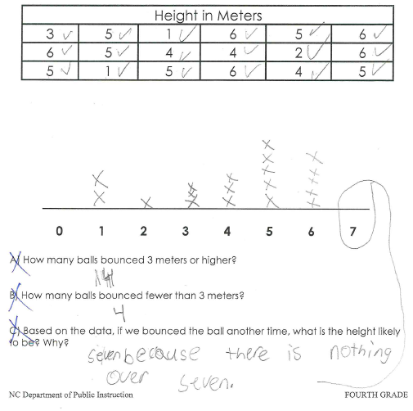

Progressing: The data are plotted correctly on the line plot, but the student incorrectly analyzed the data.
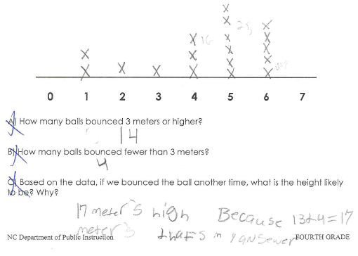

Meets Expectation: Data points are plotted correctly. The Xs are consistent and the same size. Analysis of the data is correct and an explanation was offered for Part C.
