NC.4.MD.4
Let’s Get Physical
Domain | Measurement and Data
Cluster | Represent and interpret data.
Standard(s) | NC.4.MD.4 Represent and interpret data using whole numbers.  - Collect data by asking a question that yields numerical data.  - Make a representation of data and interpret data in a frequency table, scaled bar graph, and/or line plot.  - Determine whether a survey question will yield categorical or numerical data.
Materials | activity sheet, pencils
Task | Last week, Mr. Cecil’s class started learning about the importance of good nutrition and exercise. They decided to keep track of the number of laps each child ran on the track for the week. Mr. Cecil listed the number of laps on a piece of notebook paper.  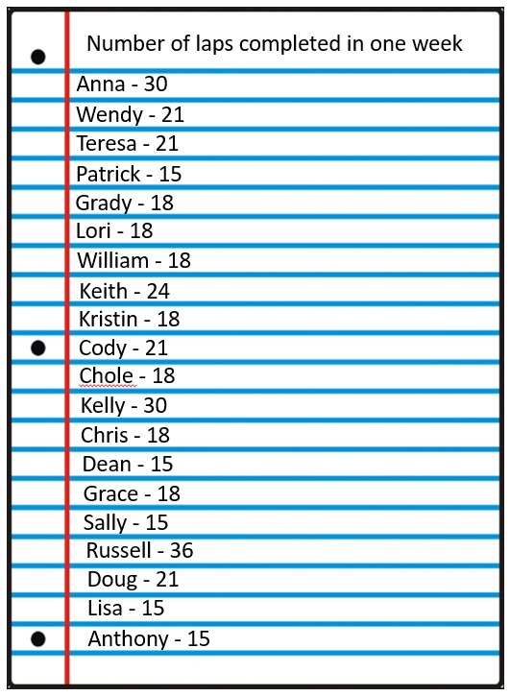  Part 1: Students will create a frequency table to help you analyze the collected data.  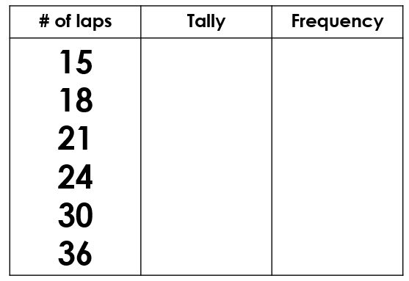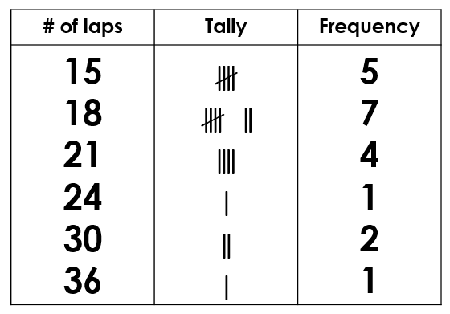  Part 2: Students will analyze the data by responding to the following questions:  1. What was the greatest number of laps that was run? (36)  2. What was the smallest number of laps? (15)  3. How many laps did most students run? (18)  4. What was the total number of laps run by Mr. Cecil’s class? (405)  Extension: If 6 laps around the track equals 1 mile, how many students ran at least 5 miles in a week?

Rubric
Level I  Not Yet | Level II  Progressing | Level III  Meets Expectation
Student work exhibits only 1 of the following characteristics:  - Correct number of tally marks in the table  - Correct number listed in the frequency column of the table  - Answers questions correctly | Student work exhibits 2 of the following characteristics:  - Correct number of tally marks in the table  - Correct number listed in the frequency column of the table  - Answers questions correctly | Student work exhibits all of the following characteristics:  - Correct number of tally marks in the table  - Correct number listed in the frequency column of the table  - Answers questions correctly

Standards for Mathematical Practice
1. Makes sense and perseveres in solving problems.
2. Reasons abstractly and quantitatively.
3. Constructs viable arguments and critiques the reasoning of others.
4. Models with mathematics.
5. Uses appropriate tools strategically.
6. Attends to precision.
7. Looks for and makes use of structure.
8. Looks for and expresses regularity in repeated reasoning.

Let’s Get Physical
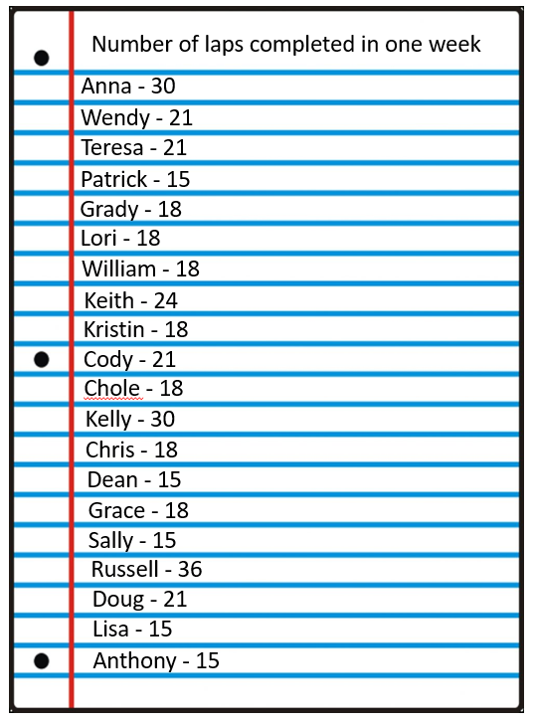
Last week, Mr. Cecil’s class started learning about the importance of good nutrition and exercise. They decided to keep track of the number of laps each child ran on the track for the week. Mr. Cecil listed the number of laps on a piece of notebook paper.
Create a frequency table to help you analyze the data.
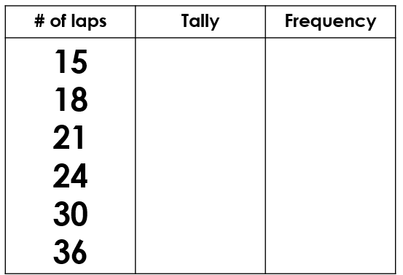
Help Mr. Cecil’s class analyze the data by answering the questions below:
1. What was the greatest number of laps that was run? _________
2. What was the smallest number of laps? _________
3. How many laps did most students run? _________
4. What was the total number of laps run by Mr. Cecil’s class? _________
Extension: If 6 laps around the track equals 1 mile, how many students ran at least 5 miles in a week?

Scoring Examples
Not Yet: The student sometimes tallied correctly, but was unable to write the correct frequency or analyze the data correctly.
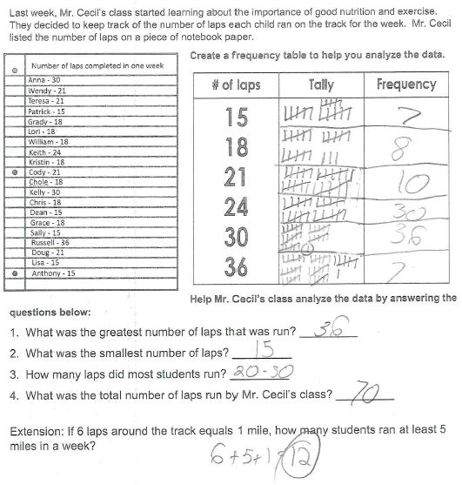

Progressing: The student tallied correctly and wrote the correct number in the frequency table for each number of laps. However, the student did not answer all questions correctly.
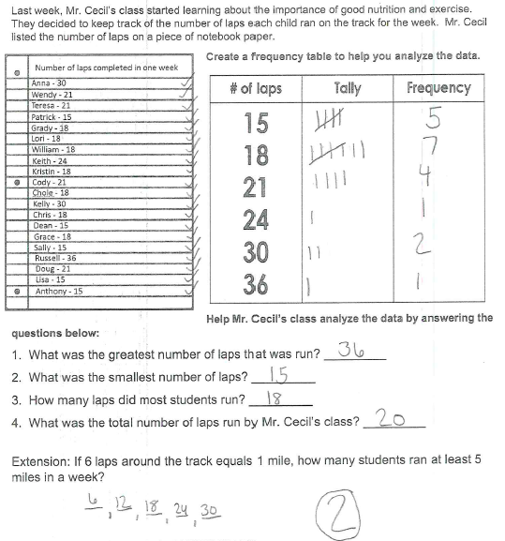

Meets Expectation: The student tallied correctly and wrote the correct number in the frequency table for each number of laps. The student correctly analyzed the data from the frequency table.
