NC.4.MD.4
Migrating Monarchs
Domain | Measurement and Data
Cluster | Represent and interpret data.
Standard(s) | NC.4.MD.4 Represent and interpret data using whole numbers.  - Collect data by asking a question that yields numerical data.  - Make a representation of data and interpret data in a frequency table, scaled bar graph, and/or line plot.  - Determine whether a survey question will yield categorical or numerical data.
Materials | activity sheet, pencils
Task | Every September, people from all over North Carolina visit the Blue Ridge Parkway to witness the Monarch Butterfly migration. Park Ranger Zaara collects data about the butterflies in order to learn more about them. Study the frequency table in her journal.  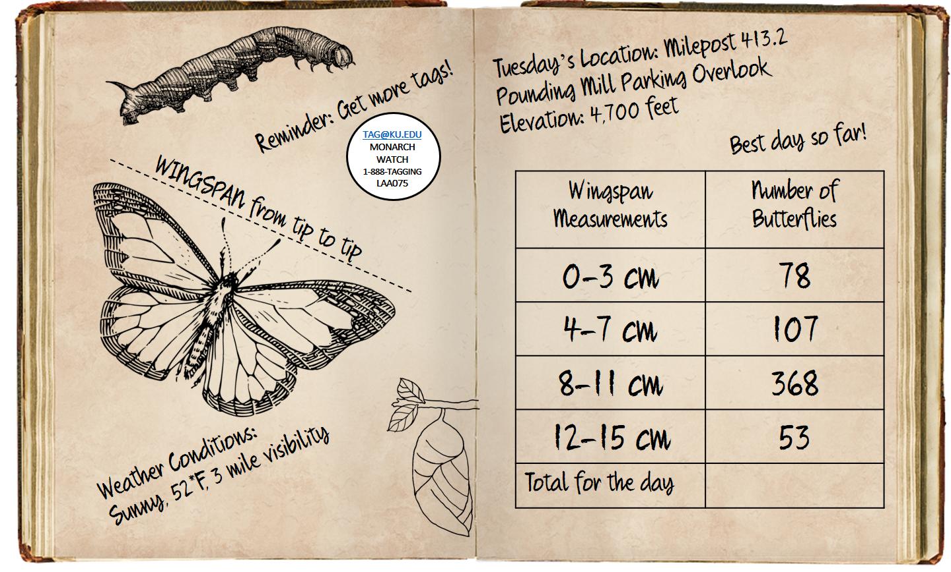  After studying the information in the journal, students will analyze the data by responding the following questions:  1. Which range of wingspan measurements did most of the butterflies have? (8-11 cm)  2. Which range of wingspan measurements did the fewest butterflies have? (12-15 cm)  3. How many total butterflies did Ranger Zaara see on Tuesday? (606)  4. Another butterfly just landed! Based on the data, what would you predict its wingspan to be? Justify your answer. (8-11cm, because more of the collected butterflies had that range of wingspans)
Rubric
Level I  Not Yet | Level II  Progressing | Level III  Meets Expectation
Student answers 0-1 questions correctly. | Student answers 2-3 questions correctly. | Student answers all of the questions correctly.
Standards for Mathematical Practice
1. Makes sense and perseveres in solving problems.
2. Reasons abstractly and quantitatively.
3. Constructs viable arguments and critiques the reasoning of others.
4. Models with mathematics.
5. Uses appropriate tools strategically.
6. Attends to precision.
7. Looks for and makes use of structure.
8. Looks for and expresses regularity in repeated reasoning.
Migrating Monarchs

Every September, people from all over North Carolina visit the Blue Ridge Parkway to witness the Monarch Butterfly migration. Park Ranger Zaara collects data about the butterflies in order to learn more about them. Study the frequency table in her journal.
After studying the information in the journal, analyze the data by responding the following questions:
1. Which range of wingspan measurements did most of the butterflies have? _____________________________________________________________________________
2. Which range of wingspan measurements did the fewest butterflies have? _____________________________________________________________________________
3. How many total butterflies did Ranger Zaara see on Tuesday? ______________
4. Another butterfly just landed! Based on the data, what would you predict its wingspan to be? Justify your answer. __________________________________________________________________________________________________________________________________________________________
Scoring Examples
Not Yet: The student did not know how to interpret the frequency table. The student added the number of butterflies and added it to each wingspan measurement. The student added all sums to answer Part 3. It is unclear how the student determined the numbers for Part 4.
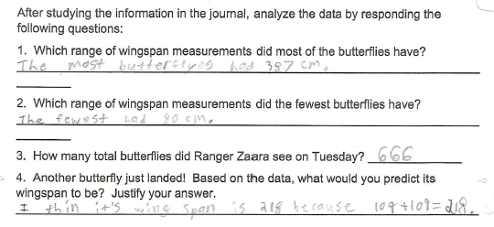
Progressing: All parts are correct, except the last question. The student could not infer from the data, but instead looked for a pattern.
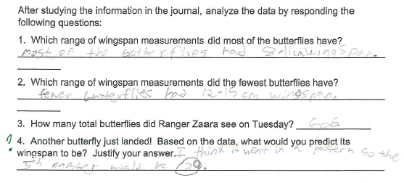
Meets Expectation: All parts are correct, and there is a logical explanation for the prediction in Part 4.
