NC.4.MD.4
Moon Phases
Domain | Measurement and Data
Cluster | Represent and interpret data.
Standard(s) | NC.4.MD.4 Represent and interpret data using whole numbers.  - Collect data by asking a question that yields numerical data.  - Make a representation of data and interpret data in a frequency table, scaled bar graph, and/or line plot.  - Determine whether a survey question will yield categorical or numerical data.
Materials | activity sheet, graph or blank paper, pencils, colored pencils (optional)
Task | Mr. Potter’s class has been researching moon phases in science. They have created the chart below that shows the dates of the full moon, new moon, first quarter moon, and last quarter moon for each month. Using the data in the chart, determine how many times during the year each moon phase occurred. Create a bar graph to display your findings.  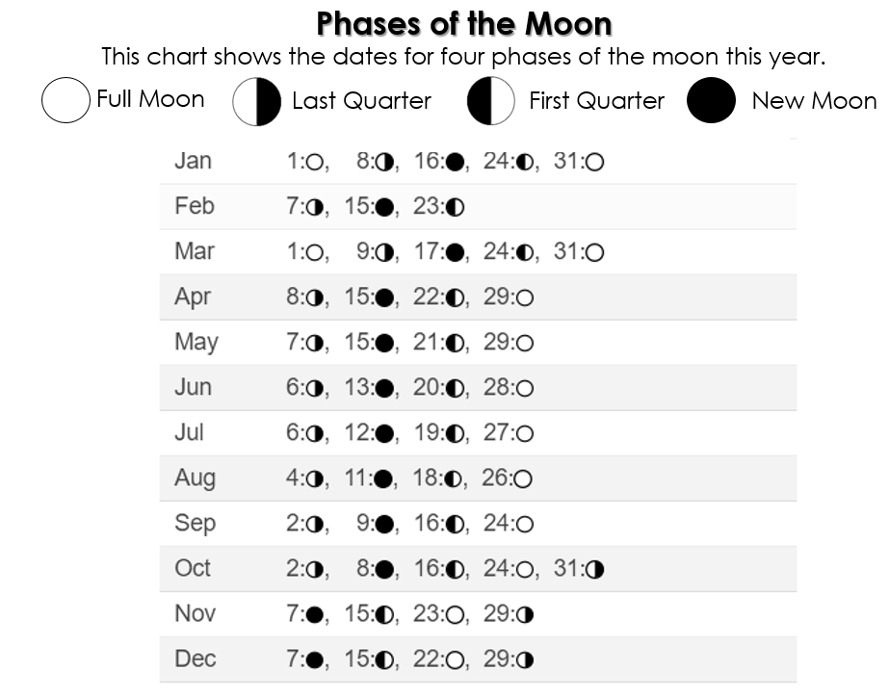  Part 1: Students will create a bar graph that displays the data. They will need to include a title and labels for the x-axis and y-axis. In this task, students will have to determine several things:  - Will the graph exhibit data vertically (with moon phases on the x-axis and the number of occurrences on the y-axis) or horizontally (with the number of occurrences on the x-axis and the moon phases on the y-axis)?  - What is the best scale (1’s? 2’s? 5’s?)  *In order to preserve the high cognitive demand of the task, allow students to explore these options without requiring a mandated procedure. If students are made to follow a set of rules (ex. must be horizontal, must use scale of 1), the cognitive demand decreases. In addition, all of the graphs end up looking the same, which limits discussion.  *This data represents discrete, rather than continuous data. Therefore, the bars on the bar graph should have space between them and should not touch one another.  Below are examples of possible student responses to Part 1:  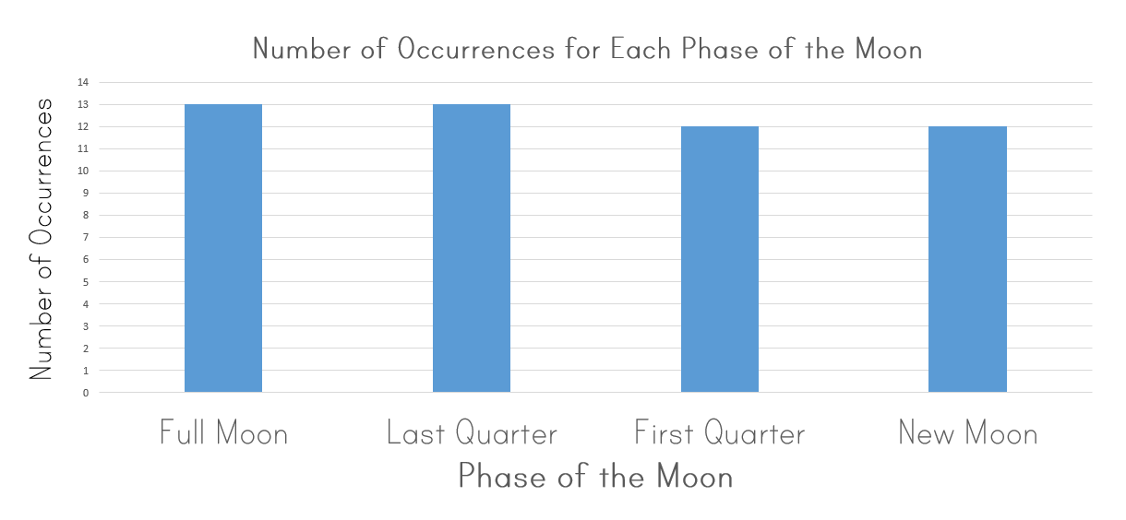  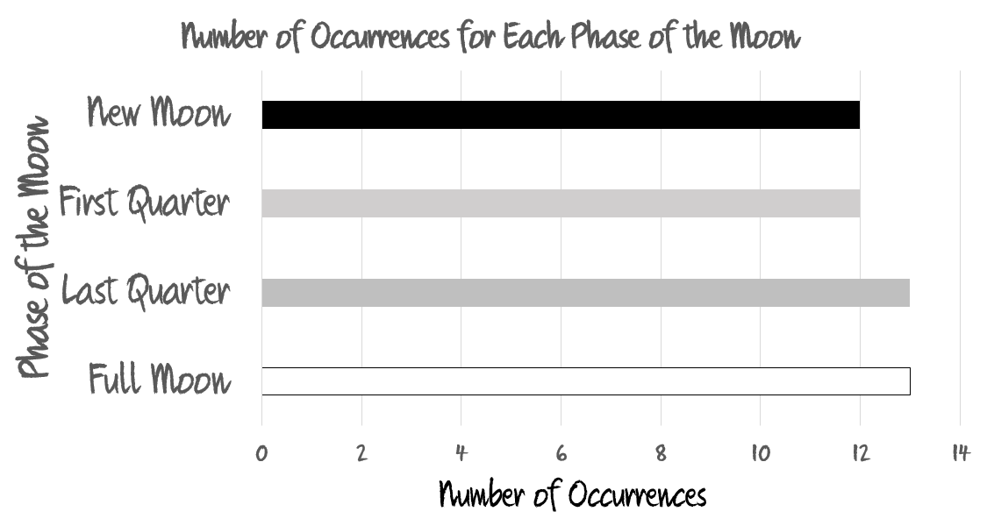  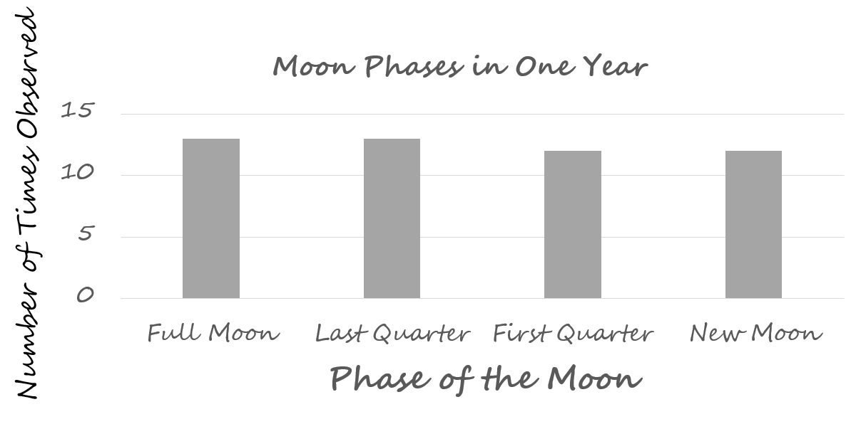  *In these examples we can see a variety of ways that students could possibly represent data. Not only do they have options with choosing a horizontal vs. vertical graph, they must also decide the scaling of the graph (1’s, 2’s, 5’s). It is by allowing them to choose their methods that the teacher can begin to get a sense of what a student deems important (Should my graph show the moon phases in order of frequency? Should my graph show moon phases in alphabetical order? Should my graph show moon phases in the order they appear on the chart?). Additionally, a teacher can get a sense of a child’s mathematical understandings and misconceptions.  *As you are observing students creating graphs, make some decisions as to which graphs you are going to highlight in discussions later in the lesson. Consider pulling graphs with different scales (1’s, 2’s, 5’s) and different orientations (horizontal, vertical). It is acceptable to pull incorrect graphs if you think that the resulting discussions will help to clear up misconceptions later.  Part 2: Students will analyze the data by responding the following questions:  1. How many full moons occurred during the year? (13)  2. How many new moons occurred during the year? (12)  3. Summarize what you learned about these four phases of the moon by analyzing this data. (Every year is going to have at least 12 full moons, new moons, first quarter moons, last quarter moons. Sometimes, there will be more instances depending on the number of days in the month.)  4. Use what you know about the phases of the moon to explain why the facts you mentioned in question 3 happen. (It takes about one month (technically 27.3 days) for the moon to orbit the earth. As the moon is moving around the earth, we see different parts of the moon illuminated.)  5. What scale did you choose to use when creating your graph? (answers will vary)  6. Why did you choose to use that scale? (answers will vary)  7. What challenges did you encounter as you created your graph? What did you do to solve these challenges? (answers will vary)  Part 3: Follow-up discussion  Display 4-6 graphs around the room and allow students to do a gallery walk to study the graphs. Make sure that the graphs you display feature a variety of representations, including different scales and orientations. Ask students to consider these prompts as they study the graphs:  1. How does scale influence the graph?  2. In this case, is one scale easier to read than another?  3. In this case, does the orientation of the data matter?  4. Do any of the graphs make you realize something that you didn’t consider when you were creating your own graph?  Once students have had a chance to reflect on the questions during the gallery walk, call them back together and begin your discussion of these prompts. As a result of your discussion, you want students to understand:  - The scale is important.  - In using 1’s and 2’s, it is easier to interpret the value of the bars. Because the maximum number we are graphing is 13, we do not need to have a scale as large as 5 to be sure to include all of the data.  - If possible, place a graph with a small scale (1’s or 2’s) beside a graph with a larger scale (5’s). Prompt: Look at the height (or length) of the bars. Are they the same? (No) Is the number of phases the same? (Yes) Why are the lengths different? (The scale is different.) How can this unintentionally lead to a misunderstanding of the data or values in the bars? (People could think that because the size of the bars is different, the value of the bars in different.)  - Follow up with: Should we always use a small scale? (No) Can you think of a time when a large scale is more appropriate? (When dealing with numbers that are spread further apart.)  - Orientation of the bars is not always important.  - In this instance, it is not important to orient the bars in the graph horizontally or vertically. The data you are displaying is not measurement data. For instance, if you were displaying height of plants or distance run, the orientation helps someone to infer the situation being represented by the graph.
Rubric
Level I  Not Yet | Level II  Progressing | Level III  Meets Expectation
Student work exhibits 0-1 of the following characteristics:  - Correct representation of data with the bars in the graph.  - Title of graph and both axes are correctly labeled.  - Able to interpret the graph by answering the all of the questions. | Student work exhibits 2 of the following characteristics:  - Correct representation of data with the bars in the graph.  - Title of graph and both axes are correctly labeled.  - Able to interpret the graph by answering all of the questions. | Student work exhibits all of the following characteristics:  - Correct representation of data with the bars in the graph.  - Title of graph and both axes are correctly labeled.  - Able to interpret the graph by answering the questions.

Standards for Mathematical Practice
1. Makes sense and perseveres in solving problems.
2. Reasons abstractly and quantitatively.
3. Constructs viable arguments and critiques the reasoning of others.
4. Models with mathematics.
5. Uses appropriate tools strategically.
6. Attends to precision.
7. Looks for and makes use of structure.
8. Looks for and expresses regularity in repeated reasoning.

Moon Phases

Mr. Potter’s class has been researching moon phases in science. They have created the chart below that shows the dates of the full moon, new moon, first quarter moon, and last quarter mon for each month.

Using the data in the chart, determine how many times during the year each moon phase occurred. Create a bar graph to display your findings.
After studying the information in the journal, analyze the data by responding the following questions:

1. How many full moons occurred during the year? ____________
2. How many new moons occurred during the year? ____________
3. Summarize what you learned about these four phases of the moon by analyzing this data. ____________________________________________________________________________________________________________________________________________________________________________________________________
4. Use what you know about the phases of the moon to explain why the facts you mentioned in question 3 happen. ____________________________________________________________________________________________________________________________________________________________________________________________________
5. What scale did you choose to use when creating your graph? ____________
6. Why did you choose to use that scale? ________________________________________________________
7. What challenges did you encounter as you created your graph? What did you do to solve these challenges?________________________________________________________________________________________________________________________________________________________________________________________
Scoring Examples
Not Yet: The scale is not equally spaced in the graph. Data is graphed incorrectly, with no labels. The data is not analyzed correctly.
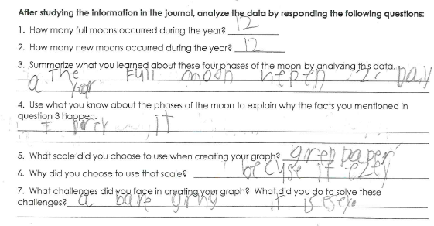
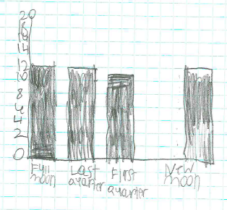
Progressing: The student miscounted the number of last quarter moons, which makes some data incorrect. The graph is labeled correctly, with three of the four moon phases graphed correctly. The graph’s scale is inconsistently spaced.
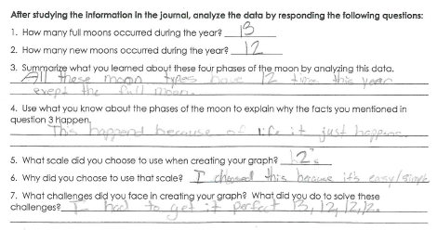
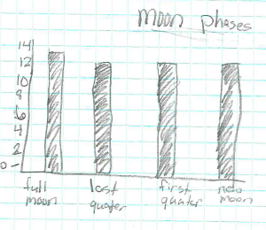

Meets Expectation: The data is represented and labeled correctly and is analyzed correctly.
