Mystery Number
In this lesson, students explore place value concepts with two-digit numbers as they build and discuss numbers with more ones than tens and more tens than ones.

NC Mathematics Standard:
Understand place value.
NC.1.NBT.2 Understand that the two digits of a two-digit number represent amounts of tens and ones.
- Unitize by making a ten from a collection of ten ones.
- Model the numbers from 11 to 19 as composed of a ten and one, two, three, four, five, six, seven, eight, or nine ones.
- Demonstrate that the numbers 10, 20, 30, 40, 50, 60, 70, 80, 90 refer to one, two, three, four, five, six, seven, eight, or nine tens with 0 ones.

Additional/Supporting Standard:
Extend and recognize patterns in the counting sequence.
NC.1.NBT.7 Read and write numerals and represent a number of objects with a written numeral to 100.

Standards for Mathematical Practice:
2. Reason abstractly and quantitatively
3. Construct viable arguments and critique the reasoning of others
4. Model with mathematics
5. Use appropriate tools strategically
7. Look for and make use of structure

Student Outcomes:
- I can create a two-digit number with ones and tens.
- I can look for patterns and use various strategies to create two-digit numbers.
- I can explain my own thinking and discuss the thinking of others.

Math Language:
place value tens ones model

Materials:
- Materials and manipulatives to use for building numbers such as ten frames, unifix cubes, or connecting cubes, tens and ones mats
- Explore Problem: Rachel’s Number
- Additional Activity Sheet: Brian’s Number
- Exit Ticket: Leah’s Number

Advance Preparation:
- Copies of student problems (and copies to display for all to see)
- Gather materials and manipulatives for student use

Launch:
- Introduce Problem (5 minutes)
Explain that Rachel’s class was playing a game called Mystery Number. Her teacher gave a clue for a two-digit number that confused the class. We will help Rachel figure out the mystery number. Display the problem and read the problem aloud.

Rachel has a group of tens and ones. She has more ones than tens. What number could she have?

Explore:
- Solving the Problem (15 minutes)
Organize students for problem solving and pass out math manipulatives that can be used for building numbers. Provide each student with an activity sheet including the problem. Read the problem aloud again. Encourage students to talk about the problem and begin solving with their materials while verbally explaining the strategies they are using with their partner. As students discuss and work, watch and listen carefully to see how students solve the task.
How are the students solving the task?
What manipulatives, drawings, or words are the students using to represent the problem?

If students need prompting, ask some of the following questions to focus their thinking or clarify their work:
- How did you begin working on the problem?
- How did you get that number?
- What did you partner try?
- Can you convince me that your answer makes sense?

As students work, carefully select students to present their thinking to the class. Look for students who used various strategies. Also look for students who tried a strategy first and then were unsuccessful but tried a second strategy and were successful. Look for strategies that will generate discussion and help other students move toward a deeper understanding of place value with manipulatives and words.

Discuss:
- Discussion of Solutions (20 minutes)
Bring the students back together and have the selected students/groups share their strategies for solving the task. As students are sharing you can record their thinking for others to see on chart paper or on the board. You might start with the more concrete ways such as tens frames or unifix cubes and move on to more abstract approaches. Ask questions such as:

- Was there only one way to solve this problem? How do you know?
- What was similar about the strategies?
- How is ___’s. method similar to (or different from) ____’s method?
- Can you explain your representation?

Notes:
- The manipulatives and strategy to use for this lesson will depend on the time of year. If it is the beginning of the year, model and use ten frames to build your number and write your number. If it is the end of the year, you may model and use base ten blocks or hundred charts to find and explain numbers.
- You can show students how to use tens and ones mats to organize their thinking. Teach into this strategy if no one used it.
- You may also represent the numbers using unifix cubes or counters. Show how you know that you need to put more counters or cubes on the ones side of the tens and ones mat because the problem says that Rachel has more ones.

Additional Activities (if needed)
- Practice Problem (15-20 minutes)
Now that students have seen a strategy using a tens and ones mat. Give the students the following problem.

Brian has a group of tens and ones. He has more tens than ones. What number could he have?

Show your thinking using words numbers and/or pictures.

Circulate through the room while students are working to solve the problem, prompting and questioning as needed to help students complete the task. As students are working, carefully make notes selecting students to share their various strategies to the class. Look for students who used multiple strategies. Also look for strategies that will generate a discussion and help students move toward a deeper understanding of place value. Students may represent their thinking in various ways – they are not required to use only ten frames and counters. Encourage those children who are struggling or unable to represent their thinking to use ten frames and counters.

If students get stuck you could ask questions such as:
- What facts do you have?
- How might using the tens and ones mat help?
- What do you already know that could help you figure out what to do?
- Can you guess and check?

Once all students have had the opportunity to show their thinking using the strategy of organizing with tens and ones mats, allow students to share what they learned and what was tricky for them. Share a couple of examples of what you saw students doing to show their thinking. If time allows, students can share their own work. Further discussion could be prompted by using questions such as:
- What patterns do you notice?
- What other possible answers could there be?
- What other way could you represent your solution?

Evaluation of Student Understanding
Informal Evaluation:
Observe and monitor students as they are solving problems using place value materials. Notice if students are
- using language of tens and ones
- representing the numbers correctly with manipulatives, drawings, numbers, or words
- explaining how their number makes sense with the problem

Formal Evaluation/Exit Ticket: (10 minutes)

Leah has a group of cubes. When she counted them she had more ones than tens. What number might she have?

Explain your thinking using words, numbers, and/or pictures.

Meeting the Needs of the Range of Learners
Intervention:
- You could give students a group of cubes or counters that you have pre-counted. Have students place one cube or counter in each space on a ten frame. Count the number and then write the number and look to see if you have more ones or more tens. Relate back to the problem of to determine if there should be more tens or ones.
- Students might also be given a number range. Saying that Leah’s number is less than 20.

Extension:
- Allow students to come up with multiple numbers for the problem.
- Have students write an equation to show their number in expanded form.

Possible Misconceptions/Suggestions:
Possible Misconceptions | Suggestions
Students might write numbers opposite of what their picture shows. | Make sure that students go back and count their numbers and then write it to match.
Students might call tens “ones” and ones “tens.” | Go back to tens frames and build the teen numbers and talk about how many tens and how many ones are there

Special Notes:
- This task is one that can and should be repeated throughout the school year. The time of year will determine what type of manipulatives and what number range students will use.

Possible Solutions:
- Students may use a variety of manipulatives, drawings, and/or strategies to show their thinking. Some examples of representations are shown below.
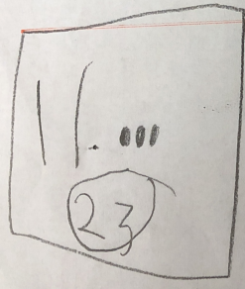
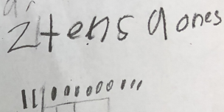
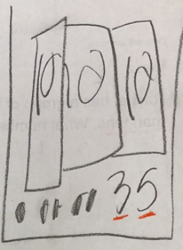

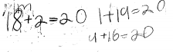
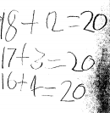
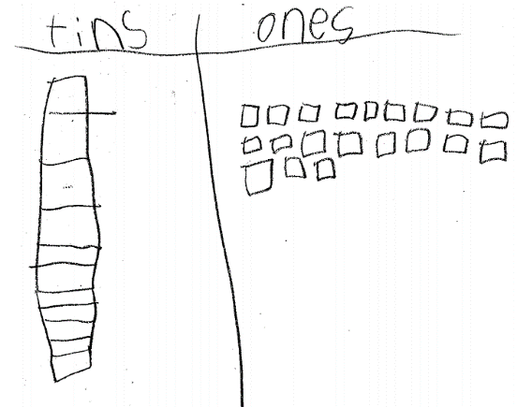
Activity Sheet: Rachel’s Number
Name: __________________________________________
Rachel has a group of tens and ones. She has more ones than tens. What number could she have?
Show your thinking using words, numbers, and/or pictures.

______________

Activity Sheet: Rachel’s Number
Name: __________________________________________
Rachel has a group of tens and ones. She has more ones than tens. What number could she have?
Show your thinking using words, numbers, and/or pictures.

______________
Additional Activity: Brian’s Number
Name: __________________________________________
Brian has a group of tens and ones. He has more tens than ones. What number could he have?

Show your thinking using words, numbers, and/or pictures.

______________

Exit Ticket
Name: __________________________________________
Leah has a group of cubes. When she counted them she had more ones than tens. What number might she have?

Show your thinking using words, numbers, and/or pictures.

______________

