Quick Images with Two-Digit Numbers

In this lesson, students build fluency with recognizing and creating representations of numbers within 100. Students deepen their place value understanding as they work with ten frame cards. There are several variations built into the lesson for number ranges and response options.

NC Mathematics Standard:
Understand place value.
NC.1.NBT.2 Understand that the two digits of a two-digit number represent amounts of tens and ones.
• Unitize by making a ten from a collection of ten ones.
• Model the numbers from 11 to 19 as composed of a ten and one, two, three, four, five, six, seven, eight, or nine ones.
• Demonstrate that the numbers 10, 20, 30, 40, 50, 60, 70, 80, 90 refer to one, two, three, four, five, six, seven, eight, or nine tens, with 0 ones.

Additional/Supporting Standards:
Extend and recognize patterns in the counting sequence.
NC.1.NBT.1 Count to 150, starting at any number less than 150.

Standards for Mathematical Practice:
2. Reason abstractly and quantitatively.
3. Construct viable arguments and critique the reasoning of others.
4. Model with mathematics.
7. Look for make use of structure.

Student Outcomes:
- I can identify a two-digit number based on the amounts of tens and ones.
- I can create a representation of a two-digit number using ten frame cards.

Math Language:
What words or phrases do I expect students to talk about during this lesson?
Digit, ones, place, tens, value,

Materials:
- ten frame cards
- hundred boards
- number cards, connecting cubes or base ten blocks (optional)

Advance Preparation:
- Gather materials and make copies

Launch:
1. Introduction to Quick Images (5-10 minutes)
Pass out ten frame cards to the students.
They will be making the same image that you show to the class on ten frame cards.

Depending on your students’ abilities, your representation may be:
- Level 1: Only 1 ten frame that is partially filled (1-9 dots)
- Level 2: Only full ten frames (multiples of ten)
- Level 3: A combination of full ten frames and 1 partially filled ten frame (up to 99)

Show the image for students to see for 5 seconds.
Give students 20 seconds to begin to make the representation using their own cards. Show the image again for 5 seconds. Allow the students to complete their representation.

When discussing students’ work, suggested questions include:
- How many tens and/or ones were in my picture?
- How many total dots do we have?
- What strategy did you use to make your image?

Explore:
2. Quick Images with Partners (10-15 minutes)

Students will continue the Quick Image activity with partners. Differentiate your students by telling them which levels they should be playing.

As students are working, observe:
- Can students accurately identify the number of tens and/or ones?
- Can students accurately identify the total number of dots?

Variations based on students’ levels and teacher’s choice:
- Give students connecting cubes or base ten blocks. After viewing the Quick Image, they then must build the number with those materials.
- Give students a hundred board. After viewing the Quick Image, they then must locate the number on a hundred board.
- Give students number cards. After viewing the Quick Image, they then must create the number with number cards.

Discuss:
3. Discussing Quick Images (5-10 minutes)
After Quick Images has been played, discuss the game with the students.
Suggested Questions:
- What strategy did you use when you played the game?
- What was a difficult part of the game?

If time permits, give them another 1-3 images to work with.
For each image, ask:
- What strategy did you use?
- Do you feel faster at copying my image compared to the beginning of today?

Additional Activities (Optional)
4. Finding Numbers on the Hundreds Board
Students need a hundred board and ten frame cards. One partner makes a two-digit number using ten frame cards. The partner then must find it on the hundreds board. Variation: One partner says a two-digit number and the other partner must make it out of ten frame cards.

5. Comparing Numbers
Choose 2 different number cards and make both two-digit numbers that can be created. For example, a 1 and a 7 could make 17 and 71. Build both numbers with place value cards. Students need to determine which 2-digit number is larger and explain their reasoning.

Evaluation of Student Understanding
Informal Evaluation:
During Quick Images, observe students to see:
- Can students accurately identify the number of tens and/or ones?
- Can students accurately identify the total number of dots?

Formal Evaluation/Exit Ticket:
Show students a quick image and have them either write the number down or identify it on a hundred board.

Meeting the Needs of the Range of Learners
Intervention:
Work with students in a small group at one of the levels below until they are successful. Then move to a higher level. Also, vary the response options as listed in “Explore” section.
- Level 1: Only 1 ten frame that is partially filled (1-9 dots)
- Level 2: Only full ten frames (multiples of ten)
- Level 3: A combination of full ten frames and 1 partially filled ten frame (up to 99)

Extension:
Students who are successful in working with numbers within one hundred may continue practice activities to build fluency with that skill. It is not an expectation of first grade, but these students may be ready to explore the idea that ten groups of ten represent one hundred and attempt to build numbers between 100-150.

Possible Misconceptions/Suggestions:
Possible Misconceptions | Suggestions
Students may not accurately count the number of counters in the quick image OR may not accurately create or copy the picture. | Work with students on counting strategies such as counting by 10s for each full ten frame, and counting and checking their counting for partially filled ten frames.
Students may not see a ten as a group of 10 ones. | Give students experiences with snap cubes and counters on a ten frame to work with the idea that a ten is composed of 10 ones.
If students are hunting all over the 100 board for the number, students may not realize that a row on the 100s chart is also a group of 10. | Give students practice laying the base ten blocks (tens on the row, units on #s) or connecting cube ten sticks on the hundreds board, or circle the groups of tens and ones with a dry erase marker on a hundred board.

Hundreds Board

Ten Frame Cards
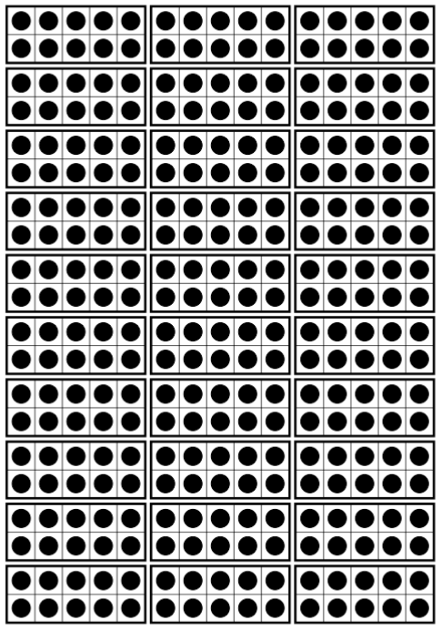
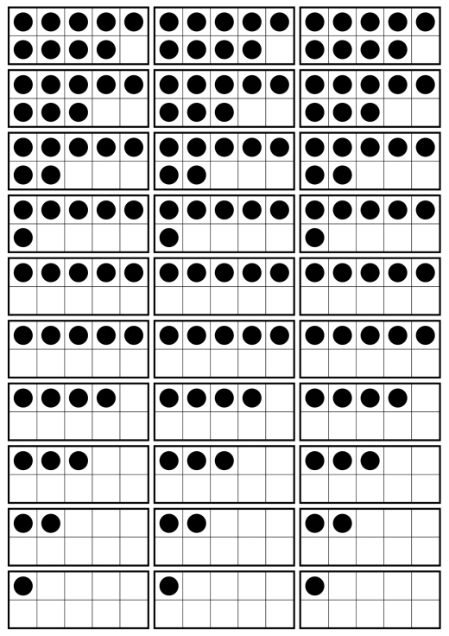
Primary Number Cards

0 | 1 | 2 | 0 | 1 | 2
3 | 4 | 5 | 3 | 4 | 5
6 | 7 | 8 | 6 | 7 | 8
9 | 0 | 1 | 9 | 0 | 1
2 | 3 | 4 | 2 | 3 | 4

5 | 6 | 7 | 5 | 6 | 7
8 | 9 | 0 | 8 | 9 | 0
1 | 2 | 3 | 1 | 2 | 3
4 | 5 | 6 | 4 | 5 | 6
7 | 8 | 9 | 7 | 8 | 9

