NC.1.MD.4
Favorite Colors
Domain | Measurement and Data
Cluster | Represent and interpret data.
Standard | NC.1.MD.4 Organize, represent and interpret data with up to three categories.  - Ask and answer questions about the total number of data points.  - Ask and answer questions about how many in each category.  - Ask and answer questions about how many more or less are in one category than another.
Materials | SF Favorite Colors, counters or cubes available, pencil
Task | Provide materials to the student. Say: Look at the data about First Graders’ Favorite Colors. The class voted for their favorite color and the chart represents how they voted. Use the chart to answer the questions.  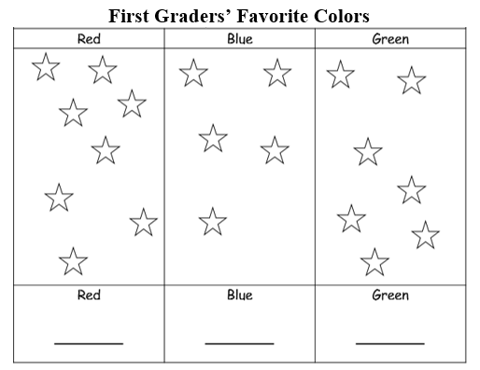  How many students voted for each color? Point to and read the categories Red, Blue, and Green. You can record your numbers on the lines. Prompt if needed: How many students voted for red? How many voted for blue? How many voted for green?  - Compare your categories. How many more students like red than green? Show your thinking with pictures, numbers, or words.  - Compare your categories. How many fewer students like blue than green? Show your thinking with pictures, numbers, or words.  Say: Can you tell anything else about the data in the chart?

Continuum of Understanding
Not Yet Proficient | Response includes 0-1 of the descriptors in “Meets Expectations” | - Correctly identifies the number of votes for each category  - Correctly solves “how many more” question  - Gives clear explanation of “how many more”  - Correctly solves “how many fewer” question  - Gives clear explanation of “how many fewer” question  - Provides extra information about the data in the graph
Progressing | Response includes 2 of the descriptors in “Meets Expectations”
Meets Expectations | Response includes all of the descriptors in “Meets Expectations”  - Correctly responds to the number of votes for each category  - Correctly responds to the “how many more” question and explains thinking using pictures, numbers, or words  - Correctly responds to the “how many fewer” question and explains thinking using pictures, numbers, or words

Standards for Mathematical Practice
1. Makes sense and persevere in solving problems.
2. Reasons abstractly and quantitatively.
3. Constructs viable arguments and critiques the reasoning of others.
4. Models with mathematics.
5. Uses appropriate tools strategically.
6. Attends to precision.
7. Looks for and makes use of structure.
8. Looks for and expresses regularity in repeated reasoning.

The class voted on their favorite color and the following chart represents how they voted. Use the chart to answer the questions.

First Graders’ Favorite Colors
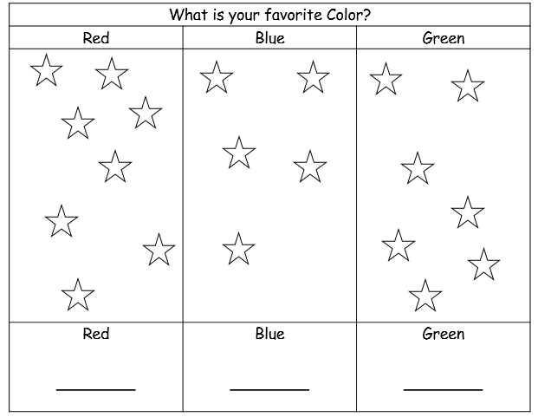

How many more students like red than green? Show your thinking with pictures, numbers, or words.

___________ students
How many fewer students like blue than green? Show your thinking with pictures, numbers, or words.

___________ students

