NC.1.MD.4
Favorite Ice Cream Flavors
Domain | Measurement and Data
Cluster | Represent and interpret data.
Standard | NC.1.MD.4 Organize, represent, and interpret data with up to three categories.  ● Ask and answer questions about the total number of data points.  ● Ask and answer questions about how many in each category.  ● Ask and answer questions about how many more or less are in one category than in another.
Materials | BLM First Graders’ Favorite Ice Cream Flavor
Task | Show the student BLM First Graders’ Favorite Ice Cream Flavor. Say: Look at the data about First Graders’ Favorite Ice Cream Flavor. How many students voted for each kind of ice cream? Point to and read the categories Chocolate, Vanilla, and Strawberry. You can record your numbers in the boxes. Prompt if needed: How many students voted for chocolate? How many voted for vanilla? How many voted for strawberry?  - Compare your categories. How many more students like strawberry ice cream than vanilla ice cream? Show your thinking with pictures, numbers, or words.  - Compare your categories. How many fewer students like vanilla ice cream than chocolate ice cream? Show your thinking with pictures, numbers, or words.  Say: Can you tell anything else about the data in the graph?

Continuum of Understanding
Not Yet Proficient | Response includes 0-1 of the descriptors in “Meets Expectations” | - Correctly identifies the number of votes for each category  - Correctly solves “how many more” question  - Correctly solves “how many fewer” question  - Provides extra information about the data in the graph
Progressing | Response includes 2 of the descriptors in “Meets Expectations”
Meets Expectations | Response includes all of the descriptors in “Meets Expectations”  - Identifies the correct number of votes for each flavor of ice cream  - Solves “how many more” question correctly  - Solves “how many fewer” question correctly

Standards for Mathematical Practice
1. Makes sense and perseveres in solving problems.
2. Reasons abstractly and quantitatively.
3. Constructs viable arguments and critiques the reasoning of others.
4. Models with mathematics.
5. Uses appropriate tools strategically.
6. Attends to precision.
7. Looks for and makes use of structure.
8. Looks for and expresses regularity in repeated reasoning.
First Graders’ Favorite
Ice Cream Flavor
Chocolate | Vanilla | Strawberry

How many more students like strawberry ice cream than vanilla ice cream? Show your thinking with pictures, numbers, or words.

How many fewer students like vanilla ice cream than chocolate ice cream? Show your thinking with pictures, numbers, or words.

Scoring Examples

The student received “Not Yet Proficient” because the student did not correctly compare “how many more” or “how many fewer.” The student drew circles to represent the number of votes for each flavor and choose the greater number when asked How many more…? Next, the student drew circles to represent the number of votes for all three categories and attempted to count all the circles to find a total when asked How many fewer…? This student could benefit from using materials (cube towers, counters, etc.) to represent the amounts of the two flavors being compared. Guide students to place the representations side by side and point out the fact that one flavor had more votes and one has fewer. Using the model, explain what is meant when we say there are more or fewer cubes in one set than the other. This may be done by removing the cubes that represent “how many more” or adding cubes that represent “how many fewer”.

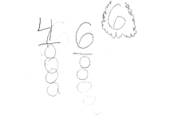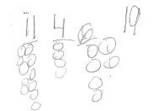
This student received “Progressing” because the student could correctly interpret the data to compare “how many more,” but not “how many fewer.” The student used ten frames to compare amounts and represent that there are two more votes for strawberry than vanilla. Instead of comparing for the second problem, the student finds the sum of the two flavors. This student could benefit from determining the difference in the quantities by using the number relationship between addition and subtraction (4 + ? = 12 or 12 – 4 = ?). Encourage the student to explain why the solution could be found by counting on from 4 or subtracting from 12. Using a representation that shows the one-to-one match of the sets could also be helpful.

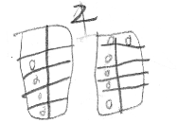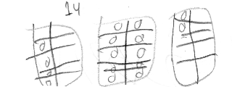

This student received “Meets Expectations” because the student could interpret the data to answer both comparing questions. The student uses comparison drawings with lines and dashes to help determine the differences. This student could benefit from using more efficient strategies (number line, number bond, relationship between addition & subtraction, etc.) to represent the number relationships. Encourage the student write an equation to match each problem and explain why the solution could be found by counting on from 4 or subtracting from 12 (4 + ? = 12 or 12 – 4 = ?).

