NC.1.MD.4
What is your Favorite Color?
Domain | Measurement and Data
Cluster | Represent and interpret data.
Standard | NC.1.MD.4 Organize, represent, and interpret data with up to three categories.  ● Ask and answer questions about the total number of data points.  ● Ask and answer questions about how many in each category.  ● Ask and answer questions about how many more or less are in one category than in another.
Materials | BLM First Graders’ Favorite Colors
Task | Show the student BLM. Say: Look at the data about First Graders’ Favorite Colors. What does the data tell you about their favorite colors? Prompt, if needed: What else does the data tell you?

Continuum of Understanding
Not Yet Proficient | - The explanation is minimal or lacking in detail. It may only include the amount of students who like one particular color or only includes one comparison.
Progressing | - Provides a detailed description about the amount of students who like each color  - Compares multiple categories (Ex: Blue is the favorite color. Green is the least favorite.)
Meets Expectations | Demonstrates Complete Understanding and:  - Makes comparisons by stating “how many more/less” one category compares to another  - Identified that there were 23 students who answered the survey

Standards for Mathematical Practice
1. Makes sense and perseveres in solving problems.
2. Reasons abstractly and quantitatively.
3. Constructs viable arguments and critiques the reasoning of others.
4. Models with mathematics.
5. Uses appropriate tools strategically.
6. Attends to precision.
7. Looks for and makes use of structure.
8. Looks for and expresses regularity in repeated reasoning.

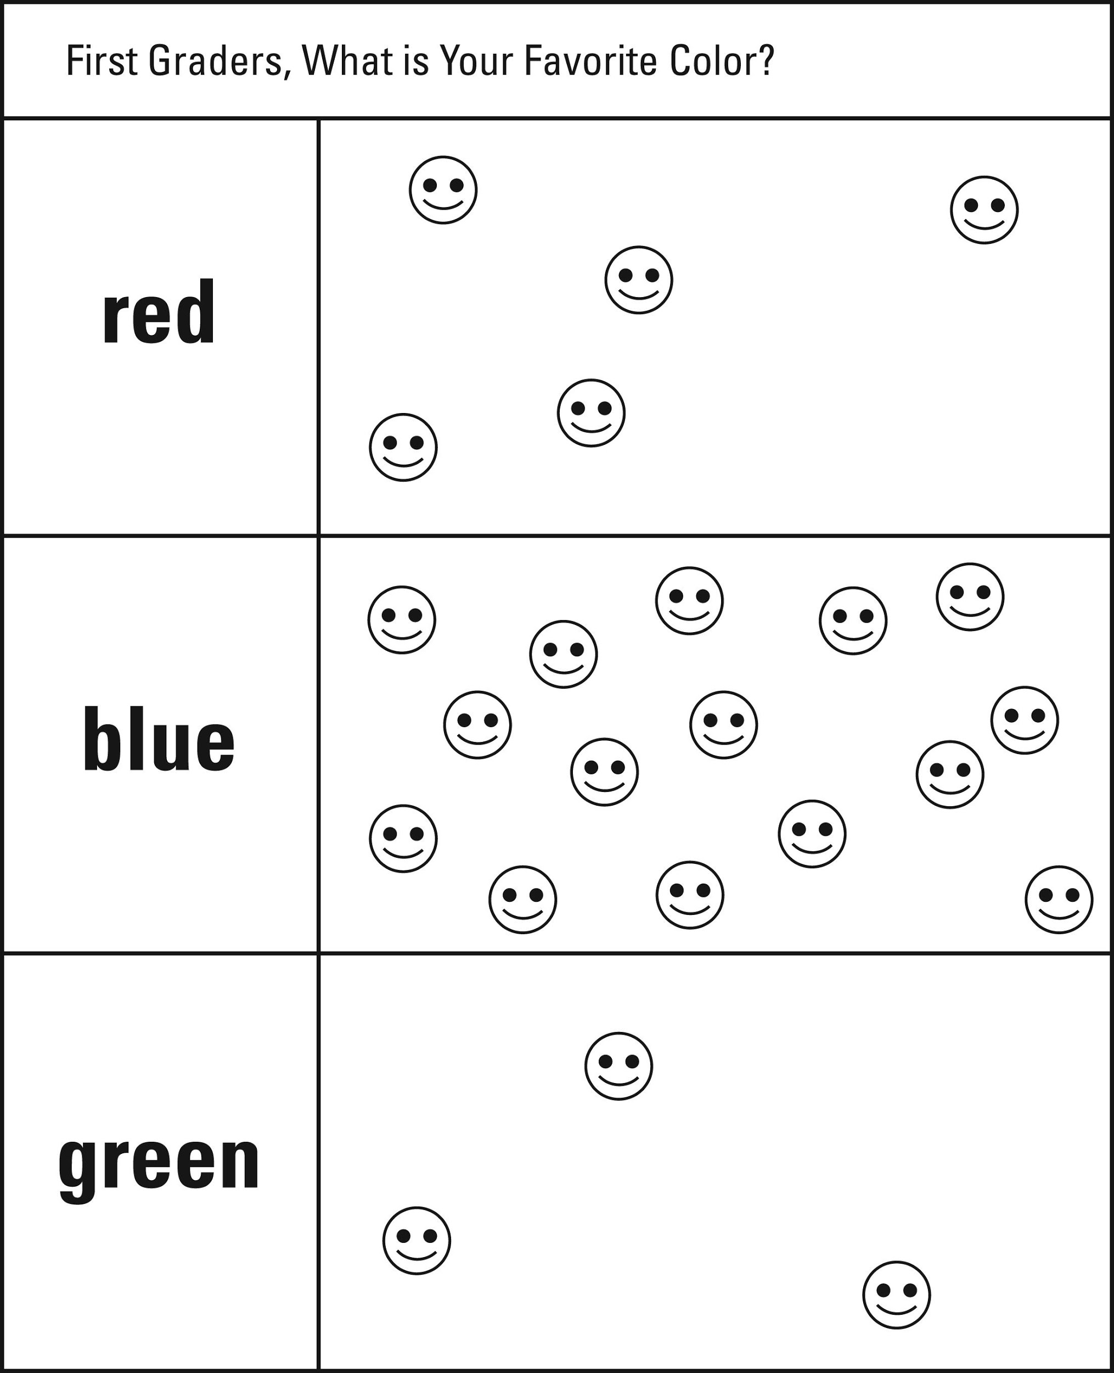
What is your Favorite Color?

