Cluster 1 Images:
Using Numbers to Explore Our Mathematical Community
Topic | Math Buckets
Description | Math buckets are useful for storing math manipulatives at each group or table. The math tools in the buckets change throughout the year. This is an example of what could be in the math buckets at the beginning of the year.
Images | 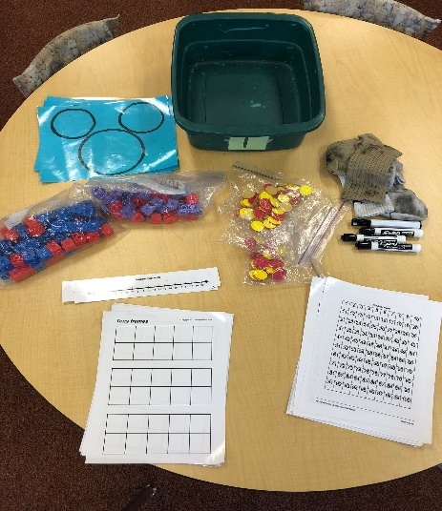  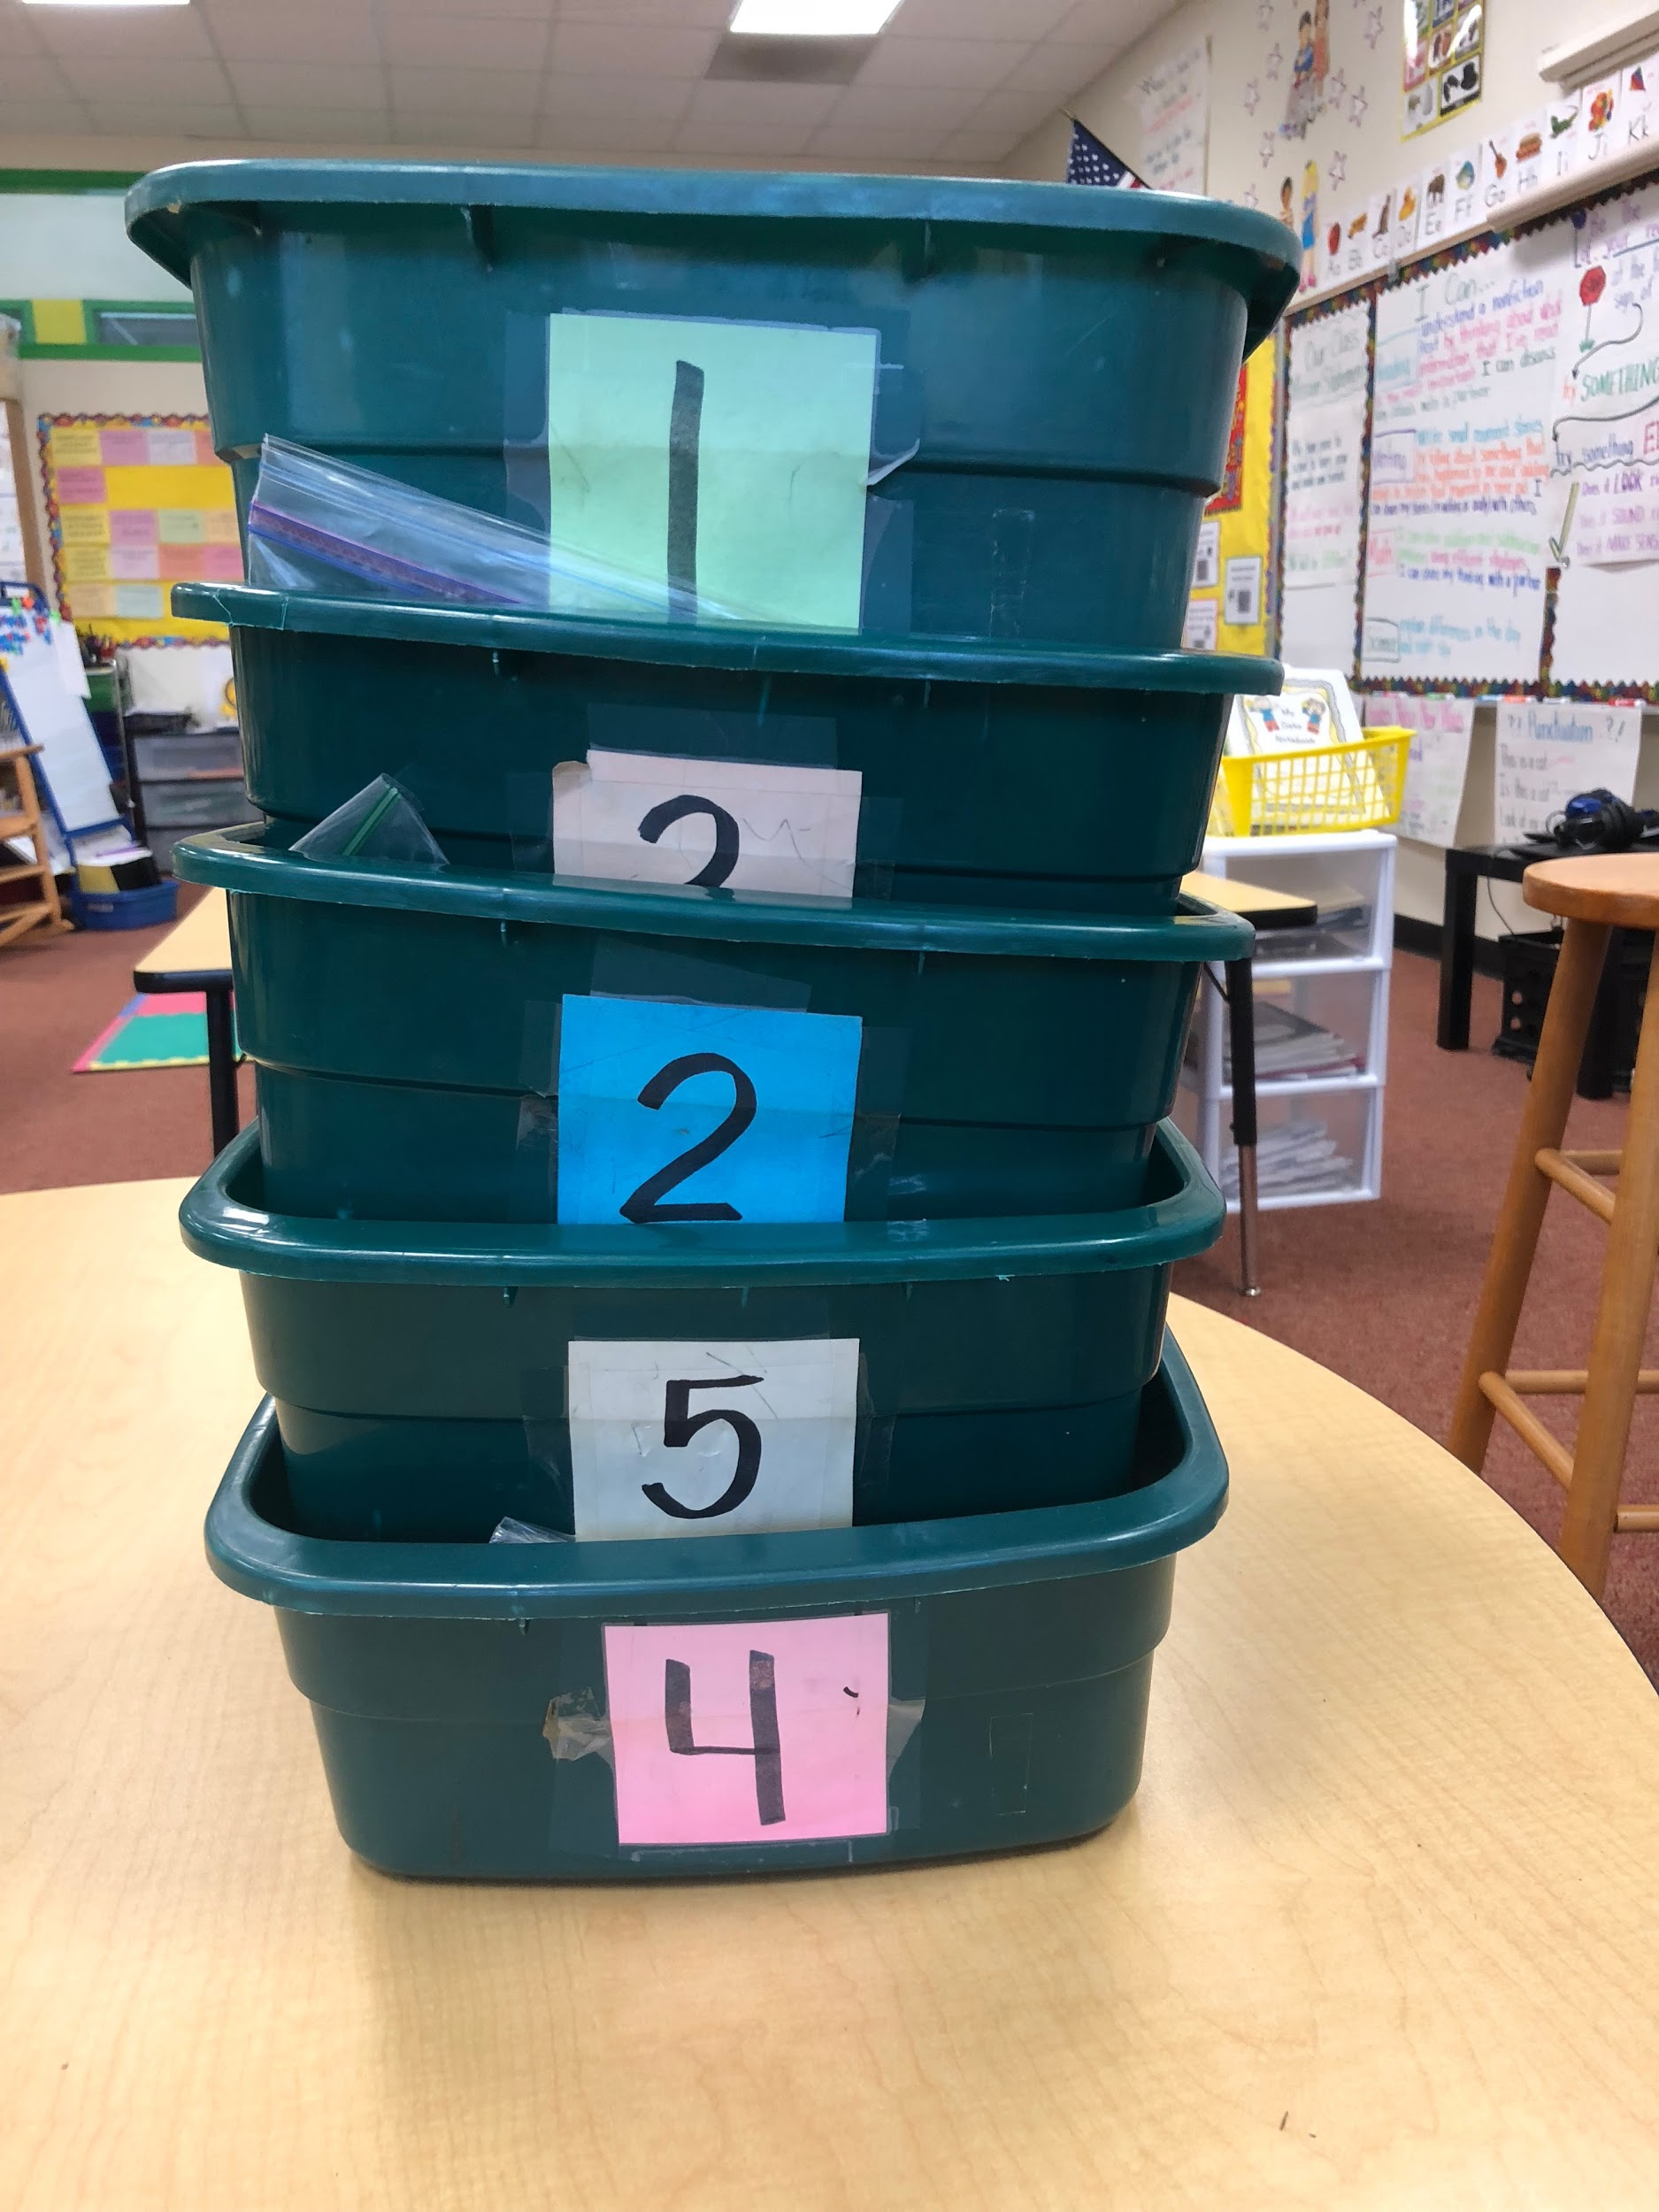
Topic | Sentence Frames
Description | Sentence frames may be used during math discussions to help students understand that 1-more and 1 less are the same as adding or subtracting 1.
Image | 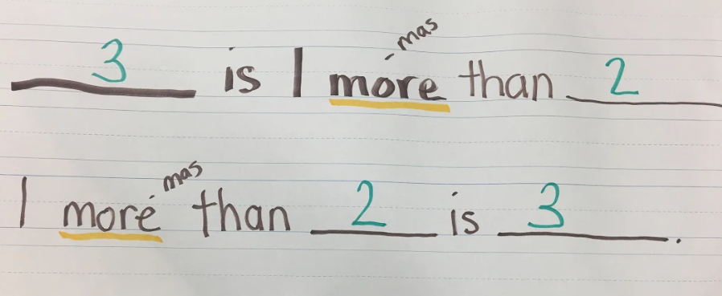

Topic | Math Talk Anchor Charts
Description | Math talk promotes active engagement and understanding. Sentence starter anchor charts are useful while teaching expectations for math talk. Charts can help support students as they explain their thinking during math and/or when they talk with partners.
Images | 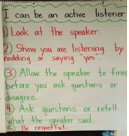  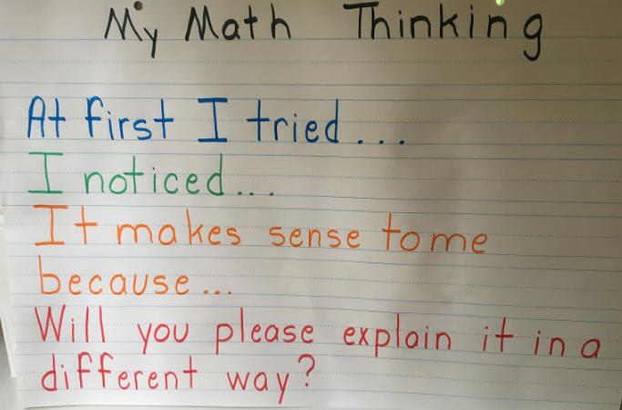  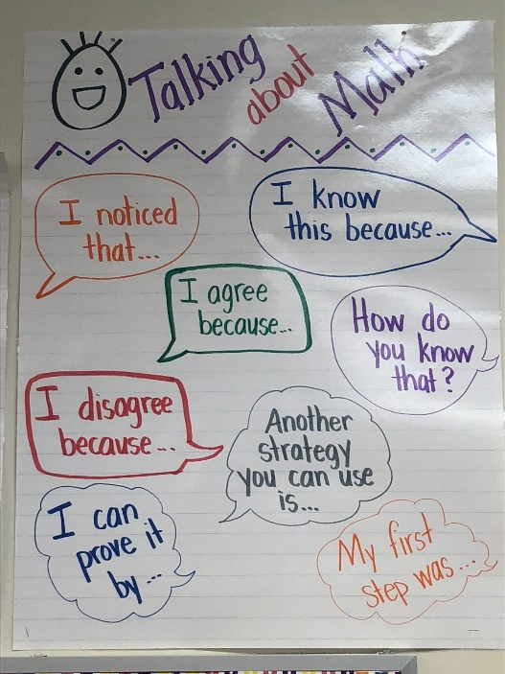  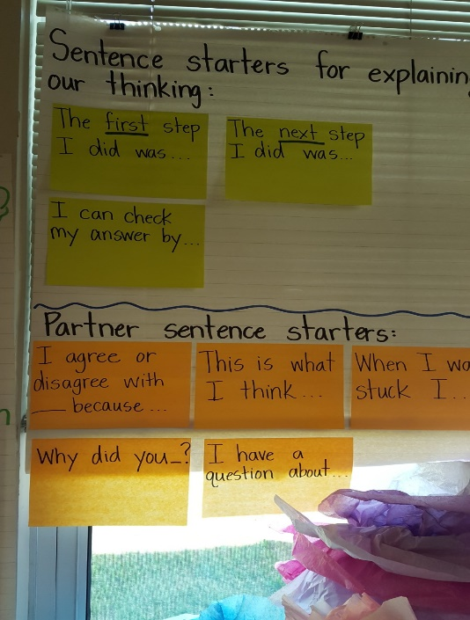

Topic | Growth Mindset
Description | Teach students about having a growth mindset. It is a way of thinking that encourages perseverance. It teaches students:  - to take responsibility for their own learning by setting goals  - that we can learn from mistakes, and  - that we can learn from each other as we share strategies for solving problems.
Image | 