NC.4.MD.4
Smokey Mountain Gem Mining
Domain | Measurement and Data
Cluster | Represent and interpret data.
Standard(s) | NC.4.MD.4 Represent and interpret data using whole numbers.  - Collect data by asking a question that yields numerical data.  - Make a representation of data and interpret data in a frequency table, scaled bar graph, and/or line plot.  - Determine whether a survey question will yield categorical or numerical data.
Materials | activity sheet, graph and blank paper, rulers, pencils, crayons (optional)
Task | Mrs. Cooper’s fourth grade class went on a field trip to Smokey Mountain to mine for gems.  Each group chose 6 of their favorite gemstones to bring back to school to add to a class collection. They decided to display the inventory of the collection in a bar graph.  Use the information below to determine how many of each kind of gemstone was collected. Use graph paper to create a bar graph to display your findings.  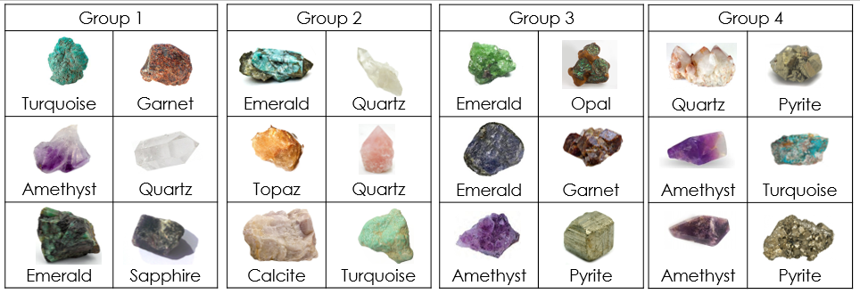  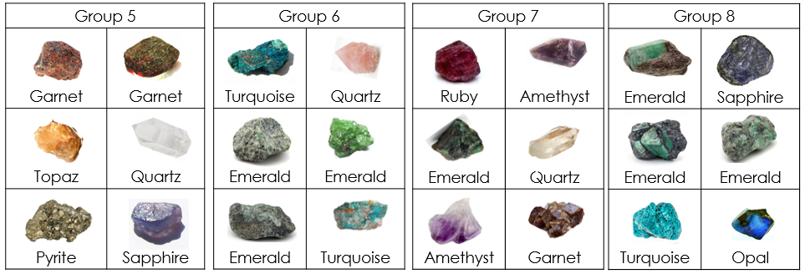  Part 1: Students will use graph paper to create a bar graph that displays the data. They will need to include a title and labels for the x-axis and y-axis.  In this task, students will have to determine several things:  - Will the graph exhibit data vertically (with gemstones on the x-axis and numbers on the y-axis) or horizontally (with gemstones on the y-axis and numbers on the y-axis)?  - What is the best scale (1’s? 2’s? 5’s?)  *In order to preserve the high cognitive demand of the task, allow students to explore these options without requiring a mandated procedure. If students are made to follow a set of rules (ex. must be horizontal, must use scale of 1), the cognitive demand decreases. In addition, all of the graphs end up looking the same, which limits discussion.  Below are examples of possible student responses to Part 1:  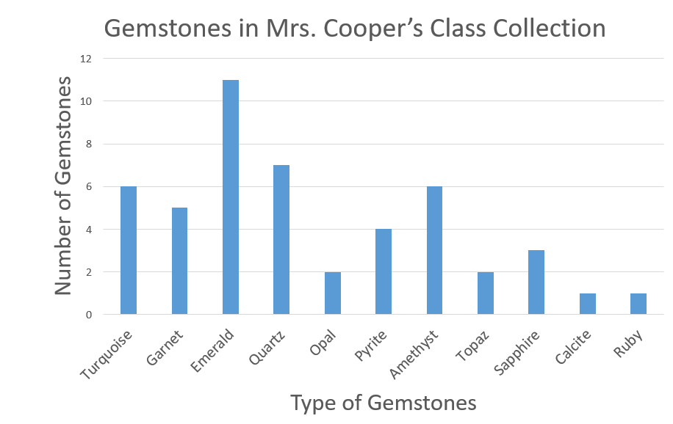  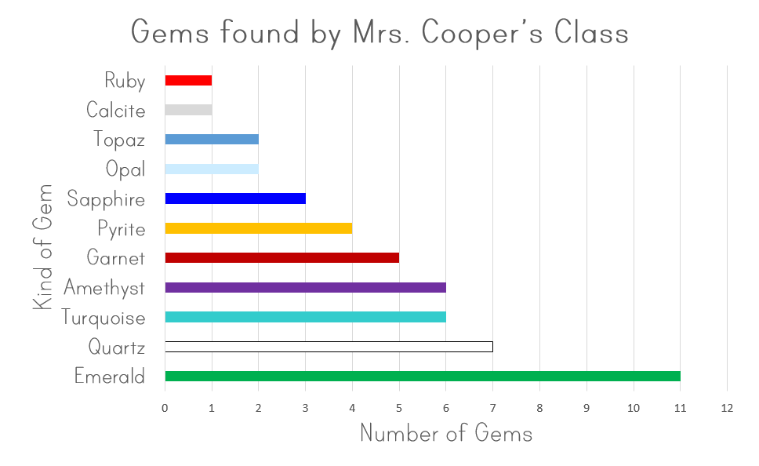  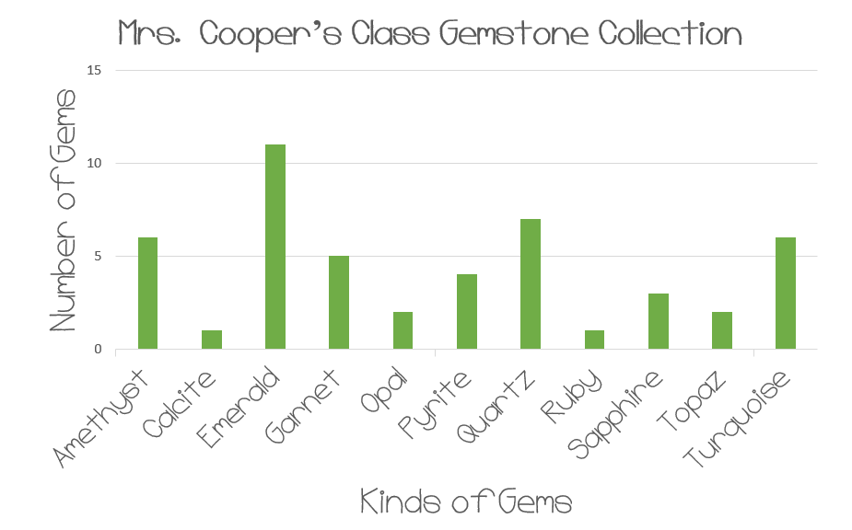  *This data represents discrete, rather than continuous data. Therefore, the bars on the bar graph should have space between them and should not touch one another.  *In these examples, we can see a variety of ways that students could possibly represent data. Not only do they have options with choosing a horizontal vs. vertical graph, they must also decide the scaling of the graph (1’s, 2’s, 5’s). It is by allowing them to choose their methods that the teacher can begin to get a sense of what a student deems important (Should my graph show the gems in order of frequency? Should my graph show my gems in alphabetical order? Should my graph show gems in the order they appear on the chart?). Additionally, it allows the teacher to get a sense of a child’s mathematical understandings and misconceptions.  *As you are observing students creating graphs, make some decisions as to which graphs you are going to highlight in discussions later in the lesson. Consider pulling graphs with different scales (1’s, 2’s, 5’s) and different orientations (horizontal, vertical). It is acceptable to pull incorrect graphs if you think that the resulting discussions will help to clear up misconceptions later.  Part 2: Students will analyze the data by responding the following questions:  1. Which gemstone appears most often in the collection? (Emeralds)  2. Which gemstone appears least often in the collection? (Calcite & Ruby are tied with 1 each.)  3. How many kinds of gemstones does the collection have? (11)  4. How many kinds of gemstones had less than 5 stones in the collection? (6)  5. What scale did you choose to use when creating your graph? (answers will vary)  6. Why did you choose to use that scale? (answers will vary)  7. What challenges did you encounter as you created your graph? What did you do to solve these challenges? (answers will vary)  Part 3: Follow-up discussion  Display 4-6 graphs around the room and allow students to do a gallery walk to study the graphs. Make sure that the graphs you display feature a variety of representations, including different scales and orientations. Ask students to consider these prompts as they study the graphs:  1. How does scale influence the graph?  2. In this case, is one scale easier to read than another?  3. In this case, does the orientation of the data matter?  4. Do any of the graphs make you realize something that you didn’t consider when you were creating your own graph?  Once students have had a chance to reflect on the questions during the gallery walk, call them back together and begin your discussion of these prompts. As a result of your discussion, you want students to understand:  - The scale is important.  - In using 1’s and 2’s, it is easier to interpret the value of the bars. Because we have 6 gem types with a value less than 5, it is difficult to represent these values accurately on the graph.  - If possible, place a graph with a small scale (1’s or 2’s) beside a graph with a larger scale (5’s). Prompt: Look at the height (or length) of the bars. Are they the same? (No) Is the number of gemstones the same? (Yes) Why are the lengths different? (The scale is different.) How can this unintentionally lead to a misunderstanding of the data or values in the bars? (People could think that because the size of the bars is different, the value of the bars in different.)  - Follow up with: Should we always use a small scale? (No) Can you think of a time when a large scale is more appropriate? (When dealing with numbers that are spread further apart.)  - Orientation of the bars is not always important.  - In this instance, it is not important to orient the bars in the graph horizontally or vertically. The data you are displaying is not measurement data. For instance, if you were displaying height of plants or distance run, the orientation helps someone to infer the situation being represented by the graph.
Rubric
Level I  Not Yet | Level II  Progressing | Level III  Meets Expectation
Student work exhibits 0-1 of the following characteristics:  - Correct representation of data with the bars in the graph.  - Title of graph and both axes are correctly labeled.  - Able to interpret the graph by answering the all of the questions. | Student work exhibits 2 of the following characteristics:  - Correct representation of data with the bars in the graph.  - Title of graph and both axes are correctly labeled.  - Able to interpret the graph by answering all of the questions. | Student work exhibits all of the following characteristics:  - Correct representation of data with the bars in the graph.  - Title of graph and both axes are correctly labeled.  - Able to interpret the graph by answering the questions.

Standards for Mathematical Practice
1. Makes sense and perseveres in solving problems.
2. Reasons abstractly and quantitatively.
3. Constructs viable arguments and critiques the reasoning of others.
4. Models with mathematics.
5. Uses appropriate tools strategically.
6. Attends to precision.
7. Looks for and makes use of structure.
8. Looks for and expresses regularity in repeated reasoning.

Smokey Mountain Gem Mining

Mrs. Cooper’s fourth grade class went on a field trip to Smokey Mountain to mine for gems.
Each group chose 6 of their favorite gemstones to bring back to school to add to a class collection. They decided to display the inventory of the collection in a bar graph.

Use the information below to determine how many of each kind of gemstone was collected. Create a bar graph to display your findings. Be sure to include a title, a label for the x-axis, and a label for the y-axis.

Once the graph is created, answer the questions below.

1. Which gemstone appears most often in the collection? _____________
2. Which gemstone appears least often in the collection? _____________
3. How many kinds of gemstones does the collection have? ___________
4. How many kinds of gemstones had less than 5 stones in the collection? _____________
5. What scale did you choose to use when creating your graph? ______________
6. Why did you choose to use that scale? _______________________________________________
________________________________________________________________________________________
7. What challenges did you encounter as you created your graph? What did you do to solve these challenges? ________________________________________________________________________________________
________________________________________________________________________________________
Scoring Examples
Not Yet: The student graphed the data incorrectly and was unable to consistently analyze the data.
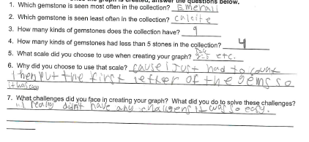
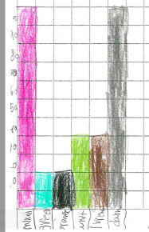

Progressing: The graph is neat and labeled correctly. The student incorrectly analyzed the data from the graph.
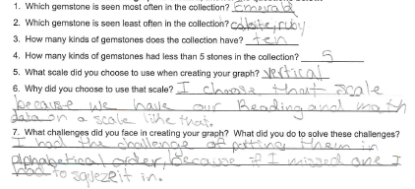
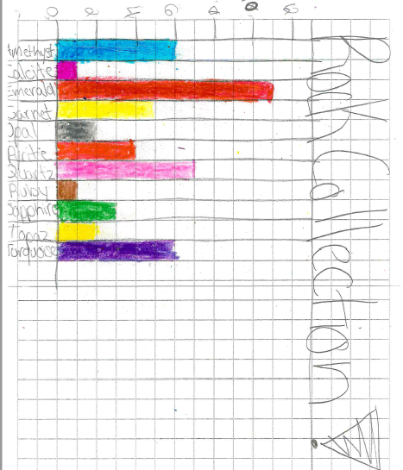

Meets Expectation: The graph is neat and orderly, easy to read, and properly labeled. Questions are answered fully and correctly.
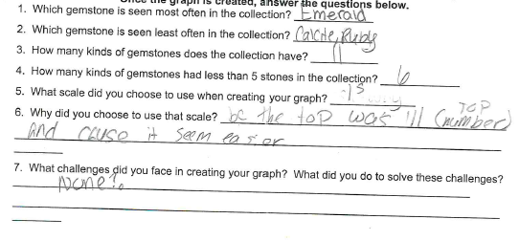
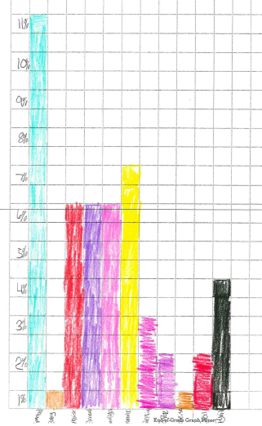
*The data points represent discrete, rather than continuous data. Therefore, the bars on the bar graph should have space between them and should not touch one another. This graph would be improved by adding space between each bar. Discussions and models would help students understand representations of discrete data and why bars should not touch.

