Cluster 1:
Represent and Interpret Data

NC.4.MD.4 Represent and interpret data using whole numbers.
- Collect data by asking a question that yields numerical data.
- Make a representation of data and interpret data in a frequency table, scaled bar graph, and/or line plot.
- Determine whether a survey question will yield categorical or numerical data.

Categorical & Numerical Data
Students need to distinguish between questions that give categorical and numerical data before they pose a question and try to interpret the data.
Categorical Data:
Values that are often words and that represent possible responses with respect to a given category. Categorical data represent characteristics such as a person's gender, hometown, or the types of movies they like.
Examples:
    - Months in which people have birthdays
    - Favorite color T-shirt
    - Favorite fruits
    - Kinds of pets

Numerical Data:
Values that are numbers such as counts and measurements. Numerical data represent objects or individuals by numbers assigned to certain measurable properties, such as time, height, weight, amount, and so on.
Examples:
    - Number of children in families
    - Pulse rates of top athletes
    - Time in minutes that students spend watching television each day
    - Weights of newborn babies

*Special Note: Categorical data can take on numerical values (such as scales “1-10” with “1” indicating a low preference and “10” indicating a high preference), but those numbers don't have mathematical meaning and are merely categories or labels of preference. An example includes rating a restaurant’s food on a scale of 1 to 10.
Graphing Investigation Model
PCAI (Graham, 1987)

Graphs Fourth Graders Should Use and Understand

Frequency Tables:
A frequency table may include tallies and/or numbers of the total data points for each category. Frequency tables help organize the data so it can be interpreted.
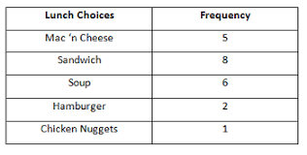
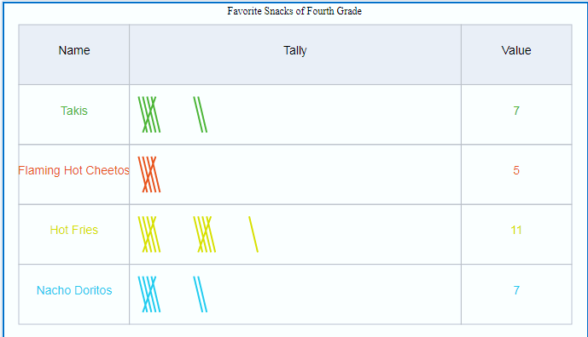

Bar Graphs:
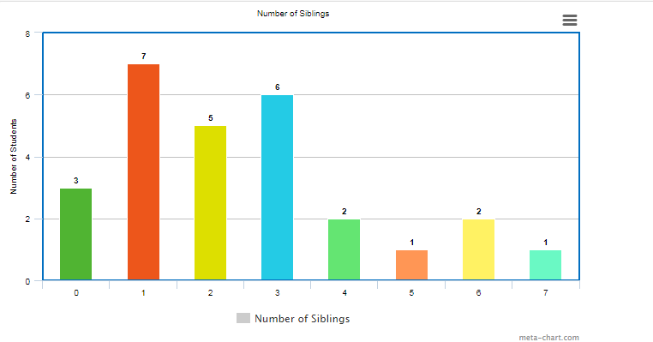
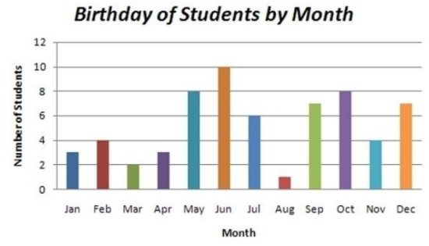
A bar graph can be used to represent both categorical and numerical data. Bar graphs should include a title, x-axis label, y-axis label, and a scale for the frequency or count. On a bar graph displaying numerical data, students may confuse the frequency (count of data points) with the actual data points since there are numbers on both axes. Students may need to transition from a frequency table to a bar graph to help them understand how to read and represent both categorical and numerical data.

Line Plots:
A line plot consists of numerical data. There is no y-axis on a line plot; the total for each category is found by counting the number of X’s in each category. For example, in the graph below, seven students spent 45 minutes studying their multiplication facts each week. The entire number line doesn’t need to be shown on a line plot starting at 0. The line plot may begin and end with the minimum and maximum data points (30 minutes was the minimum data point and 70 minutes was the maximum for the data below).
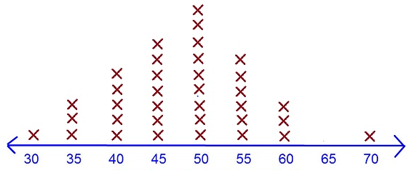
Studying for Multiplication Facts

Number of Minutes Studied Last Week

