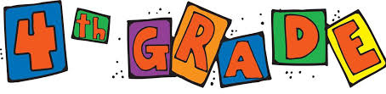
Dear Family,

Welcome to Fourth Grade!
In fourth grade, we begin the year by focusing on using data to build a mathematical community. The purpose of this letter is to give you some background information about our first unit in mathematics.

Focus of the Unit
Your fourth grader will learn that math is an essential part of the world around us. Math can and should be relevant, creative, inspiring, and even fun. Mathematics involves meaningful talk as students explain their thinking and strategies. Our class will establish expectations for math talk and create a “math mindset” or belief that everyone can successfully do math. They will learn to take risks and persevere when problem-solving, even when the problems they encounter are new or challenging to them. Students will learn that a math community values mistakes as learning opportunities and values effort and productive struggle to stretch and grow. Students will collect and interpret data about themselves and the entire class as we are learning about each other and building our mathematical community. Activities in this unit of study will build a foundation for the entire year.

Building Off Past Mathematics
In previous grade levels, students collected data by asking survey questions and organized it in tables, bar graphs, and picture graphs. Students also solved one- and two-step “how many more” and “how many less” problems using information presented in the graphs.

Strategies that Students Will Learn
Students will get to know each other by posing questions and collecting data about themselves and from their worlds (how we get to school, hobbies preferred, number of siblings, etc.). They will analyze the information collected, represent the data in tables, bar graphs, and line plots, and interpret what that information tells them about our class. Students will also determine whether a survey question yields categorical or numerical data.
- Categorical data represent characteristics such as a person's gender, hometown, or the types of movies they like.
- Numerical data is data that is measurable, such as time, height, weight, amount, and so on.
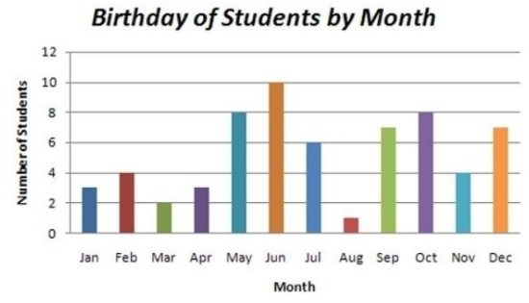
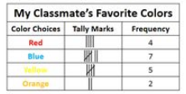
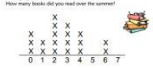
- Special Note: Categorical data can take on numerical values (such as scales “1-10” with “1” indicating a low preference and “10” indicating a high preference), but those numbers don't have mathematical meaning and are merely categories or labels of preference. An example includes rating a restaurant’s food on a scale of 1 to 10.

Ideas for Home Support
Great Mathematicians  learn from their mistakes.  Research shows that when we make mistakes, synapses fire and our brains grow.  How can parents help?  - When your child gets something wrong, remind them that their brain is growing and that’s a good thing.  - Use examples from everyday life. Talk with your child about mistakes you’ve made and how your brain has grown through those mistakes. | Great Mathematicians  listen to and learn from each other.  Playing games and cooperative activities creates opportunities to listen and learn from others.  How can parents help?  - Before doing a task together, take turns saying the steps. Each person says a step until finished. This teaches the importance of listening carefully to complete a job.  - Encourage your child to explain their strategies or the moves they make when playing a game or solving a puzzle.
Great Mathematicians  ask questions.  In the real world, mathematicians answer questions. Crucial skills valued among mathematicians include inquiry, ability to investigate, and asking questions to gather information.  How can parents help?  - Your child’s natural curiosity leads to great questions. Take a minute to investigate answers to questions your child wonders about.  - Tell your child things you wonder about and work together to research solutions.  - Look at graphs in the world and discuss why the data was collected and what it tells about our world.  More information for parents can be found at YouCubed: https://www.youcubed.org/ | Great Mathematicians  persevere when things are difficult.  Being able to persevere when things become difficult is an important skill in math and in everyday life. Perseverance is strongly tied to growth mindset.  How can parents help?  - Read stories of perseverance and discuss ways characters persevered to reach goals.  - Salt in His Shoes: Michael Jordan in Pursuit of a Dream by Deloris Jordan & Roslyn Jordan  - The Most Magnificent Thing by Ashley Spires  - Brave Irene by William Steig  - You Can Do It, Bert! by Ole Könnecke  - She Persisted by Chelsea Clinton  - How to Catch a Star by Oliver Jeffers  - Flight School by Lita Judge  - Watch videos that demonstrate perseverance.  - Soar: https://vimeo.com/148198462  - John Legend: https://www.youtube.com/watch?v=LUtcigWSBsw  - Famous Failures:  https://www.youtube.com/watch?v=zLYECIjmnQs
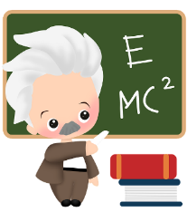
Einstein, one of the world’s most well-known ‘geniuses’, said that his biggest achievements came from the number of mistakes he made and the persistence he had shown. When he made mistakes, he persevered, trying even harder. What a great example to refer to when a child needs a reminder that everything can’t be easy the first time and to keep trying!

Thank you for serving as partners in your child’s success as a mathematician!
<signature>

