Getting to Know Our Class: Day 1
This lesson focuses on developing a mathematical community at the beginning of the school year. Students collect data and make a scaled bar graph and a line plot, which they worked with in third grade and fourth grades. This lesson gives students an initial experience distinguishing between the two types of data collected for bar graphs and line plots in third and fourth grade, respectively. This lesson does not include any work with data that changes over time or line graphs.

NC Mathematics Standards:
Measurement and Data
NC.5.MD.2 Represent and interpret data.
- Collect data by asking a question that yields data that changes over time.
- Make and interpret a representation of data using a line graph.
- Determine whether a survey question will yield categorical or numerical data, or data that changes over time.
Review Standards
NC.3.MD.3 Represent and interpret scaled picture and bar graphs:
- Collect data by asking a question that yields data in up to four categories.
- Make a representation of data and interpret data in a frequency table, scaled picture graph, and/or scaled bar graph with axes provided.
- Solve one and two-step “how many more” and “how many less” problems using information from these graphs.
NC.4.MD.4 Represent and interpret data using whole numbers.
- Collect data by asking a question that yields numerical data.
- Make a representation of data and interpret data in a frequency table, scaled bar graph, and/or line plot.
- Determine whether a survey question will yield categorical or numerical data.

Standards for Mathematical Practice:
- Make sense of problems and persevere in solving them.
3. Construct viable arguments and critique the reasoning of others.
4. Model with mathematics.
6. Attend to precision.

Student Outcomes:
- I can pose questions and collect data from my classmates.
- I can communicate with others about my data.
- I can create a graph to represent data.

Math Language:
- data
- question
- graph, bar graph, line plot
- scale
Materials:
- graphs to display (At the Zoo bar graph, At the Zoo – with Labels bar graph, At the Zoo line plot)
- data collection materials such as post-its, notecards, clipboards, etc.
- graph paper and colored pencils/crayons (optional)
- notecards (1 per student)
- Optional: anchor chart, poster of Math Practice #3 (http://www.debbiewaggoner.com/math-practice-standards.html)

Advance Preparation:
- Gather materials
- Plan how to group students into pairs

Launch:
- Introduce the Context (10 minutes)
A. Bar Graph Introduction:
- Display the bar graph “At the Zoo” for the class to see. Ask: What type of data is on the graph? Ask: What types of labels do we need on the graph? Give students time to respond to the questions as partners and then share ideas with the whole class.
- Tell the class that the graph displays people’s favorite animals at the zoo. The choices included: Snakes, Giraffes, Monkeys, Elephants. Display the labeled version of the graph.
- Ask students questions about the data:
  - Which animal was the most liked?
  - Which animal was liked the least?
  - Can you estimate how many people voted?
  - It looks like twice as many people liked giraffes than snakes. Is that right? How could we find out?
    - Allow students to time to discuss this in partners or small groups. Students should identify that the statement is incorrect and provide reasoning why it is incorrect.
    - Say, “Sometimes in math it is okay to make a mistake as long as we figure out where we messed up and fix it.”
B. Line Plot Introduction:
- Display the line plot At the Zoo for the class to see.
- Ask, What type of data is on the graph?
- Ask, Why do you think a line plot was used instead of a bar graph?
- Ask, Based on the data can we determine how many people answered the question?
  - After students respond, remind students that every X stands for a data point, or in this case a person. The number of people surveyed is the same as the number of X’s on the line plot.
- Tell students that the data represents the number of hours that each person spent at the zoo.
- Ask questions about the data:
  - What was the most hours that someone spent at the zoo?
  - What was the least hours that someone spent at the zoo?

- Say, Work with your table to come up with 2 questions that you could ask about the data in the table.
- Have a few groups share their questions with the class and discuss how the line plot could be used to help answer the questions.

- Introduce the Task (10 minutes)
Tell students that today they will work with a partner to create two questions to find out more about classmates. Tell students that they need 1 question that they can use to make a bar graph, and another question that they can use to make a line plot. Ask students what type of question is needed for each (Students should understand that bar graphs have categories and line plots display numeric data. Tell students that they need to work with their partner to think about how to collect the data. How can they keep track of who has responded and what responses are? Tell students that they should try to get data from everyone. Tell partners that they will need to get the questions and plan for collecting data approved before beginning the survey (This allows you to make sure all questions are appropriate and to be sure that pairs have both types of questions and a plan for collecting the data).

If students are stuck thinking of a bar graph question, you could suggest:  - Which place would you want to visit?  - What is your favorite restaurant?  - Which kind of pizza do you like best?  - Which kind of ice cream do you like best?  - Which subject is your favorite school subject?  - Which sport is your favorite to watch or play? | If students are stuck thinking of a line plot question, you could suggest:  - How many people live in your house?  - How many brothers or sisters do you have?  - How many years have you gone to this school?  - How long is your arm span (finger to finger stretched out)?  - How many pencils did you bring with you to school today?

Observation | Questions to Ask
Students have difficulty coming up with a question. | - What would you like to know about your classmates?  - If someone were going to ask you a question about yourself what would you want them to ask you?  - What are some of your favorite things?  - What is something about yourself that can be counted
Students have difficulty coming up with 4 possible choices for the bar graph. | - How can we come up with 4 choices that your classmates are likely to choose?  - What are some choices you think your classmates would choose?  - How would you answer this question?

Explore:
- Collecting the Data (15 – 20 minutes)
After determining their question, students will collect data to answer the question. They should spend time asking other students to answer their questions. The goal is for students to collect data from at many classmates as possible. Allow each pair of students to determine how they will collect the data. Some students may move around the room asking their classmates to respond to the question, some students may have their classmates respond on slips of paper, and some may ask students to respond by raising their hand. It is important that the students decide how they will collect the data.

As students collect data, observe and ask questions to support them. This provides teachers with a chance to informally assess their students. Use these observations for the discussion that will follow in the next part of the lesson.
Observe:
--Who interacts well with others in the class? Who needs prompting and support?
--Who is keeping track of the data? How are students keeping track of the data?
--What difficulties or challenges are students having as they collect data?
--What data collection methods work well? What data collection methods did not work well? Why did they work or not work?
--How do students ensure they do not duplicate a response?

4. Give students the opportunity to graph their data on a bar graph and line plot. Once finished students should make 2 statements about the data. Challenge students to see if they can write a statement that includes two categories on the bar graph or two quantities on the line plot.

Discuss:
5. Discussion of Solutions (15 – 25 minutes)
Bring students together to discuss the experience. They need their work and data collection materials. Use the following questions to assist you with the discussion.

Sample Questions | Possible Responses or Talk Frames
- What was something interesting you learned today about your classmates? | - “An interesting fact that I learned was that my classmates ______.”
- What does your data tell you about the class? | - “I learned that my classmates’ favorite ___ is ___ and their least favorite ___ is ____.”  - “I learned that the most ____ in my class is _____ and the least _____ in my class is ____.
- How did you keep track of your data? Did you have any trouble keeping track of who had answered your question? | - “I had a hard time determining who I had asked until I starting writing names down on my paper.”  - “I wrote down names and their choice at the same time. That helped a lot.”  - “I liked making a list to keep track of the students I asked. It helped me not to repeat someone.”
- Why is it important when we collect information to be certain we ask the same person the question only once? | - “If someone gets more votes than other people our data won’t be right.”  - “If we want to find out the class favorite and least favorite everyone should only get one vote.”  - “If we want to find out the class’ largest ____ and smallest ____, then everyone should only get one response because otherwise we might think a larger or smaller amount is more common.”
- Who would like to share your question and tell us about the results? | - Responses will vary based on the question and data.

6. Conclude the discussion by saying, Think about what we did today. We talked to each other and communicated about our questions and our data. Why is it important to talk and communicate in mathematics? We were also careful to record our data accurately and we used graphs to model information about our class. Ask: Can you help me finish the sentence? “Mathematicians are people who ____________.” Allow students to record and post responses. Say, This year our math class will include many discussions, arguments, and communication in order to deepen our thinking and expand our mathematics understanding.

Evaluation of Student Understanding:
Informal Evaluation:
Observe students and ask questions as they are collecting data. Look for students who may need more support keeping track of their data.

Formal Evaluation:
As an exit ticket, redisplay the “At the Zoo” line plot graph. Ask: How many fewer people spent 7 hours than 2 hours at the zoo? What additional information can we learn from the graph? Can you write a sentence about the graph?

Meeting the Needs of the Range of Learners:
Interventions:
- For students who struggle coming up with a question, give them options for questions and let them select the possible choices.
Extensions:
- Students can pose additional questions with more than four choices.
- Students can explore different scales when creating their graphs.

At the Zoo

At the Zoo (with Labels)

Snakes Giraffes Monkeys Elephants

At the Zoo

 |  | X | X
 |  | X | X | X
 |  | X | X | X | X
 | X | X | X | X | X | X
X | X | X | X | X | X | X
1 | 2 | 3 | 4 | 5 | 6 | 7

Building Mathematical Mindsets: Day 2 for Grades 5
Lesson Overview:
Standards:
SMP 1 - I can make sense of and understand math.
SMP 2 - I can think about number relationships.
SMP 7 - I can notice patterns and structures in math.
Mathematical Mindset Goal:
Everyone can learn math to the highest levels. There is no such thing as a math person or math brain.
• You can learn anything.
• The more work you do, the better you will get in math.
Materials:
- chart paper and markers for Mindset anchor chart
- Pattern student copies
- sets of mindset attributes cards (student pairs or groups of 3)
- math reflection journals per student
- Standards for Mathematical Practice posters
Video:
Growth Mindset https://www.youtube.com/watch?v=ElVUqv0v1EE (2:31)

Before: 15 minutes
Say: I am so excited about all the great ideas that we are going to be thinking about together in math this year! There are so many interesting mathematical things for us to consider together. We are going to begin this year by thinking about what it means to think like a mathematician. One of the most important things for you to understand as a mathematician is ‘Everyone can learn math to the highest levels. There is no such thing as a math person or math brain.’ Sometimes, grown-ups say things like ‘I am not a math person’ or ‘I am bad at math’, but that’s not true. Scientists have studied the human brain, and they have discovered that there is no such thing as a “math” person. And that is great news for ALL of us. Scientists have discovered these two things about math smartness:

- You can learn anything (even things that you think are really hard).
- The more work you do, the smarter you will get.

(Create a fixed and growth mindset anchor chart with one characteristic you are describing of fixed and growth mindset below. The suggested characteristic is underlined.)
Some people (like the grown-ups that I mentioned earlier) have a fixed mindset. People with a fixed mindset believe people are either born smart or they are not. And they think that there is nothing you can do to change how well you understand math. Actually, no one is born smart in math. We just think that some people are smarter because they have different experiences that allow them to solve some problems that other people may find hard. But the good news is that everyone can learn those things if they work hard and have more experiences and practice with the things they want to learn.

Other people have a growth mindset. They believe that if you work hard and try, you can get better at math. This year we may work on some math that is hard for you. What I want you to think when that happens is, “This math is hard, but I know if I work hard that I can figure it out. I just haven’t had enough practice and time with it yet.”

Tell students that you are giving them a set of cards with characteristics of fixed and growth mindset. They should work with their group to decide which are fixed mindset and which are growth mindset.

Have students sort cards and then add attributes on to the fixed and growth mindset anchor chart.

Introduce today’s math activity: Tell students that they will be working with a partner or group of 3 to complete today’s activity. Remind students that they may struggle to complete this activity. Ask students what someone with a growth mindset would do if they got stuck.

Addition Patterns: Say, You are going to be looking at patterns to see what you notice. (Provide handout) These are special addition patterns that are named after shapes. (Read through the instructions and emphasize the questions to guide their exploration. Make sure students know where to find tools such as graph paper, counters, and calculators. Tell students to record what they notice to share with the class in our discussion later).
During: 25 minutes
As students are working, circulate to make sure students are working collaboratively and thinking about which groups may be ideal to share in the discussion in the after section. Teachers might ask students questions during the explore such as:
- What have you noticed so far?
- What did you notice that is interesting?
- What do you notice about the shape itself?
- What do you notice about the number of dots?
- Can you predict how many dots the next shape will have?
- Is it possible to find the number of dots in the tenth shape without drawing or building them?
- What would the next shape look like? Could you build it?
After: 20 minutes
Have selected students share some of the interesting things that they noticed about the patterns. [Students may notice the length of the sides on the outside shape always has 1 more than the previous shape. They may notice the number being added increases by 1 on the triangular pattern, adds the next odd number on the square patterns, or adds three more than the previous time on the pentagonal patterns. Student might notice that the square patterns can just be multiplied by the number of shapes in the sequence (ie the first shape is 1 x 1 dots, the second shape is 2 x 2 dots, the third shape is 3 x 3 dots, etc)].

After the discussion, briefly point out the Standards for Mathematical Practice posters in your room, and tell students that these practices are ones that are habits of mathematicians. Point out one or two that you may have seen in action today [ie. Students may have persevered (MP#1) when it was hard to find a pattern with the shapes. Students look for and used patterns (MP#7). Students may have thought about quantitative relationships between numbers in the problem (MP#2).

Show the following video that reflects back on Growth Mindset, remind students that there is no such thing as a “math person” and everyone can learn.
https://www.youtube.com/watch?v=ElVUqv0v1EE

Introduce math reflection journals. Share how you plan to use the journal this year and any guidelines that you would like for students to use when writing a new entry (ie recording date, title or question, etc). Ask students to complete their first entry reflecting on something that our talk about fixed and growth mindset made them think about and/or something interesting they noticed while working on the today’s math activity.

Ideas, tasks, and some videos for this series of lessons were developed from the following the Week of Inspiration and Tasks tabs at https://www.youcubed.org/ and Jo Boaler’s book Mathematical Mindsets: Unleashing Students’ Potential Through Creative Math, Inspiring Messages, and Innovative Teaching. However, these lessons and videos are in a different order, contain additional detail, have an explicit connection to Standards for Mathematical Practice, and contain a few outside sources. https://www.youcubed.org/ is a free site, but you will have to register to access some of the materials. Ideas for today’s pattern work were taken from Creative Problem Solving in School Mathematics by George Lenchner.

Fixed vs. Growth Mindset Card Sort
Does not want to try hard things. Wants easy work or shortcuts. | Enjoys practicing and working hard at new things.
Wants hard work. Thinks easy work is boring. | Does not like practice or hard work. Thinks it means that he or she is not smart.
Wants to forget mistakes. Tries to hide or make excuses for mistakes. | If something is hard, it makes him or her try harder.
Sees mistakes as a chance to learn. Tries to think about what to do differently next time. | Gives up if something is hard.
Wants to give up when someone else gives feedback or criticism. | Asks lots of questions to self and others to make sure that he or she understands.
Does not get upset when someone gives feedback or criticism because he or she knows they can do better next time. | Does not ask questions or ask for help if something is hard because he or she thinks you cannot be smart if you need help.

Addition Patterns
The patterns on this page are made with shapes.
Each of the patterns are named by their shape.

Look at each pattern. Record some interesting things you notice in your math journal. Here are some questions to think about:
- What do you notice about each of the patterns?
- How many dots in each figure in the pattern?
- What do you notice about the number of dots?
- Can you figure out how many dots in the next figure by creating it with math tools or drawing?
- How could you figure out how many dots in the 10th shape for each pattern?

Triangular Pattern
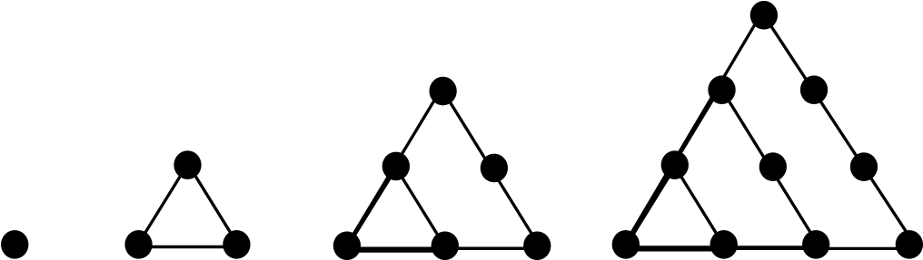

Square Pattern
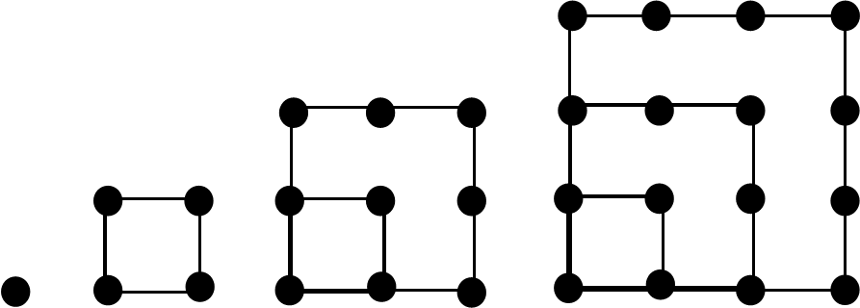

Pentagonal Pattern
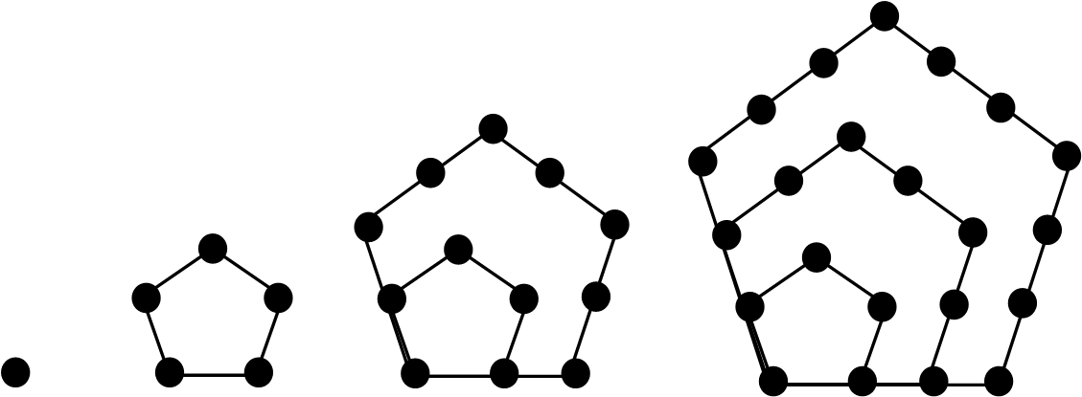

Could there be such a thing as a Hexagonal Pattern? If so, what would it look like?

Building Mathematical Mindsets: Day 3 for Grade 5
Lesson Overview:
Standards:
SMP 4-I can use math to represent the world around me.
SMP 7-I can notice patterns and structures in math.
SMP 8-I can make statements describing patterns I see in math.
Mathematical Mindset Goal:
Math is about creativity and sense making. Math is about making connections and communicating.
Math is about creating ways to solve that others can see, discuss, and critique. Math is about looking for patterns around us and representing our ideas.
Materials:
- poster of Standards for Mathematical Practice
- student copies of Design Your Fourth
- square tiles
- graph paper
- math journals
Video:
Four Boosting Messages from Jo & Her Students https://www.youcubed.org/resources/four-boosting-messages-jo-students/ (8:35)
Fibonacci https://www.youtube.com/watch?v=P0tLbl5LrJ8 (3:43)
Dance of Venus and Earth around the Sun https://youtu.be/tTYGLoVb5xA (0:27)
Before: 15 minutes
Say: Yesterday, we talked about the difference between having a fixed mindset and a growth mindset. What do you remember about the difference between the two mindsets? We are going to watch a video clip that helps us remember some of the important things we discussed yesterday. As you watch, I also want you to ask yourselves what math is all about. After the clip, we will talk about what mathematics really is. Video Clip: https://www.youcubed.org/resources/four-boosting-messages-jo-students/

After the video clip, ask: What did you learn about what math really is when you watched this video clip?

Summarize:
Math is about creativity and sense making. Math is about making connections and communicating.
Math is about creating ways to solve problems that others can see, discuss, and critique. Math is about looking for patterns around us and representing our ideas. We can use tools like snap cubes or square tiles, pictures, or other visual representations to show our thinking. We can use colors, labels, and numbers to communicate what we notice.

When we represent the mathematics we see around us with symbols and numbers, we are modeling the real-world with mathematics (SMP4). That is another habit of good mathematicians that we can find our Standards for Mathematical Practice poster.

Today we are going to use mathematical creativity as we think about ways to represent one-half and one-fourth. Ask students to consider the following questions:
- How do you know when something is split in half?
- What does it mean to have half of something?

Show images from YouCubed Halving Handout shown below (https://bhi61nm2cr3mkdgk1dtaov18-wpengine.netdna-ssl.com/wp-content/uploads/2017/07/3-5-WIM-3-Halving.pdf):

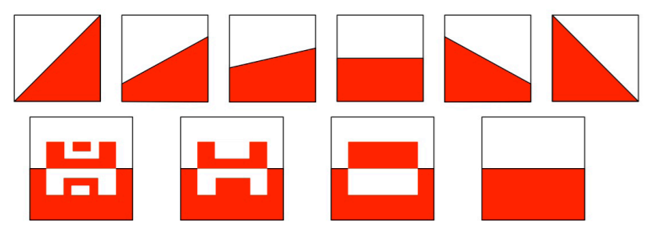
Say: Each of these images is split in half. How can you check that each is correct? How could you convince someone that each is split in half? What does it mean to split a square in half? What needs to be true in order for it to be half?

What if you were to split a square into fourths? What would that look like? How could you be sure it was separated into fourths?

Today, you are going to use mathematical creativity to split a square into fourths. You will make your own design that splits your square in fourths. You can choose your tools. You may use square tiles, graph paper or folding blank paper squares to design your fourths. You can choose your color. Or use four colors to show fourths (SMP5). Once your design is planned, you can use the blank square or the partitioned square for your design on the handout.
During: 25 minutes
Students design a fourth of a square.

After: 20 minutes
Ask students to share some of the things that they noticed as they worked. Ask students how they know that a fourth of their square is one color? Ask how they could prove it (ie possible, cutting half out and laying it over the top of the other half or counting the squares or triangles if the lined version was used). Highlight that students thought about fourths in many different ways. Many times there is more than one right way to complete a task or solve a problem. Highlight that sometimes there are interesting patterns or structures that we don’t notice at first, but as we work and think about mathematics we notice those patterns and structures. Today, many of you used a pattern or structure to help design fourths (ie You may have noticed that 1 out of every 4 squares needed to be one color).

Tell students that when they notice patterns or structures that they are showing another good practice of mathematicians (SMP7) and when they make statements about what they notice and think is true in math that they are showing yet another practice of good mathematicians (SMP8).

Ask students to cut out their squares and write their name on the back. Tell students that you will post them in the room somewhere to remind them that math is creative, and that we can use structures and patterns to help us think about mathematics. (Note that you can create a quilt like appearance by backing with black paper and spacing the squares into equal rows and columns).

Say: In a few minutes, I am going to give you a chance to reflect on what you have found interesting today in math class. We want to remember that math is not about getting answers to a bunch of questions, but is about noticing patterns, relationships, and connections as we solve problems.

The following two video clips are short videos that highlight mathematics in nature. You may use either or both videos. The first one is based on a famous pattern called the Fibonacci Sequence. In the Fibonacci Sequence each number is added to the previous number to find the next number in the sequence: 1, 1, 2, 3, 5, 8, 13, 21,… The interesting thing about this number pattern is how often these numbers occur in nature. Built with squares these numbers form a spiral. Some of the number work in this video will be harder for younger students to follow.

Fibonacci
https://www.youtube.com/watch?v=P0tLbl5LrJ8

Dance of Venus and Earth around the Sun
https://youtu.be/tTYGLoVb5xA (0:27)

Allow students 5-10 minutes to reflect on something interesting that they thought about in math class today.

Ideas, tasks, and some videos for this series of lessons were developed from the following the Week of Inspiration and Tasks tabs at https://www.youcubed.org/ and Jo Boaler’s book Mathematical Mindsets: Unleashing Students’ Potential Through Creative Math, Inspiring Messages, and Innovative Teaching. However, these lessons and videos are in a different order, contain additional detail, have an explicit connection to Standards for Mathematical Practice, and contain a few outside sources. https://www.youcubed.org/ is a free site, but you will have to register to access some of the materials. Information Additional information regarding todays tasks can be found here: https://bhi61nm2cr3mkdgk1dtaov18-wpengine.netdna-ssl.com/wp-content/uploads/2017/07/3-5-WIM-3-Halving.pdf
Note that fourth grade students completed this task with halves, so if you complete using halves instead of fourths, students will have completed the activity before. It is fine if you would like to use halves because 5th grade students may approach designing half with even more creativity than they did in 4th grade.

Design Your Fourth
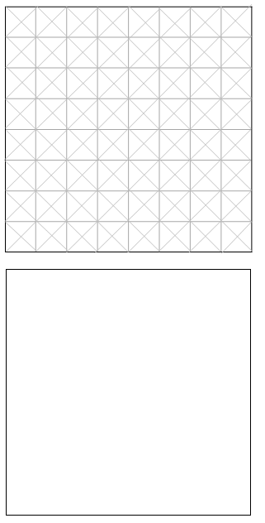

Building Mathematical Mindsets: Day 4 for Grade 5
Lesson Overview:
Standards:
SMP1-I can make sense of and understand math.
SMP 3-I can tell others my ideas in math. I can listen to the ideas of others in math.
SMP5-I can choose good tools to help me think about math.
SMP 6-I can use precise language to communicate my math ideas.
Mathematical Mindset Goal:
Mathematicians ask questions about their own work and the work of others to make sense of math.
Mistakes are valuable. Our brains are growing when we make mistakes
Materials:
- anchor chart of math questions
- math journals
- anchor chart paper for norms developed in class
- student copies of Brain Teaser Puzzles
- Variety of manipulatives that student can use as tools
Video:
Mistakes are Powerful https://www.youcubed.org/resources/mistakes-powerful-video/ (2:44)
You Can Learn Anything https://www.youtube.com/watch?v=JC82Il2cjqA (1:30)
Before: 15 minutes
Say: We are using our first week of school to begin building a mathematical mindset that will help us to grow as mathematicians all year long. What are some of the things that we have talked about over the past few days that we can remember throughout the year. Give students opportunity to share a few of the ideas from the past few days (ie Everyone can learn math. There is no such thing as a math person. You can learn anything. Math is about creativity and sense making. Math is about making connections and communicating. Math is about looking for patterns around us and representing our ideas.)

Say: Today, we are going to talk about two other important habits of mathematicians. Mathematicians ask many questions. Questions are really important. When we ask questions about what we are seeing or ideas that our classmates are sharing, we are trying to make sense of the mathematics we are exploring. Mathematicians ask many questions. Sometimes they ask questions of their own work, and other times they ask questions about the thinking of other mathematicians. We have already seen that our classmates sometimes see things in a different way. We can learn more about a math idea by trying to think deeply about how the different representations we see are connected:

Mathematicians ask questions like…
- Does that make sense?
- Why does that work?
- How is that strategy connected to the one I used? What is different? What is the same?
- Does that work all of the time, or is this a special case?
- What do these numbers represent?
- Is my answer reasonable?

Researchers have found that students who ask these kinds of question have higher achievement in math. Of course! If you ask questions to understand and learn from thoughts and ideas that develop because of the questions, then your brain is growing.

Today, we are also going to talk about something that may surprise you: Mistakes are valuable.
Scientists studying how we learn have discovered that our brains are growing when we make mistakes (mistakes are a good thing). So that means that it is through mistakes that we grow and learn. So, easy “work” is a waste of time. Our brain is not growing and learning when we only do things that are easy for us.

Watch this short video clip from YouCubed: Mistakes are Powerful https://www.youcubed.org/resources/mistakes-powerful-video/ (2:44)

So, we can appreciate mistakes because it means we are growing and learning. Sometimes a mistake can be shared in class so that we can all talk about it. That helps us all to understand what we are learning about a little bit better. So, we should all thank someone who makes a mistake because they are helping us all to grow and learn!

Today, we are going to work with partners to solve several puzzles. Work with your partner to ask questions and make sense of each puzzle. Listen to your own questions and to your partner’s questions. Jot down some questions you ask. Take notes about what you notice as you try to answer your question. Consider which tools might help you to think about the problem. How can you use the tools to show your thinking?

Tell students that they may make mistakes today as they are trying to solve the puzzles, but they can know that their brain is growing and that they just have to keep working to figure it out.

During: 25 minutes
Give student time to work with partners to solve the puzzles (at end of this document). As students are working, move around the room visiting as many pairs as possible. Acknowledge how students are working with their partners, sharing ideas, asking questions, listening to their partner’s ideas, and responding when they make a mistake.

After: 20 minutes
During math class this year, we will have a lot of opportunities to share ideas (SMP3). Before we have our discussion today, let’s think about some norms for our classroom discussions. When a group or family works together to make norms, they think about some things they like and that they don’t like when they work with others. Since we will be working with partners, in groups, and as a whole class sometimes, let’s set up some norms that will help us work together. Talk in your table group – Talk about some things that you like when you are working with others. Give students about 5 minutes to discuss ideas. Make a class norms anchor chart. Make 2 sections on the chart: “Things we will do when we work together:” and “Things that we won’t do when we work together.” After students have had some time to think, then have students share ideas. Ask if someone else agrees with that norm. If so, ask someone to explain why. Provide the prompt….”I agree because…” Say: Sometimes we disagree with our classmates. Does it mean that we don’t like them or that we think they are not smart if we disagree? (of course, not…it just means we are thinking in a different way). Then ask if any one disagrees with the norm…., and why. Provide the prompt, “I disagree because…” Through the discussion, come to a consensus on what the norm should be (it may be an adapted version of the original). Collect about 3 norms for what we like. Then repeat with ideas that we don’t like.

Keep in mind that you will need to continue to work with students on listening to other’s ideas. You may talk about behaviors that show that we are listening and interested in ideas that others are sharing.
Some behaviors that are important for listening:
- Look at the person who is speaking.
- Listen to hear, but most importantly, listen to understand. Your brain should be thinking does this make sense? How does this connect with what I was already thinking or what I’ve already done? Do I agree or disagree?
- Lean in a little to show interest.
- You can ask questions to help you understand, but be careful not to interrupt mid-sentence. Let the speaker finish their thought.

Say: Let’s practice using our new norms today with a discussion about strategies used to complete some of the puzzles today. What strategies did you use? What questions did you ask as you were working?

Encourage students to clarify when they make general statements like “It had to add to seven every time.” Ask, what is “it”? Or if a student says, “I did it differently.” Ask, what is it? How was ___ different?” Is there a math word we can use to talk about the answer when we add? (SMP 6)

Discuss what happened when ideas didn’t work today. Remind students that we all make mistakes as we learn. It’s how our brain grows. None of us were born knowing math, so we are all learning and moving forward and that is what is important. Tell students that today we worked as mathematicians persevering when a task was hard (SMP1). Some students may not have solved all of the puzzles. Encourage them to keep working on the ones they are interested in because that’s what mathematicians do, they keep thinking about problems they are interested in. We also practiced working with our classmates (SMP3) This video is a reminder about how important mistakes are in our learning. Be ready to reflect in your math journal about what you have learned today when the video finishes. https://www.youtube.com/watch?v=JC82Il2cjqA

If time allows, give students an opportunity to reflect on something interesting from math class today in their math journals.

Ideas, tasks, and some videos for this series of lessons were developed from the following the Week of Inspiration and Tasks tabs at https://www.youcubed.org/ and Jo Boaler’s book Mathematical Mindsets: Unleashing Students’ Potential Through Creative Math, Inspiring Messages, and Innovative Teaching. However, these lessons and videos are in a different order, contain additional detail, have an explicit connection to Standards for Mathematical Practice, and contain a few outside sources. https://www.youcubed.org/ is a free site, but you will have to register to access some of the materials. Puzzle ideas were taken from Creative Problem Solving in School Mathematics by George Lenchner.

Name: ___________________________ Date: ___________________
Grade 5 Brain Teaser Puzzles
1. Oops! The bowling pins were set up in the wrong direction! Change the bowling pins to be set correctly pointing in the opposite direction by only moving 3 bowling pins.

2. Toothpick Puzzle:
16 toothpicks are arranged as shown.
Remove 4 toothpicks so that only 4 congruent triangles remain (Congruent means the same shape and same size)
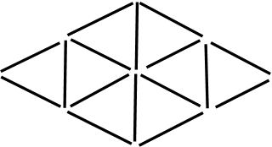
3. Arrange the digits 1 to 7 in these circles so the sum of numbers along each line is 10.
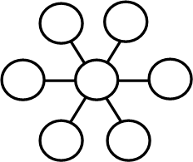

4. Describe how to fold this paper so that the numbered sections lie on top of one another in order from 1 to 8.
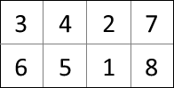

5. Use the 7 tangram blocks to cover each of two pictures on the next page. Trace the blocks to show how you covered the shapes.
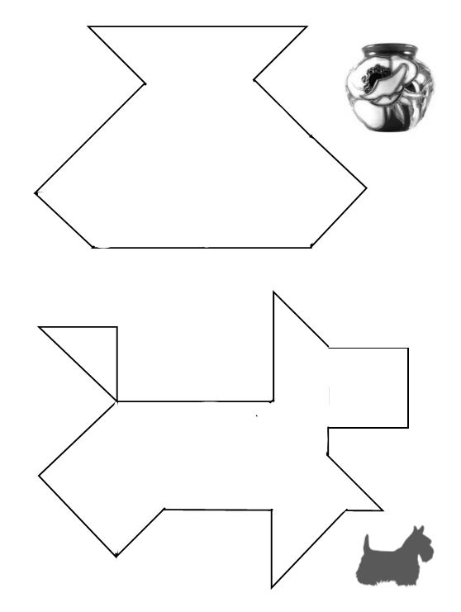

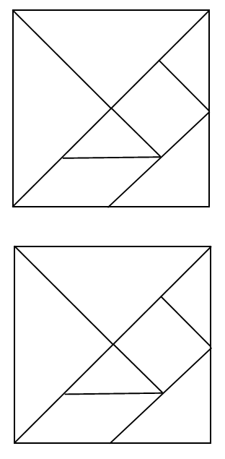

Building Mathematical Mindsets: Day 5 for Grade 5
Lesson Overview:
Standards:
SMP 3-I can tell others my ideas in math. I can listen to the ideas of others in math.
SMP 7-I can notice patterns and structures in math.
SMP 8-I can make statements describing patterns I see in math.
Mathematical Mindset Goal:
Math class is about learning, not performing. Depth is more important than speed. We need to think deeply, connect methods, reason, and justify our thinking.
Materials:
- student copies 8 Squares recording
- 1 set of 8 squares already cut apart per group of 3-4
- color tiles
- graph paper
- math journals
Video:
Boosting Messages video https://www.youcubed.org/resources/four-boosting-messages-jo-students/ (8:35)

Before: 10 minutes
Say: We have learned quite a bit this week about what it means to think mathematically. One more important idea to remember throughout math class this year is that math class is about learning, not performing. Our class times will be focused on learning and growing as mathematicians. Math is not about answering a bunch of questions and getting them right. Our goal is to think deeply, connect representations, reason, and justify our thinking. Thinking deeply about math ideas is much more important than speed.

Laurent Schwartz won the Fields Medal in mathematics and was considered one of the greatest mathematicians of his time. He wrote a book about his life and said that when he was in school, he felt stupid because his school valued fast thinking, but he thought slowly and deeply. He said,
“I was always deeply uncertain about my own intellectual capacity; I thought I was unintelligent. And it is true that I was, and still am, rather slow. I need time to seize things because I always need to understand them fully. Towards the end of the eleventh grade, I secretly thought of myself as stupid. I worried about this for a long time.
I’m still just as slow…At the end of the eleventh grade, I took the measure of the situation, and came to the conclusion that rapidity doesn’t have a precise relationship to intelligence. What is important is to deeply understand things and their relationship to each other. This is where intelligence lies. The fact of being quick or slow isn’t really relevant.” (Jo Boaler, Mathematical Mindsets, page 30)

Ask students what Laurent Schwartz meant by this statement: “…rapidity doesn’t have a precise relationship to intelligence.” (You might also emphasize again that he was an award winner and considered one of the greatest mathematicians of his time).
Additional information: First woman, Maryam Mirzakhani to win the Fields Medal stated: “You have to spend some energy and effort to see the beauty of math.” "It is fun — it's like solving a puzzle or connecting the dots in a detective case," Mirzakhani said when she won the prestigious Fields Medal in 2014. "I felt that this was something I could do, and I wanted to pursue this path."

More information can be found here: https://www.bing.com/videos/search?q=maryam+mirzakhani+youtube&view=detail&mid=DE9136A15EB3877044FADE9136A15EB3877044FA&FORM=VIRE

Summarize: Top mathematicians think slowly and deeply. We should not race to finish first, but rather we should focus on finishing with a greater understanding.

Tell students that today we are going to complete an activity called “8 squares.” Your table group will be given sets of shapes. Those shapes can be used to form 8 squares. Your first job is to work as a table group to make the 8 squares. After you have the 8 squares, your group will work together to decide the fractional size of each piece if 1 square is one whole. Who remembers how we decided that we could know if half of a square was covered earlier this week? And what about one fourth? You may find some halves and fourths in these pieces, but there are also some other fractions. Take the time to think deeply about the pieces with your group? What size is each piece? How do you know? Your group will record the squares and size of each piece on the recording sheet.

During: 30 minutes
Students work in table groups to build the 8 squares and identify the fractional value of each piece.
- What strategies did you use to build a square?
- How did you decide the fractional value of that piece?
- Can you use one piece to find the fractional value of another piece?
After: 20 minutes
Discuss strategies used to build squares and to identify the size of each piece. Highlight standards for mathematical practice used in class. Students may identify and make use of mathematical structures (MP7) and possibly making mathematical claims (MP8) by using understanding that any time a half is cut into 2 equal parts, you have a fourth. And anytime you cut a fourth into 2 equal parts you have an eighth. Students may also provide mathematical arguments and critique the reasoning of their peers (MP3). You might make note of students who were taking time to deeply think about the relationships between the sizes of different pieces.

Say: Let’s make learning deeply our community class goal. Our goal is to listen and learn from peers. We have a lot to learn, and we will learn it best when we see ourselves as a team with a goal of learning and learning deeply. Let’s watch this video that summarizes many of the ideas that we have talked about this week. Think about what is most important for you to remember as you learn math this school year. After this video you will have an opportunity to write about it in your journals and find a way to represent what you want our math classroom to be like this year.
https://www.youcubed.org/resources/four-boosting-messages-jo-students/

Give students an opportunity to reflect in their math journals and create a small poster titled: Our Math Classroom is a Place Where…” Then students should represent with words, lists, illustrations, or graffiti write what they hope their classroom will be like over the entire school year. Tell students that we will continue to use these posters to remind us of what we want our math class to be like this year.

Ideas, tasks, and some videos for this series of lessons were developed from the following the Week of Inspiration and Tasks tabs at https://www.youcubed.org/ and Jo Boaler’s book Mathematical Mindsets: Unleashing Students’ Potential Through Creative Math, Inspiring Messages, and Innovative Teaching. However, these lessons and videos are in a different order, contain additional detail, have an explicit connection to Standards for Mathematical Practice, and contain a few outside sources. https://www.youcubed.org/ is a free site, but you will have to register to access some of the materials. Today’s 8 square activity was adapted from an idea in Comprehending Math (Chapter 3: Visualization) by Arthur Hyde
Key:
There is more than one way for squares to be formed, but here is one possible way:
D-H-H, D-J-J, J-K-G, R-N-M, S-A-S, S-B-C-S, E-P-P, F-Q-O-O
Sizes:
A = ¾, B= 3/8, C= 3/8, D=1/2, E=1/2, F=1/8, G=1/2, H=1/4, J=1/4, K=1/4, M=3/8, N=1/2, O=1/4, P=1/4, Q=3/8, R=1/8, S=1/8

8 Squares Name: ____________________
Record how your group formed the 8 squares. Draw as close as possible, but you can use the letters of the shapes to label the pieces as well. Use a fraction to describe the size of each piece if one square is one whole.

A = | B = | C = | D = | E = | F =
G = | H = | J = | K = | M = | N =
O = | P = | Q = | R = | S =
How much of a whole is each piece?
