Family Letter
5th Grade Representing and Interpreting Data

Dear Family,

During the week of <date> we will begin a new math unit focused on representing and interpreting data. The purpose of this letter is to provide background information about our new unit.

Focus of the Unit
In this unit, students will determine whether a survey question will yield categorical data, numerical data, or data over time. They will formulate a question that yields data over time (i.e. rainfall, plant growth, temperature, etc.) and collect the data. Students will also create and interpret a line graph of the data.

Building on Past Mathematics
In previous grade levels, students collected data by asking survey questions and organized it in bar graphs, pictographs, and line plots. Students also solved one- and two-step “how many more” and “how many less” problems using information presented in the graphs.

Strategies that Students Will Learn
In this unit, students will: (1) ask questions that will yield data that changes over time, (2) collect the data, (3) represent it using a line graph, and (4) answer questions about the data.
For example, when investigating the growth of a class plant, students may ask the question, “How tall will our class plant grow during the first 18 weeks?” They would then collect the data over time to create a graph, similar to the line graph shown below:
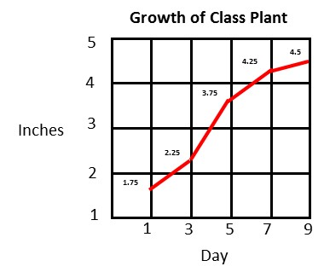
Students would then use the graph to answer questions about the data:
- How tall was our plant on Day 5?
- How much did our plant grow from Day 3 to Day 7?
- What can we say about our plant’s growth over the first 9 days?
- What predictions could we make about our plant’s growth over the next 9 days?

Ideas for Home Support
Identify opportunities to track data over time. Some opportunities might include recording the money in a savings account or changes in gas prices. Use a line graph to track the data and discuss changes that occur over time. Talk about patterns you notice and what can be learned from those patterns.

Thank you for serving as partners in your child’s success as a mathematician!
<signature>

