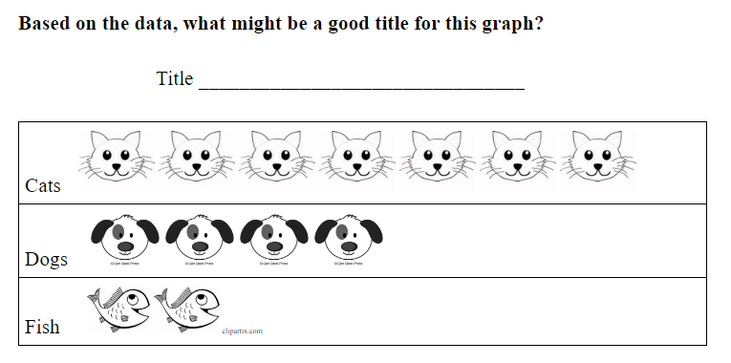

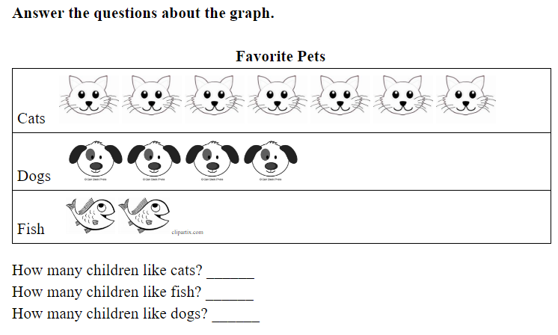

**Make a graph to show a set of 5 red, 3 blue, and 2 yellow connecting cubes.**

**Title ________________________________________**

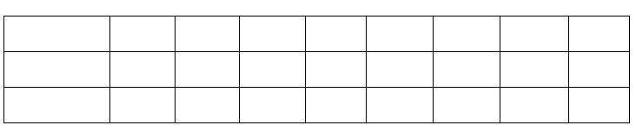

**Answer the questions about the graph.**

**What was the most liked sport?**

**What was the least liked sport?**

**Favorite Sports**

|  |  |  |  |  |  |  |  |  |
| --- | --- | --- | --- | --- | --- | --- | --- | --- |
| **Soccer** | **\*** | **\*** | **\*** | **\*** | **\*** | **\*** | **\*** | **\*** |
| **Basketball** | **\*** | **\*** | **\*** | **\*** | **\*** |  |  |  |
| **Baseball** | **\*** | **\*** | **\*** |  |  |  |  |  |

**How We Get Home**

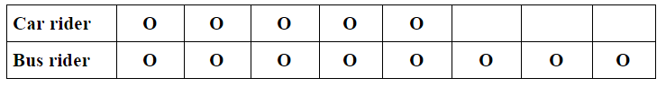

**How many students are in each category?**

**Which category has more students?**

**How many more?  How do you know?**

|  |  |
| --- | --- |
| **Favorite Milk Flavors** | |
| White |  |
| Chocolate |  |
| Strawberry |  |

How many students voted? _____________________________

How many liked white milk and strawberry milk together? ____

What is the least popular flavor? _________________________

How do you know? ____________________________________

**Answer the questions about this set of shapes.**





**How many shapes in all?**

**How many more circles than squares?**

**How many fewer squares than circles?**

**How do you know?  Show your thinking with pictures, numbers, or words.**

**Favorite Sports**

|  |  |  |  |  |  |  |  |  |
| --- | --- | --- | --- | --- | --- | --- | --- | --- |
| **Soccer** | **\*** | **\*** | **\*** | **\*** | **\*** | **\*** | **\*** | **\*** |
| **Basketball** | **\*** | **\*** | **\*** | **\*** | **\*** |  |  |  |
| **Baseball** | **\*** | **\*** | **\*** |  |  |  |  |  |

**Answer the questions about the graph.  Explain using pictures, numbers, or words.**

**How many more students liked soccer than basketball?**

**How many fewer students like baseball than soccer?**

**What 2 statements can you make about this graph?**

|  |  |  |  |  |  |  |  |  |
| --- | --- | --- | --- | --- | --- | --- | --- | --- |
| **Spring** | **X** | **X** | **X** | **X** | **X** |  |  |  |
| **Summer** | **X** | **X** | **X** | **X** | **X** | **X** | **X** | **X** |
| **Fall** | **X** | **X** |  |  |  |  |  |  |
| **Winter** | **X** | **X** | **X** |  |  |  |  |  |

**The students voted for their favorite sports. 4 voted for soccer, 6 voted for basketball, and 8 voted for baseball. Create a graph to show this information.**

Title: _________________________

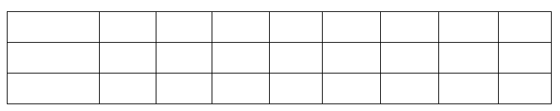

**What are some questions we can ask about the information?**