**What are the next 5 numbers after 21?**

**21, ______, ______, ______, ______, ______**

**When you count up from 57, what are the next 5 numbers you say?**

**57, ______, ______, ______, ______, ______**

**What are the 5 numbers before 78?**

**______, ______, ______, ______, ______, 78**

**When you count back from** **92, what are the next 5 numbers you say?**

**______, ______, ______, ______, ______**

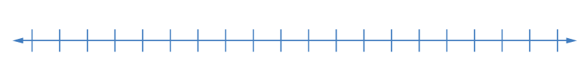

92

**Number Detectives: Please search for the missing numbers on this hundred chart. Complete the chart.**

|  |  |  |  |  |  |  |  |  |  |
| --- | --- | --- | --- | --- | --- | --- | --- | --- | --- |
|  |  |  |  | **65** |  |  |  |  |  |
|  |  |  |  |  |  |  |  |  |  |
|  |  |  |  |  |  |  |  |  |  |
|  |  |  |  |  |  |  |  |  |  |

**Maria says that this drawing represents 51. Her sister Brianna says the drawing represents 15. Do you agree with Brianna? Why or why not?**



**Karen say 73 comes before 74 on a number line. Is she correct? Explain using pictures, words or numbers.**



**Hugo’s mom gave him 49 cookies for his class party. His friend said that if he had one more he would have 50 cookies. Was his friend correct? Explain using pictures, words, or numbers.**

**Mary’s sister was saving money to buy a puppy. She had $101 dollars saved. The puppy cost $100. How much money will Mary have left if she buys the puppy? Explain using pictures, words, or numbers.**

**Antonio says he knows how to count to 150. He starts at 100 and says 101, 102, 103, 104, 105, 106, 107, 108, 109, 110, 120, 130, 140, 150. Did Antonio count correctly? How do you know?**