Strategies (Beyond Counting) to Add & Subtract
In this lesson, students begin to move beyond counting as a strategy for solving addition and subtraction problems. They will use what they know about numbers and relationships between numbers to add and subtract with other strategies. Students will start to see connections between strategies to help them transition their thinking.

NC Mathematics Standard:
Add and subtract within 20
NC.1.OA.6 Add and subtract, within 20, using strategies such as:
- Counting on
- Making ten
- Decomposing a number leading to a ten
- Using the relationship between addition and subtraction
- Using a number line
- Creating equivalent but simpler or known sums

Additional/Supporting Standard:
NC.1.OA.9 Demonstrate fluency with addition and subtraction within 10.

Standards for Mathematical Practice:
1. Make sense of problems and persevere in solving them.
3. Construct viable arguments and critique the reasoning of others.
4. Model with mathematics
7. Look for and make use of structure.

Student Outcomes:
- I can use what I know about numbers and adding or subtracting to solve problems instead of counting.
- I can decompose numbers to help me get to a ten (friendly number).
- I can try a new strategy when solving addition and subtraction problems.
- I can determine if a strategy was used efficiently and the problem solved correctly.

Math Language:
Add Subtract
Strategy Decompose

Materials:
- Problem written (or projected on board) for all to see
- Basket of tools for student use, including items such as: cubes, counters, ten frames, number lines, dry erase markers, etc.
- Individual whiteboards and markers or math notebooks and pencils
- Exit Tickets

Advance Preparation:
- Gather materials and make copies of problem and/or exit ticket.

Launch:
- Present the Task (5 minutes)
Discuss with students all they have been learning as mathematicians about adding and subtracting. Remind them it is important to be accurate. Tell them that their job today is going to be helping a fellow first grader determine if she solved a math problem correctly. Read the problem at least once aloud to the children (again as seen necessary).
Malia had this problem to solve:
The elephants at the zoo get apples as a treat. If the elephants ate 7 apples for a
treat in the morning and 6 apples for a treat in the afternoon, how many apples did the elephants eat today?
Malia solved the problem and says the elephants ate 13 apples today. Is she correct? Show how you know if she is correct or not using drawings, numbers, and/or words.
Ask students to work with a partner (or in groups of 3) to talk about the problem. They should decide if Malia is correct or if they disagree with her response. Most importantly, be sure students understand that they are to show how they know Malia is correct or not correct with drawings, numbers, and/or words.

Explore:
- Solving the Problem (10-15 minutes)
Give students time to talk about the problem and begin working on proving or disproving Malia’s response. They should be talking and collaborating with one or two other children. As students discuss and work, listen to their reasoning and notice what they do to solve the task.
- Are all students in the group participating in discussion of the problem?
- What thoughts are students sharing?
- What are students doing (with objects or on paper) to represent the problem?
- How are students organizing information from the problem? (oral? written?)

Some students may struggle to get started on this problem, especially if they are not used to
tasks like this (examining someone’s work instead of solving for a number answer).
Students may need some prompting if they get stuck in the process of determining their
responses. When providing direction or prompts, resist the urge to lead students. Instead, ask
questions to focus their thinking, help them see other possibilities, or clarify their work. Some
ideas include:
- What are you trying to find out? How could you do that?
- Can you explain what you were thinking here?
- Does your work match the task?”
- Do you think she is correct? Why (or why not)?
- How could you show with objects or numbers what you’re thinking?

As students are working, watch for different strategies used for proving whether Malia’s response is correct or not. The goal is to move students beyond using a strategy focused solely on counting. As you are watching students work and noticing their thinking, carefully select students to share their work with the class. Look for strategies that are represented a bit differently and will spark discussion or any strategies based in number sense and not simply counting. Have conversation with the student(s) in order for him/her to solidify understanding.

Consider the order in which to have targeted students share their work. Begin with a student
who used a counting strategy and move toward other, higher-level strategies.

Discuss:
- Discussion of Solutions; Highlighting Specific Strategies (20-25 minutes)
Bring the class back together. Ask all students to show if they think Malia is correct or incorrect using a signal (such as thumbs up/down). Note the number of students that find her correct and incorrect. Have selected students share their strategies and thinking. As students are explaining, draw/write what they are describing for others to see. Encourage children to be clear and complete in their explanations. You could use questions such as:
- “What were you thinking at first?” “What did you do next?”
- “What strategy did you use?”
- “How did you know that?”
- “What do you mean by…?”

If none of the students used decomposing a number leading to a ten as a strategy, you will now briefly share this strategy and explain how it would look using a number line. You can pretend a student used this method and say “I saw someone…” to keep it from being the teacher’s strategy and keep the focus on how students can be thinking. Using a number line will help students connect the strategy to what they already know. Model beginning at 7 on the number line then jumping to 10 because that is a friendly number (easier to work with). We do not know what 7 + 6 is, but we do know that 7 + 3 = 10. (Be sure drawing shows making a ten.) If we jump to 10 then I know that was +3 and when I think about 6 I know it can be made with 3 and 3 (reference decomposing a number, like in a number bond). So now I just need to jump 3 more from 10 and that is easy, it is 13.

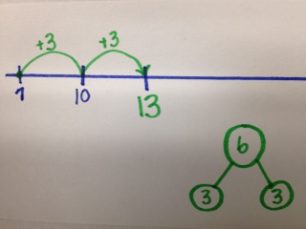

You can also show other representations for this strategy, in addition to a number line, especially if your students demonstrate understanding of making 10 and are ready to see more.

One option would be using a ten frame. Students can easily see filling a ten frame as making a ten. Encourage them to use counters and to attach numbers to their work in order to move them toward number sense and to not solely rely on the ten frame tool. It is a great idea to show multiple ways of representing and recording this kind of thinking so students fully grasp the concept. It also helps them feel empowered in how to show their thinking when they are solving problems using this strategy.

Make sure to highlight thinking of how to make 10, then how to decompose one number to get what is needed to make ten. These are both skills students should be familiar with in first grade. You will show how to use both skills together to solve problems with this strategy. Make these connections clear to students to show them they do have the skills needed to try this new strategy.

Explain to children this strategy is not actually new thinking, but it is a new way to solve a problem that they may not have tried before. Let them know it is an efficient strategy for adding larger numbers and you want them all to give it a try. (Understand that all children may not use this strategy or be able to use it effectively, but it is important to expose all children to the strategy and give them an opportunity to practice.)

Additional Activities
- Practice Problem (15-20 minutes)
Now that students have seen the strategy of decomposing leading to a ten modeled and explained, give all students the word problem below. Ask them to solve using the strategy of decomposing leading to making a ten.
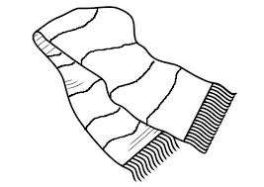
Mrs. Jones knits scarves for her family. She has made 8 scarves already and will make 4 more scarves by the end of the month. How many total scarves will Mrs. Jones make for her family?

Circulate while students are working individually, prompting and questioning as needed to help students complete the task with the requested strategy. Students may represent their thinking in various ways – they are not required to use a number line. Encourage those children who are struggling or are unable to represent their thinking on paper to use a number line to help them, but ask them not to make single jumps. Remind them of trying to make a ten to solve.

Once all students have had opportunity to solve the problem, allow them to share what they learned and what was tricky for them. Share a couple examples of what you saw students doing to show their thinking while solving with this new strategy. If time allows, students can share their own work.

Evaluation of Student Understanding
Informal Evaluation:
Observe and monitor students as they are solving problems and trying the newly introduced
strategy. Question students to uncover their thinking instead of assuming their understanding
based on their work. Have conversations with students to encourage oral explanation and use
of academic language.

Formal Evaluation/Exit Ticket:
Give students the following task to complete. Remind them to prove their answer by showing
their thinking with drawings, numbers, and/or words.

Hugo was trying to find the missing number in the equation 7 + 5 = ?
He said because 7 + 4 = 10 then 7 + 5 = 11. Do you agree with Hugo?
Prove your answer by showing your thinking with drawings, numbers, and/or words.

Possible Solutions:

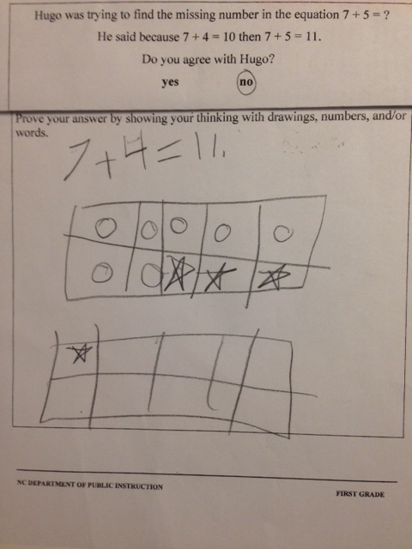
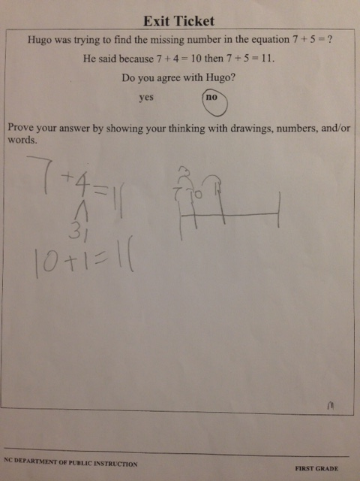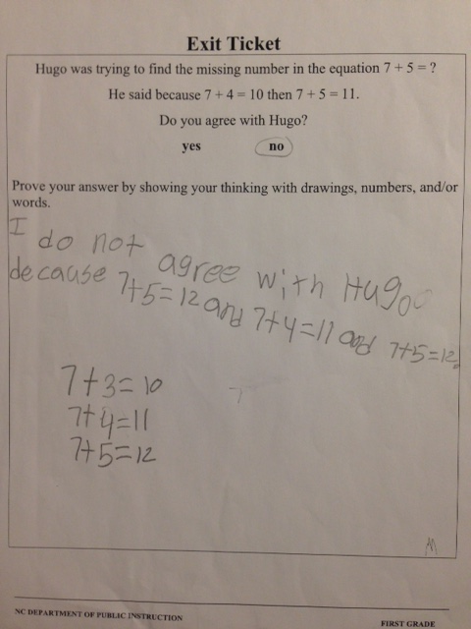

Meeting the Needs of the Range of Learners
Intervention:
- Provide students with additional materials that may help them concretely. For example, give students a number line to 20 and counters to use as markers on the number line. This will prevent the open number line from being a barrier to solving the problem.

- Ask students to write a list of addition facts that all equal ten. Allow them to use a cube tower or train of 10 cubes to assist them as needed. They can then use the list to help in decomposing a number to make 10. They may continue to use the cubes for assistance in decomposing a number as well.

Extension:
- Ask students to solve the problems in at least two ways (using two different strategies).

Possible Misconceptions/Suggestions:
Possible Misconceptions | Suggestions
Student is unable to make a ten successfully. | Have students continue with games that build computational fluency, especially with making 10.  Students can also work with partially-filled ten  frames and match to number cards showing what  is needed to fill the ten frame.
Student struggles to decompose numbers. | Have students work with cubes or counters and  number bond work mats to find combinations of a  given number. Have the students physically show  the total group of counters in the large circle then  separate the group into two smaller groups to  decompose. Repeat with the same number but  different decompositions and also with different  numbers.  Many games are available, too, for helping  students see numbers in different  groupings or combinations.

Special Notes:
Standard NC.1.OA.6 focuses on adding and subtracting using strategies. It does not require students to decompose a number leading to making a ten; that is just one of several strategies. The purpose of this lesson is not to require all students to use this strategy in solving all problems from now on. It is meant to give students another option, especially when getting to a ten is quite simple or obvious (like when working with 9 or 8). Students may not all make this jump in their use of strategies, but exposure like this lesson opens the door for students to try strategies grounded in number sense.

Malia had this problem to solve:
The elephants at the zoo get apples as a treat. If the elephants ate 7 apples for a treat in the morning and 6 apples for a treat in the afternoon, how many apples did the elephants eat today?

Malia solved the problem and says the elephants ate 13 apples today. Is she correct? Show how you know using drawings, numbers and/or words.

Malia had this problem to solve:
The elephants at the zoo get apples as a treat. If the elephants ate 7 apples for a treat in the morning and 6 apples for a treat in the afternoon, how many apples did the elephants eat today?

Malia solved the problem and says the elephants ate 13 apples today. Is she correct? Show how you know using drawings, numbers, and/or words.

Mrs. Jones knits scarves for her family. She has made 8 scarves already and will make 4 more scarves by the end of the month. How many total scarves will Mrs. Jones make for
her family?

Mrs. Jones knits scarves for her family. She has made 8 scarves already and will make 4 more scarves by the end of the month. How many total scarves will Mrs. Jones make for
her family?

Mrs. Jones knits scarves for her family. She has made 8 scarves already and will make 4 more scarves by the end of the month. How many total scarves will Mrs. Jones make for
her family?

Exit Ticket
Hugo was trying to find the missing number in the equation 7 + 5 = ?
He said because 7 + 4 = 10 then 7 + 5 = 11.
Do you agree with Hugo?
yes no

Prove your answer by showing your thinking with drawings, numbers, and/or words.

