NC.1.OA.6
Help a Friend
Domain | Operations and Algebraic Thinking
Cluster | Add and subtract within 20.
Standard | NC.1.OA.6  Add and subtract, within 20, using strategies such as:  - Counting on  - Making ten  - Decomposing a number leading to a ten  - Using the relationship between addition and subtraction  - Using a number line  - Creating equivalent but simpler or known sums
Materials | SF, pencil
Task | Read aloud the prompt. If your friend did not know the answer to 8 + 6, how would you tell him to figure it out? Explain the steps he should take.

Continuum of Understanding
Not Yet Proficient | Response includes 0-1 of the descriptors in “Meets Expectations” | Strategies:  - Counting on  - Making ten  - Decomposing a number leading to a ten  - Using the relationship between addition and subtraction  - Using a number line  - Creating equivalent but simpler or known sums
Progressing | Response includes 2 of the descriptors in “Meets Expectations”
Meets Expectations | Response includes all the descriptors in “Meets Expectations”  - Correctly explains steps using a strategy other than counting all  - Strategy leads to a correct answer of 14  - Explanation of the strategy is clear

Standards for Mathematical Practice
1. Makes sense and persevere in solving problems.
2. Reasons abstractly and quantitatively.
3. Constructs viable arguments and critiques the reasoning of others.
4. Models with mathematics.
5. Uses appropriate tools strategically.
6. Attends to precision.
7. Looks for and makes use of structure.
8. Looks for and expresses regularity in repeated reasoning.

If your friend did not know the answer to 8 + 6, how would you tell him to figure it out? Explain the steps he should take.

Scoring Examples

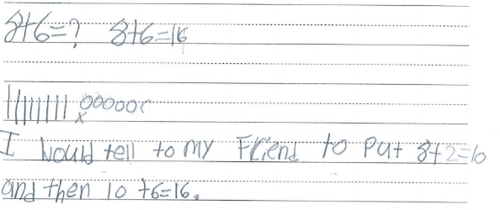
These students received “Not Yet Proficient” because they did not determine the correct answer or have clear explanations of their strategies. The first student named a strategy and did not solve the problem or explain the steps. The next step could be to ask the student Where did you start on your number line? and to show how he/she solved the problem. Then, review the steps verbally. The second student’s strategy is unclear and does not have a correct answer. However, the student has shown a counting all strategy as well as the first step in a making ten strategy. The next step could include prompting for more details by saying I noticed you added 2 to make a ten. Where did you get the 2 from? How could you show that in your picture and explain it with your words?
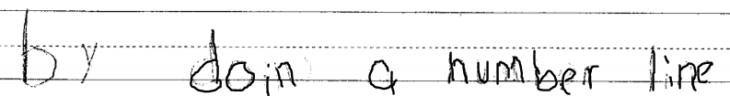

This student received “Progressing” because the student had the correct answer and, while the explanation is not clear, there is evidence that the student used a counting on strategy because the explanation started with a bundle of eight. The next step could be to help the student clarify the explanation. In addition to the written explanation, the student could name the strategy and include a picture that shows the thinking. This would provide more evidence of how the student’s strategy led to the correct answer.
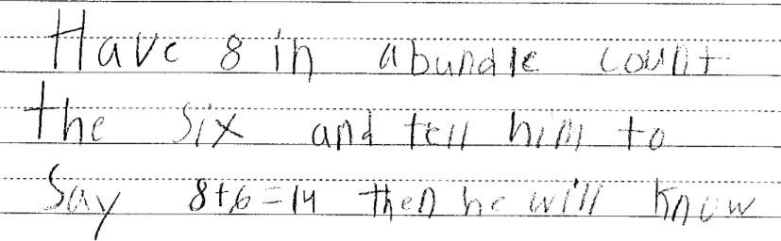
These students received “Meets Expectations” because they met all of the descriptors. The strategies led to correct answers, the correct answers were given, and the use of pictures, numbers, and words created clear explanations.
