NC.1.OA.1
How Many Flowers? (Version 1)
Domain | Operations and Algebraic Thinking
Clusters | Represent and solve problems.  Understand and apply the properties of operations.  Add and subtract within 20.
Standards | NC.1.OA.1 Represent and solve addition and subtraction word problems, within 20, with unknowns, by using objects, drawings, and equations with a symbol for the unknown number to represent the problem, when solving:  • Add to/Take from-Change Unknown  • Put together/Take Apart-Addend Unknown  • Compare-Difference Unknown  NC.1.OA.4 Solve an unknown-addend problem, within 20, by using addition strategies and/or changing it to a subtraction problem  NC.1.OA.6 Add and subtract, within 20, using strategies such as:  • Counting on  • Making ten  • Decomposing a number leading to a ten  • Using the relationship between addition and subtraction  • Using a number line  • Creating equivalent but simpler or known sums  Add to/Change Unknown
Materials | SF, cubes or counters, pencil
Task | Provide materials to the student. Read the problem to the student: I have a vase with 5 flowers. Mom put more flowers in the vase. Now I have 12 flowers in the vase. How many flowers did Mom put in the vase? Write a number sentence that matches this story. Use a symbol for the unknown number. Once an equation is written, say: Solve the problem and show your thinking with pictures, numbers, or words.

Continuum of Understanding
Not Yet Proficient | Response includes 0-1 of the descriptors in “Meets Expectations” | Strategies Used:  - Trial and Error  - Counting All  - Counting On  - Think-Addition  - Makes Tens  - Basic Facts  - Creates easier or known sums  - Doubles  - Doubles +/- 1, 2  - Other:
Progressing | Response includes 2 of the descriptors in “Meets Expectations”
Meets Expectations | Response includes all the descriptors in “Meets Expectations”  - Correctly solves the problem: 7 flowers  - Clearly explains using strategies such as basic facts, near-doubles, making tens and/or the relationship between addition and subtraction (instead of counting all)  - Equation is accurate (e.g., 5 + * = 12; 12 = 5 + *)

Standards for Mathematical Practice
1. Makes sense and perseveres in solving problems.
2. Reasons abstractly and quantitatively.
3. Constructs viable arguments and critiques the reasoning of others.
4. Models with mathematics.
5. Uses appropriate tools strategically.
6. Attends to precision.
7. Looks for and makes use of structure.
8. Looks for and expresses regularity in repeated reasoning.

I have a vase with 5 flowers. Mom put more flowers in the vase. Now I have 12 flowers in the vase. How many flowers did Mom put in the vase?
Write a number sentence that matches this story. Use a symbol for the unknown number.
Solve the problem.
Show your thinking with pictures, numbers, or words.

__________________ flowers

Scoring Examples

The student received “Not Yet Proficient” because the student did not create a model or an equation to correctly represent the problem. The student drew circles and created a number bond in which the known numbers were added together to get a total of 18. This student did not attempt to use an equation to represent the action of adding to a known amount to get the total. This student could benefit from using concrete representations to model the beginning number and adding to the amount to get the end sum. It may also be helpful to make a connection to an equation to represent the beginning, middle, and end of the story while using a question mark or other symbol to represent the unknown in the middle of the story.
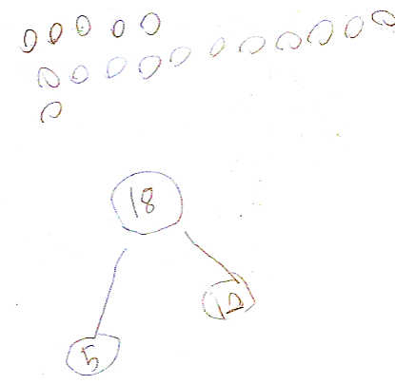

This student received “Progressing” because the student could solve the problem correctly using a number line to represent adding to the beginning number. The student began on the number line at 5 and counted on to 12. The student labeled the hops on the number line to represent the amount added to the beginning number. Then the student incorrectly inserted the numbers in the equation and did not use a symbol to represent the unknown. This student could benefit from guided practice to set up the equation with a symbol to represent the unknown while making a connection to the solution strategy used on the number line and the numbers in the equation.
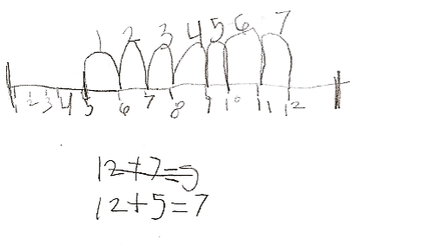
This student received “Meets Expectations” because the student could correctly solve the problem with pictures, numbers, and words. The student represents adding to with flowers and numbers. This student could benefit from using more efficient strategies (number line, number bond, etc.) that represent the number relationships. In addition, a higher range of numbers could be used with future tasks. Encourage the student to explain why the solution path could be adding on from 5 or subtracting from 12.

