Fifth Grade – Cluster 1 Assessment

This assessment assesses students’ ability to:
- Identify the origin, x-axis and y-axis
- Represent real-world and mathematical problems by graphing points on a coordinate plane
- Identify trends in data
- Describe a relationship of a coordinate to the x- and y-axis
- Form ordered pairs from corresponding terms
- Graph coordinates on a coordinate plane
- Identify relationships between corresponding terms

NCSCOS 2017 Standards:
This assessment addresses each of the following 2017 NC Mathematics Standards:

Standard | Questions
NC.5.OA.3 | 2, 6, 8, 10, 12
NC.5.G.1 | 1, 5, 7, 11, 13, 14, 15
NC.5.MD.2 | 3, 4, 9, 16, 17
Question | Standard | Answer
10 | NC.5.OA.3 | C
11 | NC.5.G.1 | A
12 | NC.5.OA.3 | D
13 | NC.5.G.1 | C
14 | NC.5.G.1 | A
15 | NC.5.G.1 | B
16 | NC.5.MD.2 | B
17 | NC.5.MD.2 | Rubric

Question | Standard | Answer
1 | NC.5.G.1 | B
2 | NC.5.OA.3 | A
3 | NC.5.MD.2 | C
4 | NC.5.MD.2 | D
5 | NC.5.G.1 | B
6 | NC.5.OA.3 | D
7 | NC.5.G.1 | C
8 | NC.5.OA.3 | C
9 | NC.5.MD.2 | D

Question 17 (4 points)
Student receives one point for each of the following bullets:
- Student creates a title that indicates the data represented (ie Cassandra’s Sister’s Weight)
- Student labels the x-axis with months old and the y-axis with pounds
- Student accurate represents the data on the table
- Student makes 2 true statements about the data in the graph
Student Name: ________________________ Date: _________

5th Grade – Cluster 1 Assessment

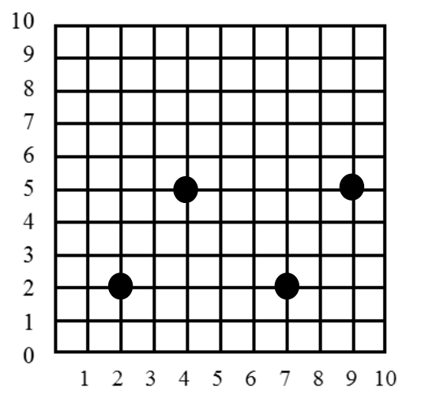
1. Five friends live in the same neighborhood. The locations of their homes form a trapezoid. The locations below show the homes of four of the friends. Which of the following could be the coordinates of the fifth friend’s house?

A (5, 4)
B (9, 2)
C (7, 7)
D (4, 2)

2. Kiana kept track of the number of books she read during the school year. She plotted the information on a coordinate grid. If her pattern of reading continues, how many books will she have read at the end of 16 weeks?
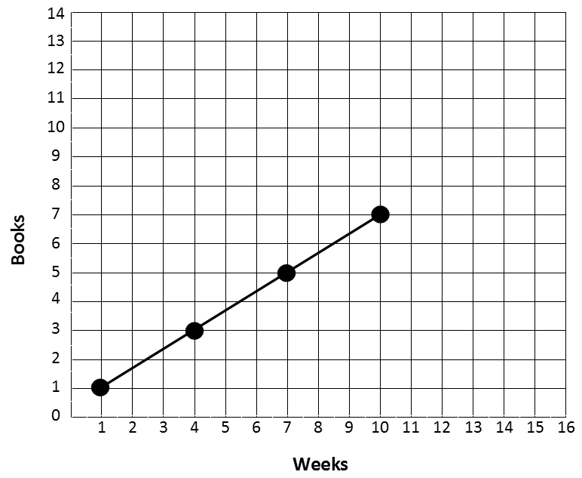
A 11 books
B 13 books
C 14 books
D 16 books

This graph shows the change in population in Charlotte, North Carolina between 1850 and 2017. Use the graph below to answer questions 3 and 4.

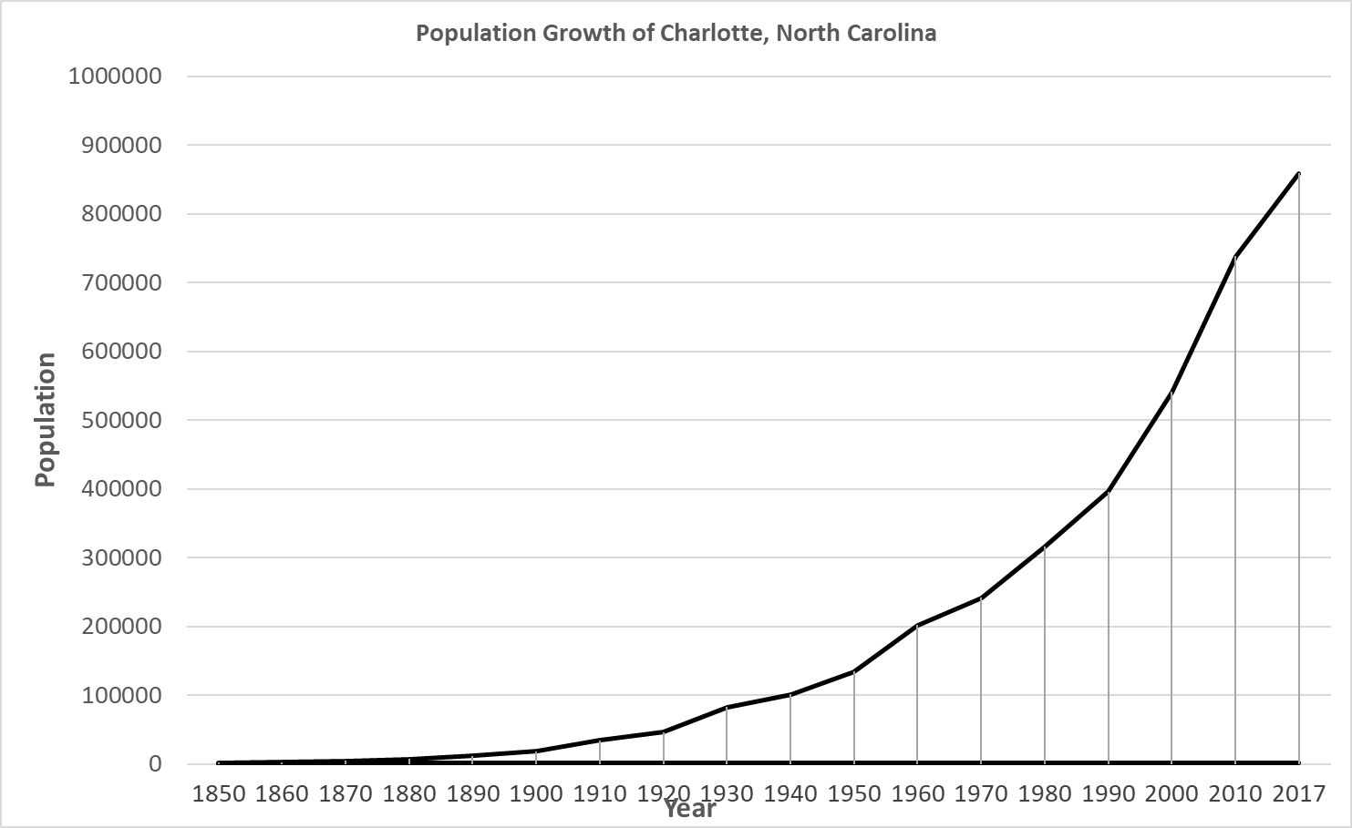

3. A decade is a group of 10 years. In which decade did the population of Charlotte reach 500,000?
A During the 1930’s
B During the 1980’s
C During the 1990’s
D During the 2000’s

4. In which time frame did the population of Charlotte grow the fastest?
A Between 1850 and 1880
B Between 1890 and 1920
C Between 1930 and 1960
D Between 1980 and 2010

5. Diraj made a square on this coordinate grid. Three of the vertices were located at the following points: (8,7), (4,7), and (4,3). What is the location of the fourth vertex?

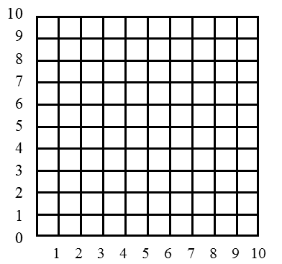
A (4, 6)
B (8, 3)
C (9, 3)
D (3, 8)

6. A botanist was studying the impact of pollution on plant growth.
      - Every two weeks, she recorded data in sets of ordered pairs.
- The x-coordinate is the number of weeks at the time of recording.
- The y-coordinate gives the height of the plant in inches.
She recorded the following coordinates for a plant exposed to pollution:

(2, 4), (4,10), (6,15), (8,19), (10,22)

If the pattern continues, at which week should the botanist expect no change in plant height?

A Week 12 B Week 13
C Week 14 D Week 16

7. Raul made a parallelogram on this coordinate grid. Three of the vertices were located at the following points: (4,6), (10,6), and (10,2). What is the location of the fourth vertex?

A (6, 2)
B (4, 0)
C (4, 2)
D (0, 6)

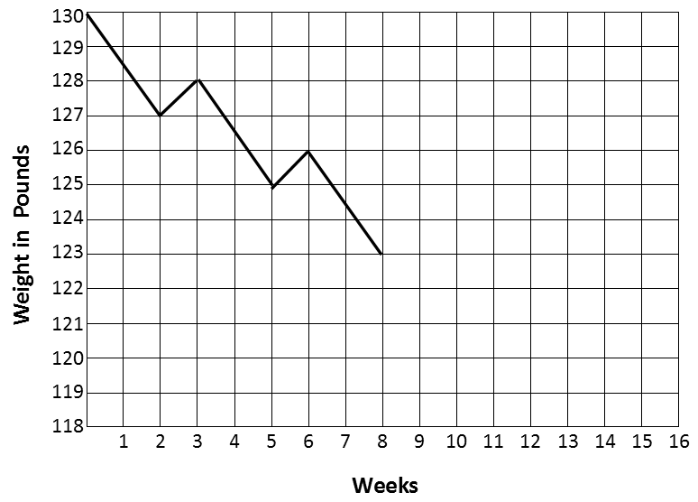
8. Marianna’s mom wants to lose at least 10 pounds. She created a coordinate grid to keep track of her weight each week. She noticed a pattern in her weight loss. If this pattern continues, in how many weeks should she expect to weigh less than 120 pounds?

A Week 12
B Week 13
C Week 14
D Week 15

9. Which graph should be used to represent the data collected using this survey question: How many minutes do you watch TV each day?

A line graph
B picture graph
C bar graph
D line plot

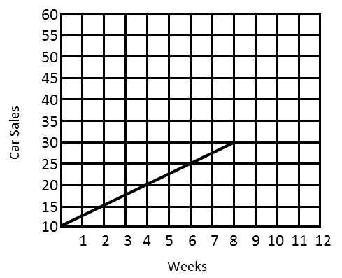
10. A car dealership wanted to increase the number of cars sold. The dealership began advertising on the radio, Facebook, and billboards. They also began to offer competitive prices to draw more buyers. The graph below shows the current trend in car sales. If the trend continues, how many cars can they expect to sale in the 12th week?

A 32
B 35
C 40
D 45

11. Meredith made mystery shapes on a coordinate grid by listing the coordinates. Her friends had to connect the coordinates in order, connecting the last one to the first one. Which set of coordinates will make a triangle?
A (6, 6) (6, 3) (2, 6) (6, 9)
B (3, 5) (5, 8) (8, 7) (9, 4)
C (2, 0) (7, 0) (7, 4) (2, 4)
D (2, 8) (2, 3) (9, 3) (9, 6)

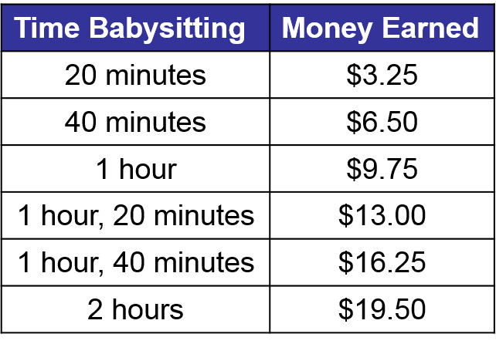
12. Lydia earns money by babysitting children in her neighborhood. She charges based on how long she babysits. She uses a pattern to determine the cost. The table below shows how much Lydia charges. How much should Lydia charge if she babysits for 3 hours, 20 minutes?

A $19.50
B $22.75
C $29.25
D $32.50

13. Four points of a coordinate grid are shown below.
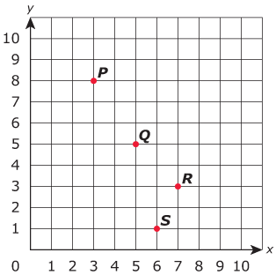
Which point has coordinates (x ,3) , where x has a value greater than 6?
A P B Q
C R D S

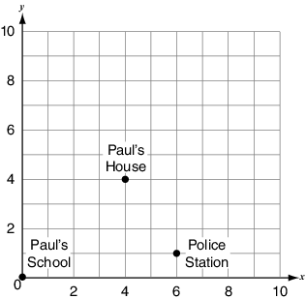
14. Three locations in Paul’s town are plotted on the coordinate grid below (1 unit square represents 1 square mile). Paul’s father works at the police station. Which directions on the grid could Paul’s father use to get from work to his house?
A move 2 units left and 3 units up
B move 3 units left and 2 units up
C move 4 units right and 4 units up
D move 6 units right and 2 units up

15. Adalee wants to plot the point (6, 4) on this grid.
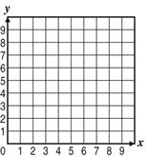

What should she do to plot the ordered pair correctly?

A begin at the origin, go up 6 spaces and over to the right 4 spaces
B begin at the origin, go over to the right 6 spaces and up 4 spaces
C begin at the origin, go over to the right 4 spaces and up 6 spaces
D begin at the origin, go over to the right 6 spaces and down 4 spaces

16. Tatyana created a survey question that involved collecting categorical data. Which of the following questions could be Tatyana’s question?

A How many days were you absent last year?
B Which state were you born in?
C How many people are in our classroom at each hour of the day?
D How many people live in your house?

Open Response Question:

17. Cassandra kept a record of her baby sister’s weight over her first 3 years. She recorded her sister’s weight every 3 months in the table below. Now Cassandra wants to make a line graph to show her sister’s weight. Use the data Cassandra collected to make a line graph. Be sure to include a title and labels on the horizontal and vertical axis.

Age in Months | Weight in Pounds
0 | 8
3 | 14
6 | 17
9 | 19
12 | 21
15 | 23
18 | 24
21 | 26
24 | 27
27 | 28
30 | 31
33 | 32
36 | 34

Write 2 sentences to describe what you notice about the data in the graph:

1. ______________________________________________________________________
________________________________________________________________________

2._______________________________________________________________________
_________________________________________________________________________

