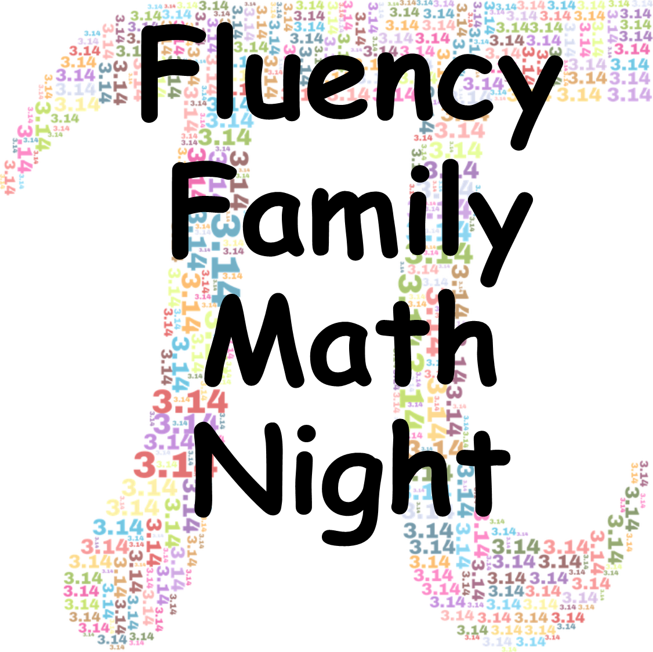
Family Math Night
- Overview
  - Summary
  - Target Audience
  - Focus Area

- Preparation Packet
  - Preparation Checklist
  - Advertisement Flier or Letter

- Event Packet
  - Sign-In Sheet
  - Preparation Checklist
  - Agenda
  - Preparation Checklist
  - Games and Materials
  - Parent Evaluation
Overview
Summary: Family Math Night is an opportunity for families to collaborate with their students using 5th grade math objectives to solve real world problems. Families interact with the child’s teacher and other school staff, as well as receive resources to use at home with their student. This family night focuses on the concepts of Order of Operations, Whole Numbers (addition, multiplication, and division), Decimals, Fractions, Geometry, and Volume. Prior to beginning, teachers may wish to print the parent letters from www.Tools4NCTeachers.com. In order to do this, click on the appropriate grade level, then cluster topic, then scroll down to the bottom of that page and you will find the parent letters.

Target Audience: Fifth Grade Families

Preparation Checklist
- Print cluster family letters from www.Tools4NCTeachers.com. See above instructions to find the appropriate cluster topic.
- Send out invitations or flyers a few weeks prior to the event to families. This can be found following the games titled: “Join Us For Family Game Night”.
- Advertise on email, school/teacher webpage/social media, phone messages, or the marquee at school.
- Prepare and print a sign-in sheet (included).
- Print the directions for each center and gather necessary materials. (included)
- Print and send a reminder before the day of the event.
- Consider displaying recent student work on current cluster for families to see.
- For each game, print the game and game cards on cardstock or paper, and cut out game cards prior to use.

Family Math Night Agenda

As students and families drop in, hand out the parent letters and provide explanations for the centers listed on the board.

During the event:
- Students will participate in the centers with their families in order to foster understanding of Order of Operations, Whole Numbers (addition, multiplication, and division), Decimals, Fractions, Geometry, and/or Volume.
- Teachers will choose from the below games as they prepare for the event, depending on where they are with their instruction of concepts.
- Some of these are certainly for later in the year while others can be used early in the fifth grade year.

Parent Fluency Building Game List
The Games file is located at the following link: http://maccss.ncdpi.wikispaces.net/file/view/5thgrade_GAMES_8.22.14.pdf/519548106/5thgrade_GAMES_8.22.14.pdf

Current Name of Game: Operation Target (NC.5.OA.2)

Parent Note: This game helps children create equations with the use of parentheses. The game is open-ended, allowing for the creation of many different possible equations, and can be played over and over again. If your child tends to stick with one or two types of operations, challenge them to try other operations. You may also need to encourage more creative solutions using parentheses and/or multiple operations.

Materials: Copy of the game, digit cards (0-9) and a recording sheet per player
Current Name of Game: Corn Shucks (NC.5.NBT.3)

Parent Note: This game has children comparing decimals. The game is open-ended, allowing for the choice of placement and creation, and can be played over and over again. Once your child begins to understand how to correctly place the numbers on the recording sheet, challenge them to begin thinking more strategically in their placement.

Materials: Recording sheet, digit cards (or 0-9 die), copy of the game
Current Name of Game: Sum with Decimals (NC.5.NBT.3 and NC.5.NBT.7)

Parent Note: This game asks children to read, write and compare decimals, add decimals to the hundredth place and use concrete models to represent decimals. This game can be played over and over, because each time different decimals can be formed. Once you feel your child has mastered the game, challenge them to Part II (the same game, but instead of building decimals to hundredths, this time they will build decimals to thousandths).

Materials: Copy of game, pair of dice and recording sheet
Current Name of Game: Pieces of Eight (NC.5.NBT.3 and NC.5.G.1)

Parent Note: This game asks children to compare decimals. The rolling of dice allows for some variation in the game, but the game board remains the same, so consider playing this game no more than about once or twice a week. Once your child begins to understand how to locate the coordinates on the recording sheet, challenge them to begin thinking more strategically in their placement.

Materials: Copy of game, pair of dice, game board, paper
Current Name of Game: Race to 10 or Bust (NC.5.NBT.1 and NC.5.NBT.7)

Parent Note: This game helps children develop efficient mental strategies when adding and subtracting decimals. The game is open-ended, allowing for the choice of placement, and can be played over and over again. Students may begin to see that strategies that work well with whole numbers, work equally well with decimal, for example, 3.8 + 0.6 is the same as 3.8 + 0.2 + 0.4. For more of a challenge, change the target number.

Materials: Copy of game, die and recording sheet
Current Name of Game: Race to 1 or Bust (NC.5.NBT.1 and NC.5.NBT.7)

Parent Note: This game asks children to add decimals. The game is open-ended, allowing for the choice of placement, and can be played over and over again. One challenge to adding decimals is organization of place value. You may want to consider using a sheet of notebook paper rather than the grid provided, allowing children to write and organize their decimals before adding them.
Materials: Copy of game, die and recording sheet

Current Name of Game: Shopping Spree (NC.5.NBT.1 and NC.5.NBT.7)

Parent Note: This games asks children to add and decimals. This game has many possible choices, so children may come up with different combinations each time they play. Therefore, this game can be played several times. Consider changing the amounts to be spent. This modification will allow for many more solution possibilities. You may want to give your child a sheet of lined paper, and have them turn the paper horizontally to help them line up their amounts before adding.

Materials: Copy of the game, timer, recording sheet and price tag sheet
Current Name of Game: Multiplication Mix-Up (NC.5.NBT.5)

Parent Note: This game asks children to multiply multi-digit whole numbers. The game is open-ended, allowing for the choice of placement, and can be played over and over again. To challenge children further, ask them to select 4 cards to create either a two digit by two digit equation or a three digit by one digit equation. They can even select 5 cards to create a three digit by two digit equation.

Materials: Copy of the game, deck of cards, calculator
Current Name of Game: Double Dutch Treat (NC.5.NBT.6 and NC.5.NBT.7)

Parent Note: This game asks children to add and divide whole numbers. The game is open-ended, allowing for many different combinations of digits, so the game can be played many times. Ask your child to look for patterns and reason about why the solutions are always even. Consider challenging your child to create their own game board with new rules to follow.

Materials: Copy of the game, game board

Current Name of Game: Decimal Dynamo (NC.5.NBT.7)

Parent Note: This game asks children to add and multiply decimals. This game asks children to multiply multi-digit whole numbers. The game is open-ended, allowing for the choice of placement, and can be played over and over again. As you play the game more and more, challenge your child to be more strategic when creating their numbers, to ensure they have the greatest possible sum of products at the end of the game.

Materials: Copy of the game, 4 dice and recording sheet, calculator
Current Name of Game: Greatest Product (NC.5.NF.4 and NC.5.NF.7)

Parent Note: This game asks children to multiply a fraction by a fraction. The game is open-ended, allowing for the choice of placement, and can be played over and over again. Consider changing the goal periodically from the greatest product to the least product. For more variation, allow your child to create fractions greater than one. Talk about the differences in the products.

Materials: Copy of the game, deck of cards; optional calculator with grid paper and colored pencils
Current Name of Game: Rolling, Rolling, Rolling (NC.5.NF.3 and NC.5. NBT.3)

Parent Note: This game asks children to look for equivalent fractions. The game is open-ended, allowing for the choice of placement, and can be played over and over again. Consider having your child create their own fraction game boards. Remind them that need to think of equivalent fractions as they determine which fractions to place on their created game board.

Materials: Copy of game, game board, 10 markers of one color per person, and a pair of standard dice (1-6)

Current Name of Game: Packing Blocks (NC.5.MD.5)

Parent Note: This game asks children to explore volume. This is a matching game with one solution, so limit play to no more than once or twice a week. To allow for more variation, consider challenging your child to create their own set of cards. You can also modify the game, allowing various block sizes to be packaged together.

Materials: Copy of the game, game cards, calculator
Current Name of Game: Blackbeard’s Treasure Box (NC.5.G.1)

Parent Note: This game asks children to find points on a coordinate plane. The game is open-ended, based on the random roll of a die, and can be played over and over again. Consider modifying the game to allow students to choose which axis they want to assign each roll, allowing for more strategic thinking. You can also change the goal by seeing who can cover four adjacent gems to form a box, instead of four in a row.

Materials: Copy of the game, standard dice, 10 markers per player (players need different colors)
*These are games that align with the current North Carolina Standards, however, there are other games available to use.*

Join Us for Family Math Night
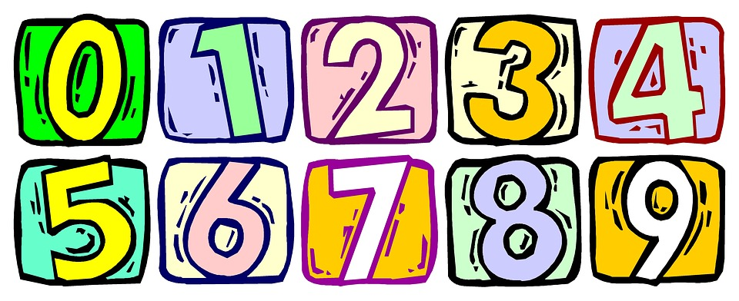

When: (Insert Date & Time Here)
Where: (Address Here)
Learn fifth grade math strategies while having a great time with your student. There will be special fun activities for you to learn with your child. We look forward to seeing you at this exciting educational event!

Join us for Family Math Night

When: (Insert Date & Time Here)
Where: (Address Here)

Learn fifth grade math strategies while having a great time with your student. There will be special fun activities for you to learn with your child. We look forward to seeing you at this exciting educational event!
Family Math Night Sign-In
Date:________________
Family Member(s) | Student Name

Thank you for attending our Family Math Night!
We value your feedback.

- What was your favorite part of Family Math Night?

- What would you change about our Family Math Night?

- What did you learn from Family Math Night?

- Additional Comments:

Thank you for attending our Family Math Night!
We value your feedback.

- What was your favorite part of Family Math Night?

- What would you change about our Family Math Night?

- What did you learn from Family Math Night?

- Additional Comments:

