Growing Sumandas

In this lesson, students will explore a growing pattern and then graph the pattern on a coordinate plane.

Common Core Standard:
Graph points on the coordinate plane to solve real-world and mathematical problems.
NC.5.G.1 Graph points in the first quadrant of a coordinate plane, and identify and interpret the x and y coordinates to solve problems.

Standards for Mathematical Practice:
2. Reason abstractly and quantitatively
- Model with mathematics
- Use appropriate tools strategically
7. Look for and make use of structure

Student Outcomes:
- I can model and extend a pattern
- I can represent a pattern using models, drawings, words, tables, and graphs
- I can make connections between a pattern and a graph

Materials:
- Pattern blocks (at least 15 squares and 5 triangles per student or pair of students)
- Growing Sumandas sheet (1 for each student)

Advance Preparation:
- Gather pattern blocks
- Copy the Growing Sumandas sheet
- Consider whether students will work in pairs or as a class for this task
- If students are working in pairs, they should have some experience with patterns, including working with tables
- If students are working pairs they should have experience using a table to plot points on a coordinate grid.

Directions:
- Distribute pattern blocks.
- Present the following scenario to the students:
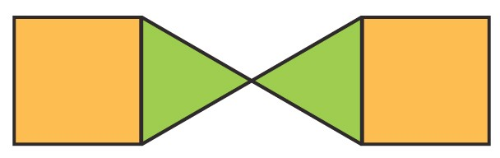
During your scientific exploration to a newly discovered rainforest you encounter a new creature called a sumanda.

- Invite students to build the sumanda with their blocks. Tell them that this is the sumanda at 1 year old.
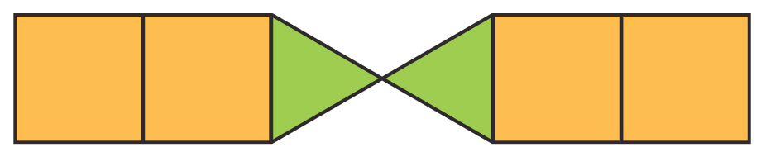
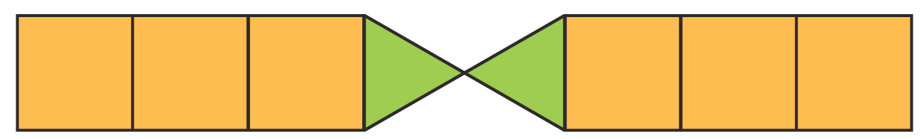
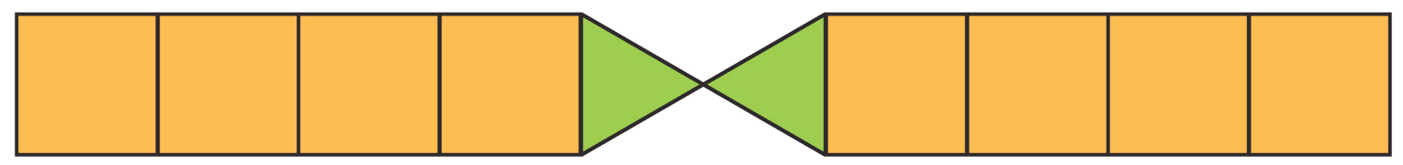
- Tell students that they will observe the sumanda’s growth. Demonstrate and have students build years 2, 3, and 4 beneath year one:
  - years old

  - years old

  - years old

- Use the Growing Sumandas sheet to guide your instruction. Ask students to complete one section at a time, then elicit student answers and model the component. However: If students have experience with this process, have them work in pairs with much less teacher guidance.
- To close, extend student thinking by asking the questions below.

Questions to Pose:
As students work in pairs:
- How did you decide to draw your table? How does your table relate to the blocks?
- What surprised you about the graph? Why was it surprising?
- What challenges are you running into? What are you doing to help you face them?

After:
- What do you notice about the shape of the graph? Why does this shape make sense?
- How does the graph help you describe the sumanda’s growth?
- How can the graph help you predict the sumanda’s future growth?
- What does this point on the graph tell you about the sumanda?

Possible Misconceptions/Suggestions:

Possible Misconceptions | Suggestions
Students have difficulty placing the attribute on the axis (number of years on the x-axis and number of blocks on the y-axis). | Have the students examine a collection of simple line graphs. Ask them to draw conclusions about the type of data listed on each axis. Note that the x-axis shows the data you are changing. The y- axis should show the data being measured.

Special Notes:
A follow up task should follow this process with 2 patterns. The patterns should be graphed on the same coordinate grid and analyzed (5.OA.3).

Solutions:
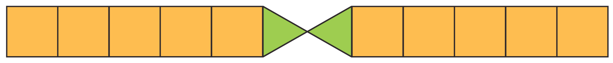
Extend the Pattern:
  - years old

  - years old

Words: Student words will vary. One example is - Each year, the sumanda grows one square on each side.

Table: Function tables may be set up horizontally or vertically. One example is –
Years old (n) | 1 | 2 | 3 | 4 | 5 | 6
Number of blocks | 4 | 6 | 8 | 10 | 12 | 14

Number of blocks at the 10th stage: 22

Pattern Rule: Student answers may vary. Some examples are –
  - There are twice as many squares as the age of the sumanda. There are always 2 triangles.
  - Add 2 blocks to the previous year
  - Multiply the age by 2 then add 2 more
  - Number of blocks = 2 n + 2
  - Number of blocks = (2 x n) + 2
Coordinate points: (1,4) (2,6) (3,8) (4,10) (5,12) (6,14)

Adapted from Partners for Mathematics Learning, 2008

Growing Sumandas, side 1

Based on this pattern, draw and extend the sumanda for 2 more years: 5 years old

6 years old
Use words to describe the pattern | Create a table to describe the pattern
Draw and describe the 10th stage of the pattern | Write a rule for this pattern

Adapted from Partners for Mathematics Learning, 2008

Growing Sumandas, side 2

Use the table to write the coordinate points for this pattern:

Plot the coordinate points on the graph below. Should these points be connected to form a line graph? How do you know?

Title

Adapted from Partners for Mathematics Learning, 2008

