NC.5.MD.2
Henry’s Music Dilemma
Domain | Measurement and Data
Cluster | Represent and interpret data
Standard(s) | NC.5.MD.2 Represent and interpret data.  • Collect data by asking a question that yields data that changes over time.  • Make and interpret a representation of data using a line graph.  • Determine whether a survey question will yield categorical or numerical data, or data that changes over time.
Materials | Henry’s Music Dilemma handout
Task | Henry’s Music Dilemma  Henry loves listening to music. He wants to purchase a new app for his phone that allows him to listen to his favorite tunes. He found an app called Jukebox Jam that charges 25 cents for each hour. He is not sure if the app will be too expensive or not. Henry decides to create a line graph to show how much it would cost to listen for 2 hours every day for one month. Create a line graph to show the total amount Henry will have spent on music throughout the month if he uses Jukebox Jam every day. Remember your line graph should have a title, x-axis labels (horizontal), and y-axis labels (vertical).  Use your graph to answer the following questions:  1. How much will Henry spend in a month with 30 days?  2. Henry originally thought it might cost around $12 each month to listen to music using an app. What is the greatest number of days he can listen to music using Jukebox Jam if he only spends $12 each month?  3. Another app Music Mania charges a flat fee of $15 dollars each month. Customers can listen to as much music as they want for that price. Would you recommend that Henry purchase Music Mania or Jukebox Jam? Explain your thinking.

Rubric
Level I  Not Yet | Level II  Progressing | Level III  Meets Expectations
- Students is not yet able to create a graph representing the hours of listening and cost to use Jukebox Jam. | - Students creates a line graph that may be missing some labels or have minor errors in plotting data on the graph.  - Student is able to answer 1 or 2 of the questions correctly using the data in the graph (See answers in Level III). | - Student creates a line graph showing the total cost and listening hours for Jukebox Jam. Student graph includes a main title, labels for the x-axis and labels for the y-axis (see example below).  - Student states that Henry will spend $15.50 in 30 days if he listens for 2 hours each day.  - Student states that Henry can listen for 24 days if he only spends $12 each month.  - Student selects either Music Mania or Jukebox Jam and gives a reasonable explanation why.  - Henry should choose Jukebox Jams because it will only be $15.50 in one month at most. He might have some days where he is too busy to listen for 2 hours, so he would end up spending less if he is paying by the hour.  - Henry should choose Music Mania because it costs 50 cents less for 30 days. And some months have 31 days so those would cost $16.  - Henry should choose Music Mania because he may listen more than 2 hours on the weekends or when he takes a trip. That way he doesn’t have to worry that he might spend way more than he thought one month.

Example Jukebox Jams Line Graph:
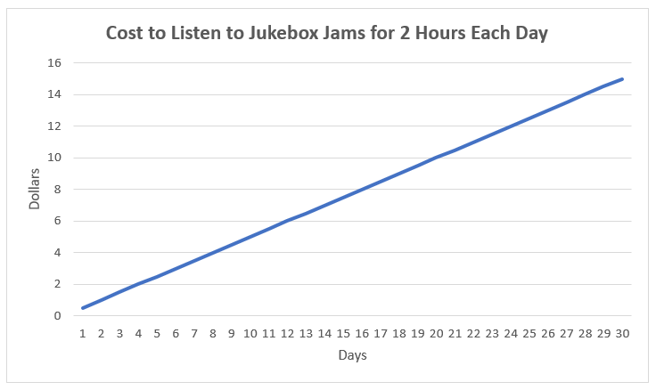

Standards for Mathematical Practice
1. Makes sense and perseveres in solving problems.
2. Reasons abstractly and quantitatively.
3. Constructs viable arguments and critiques the reasoning of others.
4. Models with mathematics.
5. Uses appropriate tools strategically.
6. Attends to precision.
7. Looks for and makes use of structure.
8. Looks for and expresses regularity in repeated reasoning.

Henry’s Music Dilemma

Henry loves listening to music. He wants to purchase a new app for his phone that allows him to listen to his favorite tunes. He found an app called Jukebox Jam that charges 25 cents for each hour. He is not sure if the app will be too expensive or not. Henry decides to create a line graph to show how much it would cost to listen for 2 hours every day for one month. Create a line graph to show the total amount Henry will have spent on music throughout the month if he uses Jukebox Jam every day. Remember your line graph should have a title, x-axis labels (horizontal), and y-axis labels (vertical).

Use your graph to answer the following questions:
1. How much will Henry spend in a month with 30 days?

2. Henry originally thought it might cost around $12 each month to listen to music using an app. What is the greatest number of days he can listen to music using Jukebox Jam if he only spends $12 each month?

3. Another app Music Mania charges a flat fee of $15 dollars each month. Customers can listen to as much music as they want for that price. Would you recommend that Henry purchase Music Mania or Jukebox Jam? Explain your thinking.

