Cluster 2 Images:
Building a Conceptual Understanding of Addition and Subtraction
Topic | Math Strategies Charts
Description | Students could reference charts like these as reminders of tools and common math strategies that may be used when working independently or in groups. Charts like these are most powerful when created over time with students as strategies surface during classroom experiences. Students are not expected to memorize and use specific strategies. Instead, they are given opportunities to choose strategies that make sense to them. Teachers choose student work to be shared during discussions that will reveal a variety of strategies (concrete to more abstract) and will help students choose more efficient problem-solving methods over time. When appropriate, teachers may cover up strategies that students should replace with more efficient strategies (such as counting all).
Images | 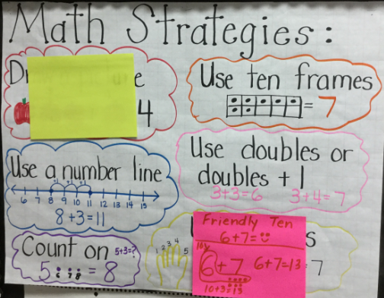  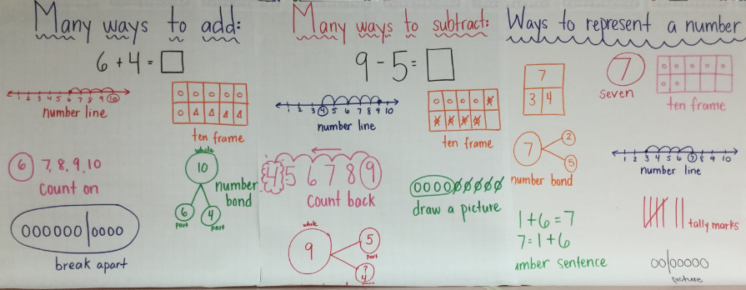  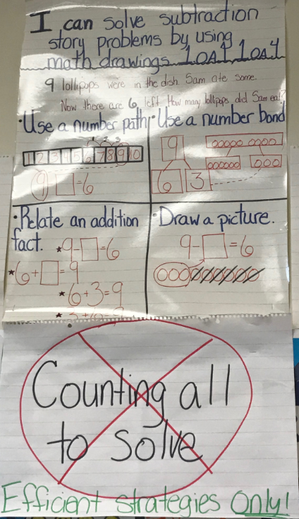

Topic | Make a 10 and Then Add On
Description | This visual demonstrates how to decompose an addend to make 10 and then use the 10 to add on easily. Students should know 10 and some more facts from Kindergarten. In cluster two, students should be exposed to hands-on experiences to make 10. Representing this strategy with equations is not expected at this time.
Image | 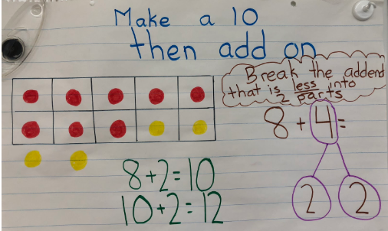
Topic | Graphic Organizers
Description | Graphic organizers are useful to introduce math vocabulary. This is just one example of what that might look like. It is important to expose students to interchangeable terms such as fact, number sentence, and equation. Adding examples and images to graphic organizers helps students understand and remember math terms.  Note: The consistent and accurate use of symbols to write number sentences is not expected until mid-year, though students may have been exposed to symbols at the end of kindergarten.
Image | 