Number Talk: Using Double Ten-Frames to Make Ten and Add More
In this lesson, students build addition fluency using double ten-frames by making ten and adding more.

NC Mathematics Standard:
Add and subtract within 20.
NC.1.OA.6 Add and subtract, within 20, using strategies such as:
• Counting on
• Making ten
• Decomposing a number leading to a ten
• Using the relationship between addition and subtraction
• Using a number line
• Creating equivalent but simpler or known sums

Additional/Supporting Standards:
Understand and apply the properties of operations.
NC.1.OA.3 Apply the commutative and associative properties as strategies for solving addition problems.
Add and subtract within 20.
NC.1.OA.9: Demonstrate fluency with addition and subtraction within 10.
.
Standards for Mathematical Practice:
2. Reason abstractly and quantitatively
- Construct viable arguments and critique the reasoning of others
- Use appropriate tools strategically
- Attend to precision
- Look for and make use of structure

Student Outcomes:
- I can make ten using double ten-frames and add more to determine the sum.

Math Language:
addition  altogether  add | addends  sum  equal/same amount | join  combine  total

Materials:
- a series of tens frames (actual tens frames with counters, tens frames representations on a chart or display images from a website such as https://www.slideshare.net/LPonton/1st-gr-double10framessetmakingtens)
- chart or board to record students’ responses
- markers

Advance Preparation:
- Before beginning the first number talk, establish number talk norms. Students gather in a common meeting area near the chart or board. No paper or pencil is needed for students with this activity. Teachers pose a problem and students mentally solve the problem in whatever way makes sense to them. When students have a solution, and can describe their strategy, they show a “thumbs up” quietly at their chests to communicate with the teacher they are ready to share. During wait time, students are encouraged to think of different strategies and hold up additional fingers to show the number of solution strategies they have.

Launch:
- Posing the Problem (1 minute)
- The teacher displays double ten-frames and asks students: How many counters do you see? How do you see them?
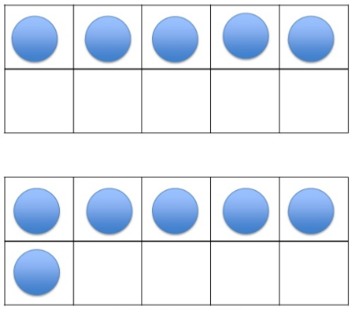
Set A

https://www.slideshare.net/LPonton/1st-gr-double10framessetmakingtens

Explore:
- Solving the Problem (1-2 minutes)
  - Give students quiet think time to solve the problem mentally. Then they hold up their thumb to indicate when they have a solution and can share their strategy. Giving ample wait time is imperative.

Discuss:
- Sharing Our Thinking (5-10 minutes)
  - Once most of the students have indicated they have a solution and strategy, the teacher calls on a few students to share their thinking. The teacher listens and asks clarifying questions to ensure that students’ thinking is accurately represented. Both correct and incorrect strategies are recorded without judgement for students to consider. For example, a student may explain I saw 5 in the top ten frame and five in the top row of the bottom ten frame and I knew 5 plus 5 is a double that makes 10. Then I just added the one other counter to ten to make 11. Then the teacher could record the equation 5 + 5 + 1 = 11 to represent the student’s thinking. Another student may only see the 5 + 1 = 6 and another could see it as 5 + 6 = 10.
  - Once a variety of solutions and strategies are shared, the teacher makes sure all students’ answers are represented by asking a question such as Did anyone get a different answer than 10, 11, or 6? Did anyone see it a different way?
  - Students should carefully consider the solutions and strategies presented. Help make connections between strategies by asking questions such as How is Sally’s strategy like John’s strategy? or How is Sally’s strategy different from John’s strategy? Also, help students learn to view incorrect answers as learning opportunities as misconceptions are identified and addressed.
- At the end of the lesson, make students agree that the sum of counters is eleven and it may be thought of as 5 + 5 = 10 and 10 + 1 = 11.
- Repeat this process (Launch, Explore, and Discuss) with the following problem sets:
Set B Set C
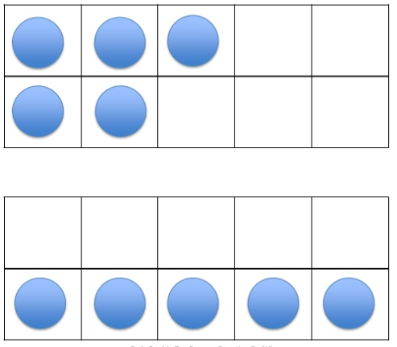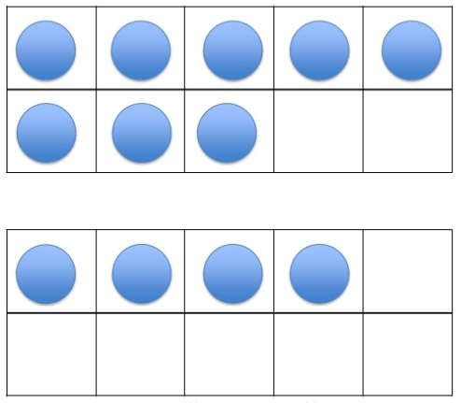
https://www.slideshare.net/LPonton/1st-gr-double10framessetmakingtens

General questions to promote class conversation about strategies:
• Who would like to share how many dots they see?
• I heard you say _____, did I hear correctly?
• Did anyone see it a different way?
• Can someone explain how ____ saw it in their own words?
• Raise your hand if you understand what ____ just shared.

Evaluation of Student Understanding
Informal Evaluation: Observation
Observe during the number talk for the following: What strategies do students share? Who participates? What do they say? How do they explain their thinking?

Make note of students’ names and target next steps in whole group and small group number talks. If the strategy you are hoping to elicit does not surface, continue to use similar representations in subsequent number talks. If most students can see and understand the idea of making a ten as an efficient strategy using counters, change the focus of your number talks (possibly to a series of equations that could be solved by making ten).

Next Steps Based on Informal Observations:

Whole Group | Small Group - Intervention
This number talk was chosen to highlight fluently making 10 using double ten-frames.  The teacher may repeat the lesson using three different sets of double ten-frames to make ten or move to a new concept once most of the students have mastered this skill. | The teacher may use a single ten-frame and dot images to increase fluency with making 10 by determining how many more dots are needed to make 10.

Possible Misconceptions/Suggestions:

Possible Misconceptions | Suggestions
Students may think there is only one way to find the sum of the dots on the double-ten frames. | Explain to students they are determining the total number of counters by joining/combining both ten-frames sets together in any order or grouping.
Students may think that the only way to add the dots is the way they are arranged on the two different ten frames. (Example 5 + 6 instead of 5 + 5 = 10 and 10 + 1 = 11) | Elicit and record multiple strategies that can be applied to the number talk. Ask questions such as Does anyone see it in a different way?  Continue to use similar representations in subsequent number talks. As students become comfortable with mental math and talking about their strategies, they will become more flexible in their thinking.

Adapted from Parrish, S., & Parrish, S. (2014). Number talks: Helping children build mental math and computation strategies, grades K-5. Sausalito, CA., USA: Math Solutions.

