Family Letter
5th Grade Whole Number Multiplication and Division Concepts

Dear Family,

During the week of <date> we will begin a new math unit focused on whole number multiplication and division. The purpose of this letter is to provide background information about our new unit.

Focus of the Unit
This unit on whole number multiplication and division builds on students’ work from fourth grade. Students are introduced to the traditional U.S. standard algorithm for multiplication. Students also extend their understanding of division to 2-digit numbers.

Building off Past Mathematics
In previous grade levels, students learned that multiplication is counting or combining equal sized groups. Situations involving multiplication have a number of groups and a number of objects in each group. For instance:
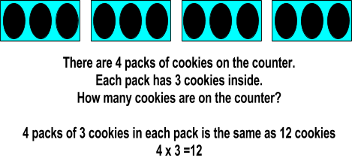

So, students read multiplication equations like 4 x 3 = 12 as “4 groups of 3 objects is the same as 12 objects”. Multiplication can also been seen as skip counting or repeated addition (4 x 3 can also be thought of as 3 + 3 + 3 + 3). Students also learned that multiplication can be interpreted as a comparison. For example, 45 = 5 x 9 means that 45 is 5 times as many as 9 and 9 times as many as 5.

Students have learned that division is separating a number of objects into equal shares or groups. Situations involving division contain a total number of objects, the number of groups, and the number of objects in the groups.

For instance:
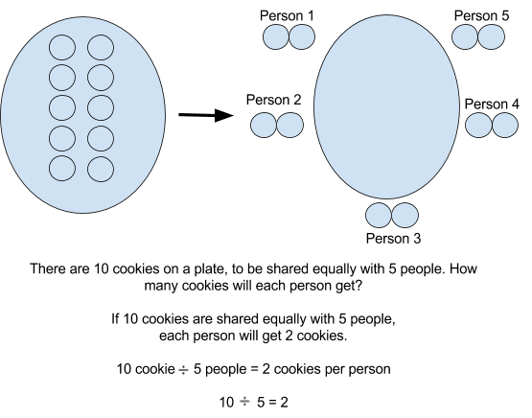
Division can also been viewed as repeated subtraction:
Students use their understanding of multiplication and division to solve story problems about real-life situations. These story problems involve situations where the number of groups, number of objects in a group, or total amount are missing. It is important that students “act out” story problem situations, so they can clearly see what information is given and still needed.

Strategies that Students Will Learn
In fifth grade, students use their previous understanding of multiplication and division strategies, and apply them to larger numbers. Below are some specific strategies that students use as they solve multiplication situations:
Strategies for Multiplication
Use facts you already know
Use an array to break apart unknown facts | “I do not know what 6 x 8 is, but I do know that 6 x 4 = 24  and  6 x 4 again is 24, and 24 + 24 = 48. So, 6 x 8 = 4.”  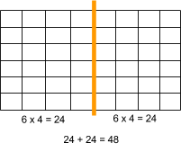
Use an area model to break apart numbers by their place value | 47 x 35 = (40 x 30) + (40 x 5) + (30 x 7) + (7 x 5)  47 x 35 = 1200 + 200 + 210 + 35  47 x 35 = 1645  Example of an area model:  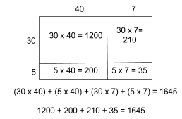
U.S. Standard  Algorithm | 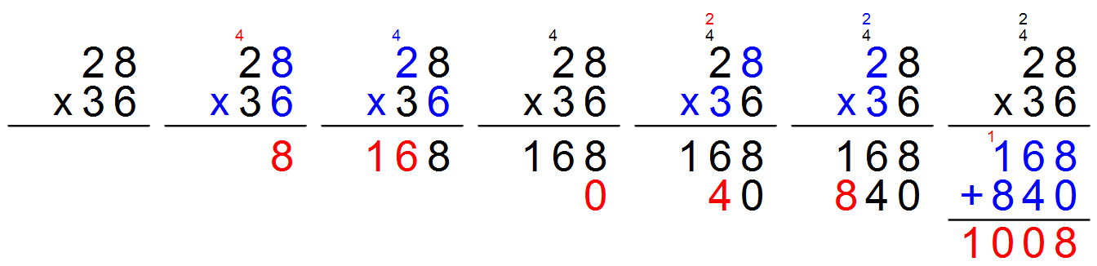

Strategies for Division
Repeated subtraction in groups | Taking a group at a time  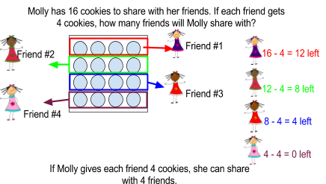
Separating into groups | 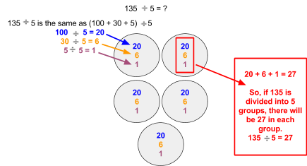
Using relationship between multiplication and division | 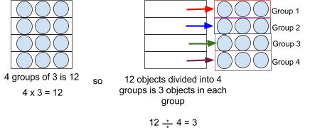
** Although the division situations may have the same equation, the story may be different. | 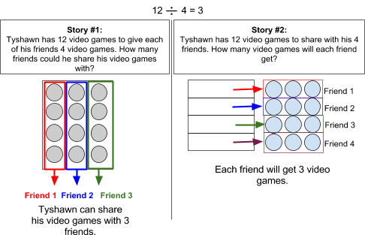

Ideas for Home Support
As a family, notice things that you purchase that come in groups and how many come in each group. As you plan for parties and events, involve your child in the process of determining how many packs of cups, plates, utensils, etc. are needed to serve the attendees. This helps them see and apply multiplication and division in a real-life context. Also, talk about other situations where you see multiplication and division in your everyday life, such as: how many legs are on all the ants on the log? How many juice boxes are on the shelf? If I bake 48 cookies for your class, how many cookies will each student get?

Thank you for serving as partners in your child’s success as a mathematician!
<signature>

