Family Letter
5th Grade Volume Concepts

Dear Family,

During the week of <date> we will begin a new math unit focused on volume. The purpose of this letter is to provide some background information about our new unit.

Focus of the Unit
This unit is based on the understanding that volume is a form of measurement. Students will learn that the unit of volume, such as a cube with side lengths of 1 inch, is called a unit cube. They will explore by building objects, such as rectangular prisms (like shoe boxes, tissue boxes, juice boxes, etc.), with layers of unit cubes to see how the volume is comprised. Students will use this experience to help them visualize and compare the volumes of rectangular prisms with different dimensions. Students will begin to reason about volume and understand that they can find the number of unit cubes in each layer by multiplying the length times the width of the rectangular prism. They also come to understand that the height of the prism is important, as it identifies how many layers of unit cubes will fit in the prism. After many opportunities to explore this idea, students can begin to utilize the formula, V=l x w x h (The volume of a rectangular prism is the same as the length times the width times the height).

Building off Past Mathematics
In previous grade levels, students explore the idea of arrays and area by covering spaces with objects and counting the number of objects. Also, in previous grade levels, students have estimated and measured liquid volumes and masses of objects, but not the geometric volume of an object. In fifth grade, students build on their understanding of area as they cover the base of a rectangular prism, and add additional layers to fill it.
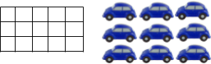
An array is an arrangement of a set of objects in rows and columns.

Strategies that Students Will Learn
Students use their prior experiences with area to help them determine the area of the bottom layer of a rectangular prism then add the layers of unit cubes on top of that bottom layer. For example, students can find the volume of a 3 x 3 bottom layer and 4 additional layers on top of the bottom layer, by finding the area of the bottom layer (3 x 3) and then multiplying that by the 4 additional layers to find the total volume: (3 x 3) x 4. Students also learn that they can break apart a rectangular array into smaller sections to find the volume of the whole object (example one). Students will apply this same strategy with solids that are comprised of more than one rectangular prism (example two). See examples below:

Example One:
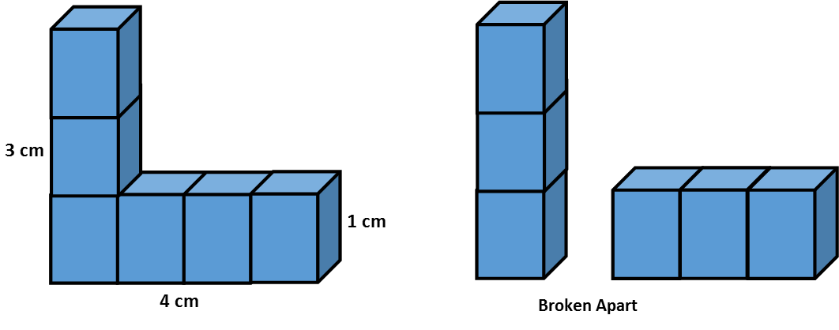
Example Two:
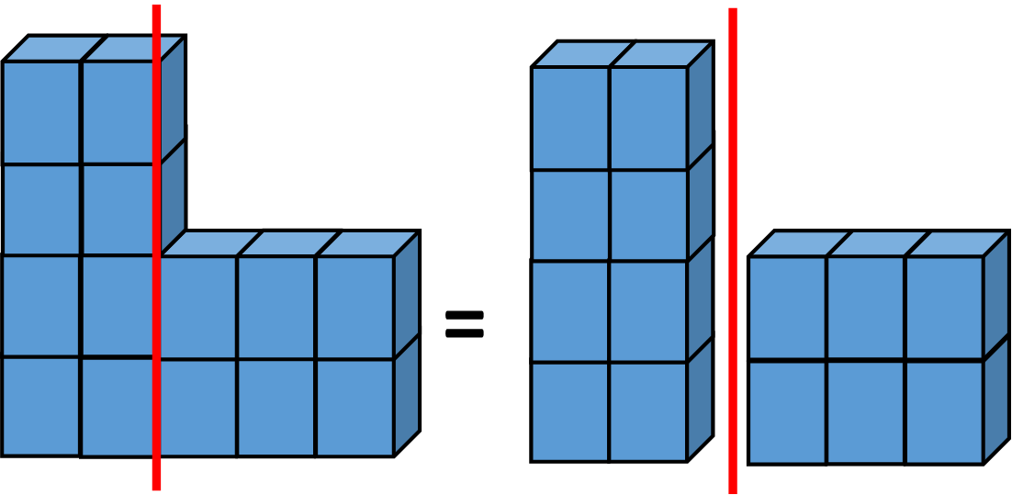

Ideas for Home Support
Volume can be found in many places in our world. As you shop at the grocery store, notice items that are packaged and sold in boxes (non-standard units). Predict with your child how many objects might fit in a box. Another opportunity for discussing volume is to compare the space in different rooms in your home or at school. Ask questions such as, “Which room do you predict has the largest volume? Smallest volume?”

Volume provides a third dimension to measurement, and students can become confused about how it relates to objects and area. Consider providing opportunities for your child to build rectangular prisms with unit cubes (standard units), and describe how they know how many unit objects there are (the volume). Emphasize that the unit objects are arranged in rows and columns, not randomly.

Thank you for serving as partners in your child’s success as a mathematician!
<signature>
