Student Representations for Addition Within 10
Student Representations | Description of Strategies
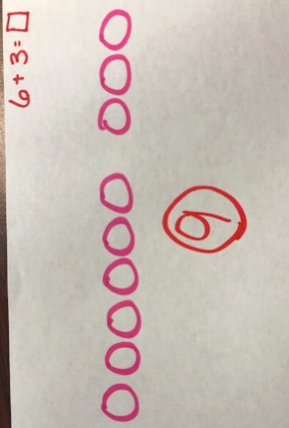 | These students are using the counting all strategy.  The next step could be to use counting on strategies (“I see 6…7, 8, 9.”).
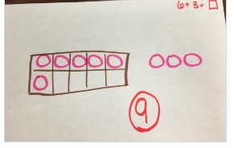

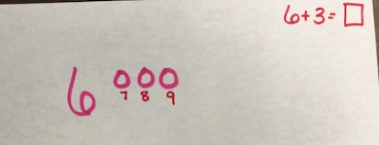 | These students demonstrate understanding of the counting on strategy.  Next steps could include working with counting on using higher numbers.  As students are successful with the counting on strategy, they could move on to other strategies including making ten, etc.
